
The United Republic of Tanzania

MWANZA REGION
SOCIO-ECONOMIC PROFILE, 2016
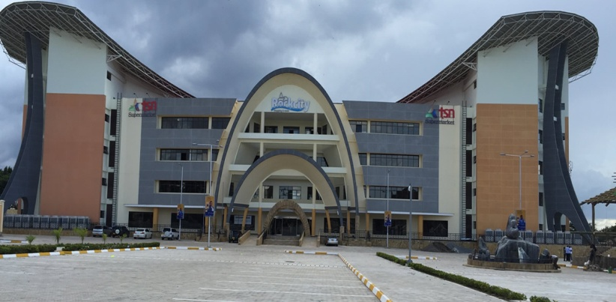

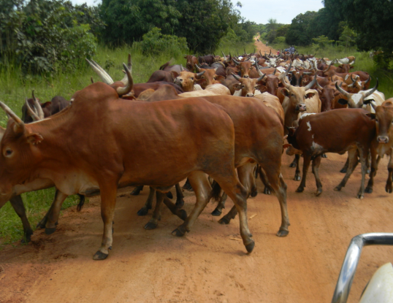
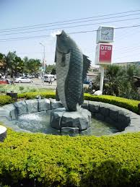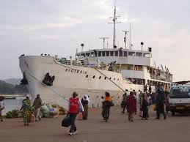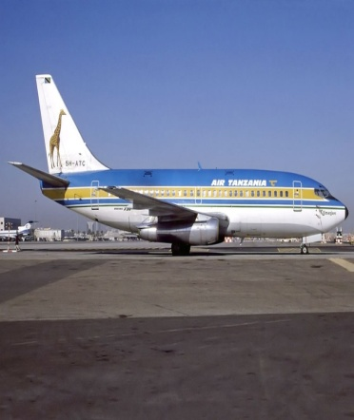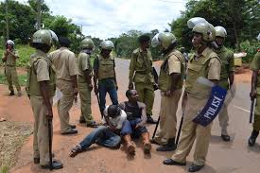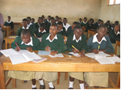
December, 2016
The United Republic of Tanzania

MWANZA REGION
SOCIO-ECONOMIC PROFILE, 2016

Jointly prepared
By
Ministry of Finance,
National Bureau of Statistics

and

Mwanza Regional Secretariat


National Bureau of Statistics
Dar es Salaam

December, 2016

Foreword
The goals of Tanzania’s Development Vision 2030 are in line with United Nation’s Sustainable Development Goals (SDGs) .The major goals are to achieve a high-quality livelihood for the people, achieve food security, develop a strong and competitive economy, to ensure equality and empower all women and girls. Monitoring the progress in achieving these goals needs for timely and accurate statistical information at all levels.
Problems especially in rural areas are many and demanding. Social and economic services require sustainable improvement. The high primary school enrolment rates recently attained have to be maintained and so is the policy of making sure that all pupils who pass standard seven examinations join Form One. The food situation is still precarious; infant and maternal mortality rates continue to be high and unemployment triggers mass migration of youths from rural areas to the already clogged urban centers.

Added to the above problems, is the menace posed by HIV/AIDS, the prevalence of which hinder efforts to advance into the 21st century of science and technology. The pandemic has been quite severe among the economically active population leaving in its wake an increasing number of orphans, broken families and much suffering. AIDS together with environmental deterioration are the new problems which cannot be ignored.

Our efforts to meet both the new and old challenges are hampered by many factors including ill prepared rural development programs followed by weak implementation, monitoring and their supervision. The shortcomings in policy formulation, project identification, design and implementation due to the lack of reliable and adequate data and information on the rural development process have to be addressed. The availability of reliable, adequate and relevant qualitative and quantitative data and information at regional level is a prerequisite for the success of the formulating, planning, implementation, monitoring and evaluation of regions’ development programs.

The publication of the Mwanza Region Socio-Economic Profile series by the President Office, Regional Administration and Local Government Authority in collaboration with the National Bureau of Statistics and Mwanza Regional Administration
Management Team should be viewed as a second fruitful attempt towards finding a solution to the existing problem of data and information gap at regional level.

The Regional Profile series cover a wide range of data and information on geography, population, social-economic parameters, social services, economic infrastructure, productive sectors and cross cutting issues. The publication so far has proved to be high demand and vital source of information to many policy makers, planners, researchers, donors and functional managers.

The 2016 Mwanza Region Socio-Economic Profile has taken advantage of the experience gained in the production of other Region and District Council Socio-Economic Profiles in the country. It provides valuable information to our clients. Constructive views and criticisms are invited from readers to make a profile like this a better tool in the implementation of the country’s policies and programs.

I would like to take this opportunity to acknowledge with thanks, NBS for their technical support and staff of Mwanza Regional Office who ardent their time to ensure the successful completion of this assignment.

Regional Administrative Secretary
November, 2016.

Acronyms
AIDS Acquired Immune Deficiency Syndrome
ARI Acute Respiratory Infections
ARV Antiretroviral
CBO Community Based Organization
CRDB Cooperative Rural Development Bank
DC District Council
DPT3/HB3 Diptheria Pertusis Tetanus 3 ^{rd} doze/ Haemoglobin Level
ECF East Cost Fiver
FAO Food Agriculture Organization
GIS Geographical Information Sytem
Govt Government
Ha Hectares
HIV Human Immune Virus
IMR Infant Mortality Rate
MVC Most Vulnerable Children
NCD New Castle Disease
NMB National Microfinance Bank
NBC National Bank of Commence
OPV3 Oral Polio Vaccine 3rd Doze
PMTCT Prevention Mother to Child Transmission
SACCOS Savings and Credit Cooperative Societies
Sq. Km. Square Kilometre
Std VII Standard seven
STI Sexual Transmitted Infection
TB Tuberculosis
TBAs Traditional Birth Attendants
TC Town Council
TPR Toilet Pupil Ratio /Teacher Pupil Ratio
TT2 Tetanus Toxoid 2 ^{nd} doze
TPB Tanzania Postal Bank
U5MR Under Five Mortality Rate
UTI Urinary Track Infection
VCT Voluntary Counselling and Testing
VHC Village Health Committee
VHWs Village Health Workers
VWC Village Water Committee
VWF Village Water Fund
WUG Water User Group

CHAPTER ONE

Land, Climate, Agro-Ecological Zones and People

1.0 An Overview
Chapter One gives information about the geographical location, land area, administrative units, climate and agro-ecological zones of Mwanza region. Information about ethinic groups, population distribution, size and other demographic characteristics is also briefly explained. Housing composition and size are also discussed in this Chapter.

1.1 Geographical Location
Mwanza region is among the 25 regions of Tanzania mainland and was reestablished on 1st October 2012 after being subdivided into three regions. Other regions are Geita and Simiyu. The name Mwanza comes from the word Ng’wanyanza, the name of the fishing village which was wrongly pronounced by Arab traders and explolers as Mwanza. The name meant “the place where the great lake starts”. Mwanza region is on the northern part of Tanzania mainland along the shores of Lake Victoria, which is the largest lake in Africa and second in the world after Lake Supirior. These waters in turn separate the region from neighbouring countries of Kenya and Uganda. The other Tanzania regions surrounding this lake are Kagera, Geita, Simiyu and Mara.

Mwanza region have unique features due to its location and the presence of the Lake Victoria. This Lake played so dominant role in the people’s lives particularly on social and economic affairs, possible because all the region’s councils have access to the lake except Kwimba. The Lake also placed Mwanza at the hub of all areas surrounding the lake in Tanzania and beyond and considered as a business centre for the Great Lakes Region. Uganda lake-borne traffic to Dar es Salaam passes through Mwanza. The Region also connects the Democratic Republic of Congo, Rwanda and Burundi to Kisumu by lake to Mwanzaport. Alternatively overland via Sirari, so the same port. Internaly, regions such as Kagera, Geita and Mara regions get access to the rest of the mainland via Mwanza. Therefore, though the Region the second small in size after Dar es Salaam, but it is economically and geographically one of the most important regions of Tanzania.

Geographically, The Region shares borders with Lake Victoria in the North, Kagera and Geita in the West, Mararegion on the East whileShinyanga and Simiyu regions lies on the South and Southeastern parts of the region. In terms of international identification, the region lies between latitudes 1⁰30’ and 3⁰0’ south of the Equator and between longitudes 31⁰45’ and 34⁰10’ east of Greenwich.

1.2 Land Area, Land Use Pattern and Administrative Units
Mwanza region has a total area of 25,233 sq. Kms divided into land area (11,796 sq.km, equivalent to 46.7 percent of total area) and water (13,437 sq.km or 53.3 percent) mostly lake Victoria. Looking at land area of the rest of regions, Mwanza regioncoversonly1.07 percent of total land area of Tanzania Mainland (883,343 sq.km) and become the second smallest regionafter Dar es Salaam. The land is mostly plain (Mbuga)stretched with some (rock) hills and valleys, divided into arable land which is suitable for crop production, forest reserves while normal forests/grassland used for grazing and the remaining land is either lying idle for some reason such as soil leaching infestation, or being edges and river beds.

At council level, though Ukerewe district has the largest area (25.0 percent), has smallest land area (10.2 percent) with large part of its area being water. Misungwi district has different senario, with large part of its area covered by land area (90 percent) and only 10 percent is being covered by water. Whist, Kwimba district council has 15.5 percent of regional area, but all of it is covered by land area. Mwanza city is the smallest council in the region with only a percent of total area of the Region followed by Ilemela municipal (4.2 percent) and Misungwi district council (8.4 percent).Rest of councils in the region have large portions of both land and water areas (Table 1.1).

Table 1.1: Land and Water Area by Council in Sq kms, Mwanza Regionl, Tanzania Mainland, 2015
Council | Land Area |  | Water Area |  | Total Area
Council | Sq. Km | Percent | Sq. Km | Percent | Sq. Km | Percent
Ukerewe | 640.0 | 10.2 | 5,660.0 | 89.8 | 6,300.0 | 25.0
Magu | 1,546.0 | 41.2 | 2,206.0 | 58.8 | 3,752.0 | 14.9
Mwanza City | 173.0 | 67.6 | 83.0 | 32.4 | 256.0 | 1.0
Kwimba | 3,903.0 | 100.0 | 0.0 | 0.0 | 3,903.0 | 15.5
Sengerema | 1,799.9 | 53.7 | 1,551.1 | 46.3 | 3,351.0 | 13.3
Ilemela | 252.0 | 23.6 | 817.0 | 76.4 | 1,069.0 | 4.2
Misungwi | 1,947.0 | 91.8 | 175.0 | 8.2 | 2,122.0 | 8.4
Buchosa | 1,535.1 | 34.3 | 2,944.9 | 65.7 | 4,480.0 | 17.8
Total | 11,796.0 | 46.7 | 13,437.0 | 53.3 | 25,233.0 | 100
Source: Compiled Data fromDistrict Executive Directors’ Offices, Mwanza Region, 2016.

Administratively, Mwanza region is divided into seven districts and eight councils subdivided into a city, municipal and six district councils, 24 divisions and 191 wards with a total of 543 villages, 367 mitaa and 3,425 hamlets distributed unevenly as shown in Table 1.1. Looking at land area, Kwimba district council covers largest part of land area of the region, about 33.1 percent followed by Misungwi with about 16.5 percent of the total land area. Mwanza city or Nyamagana municipal council has the smallest land area in the region constituting only 1.5 percent followed by Ilemela municipal (2.1 percent) and Ukerewe district council (5.4 percent).

Table1.2: Land Area and Administrative Units by Council, Mwanza region; 2015
Council | Land Area (Sq. km) | No. of Division | No. of Ward | No. of Villages | No. of Mitaa | No. of Hamlets | Percent of Land Area
Ukerewe | 640.0 | 4 | 25 | 76 | 7 | 507 | 5.4
Magu | 1,546.0 | 4 | 25 | 82 | 0 | 508 | 13.1
Mwanza City | 173.0 | 1 | 18 | 0 | 175 | 0 | 1.5
Kwimba | 3,903.0 | 5 | 30 | 119 | 14 | 857 | 33.1
Sengerema | 1,799.9 | 3 | 26 | 71 | 0 | 419 | 15.3
Ilemela | 252.0 | 1 | 19 | 0 | 171 | 0 | 2.1
Misungwi | 1,947.0 | 4 | 27 | 113 | 0 | 724 | 16.5
Buchosa | 1,535.1 | 2 | 21 | 82 | 0 | 410 | 13.0
Total | 11,796.0 | 24 | 191 | 543 | 367 | 3,425 | 100.0
Source:Compiled Datafrom District Executive Directors’ Offices, Mwanza region, 2016

1.3 Climate and Soil

1.3.1 Climate
Mwanza region in most parts experiences a bimodal rainfall partten, the short rains falling from October to December and the long rains pours between March and May. While, dry periods spell from January to end of February and between June and end of September. The Region’s average annual rainfall is about 930 mm, ranging between 1,200 mm in Ukerewe islands to 700 mm in the southern and southeastern parts of the Region. The temperature in the region is to some extent influenced by Lake Victoria, about 25⁰c – 28⁰c experienced between September and December and cool dry season last from June to August experiences low temperatures which range between 20⁰c and -11⁰c.

1.3.2 Soil
The soils vary from sand or sand loam to sand-clay or loom-clay texture “mbuga”. As follows:

- Sand soil derived from granite–These are mostly found on hills with slopes, very susceptible to erosion and very moderate natural fertility and steadily deteriorate under conditions of continuous cultivation. These soils are found in the areas commonly called Sukuma Heartland in Magu district council, covering areas of Sanjo, Kahangara, Itumbili, Busega and Kivukoni together with large part of Ukerewe district council;

- Red loams derived from limestone –The soil colour ranges from red to yellow loamy sand and or clay loam. The soil has greater ability to retain nutrients and therefore potential for agriculture, but needs more water. It is found in some parts of Katunguru and Sengerema, Ilemela and Busagala in Sengerema district council and Ilemela municipal council respectively and large part of Misungwi district council; and

- Black clay soils–The soil is mostly saturated water within 100 cm of the surface long enough to restrict the range of crops that can be grown. Its texture mostly dominated by black clay soil suitable for paddy production. It is found in large parts of Magu, Buswelu, Kwimba and Misungwi district councils regions.

Most of these soils have high nutrient contents and are considered suitable for a wide range of food and cash crops and therefore have the potential for profitable cultivation. Mwanza region soils can best be described as moderately fertile.

1.4 Agro – Ecological Zones (AEZ)
With the exception of very few hills and slopes, the region forms part of Lake Zone Plain of Tanzania, relatively homogeneous with gently undulating plains intersected by seasonally flooded valley bottom soil. In the extreme north east, central and extreme south, this pattern gives way to open flat land and covered by well or moderately drained soils with textures of sandy loams and black clay soilssuitable for cultivation. These topographic and geographical features together with climatic conditions form different five distinctive agro – economic zones.

1.4.1 Zone I
This zone covers parts of the Sengerema district council, namely, Katunguru and Sengerema, Ilemela and Busagala areas of Ilemela municipal council and large part of Misungwi district council. This zone is a highly populated area which experience pressures on land and competition between human and livestock requirements. It is experiencing a moderate and unreliable rainfall with average annual of 900 mm though some years dropped to less than 850 mm per annum. the soils are red to yellow – red, gritty sand clay loams which are widely cultivated. Major crops grown in the zone are cotton, cassava, maize and yellow gram or chick peas.

1.4.2 Zone II
The zone constitutes the majority of the areas commonly called Sukuma Heartland in Magu district council. This zone covers areas of Sanjo, Kahangara, Itumbili, Busega and Kivukoni. Population densities are slightly high with large portion of population concentrated along the lakeshore which causes pressure on land. Rains in this Zone are eratic and undependable, with annual average of 700 – 850mm. The soils are of the typical Sukumaland catena of granite inselbergs with a progression yellow-red “hill sands” to the poorly drained dark grey loam sands and clays of the valley bottoms, and low lying plains. Crop farming, livestock keeping and fishing are the main economic activities performed in this zone. The major crops grown in this zone are cotton, cassava, paddy, sweet potatoes and yellow grams.

1.4.3 Zone III
This is an area of moderate population and livestock densities of Nyanchenche in Sengerema district council, Mbarika and Inonelwa in Misungwi district council, Ngudu, Ngula and Ibindo in Kwimba district council, and Ngalu in Magu district council. The Zone has an average rainfall of 800 – 900mm per annum with soils varying from relative small areas of hill sands to large areas of poorly drained grayish loamy sandy and black clays. Main crops grown in this zone are cotton, sorghum, millets, paddy, cassava and sweet potatoes.

1.4.4 Zone IV
The Zone is predominately flat to depressed areas with very isolated hill masses and rock hills covering areas of Ng’wamashimba and Nyamilama in Misungwi and Kwimba district councils respectively. The population and livestock densities are moderate to the extent that cultivation land is available. Rains in this zone are reliable with average annual rainfall is between 750 and 900mm, but compensated by the high water retaing capacity of the soil. The soils are mostly poorly drained to water logged grey loamy sands and black clays. Crop farming and livestock keeping are the main economic activities practiced in this zone. Major crops produced are; maize, chick peas, sorghum, millet, cassava, sweet potatoes and cotton.

1.4.5 Zone V
Zone V is densely populated area occupying Ilagala, Ukara, Mumulambo and Mumbuga in Ukerewe islands characterized with heavy rains of an average rainfall of 1200mm per annum. Crop farming and fishing are main economic activities performed, while livestock keeping very limited practiced. The soils in this zone are of a sandy type and arable land is very limited. Main crops grown are; sweet potatoes, cassava, beans, peas, coffee, vegetables and fruits.

1.5 Population
Population is a source of labour for the production of goods and services and is responsible for the consumption of various products. The size, structure, distribution and quality of a population are among the important parameters for economic development. The growth and distribution of the population also determines the demand for food, water, energy and other natural resources and location of essential social services, such as education, health, water, transport and housingfor its survival. This part of a report assessed population size, growth, structure, distribution and quality of people among councils of Mwanza region.

1.5.1 Ethnic Groups
Mwanza region is among fast growing regions in Tanzania experiencing fast population growth by both natural birth and migration. As a result, more ethnic groups are found in the region. However, among all people, the region has five main ethnic groups namely: Sukuma, Zinza, Kerewe, Kurya, Jita and Kara. The Sukuma being a main ethnic group occupy all district councils of the region, while the Kerewe and Kara occupy most of Ukerewe district council and majority of them found in Ilemela, Nyamagana/Mwanza City and islands of Buschosa and Sengerema district councils. Table 1.3shows ethnicity of indigenous people by councils in Mwanza region.

Table 1.3: Ethnicity of Indigenous People by Council, Mwanza Region; Tanzania Mainland, 2015
Council | Number of Group | List of Five Major Groups
Ukerewe | 8 | Wakerewe,Wajita,Wasukuma,Wakara and Wakurya
Magu | 7 | Sukuma,Jita Kulya, Zinza, kara
Mwanza City | 10 | wasukuma, wazinza, wakerewe, Wakara, Wahaya and Wakurya
Kwimba | 8 | Wasukuma, wajita, Wakurya, Wakerewe and Wahaya
Sengerema | 9 | Sukuma, Kara, Kerewe, Jita, Haya
Ilemela | 10 | Sukuma, Kara, Kerewe, Jita, Haya
Misungwi | 6 | Sukuma, Zinza, Kerewe, Haya, Kurya
Buchosa | 9 | Zinza,jita,kerewe, kara and Sukuma
Total | 10

Source: Compiled Data from District Executive Director’s Offices - District Planning Offices, 2016

1.5.2 Population Size and Growth
The population of Mwanza region has experienced significant growth for the last two fold. Three population and housing censuses conducted in 1988, 2002 and 2012 shows that Regionpopulation increased from1,876,635 people in 1988 to 2,049,917 inhabitants counted in 2002 Population Census and reached 2,772,509 people in 2012 (Table 1.4). These data portray that, rapid population increase was observed during the 2002 – 2012 intercensal (35.2 percent increase with growth rate of 3.0 per annum) compared to 9.2 percent between 1988 and 2002 with an average annual growth rate of 0.6per annum (Table 1.4). Table 1.4 also shows Mwanza city or Nyamagana municipal council was the most affect council since its population increased by 73.1 percent with growth rate of 5.5 per annum between 2002 and 2012, followed by Misungwi district council (increase of 37.3 percent with growth rate of 3.2 per annum) and Sengerema (36.1 percent increase with growth rate of 2.8 per annum). The negative growth rates observed in Magu, Mwanza city and Kwimba were caused by the reduction of population after establishing new councils.

Table 1.4: Population Size and Growth Indicators by Council; Mwanza Region, 1988, 2002 and 2012 Censuses
Council | Population Size |  |  | Percentage Change |  | Growth Rate per Annum |  | Doubling Time (years)
Council | 1988 | 2002 | 2012 | 1988 - 2002 | 2002-2012 | 1988 - 2002 | 2002-2012 | 2002-2012
Ukerewe | 172,946 | 260,831 | 345,147 | 50.8 | 32.3 | 2.9 | 2.8 | 24.7
Magu | 311,835 | 244,356 | 299,759 | -21.6 | 22.7 | -1.7 | 2.0 | 33.9
Mwanza City | 221,209 | 209,806 | 363,452 | -5.2 | 73.2 | -0.4 | 5.5 | 12.6
Kwimba | 427,726 | 314,925 | 406,509 | -26.4 | 29.1 | -2.2 | 2.6 | 27.2
Sengerema | 303,897 | 246,421 | 335,267 | 12.3 | 36.1 | 3.5 | 2.8 | 24.4
Ilemela* | n.a | 264,873 | 343,001 | n.a | 29.5 | n.a | 2.6 | 26.8
Misungwi | 439,022 | 256,133 | 351,607 | n.a | 37.3 | n.a | 3.2 | 21.9
Buchosa* | n.a | 252,572 | 327,767 | n.a | 22.9 | 3.5 | 2.8 | 24.4
Total | 1,876,635 | 2,049,917 | 2,772,509 | 9.2 | 35.2 | 0.6 | 3.0 | 23
* Ilemela and Buchosa districts did not exist in 1988 they were parts of Mwanza, and Sengerema districts respectively
Source: National Bureau of Statistics, Computed Data from 1988, 2002 and 2012 Population Censuses Reports.

Doubling time is another key population indicator which shows how many years the region or council would double its population. This indicator alerts the decision makers to review their socio-economic goals and targets take into consideration of expected socio-economic pressures caused by their demands. Table 1.4 also shows that population of Mwanza region will double after 23 years. Doubling time vary across the councils, ranging from 12.6 years (Mwanza city) to 33.9 years in Magu district council. This means that, population of Mwanza city council will double after a short period of time, after only 13 years compared to Magu council which will take more years, almost 40 years to double its population (Figure 1).

Figure 1: Estimated Doubling Time (Years) by Council, Mwanza Region, 2012
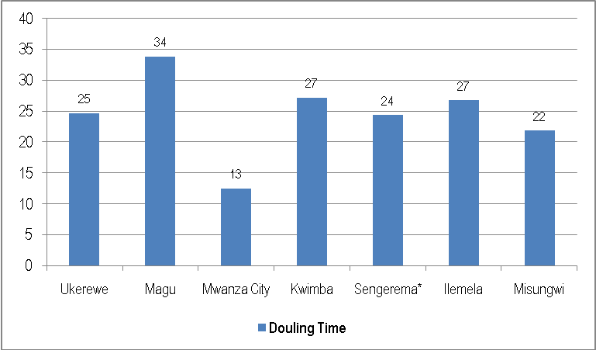
Source: National Bureau of Statistics, the 2012 Population and Housing Census Report.

Table 1.5 shows that the total population of Mwanza Region in 2012 was 2.7 million. Out of that, 66.7 percent (1.8 million) were residing in rural areas and 33.3 percent (0.9 million) resided in urban areas. It is also observed higher percentage changes of population in urban areas in both intercensal period compared to rural area. However, the region is still considered as a rural region since its rural population will take almost 36 years to double its population compared to almost 12 years for urban population to double (Table 1.5).

Table 1.5: Population Size and Growth Indicators by Location; Mwanza Region, 1988, 2002 and 2012 Censuses
Location | Population Size |  |  | Percentage Change |  | Growth Rate per Annum |  | Doubling Time (years);  2002 - 2012
Location | 1988 | 2002 | 2012 | 1988 - 2002 | 2002-2012 | 1988 - 2002 | 2002-2013 | Doubling Time (years);  2002 - 2012
Rural | 1,536,684 | 1,528,083 | 1,848,288 | -0.6 | 21 | 0.0 | 1.9 | 36.4
Urban | 339,951 | 521,834 | 924,221 | 53.5 | 77.1 | 3.1 | 5.7 | 12.1
Total | 1,876,635 | 2,049,917 | 2,772,509 | 9.2 | 35.2 | 0.6 | 3.0 | 23
Source: National Bureau of Statistics, Computed Data from 1988, 2002 and 2012 Population Censuses Reports.

1.5.3 Population Density
Figure 2 shows the first five regions in Tanzania Mainland with the highest population density. Mwanza region, with an average population density of 235 persons per sq. km is the second highest densely populated region after Dar es Salaam region (Figure 2). The third region is Kilimajaro though has big land area than Mwanza region. The fourth and fifth are Kagera and Geita regions with population density of 97 and 87 respectively (figure 2).

Figure 2: The First Five Regions with the Highest Population Densities (Sq. Km), Tanzania Mainland, 2012
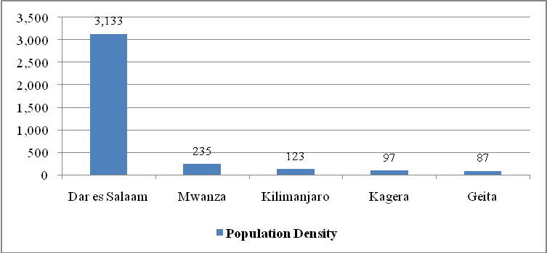
Source: National Bureau of Statistics, the 2012 Population Census Report.

Table 1.6 shows the population densities of regions of Lake Zone Region. Mwanza regionhas smallest land area and largest population compared to the rest of regions of Lake Zone. As a result, the region has population density of 235 persons per sq.km and become highly populated region far higher than the rest of regions which form a lake zone region. It is followed by Kagera region (97 persons per sq.km.) and Geita (87 people per Sq. Km.). Among other reasons, the highest population density of Mwanza region has been caused by its land area and high rate of in-migrants influenced by its location with the availability of socio-economic services and opportunities compared to other regions within and outside Lake Zone region.

Table 1.6: Population Density by Region, Lake Zone, Tanzania Mainland, 2012
Region | Land Area (Sq. Km) | Population (2012) | Population Density 2012 | Ranking (Lake Zone Only) by
 |  |  |  | Land Area | Population | Pop. Density
Shinyanga | 18,901 | 1,534,808 | 81 | 5 | 6 | 3
Kagera | 25,265 | 2,458,023 | 97 | 1 | 2 | 2
Mwanza | 11,796 | 2,772,509 | 235 | 6 | 1 | 1
Mara | 21,760 | 1,743,830 | 80 | 3 | 3 | 5
Simiyu | 25,212 | 1,584,157 | 63 | 2 | 5 | 6
Geita | 20,054 | 1,739,530 | 87 | 4 | 4 | 4
Total - Lake Zone | 120,659 | 11,832,857 | 98
Source: NBS, Computed Data from 2012 Population Censuses Reports.

Table 1.7 gives the population density at council level for the census years of 2002 and 2012. In 2002, Mwanza city with a population density of 1,213 persons per sq. km was the most densely populated council in the region, followed by Ilemelamunicipal with 1,051 persons per sq. km. Kwimba was the least densely populated council as it had only 81 persons per sq. km. In 2012, Again Mwanza city continued to be the most densely populated council with population density of 2,101 persons per sq.km.followed by Ilemela (1,361) and Ukerewe (539). Kwimba district remained the least populated council with 104 persons per sq. km. (Table 1.7). The rapid increase in the population size has caused the population density of the region to increase by 35.2 percent as it was in 2002(174 persons per sq. km.).

Table 1.7: Population Density by Council, Mwanza Region; Tanzania Mainland, 2002 and 2012
Council | Land Area (Sq.km) | Population Size |  | Population Density |  | Percent Change of Pop. Density
Council | Land Area (Sq.km) | 2002 | 2012 | 2002 | 2012 | Percent Change of Pop. Density
Ukerewe | 640.0 | 260,831 | 345,147 | 408 | 539 | 32.3
Magu | 1,546.0 | 244,356 | 299,759 | 158 | 194 | 22.7
Mwanza City | 173.0 | 209,806 | 363,452 | 1,213 | 2,101 | 73.2
Kwimba | 3,903.0 | 314,925 | 406,509 | 81 | 104 | 29.1
Sengerema | 1,799.9 | 246,421 | 335,267 | 137 | 186 | 36.1
Ilemela | 252.0 | 264,873 | 343,001 | 1,051 | 1,361 | 29.5
Misungwi | 1,947.0 | 256,133 | 351,607 | 132 | 181 | 37.3
Buchosa | 1,535.1 | 252,572 | 327,767 | 165 | 214 | 29.8
Total | 11,796.0 | 2,049,917 | 2,772,509 | 174 | 235 | 35.2
Source: NBS,Computed Data from 2002 and 2012 Population Censuses Reports.

1.5.4 Dependency Ratio
The Age Dependency Ratio gives the number of persons aged 0 – 14 years and those aged 65 years and above for every 100 persons aged 15 – 64 years. In 2012, Mwanza region had a total of 1,378, 629 dependants with more young population aged less than 15 years (46.2 percent) and only 3.5 percent elder people, depending on 1,393,880 active population. Similar observations were experienced in 2002 population census. As a result, age working group in Mwanza region supporting big number of dependants and causes dependency ratios to become highest in the country. Figure 3 shows that the number of dependants for every 100 persons of the active age group in Mwanza regionincreased from 95.5 in 2002 to 98.9 in 2012.

Looking at locations, the situation is more burdens to rural areas compared to urban areas. This means that the burden for the economically active population had increased from 107 persons to 113 persons in the referred years for rural areas and slight change in urban areas 74.5 dependency rate in 2002 against 74.9 in 2012. The results show that, the rural area was not in a better position since its dependency ratios were above the regional average of 99 persons (Figure 3).

Figure 3: Dependency Ratio by Location (Rural – Urban), Mwanza Region; 2002 and 2012
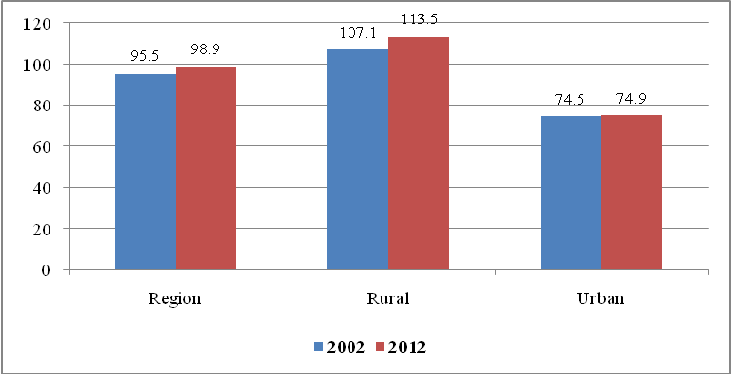
Source: National Bureau of Statistics, Computed Data from 2002 and 2012 Population Censuses Reports.

Table 1.8 indicates the magnitude of dependence ratio for each council in Mwanza region based on the 2012 population census results. At Council level, Ilemela Municipal council had the lowest dependency Ratio at 71 persons for every 100 persons of the active population, followed by Mwanza city (72 persons), while less labour force to support more dependants was experienced at Kwimba with 117 persons for every 100 persons each followed by Misungwi (112 persons). This situation portrays effects of geographical location and life style of persons between rural councils against urban councils. Mwanza city and Ilemela municipal are typical urban councils characterized by less dependants than rural councils caused by modernization and changes of life style of urbanites.

Table1.2: The Dependency Ratios by Council, Mwanza Region; Tanzania Mainland, 2012
Council | Dependant Population |  |  | Economically Active | Dependency Ratio
Council | 0 - 14 Years | 65+ Years | Total | Economically Active | Dependency Ratio
Ukerewe | 162,789 | 13,981 | 176,770 | 168,377 | 105.0
Magu | 144,770 | 11,570 | 156,340 | 143,419 | 109.0
Mwanza City | 141,431 | 10,309 | 151,740 | 211,712 | 71.7
Kwimba | 202,459 | 16,245 | 218,704 | 187,805 | 116.5
Sengerema | 324,093 | 22,754 | 346,847 | 316,187 | 109.7
Ilemela | 133,659 | 8,858 | 142,517 | 200,484 | 71.1
Misungwi | 172,270 | 13,441 | 185,711 | 165,896 | 111.9
Buchosa* | * | * | * | * | *
Total | 1,281,471 | 97,158 | 1,378,629 | 1,393,880 | 98.9
Percent of Total | 46.2 | 3.5 | 49.7 | 50.3
*Buchosa council is included in Sengerema council
Source: NBS, Computed Data from 2012 Population Censuses Report

1.5.5 Population Distribution (Age) and Sex Ratio
The populations of Mwanza region of 2012 as it was in 2002 characterised by broad based population pyramid indicating that there is highest population at young ages and decline steadily towards old ages, proving the existence of high fertility and mortality rates. Table 1.9 shows disparities between sexes along ages. In 2012, Mwanzaregion had Sex Ratio of 96 males for every 100 females, but different scenarios were observed among age groups. The first scenario is where both sexes have almost equal numbers as observed in age group 0 – 4 years, sex ratio was 99.9 boys for every 100 girls. The second scenario is whereby males are more than females observed on age groups 50 – 54, 55 – 59, 60 – 64 and 65 – 69. Whist, third scenario portrays few males than females observed on age groups 45 – 49 years and 80 and more years with 80.2 and 80,8 sex ratios respectively (Table 1.9).

Table 1.9: Population by Five Year Age Groups and Sex; Mwanza Region, 2012 Census
Age Group | Male | Percent | Female | Percent | Total | Percent | Sex Ratio
0 -4 | 249,992 | 50.0 | 250,184 | 50.0 | 500,176 | 18.0 | 99.9
5 -9 | 215,831 | 50.1 | 214,975 | 49.9 | 430,806 | 15.5 | 100.4
10 -14 | 181,406 | 49.9 | 182,400 | 50.1 | 363,806 | 13.1 | 99.5
15 - 19 | 143,652 | 48.8 | 150,842 | 51.2 | 294,494 | 10.6 | 95.2
20 -24 | 114,951 | 46.4 | 132,920 | 53.6 | 247,871 | 8.9 | 86.5
25 - 29 | 92,552 | 46.4 | 106,758 | 53.6 | 199,310 | 7.2 | 86.7
30 - 34 | 82,244 | 48.3 | 88,160 | 51.7 | 170,404 | 6.1 | 93.3
35 - 39 | 70,681 | 49.3 | 72,707 | 50.7 | 143,388 | 5.2 | 97.2
40 - 44 | 55,064 | 50.5 | 53,914 | 49.5 | 108,978 | 3.9 | 102.1
45 - 49 | 39,896 | 45.3 | 48,198 | 54.7 | 88,094 | 3.2 | 82.8
50 - 54 | 33,506 | 51.4 | 31,681 | 48.6 | 65,187 | 2.4 | 105.8
55 - 59 | 19,968 | 52.5 | 18,084 | 47.5 | 38,052 | 1.4 | 110.4
60 -64 | 19,661 | 51.6 | 18,441 | 48.4 | 38,102 | 1.4 | 106.6
65 -69 | 12,205 | 51.2 | 11,621 | 48.8 | 23,826 | 0.9 | 105.0
70 -74 | 11,462 | 49.2 | 11,822 | 50.8 | 23,284 | 0.8 | 97.0
75 - 79 | 7,450 | 50.8 | 7,218 | 49.2 | 14,668 | 0.5 | 103.2
80 + | 9,860 | 44.7 | 12,203 | 55.3 | 22,063 | 0.8 | 80.8
Total | 1,360,381 | 49.1 | 1,412,128 | 50.9 | 2,772,509 | 100.0 | 96.3

Looking at age differences, the 2012 population of Mwanza region as depicted by its pyramid below, is considered as young population, made up of children under 19 years who were 1,589,282(57.3 percent) of the region population, followed by the young population aged between 20 – 34 years with617,585 persons (22.3 percent), persons aged 60 years and above were 22,063 constitute only 4.4 percent of the total population (Figure 3).

Figure 1: Population Pyramid for Mwanza Region; 2012
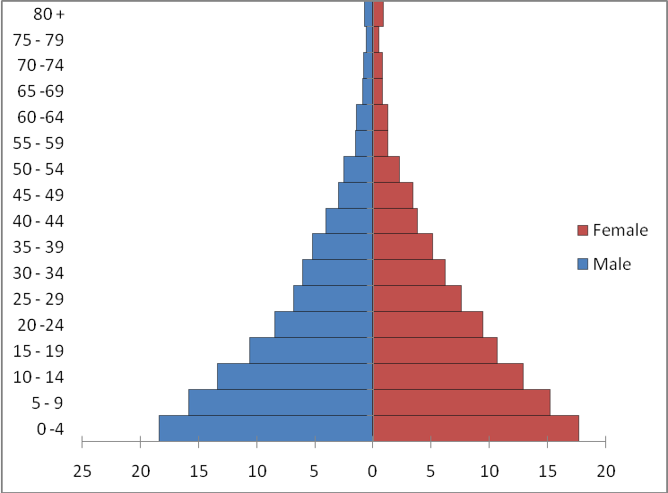
Source: NBS, Mwanza region Socio – economic Profile, 2012 Pupolation Census 2015

The population pyramid of Mwanza rural (Figure 4) depicts a similar shape as of region pyramid with very broad at its base, but decline very quickly to the elders. Figure 4 also shows the sex ratios were above 100 for population aged 5 to 19 years, 55 to 69 years and 75 to 79 years.

Figure 4: Population Pyramid for Rural Area of Mwanza Region; 2012
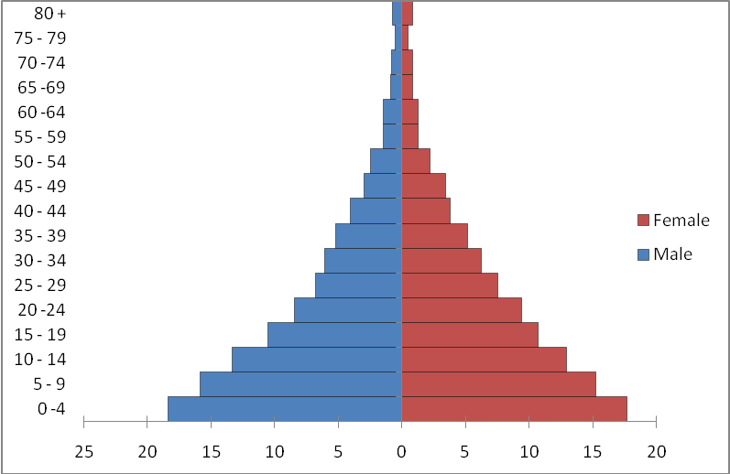
Source: NBS, Mwanza region Socio – economic Profile, 2012 Pupolation Census
However, population pyramid of Mwanza urbanhas a different structure, portraying a typical pyramid for major urban centres such as Dar es Salaam, Nairobi, Kampala and others in Africa. The pyramid (Figure 5) shows a youthful age structure, bulge in age group 15–24, an indication of youth in-migration from other regions and rural areas. However, Mwanza urban sex ratios were more than 100 for population aged 35 to 44 years and 50 to 69 years (Figure 5).

Figure 5: Population Pyramid for Urban Area of Mwanza Region; 2012
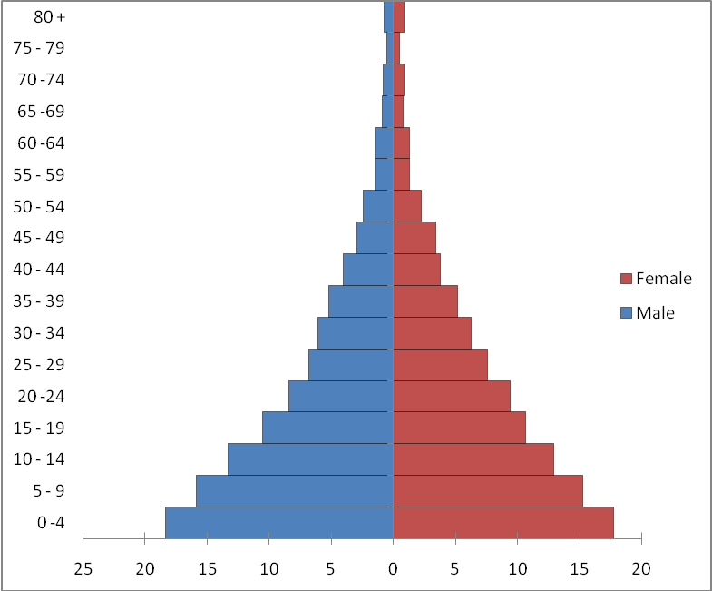
Source: NBS, Mwanza region Socio – economic Profile, 2012 Pupolation Census

1.5.6 Households and Household Size
Mwanza is among the regions in Tanzania Mainland with biggest average household sizes. With a population of 2,049,917 according to the 2002 census, there were 379,760 private households, resulted to have an average household size of 5.4. The average household increased to 5.8 in 2012. At council level, Misungwi district council with 53,560 households was the leading council in the region having an average household size of 6.6 persons. In total, three councils had their average household size above the regional value. These include, Misungwi, Kwimba and Buchosa district councils. Magu district council with 5.8 persons per household had the smallest number of households (51,335). Mwanza city council, with the least average household size of 4.8 had 75,735 households which was the largest number of households in the Region.

Table1.2: Distribution of Households and Average Household Size by Council, Mwanza Region;2002 and 2012.
Council | 2002 |  | Average Household Size | 2012 |  | Average Household Size
Council | Population | No. of Households | Average Household Size | Population | No. of Households | Average Household Size
Ukerewe | 260,831 | 40,729 | 6.4 | 345,147 | 59,000 | 5.8
Magu | 244,356 | 70,065 | 5.9 | 299,759 | 51,335 | 5.8
Nyamagana | 209,806 | 49,138 | 4.3 | 363,452 | 75,735 | 4.8
Kwimba | 314,925 | 49,891 | 6.3 | 406,509 | 62,328 | 6.5
Sengerema | 246,421 | 40,014 | 6.2 | 335,267 | 57,090 | 5.9
Ilemela | 264,873 | 53,349 | 5.0 | 343,001 | 69,815 | 4.9
Misungwi | 256,133 | 39,956 | 6.4 | 351,607 | 53,560 | 6.6
Buchosa | 252,572 | 36,618 | 6.9 | 327,767 | 52,244 | 6.3
Total | 2,049,917 | 379,760 | 5.4 | 2,772,509 | 481,107 | 5.8
Source: National Bureau of Statistics, Computed Data from 1988 and 2002 Population Censuses Reports.

CHAPTER TWO

The Regional Economy

2.0 Introduction
This chapter describes the economy of Mwanza Region by observing its status and trends of both economic and non-economic indicators, including Gross Domestic Product (GDP), Per Capita Gross Domestic Product and categories of occupations for the residents of Mwanza Region. Others are non-income indicators cover demographic characteristics, health and education status of Mwanza residents, the durability and quality of the houses in terms of the building materials used, namely, the roof, the walls and the floor. The availability of social amenities in or around the house such as access to drinking water, source of energy for cooking and lighting and toilet facilities were also considered.

Mwanza Region’s economy continues to be mixed, but dominated by the agriculture sector. Both commercial and peasantry farming are carried out, with the latter dominating. According to the results of the 2012 Population and Housing Census, the agriculturesector engage about 62.8 percent of the people aged 10 years and above in the region. Agriculture contributes most of the region’s cash income mainly from cotton, beans, maize, ground nuts, paddy, fruits and sunflower production. Generally the crop sub-sector’s performance has been adequate to ensure good food security. Poor performance of this sub-sector in some years has been attributed on the heavy dependence on variable climatic conditions in the form of rainfall. Thus, the relatively high growth rates in some years reflect the availability of favourable rainfall in those years.

Elementary occupation is the second most important occupation after agriculture, involving about7.0 per cent of active population in the Region. The trade and small businesses sub-sectors come third engaged 6.1 percent of active population. The fourth and fifth economic activities in the region are crafts and fishing employ 4.9 percent and 3.3 percent of region population respectively. The census results also shows that street vendors and related activities, though is an informal sector growing very fast and is becoming among key occupation in the region, accounting 3.1 percent of region population aged 10 years and above. Livestock keepers, though Mwanza region has large population of cattle, but engage very few active populations (0.8 percent). Other major occupationsfound in the region, include administrators, professionals and technicians.

Regional Gross Domestic Product
Mwanza Region’s economic performance from 2010 to 2015cannot be determined alone since the report produced by NBS included Geita region which was established in 2012. The 2015 National Accounts of Tanzania revised/new series data showsMwanza Region’s GDP which includes Geita region has been increasing steadily from TZS 4.1 millions in 2010 to TZS 6.7 million in 2013 and reached TZS 8.5 million in 2015 and become second contributor to national GDP after Dar es Salaamregion (Table 2.1). Table 2.1 also shows that Mbeya region was the third contributor, while Shinyanga and Morogoro were the fourth and fifth contributors respectively among top five regions with the highest GDP contributions to the National GDP.

Table 2.1: Top Five Regions with Highest GDP at Market Prices, Tanzania Mainland, 2010, 2013 and 2015
Region | 2010 |  | 2013 |  | 2015
Region | Region GDP | Percent Share | Region GDP | Percent Share | Region GDP | Percent Share
Dar -es salaam | 7,368,793 | 16.8 | 12,259,974 | 17.3 | 15,631,679 | 17.2
Mwanza | 4,016,270 | 9.2 | 6,654,600 | 9.4 | 8,452,013 | 9.3
Mbeya | 3,226,572 | 7.4 | 5,272,770 | 7.4 | 6,761,610 | 7.4
Shinyanga | 2,659,742 | 6.1 | 4,203,285 | 5.9 | 5,389,294 | 5.9
Morogoro | 2,136,943 | 4.9 | 3,433,705 | 4.8 | 4,453,211 | 4.9
National GDP | 43,836,018 | 100.0 | 70,953,227 | 100.0 | 90,863,681 | 100.0
Source: National Bureau of Statistics, National Accounts Data, 2015

Looking at zonal contribution, Lake Zone which comprises Mwanza, Kagera, Mara, Shinyanga, Simiyu and Geita regions contributed steadily in the specified years; 22.8 percent of national GDP in 2010, 22.9 percent in 2013 and 22.8 percent in 2015 (Table 2.2). Looking at regional contribution to the zonal economy, Again Mwanza region ranked first followed by Shinyanga and Kagera regions, while, the least contributor was Mara region in all three years.

Table 2.2: GDP and Per Capita GDP at Market Prices by Region, Lake Zone, 2010, 2013 and 2015
Region | 2010 |  | 2013 |  | 2015
Region | Region GDP | Percent Share | Region GDP | Percent Share | Region GDP | Percent Share
Kagera | 1,711,292 | 3.9 | 2,793,235 | 3.9 | 3,580,745 | 3.9
Mwanza | 4,016,270 | 9.2 | 6,654,600 | 9.4 | 8,452,013 | 9.3
Geita*
Shinyanga | 2,659,742 | 6.1 | 4,203,285 | 5.9 | 5,389,294 | 5.9
Simiyu**
Mara | 1,589,876 | 3.6 | 2,612,931 | 3.7 | 3,335,364 | 3.7
Total Lake Zone | 9,977,180 | 22.8 | 16,264,051 | 22.9 | 20,757,416 | 22.8
National GDP GDP | 43,836,018 | 100.0 | 70,953,227 | 100.0 | 90,863,681 | 100.0
* Geita region is incusive in Mwanza region and Simiyu inclusive in Shimyanga region.
Source: National Bureau of Statistics, National Accounts Data, 2015

Table 2.3 shows trend of region GDP, its growth rates and contribution to nation GDPbetween 2010 and 2015. Region GDP changes ranged from TZS 752,757 in 2011 to TZS 1,034,842 in 2013. Whist, percent change in GDP ranged from 12.4 percent in 2014 to 18.7 percent in 2010. Indicating that, the best year was 2011 (18.7 percent increase) and the worst year was 2014 (14 percent increase).

Table 2.3: GDP and Per Capita GDP at Current Prices, Mwanza Region, 2010 - 2015
Year | GDP at Current Prices | GDP Change |  | Per Capita GDP at Current Prices in Tshs & in US$ |  |  | Percent Contribution to National GDP
Year | GDP at Current Prices | TZS | Percent | Tshs. | Exchange Rate | US$ | Percent Contribution to National GDP
2010 | 4,016,270 |  |  | 1,126,185 |  |  | 9.2
2011 | 4,769,027 | 752,757 | 18.7 | 1,299,682 |  |  | 9.0
2012 | 5,619,758 | 850,731 | 17.8 | 1,429,220 |  |  | 9.1
2013 | 6,654,600 | 1,034,842 | 18.4 | 1,645,136 |  |  | 9.4
2014 | 7,477,587 | 822,988 | 12.4 | 1,790,731 | 1630 | 1,043 | 9.4
2015 | 8,452,013 | 974,425 | 13.0 | 2,004,353 |  |  | 9.3
* Geita region is incusive in Mwanza region.
Source: National Bureau of Statistics, National Accounts Data, 2015

2.1.1 Sector Contribution to the Region GDP
Regional GDP computed in 2016 also shows steady increase of sector contribution to the economy. Table 2.4 shows that agriculture continues to be the main sector in the region contributed about …..percent of Regional GDP in all the three years followed by ……….. sector, contributed …… percent and ……….. sector contributed …. Percent.Whist the lowest share of GDP comes from ………. sector contributed about …… percent of the GDP in all the three years (Table 2.4). Unfortunately, the contribution of street vendors and related activities, though 3.4 percent of population engaged was not included in the computation of the Regional GDP. This is a burden to the region. There is a need to solve this challenge by providing them facilities in order to formalize their business in order to capture their income to the region/councils’ GDP.

Table: 2.4Sector GDP estimates contribution, 2013, 2014 and 2015,Mwanza Region
Sector | 2013 |  | 2014 |  | 2015
Sector | Amount | Percent | Amount | Percent | Amount | Percent
Agriculture
Manufacturing/Industry
Services
Utilities (Water and Energy)
Administration
Construction
Mining
Trade
Total
Source: National Bureau of Statistics, National Accounts Data, 2016

2.1.2 Council Contribution to the Region GDP
Table 2.5 shows the computed GDP estimates by council in Mwanza Region for 2013, 2014 and 2015 years. Mwanza city council contributed …. percent of region’s GDP in 2013 due to its location and status (Business centre for east and central Africa), followed by ……… (….. percent) and …….. (……percent). The trend remained the same for the three years consecutive. On the other hand, ………………. DC’s share in the GDP was very little in all the three years (Table 2.5).

Table2.5: GDP Estimates Contribution by Council, 2013, 2014 and 2015 (Mill. Tsh), Mwanza Region
Council | 2013 |  | 2014 |  | 2015
Council | Amount | Percent | Amount | Percent | Amount | Percent
Ukerewe
Magu
Mwanza City
Kwimba
Sengerema
Ilemela
Misungwi
Buchosa
Total
Source: National Bureau of Statistics, National Accounts Data, 2016

2.2 Regional Per Capita GDP
Regional Per Capita Gross Domestic Product is obtained by dividing the Total Gross Domestic Product by the total population of a region in a given year. It shows how much of the region’s total income each person would get if this was distributed equally.

In the Tanzania Mainland economy, Mwanza region ranked second after Dar es Salaam with largest GDP per capita at current prices in Tanzania Mainland in both years. Its per capita GDP increased from TZS 5.6 million in 2012 to TZS. 8.5 million in 2015. The third, fourth and fifth regions were Mbeya, Shinyanga and Iringa regions respectively (Table 2.6).

Table 2.6: Per Capita GDP at Current Prices by Region, Tanzania mainland, 2012and 2015
Region | Per Capita Income (TZS) 2012 | Rank | Per Capita Income (TZS) 2015 | Rank
Dar -es salaam | 10,402,309 | 1 | 15,631,679 | 1
Mwanza | 5,619,758 | 2 | 8,452,013 | 2
Mbeya | 4,500,842 | 3 | 6,761,610 | 3
Shinyanga | 3,693,951 | 4 | 5,389,294 | 4
Iringa | 3,224,478 | 5 | 4,816,738 | 5
Morogoro | 3,001,144 | 6 | 4,453,211 | 6
Arusha | 2,929,003 | 7 | 4,271,447 | 7
Tanga | 2,884,020 | 8 | 4,235,095 | 8
Kilimanjaro | 2,788,912 | 9 | 4,126,036 | 9
Tabora | 2,426,906 | 10 | 3,453,511 | 12
Kagera | 2,418,560 | 11 | 3,580,745 | 10
Ruvuma | 2,341,755 | 12 | 3,544,392 | 11
Mara | 2,266,604 | 13 | 3,335,364 | 13
Rukwa | 2,100,974 | 14 | 3,180,865 | 14
Manyara | 2,052,714 | 15 | 3,026,366 | 15
Dodoma | 1,904,068 | 16 | 2,635,574 | 16
Kigoma | 1,779,335 | 17 | 2,635,574 | 17
Mtwara | 1,625,221 | 18 | 2,362,928 | 18
Singida | 1,178,718 | 19 | 1,635,873 | 21
Lindi | 1,159,599 | 20 | 1,690,403 | 19
Pwani | 1,135,341 | 21 | 1,644,962 | 20
Tanzania Mainland | 12,935,971 |  | 18,812,544
* Geita region is incusive in Mwanza region.
Source: National Bureau of Statistics, National Accounts Data, 2015

2.2.1 District Per capita GDP
Looking at distribution of region economy, Mwanza City had highest per capita GDP in the region, TZS ……….. in 2013, …………… in 2014 and …………… in 2015 followed by ……………….. in 2013, ……………… in 2014 and ………………… in 2015 and ……………… in all three years (Table 2.7). The least council in 2013 was ………….., in 2014 was …………….. and …………….. was in 2015.

Table2.7: Per Capita GDP Estimates by Council, 2013, 2014 and 2015 (Mill. Tsh), Mwanza Region
Council | 2006 |  | 2007 |  | 2008
Council | Amount | Rank | Amount | Rank | Amount | Rank
Ukerewe
Magu
Mwanza City
Kwimba
Sengerema
Ilemela
Misungwi
Buchosa
Total
Source: National Bureau of Statistics, National Accounts Data, 2016

2.3 Non-income Indicators
As stated earlier, besides GDP and per capita GDP, there are other non-income indicators that depict economic performance in a region. These indicators include food security, food consumption patterns, net enrolment, adult literacy rate, health indicators, and access to drinking safe water. They also include housing conditions in terms of types of toilet, roofing materials, and source of energy for lighting as well as for cooking.

2.3.1 Well-being of the People
The achievement of economic development of Mwanza region can also be assessed by observing the health status of residents using health indicators, including life expectancy and basic mortality rates. Generally, the region has shown successive improvement in reducing childhood mortality to targets set in the Millennium Development Goals (International goals) as well as in MKUKUTA goals (National goals). According to National goals, the country targeted to reduce under-five mortality and infant mortality up to 64 and 48 deaths for per 1,000 live births in 2015 respectively, while the target for maternal mortality was to reach 133 maternal deaths per 100,000 in 2015.

Figure 2.1 shows a great achievement of wellbeing of Mwanza residents by reaching two targets three years before time. The 2012 population census shows that Infant mortality rate has reached 44.3 deaths per 1,000 live births in 2012 against targeted 48 deaths to be reached in 2015, while under five mortality rate for the region was 63.8 deaths per 1,000 live births in 2012 compared with 64 deaths set to be reached in 2015. One general observation from these results is that Mwanza region has managed to reduce both health indicators three years before the time, under five mortality and infant mortality were lower than regional rates and targeted rates set by national goals (Figure 2.1).

Figure 2.1: Status of Infant and Under 5 Mortality Rates Against National Targets, Mwanza region, 2012
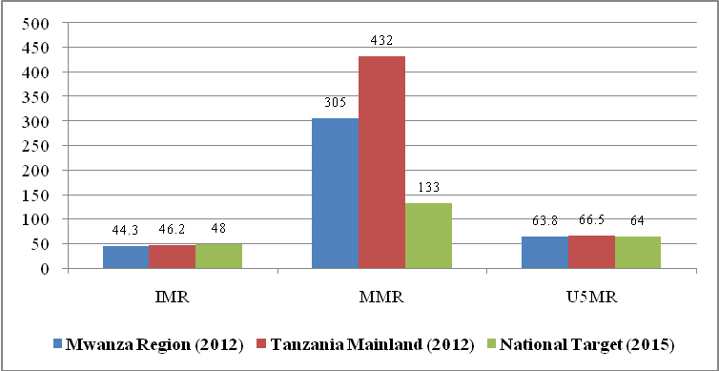
Source: National Bureau of Statistics, The 2012 Population and Housing Census Report, 2015

Table 2.8 also shows similar observations to other health indictors. The census results shows that life expectancy has increased from 54.3 years in 2002 to 64.6 years in 2012 and improvement of life expectancy for both sexes were also observed with more so on females than males (Table 2.8). reduction of martenal mortality deaths was also recorded and become the fourth lowest region in the country after Kilimanjaro (283 deaths per 100,000 expectant mothers), Geita (289) and Iringa (292) regions.

Table 2.8: Basic Health Indicators by Sex, Mwanza Region and Tanzania Mainland, 2012
Health Indicator | Mwanza Region |  |  | Tanzania Mainland
Health Indicator | Male | Female | Both Sexes | Male | Female | Both Sexes
Crude Death Rate (CDR) | 9.2 | 7.6 | 8.4 | 15 | 16 | 16
Adult Mortality Rate (AMR) | 7.9 | 6.6 | 7.2 | 8.9 | 7.8 | 8.3
Infant Mortality Rate (IMR) | 48.2 | 40.3 | 44.3 | 50.9 | 41.3 | 46.2
Child Mortality Rate (CMR) | 21.3 | 19.5 | 20.4 | 23 | 19.6 | 21.3
Under 5 Mortality Rate (U5MR) | 68.5 | 59 | 63.8 | 72.7 | 60.2 | 66.5
Maternal Mortality Rate (MMR) |  | 305 | - | - | 432
Life Expectancy (LE) | 60.5 | 64.6 | 62.4 | 60.5 | 64.6 | 62.4
Source: National Bureau of Statistics, The 2012 Population and Housing Census Report, 2015

2.3.2 Literacy Rate and Level of Education
The proportion of literacy rate and level of education attained by the community gauge the quality of human resource of the country. The census results shows thatliteracy rate of population aged 15 years and above for Mwanza Region improved from 71.3 percent in 2002 to 79.9 percent in 2012. In 2002, urban population had higher literacy rates than rural population (Figure 2.3), but higher changes of literacy rates were observed in rural areas compared to urban areas which resulted to have slightly higher literacy rate in rural areas (87.9) than urban (87.5).

Figure2.3: Levels of Literacy Rate by Location (Rural – Urban), Mwanza Region, 2002 and 2012
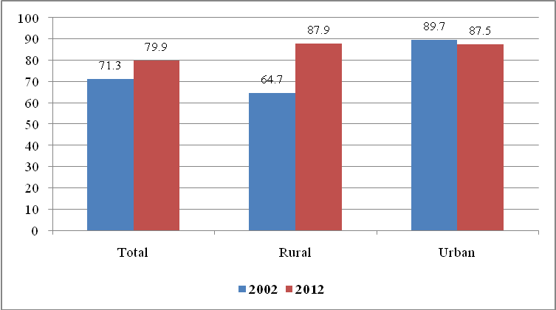
Source: NBS: 2012 Population and Housing Census Report: Mwanza Region

The Region also observed improvement in the education attainment levels between 2002 and 2012 Censuses.The proportion of the population aged 5 years and above that had attained secondary education during inter-censual period increased from 8.4 percent in 2002 to 13.2 percent in 2012 and from 0.4 percent to 1.7 percent for University or equivalent level between 2002 and 2012 respectively. The results also show that the regional population whom completed primary education decreased from 90.2 percent in 2002 to 83.7 percent (Figure 2.4).

Figure 2.4: Population Aged Five Years and Above by Level of Educational Attainment; Mwanza Region, 2002 and 2012 Censuses
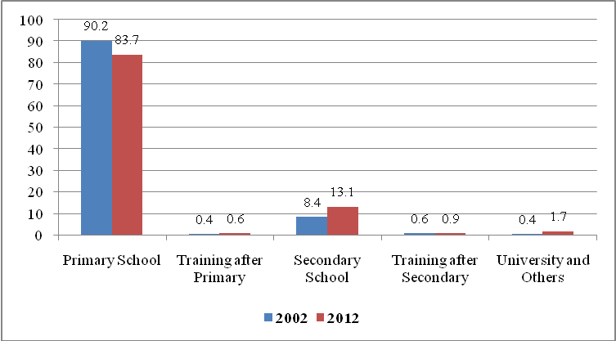
Source: NBS: 2012 Population and Housing Census Report: Mwanza Region

2.3.3 Food security and Food Consumption Patterns
Food security and level of food consumption is also an indicator of economic status of the household. The number of meals consumed in a day and the frequencies of protein intake per week particularly meat and fish are most superior in measuring economic status of the households in the region.

2.3.3.1 Food Security – Number of Meals
According to the 2007/08 National Sample Census of Agriculture, in Mwanza Region, household food insecurity was widely experienced in Mwanza region sincemajority of households (68.8 percent of the total agricultural households in the region) said they have been experiencing food insufficiency and manage to have at most two meals per day: 68.3 percent of them had two meals per day and 0.5 percent had one meal per day. Only 31.2 percent of the agricultural households said they have been satisfied with the food situation by having at least three meals per day (Figure 2.5).

Figure 2.5: Percentage of Households reportingstatus offood satisfaction, Mwanza Region 2007/08
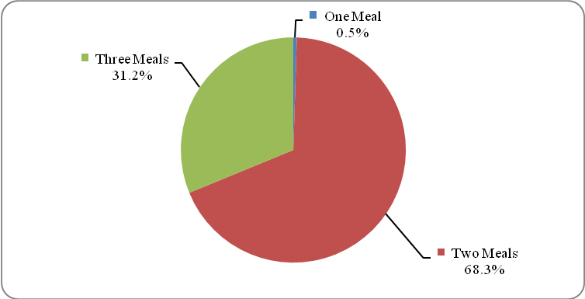
Source: NBS, National Sample Census of Agriculture, Mwanza Region, 2007/08.

Table 2.9 shows meal consumption per day in each council of Mwanza region. Ukerewe DC had the largest percentage (85.4 percent) of households eating two meals per day followed by Magu (75.3 percent) and Ilemela (73.7 percent). Whist, MisungwiDC had the large proportion (50.6 percent) of households eating three meals per day and Ukerewe DC has the lowest percentage (14.1 percent) of households eating three meals per day (Table 2.9). Small proportion of households which eat three meals as recommended by WHO, is an evidence for food insufficiency in the region.

Table 2.9: Number of Households and Number of Meals Consumed per Day by Council, Mwanza Region, 2007/08
Council | One |  | Two |  | Three |  | Total
Council | Number | Percent | Number | Percent | Number | Percent | Total
Ukerewe | 184 | 0.5 | 31,868 | 85.4 | 5,250 | 14.1 | 37,302
Magu | 150 | 0.2 | 48,363 | 75.3 | 15,698 | 24.4 | 64,211
Mwanza City | 0 |  | 0 |  | 0 |  | 0
Kwimba | 128 | 0.2 | 29,543 | 57.0 | 22,125 | 42.7 | 51,796
Sengerema | 607 | 0.7 | 57,487 | 70.1 | 23,885 | 29.1 | 81,979
Ilemela | 159 | 1.2 | 9,971 | 73.7 | 3,394 | 25.1 | 13,524
Misungwi | 94 | 0.2 | 18,676 | 49.1 | 19,239 | 50.6 | 38,009
Buchosa*
Total | 1,322 | 0.5 | 195,908 | 68.3 | 89,591 | 31.2 | 286,821
*Buchosadata included in Sengerema DC and Mwanza city had no rural area and farmers
Source: NBS, National Sample Census of Agriculture, Mwanza Region, 2007/08.

2.3.3.2 Protein (Meat and Fish) Consumption Frequencies
Protein intake among people in Mwanza region shows fish preference than meat. The results of the 2007/08 National Sample Census of Agriculture shows that, regardless of having large population of livestock, majority (53.5 percent) of the agricultural households never consumed meat during the week preceding the census. Very few households (15.7 percent) had meat more than once during the respective week.

The scenario is different for fish consumption; majority (66.9 percent) of agricultural households in Mwanza Regionconsumed fish more than once during the week preceding the census. Very few households had fish (15.7 percent) once and those who had never consume fish during the week preceding the census were only 16 percent (Figure 2.6).

Figure 2.6: Percentage of Households by the Frequency of Protein (Meat and Fish)Intake, Mwanza Region, 2007/08
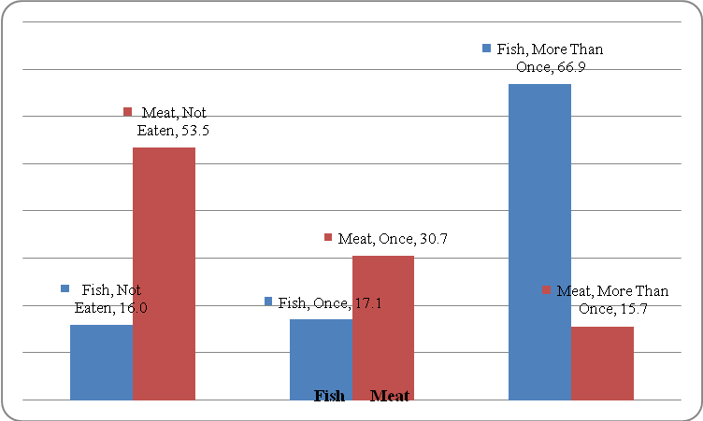
Source: NBS, National Sample Census of Agriculture Mwanza Region, 2007/08

The observation was different regarding proteinintake at council level. Ukerewe, Sengerema and Magu district councils were the biggest fish consumers in the Region, 97.4 percent, 82.7 percent and 73.3 percent of their agricultural households consumed fish respectively. Whist, Magu and Sengerema councils were the least meat consumers in the Region, 60.7 percent and 57 percent of their agricultural households never eatmeat during the week preceding the Agriculture Sample Census respectively. About 53.7 percent of the agricultural households in Mwanza Region did not eat meat is an indication of fish preference to their protein intake.

Table 2.10: Percentage of Households by the Frequency of Protein (Meat and Fish) Intake, Mwanza Region, 2007/08
Council | Not Eaten |  | Once |  | More than Once |  | Total HHs
Council | Meat | Fish | Meat | Fish | Meat | Fish | Meat | Fish
Ukerewe | 52.1 | 2.3 | 28.4 | 0.3 | 19.5 | 97.4 | 37,302 | 36,307
Magu | 60.7 | 16.5 | 25.9 | 16.0 | 13.3 | 67.4 | 64,220 | 64,220
Mwanza City | 0.0 | 0.0 | 0.0 | 0.0 | 0.0 | 0.0 | 0 | 0
Kwimba | 42.7 | 31.9 | 42.2 | 28.9 | 15.1 | 39.3 | 51,796 | 51,796
Sengerema | 57.0 | 5.9 | 28.4 | 11.4 | 14.6 | 82.7 | 81,980 | 81,979
Ilemela | 49.8 | 11.4 | 25.1 | 15.3 | 25.1 | 73.3 | 13,524 | 13,524
Misungwi | 51.4 | 30.1 | 32.3 | 31.9 | 16.3 | 38.0 | 38,008 | 38,009
Buchosa*
Total | 153581 | 45796 | 88078 | 48866 | 45171 | 191173 | 286830 | 285835
Percent | 53.5 | 16.0 | 30.7 | 17.1 | 15.7 | 66.9 | 100.0 | 100.0
*Buchosa data included in Sengerema DC and Mwanza city had no rural area and farmers
Source: NBS, National Sample Census of Agriculture, Mwanza Region, 2007/08.

2.3.4 Access to Drinking Clean Water
The Water policy requires every person to get water within short distance and source of water being improved ones, such as piped water, protected boreholes, dug wells and springs. The 2012 Population and Housing Census shows that almost 57 percent of households have access clean and safe drinking water from improved sourcesin Mwanza region. Figure 2.7 shows that access of safe and clean drinking water in Mwanza region is higher (85.6 percent) in urban areas than rural areas (38.6 percent).

Figure 2.7: Percentage of Households access Drinking Water by Location, Mwanza Region, 2012
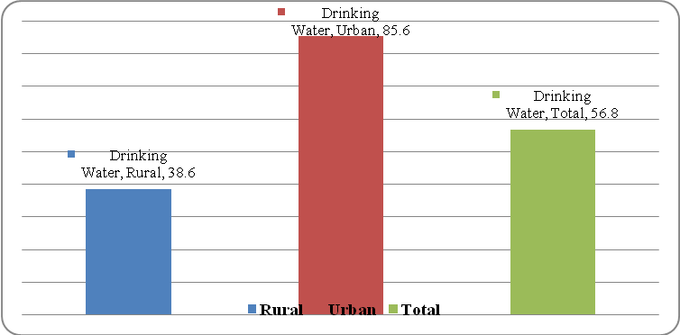
Source: NBS, Population and Housing Census, Mwanza Region Socio-economic Profile Report, 2012

Looking at sources of drinking water, Figure 2.8 shows that overall 35 percent of private households in Mwanza Region used piped water as the main source of drinking water, followed by boreholes (10.6 percent) and protected dug wells (9.7 percent). Variations occurred between urban and rural areas. In urban areas, 75.5 percent of private households used piped water as their main source of drinking water followed by protected dug wells (6.6 percent), while protected spring used by only 0.5 percent of urban private households. In rural areas, large number of private households uses boreholes (15.5 percent) and protected wells (11.7 percent) as their main source of drinking water. Only 8.9 percent of rural households have an access to piped water indicating more efforts are needed to ensure the accessibility of drinking water in rural areas of Mwanza region.

Figure 2.8: Percentage of Households Access to Drinking Water by Type of Water Source, Mwanza Region, 2012
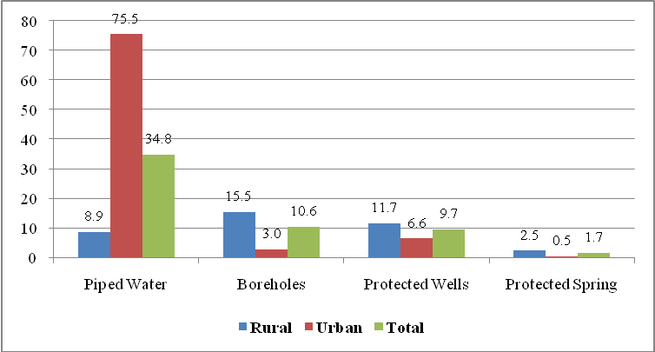
Source: NBS, Population and Housing Census, Mwanza Region Socio-economic Profile Report, 2012

However, there is a great achievement in provision of safe drinking water in the Region compared to 2002. Overall, 35 percent of private households in Mwanza Region had access to piped water as the main source of drinking water in 2012 compared to 20 percent in 2002. Access to piped water in Mwanza urban areas increased from 62.2 in 2002 to 75.5 percent in 2012. The proportion of rural households increased from 5.1 percent in 2002 to 8.9 percent in 2012 (Figure 2.9).

Figure 2.9: Percentage Distribution of Households Using Piped Water as Main Source of Drinking Water and Residence; Mwanza Region, 2002 and 2012 Censuses
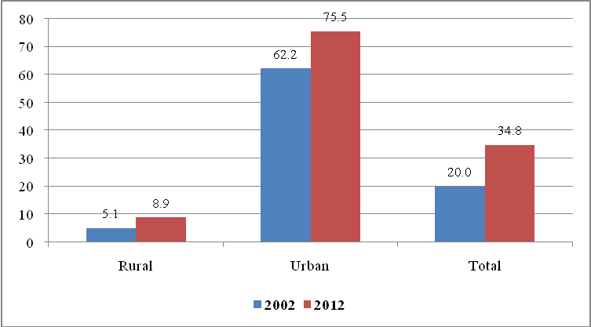
Source: NBS, Population and Housing Census, Mwanza Region Socio-economic Profile Report, 2012

2.3.5 Types of Toilets
Type of toilet facility is another non- income poverty indicator of the households. The 2012 Population and Housing Census Report shows a slight decrease in households with no toilet facility from 12.2 percent in 2002 to eight (8.3) percent in 2012.Figure 2.10 also shows that the use of traditional pit latrines in Mwanza region decreased from 81.7 percent in 2002 to 68.3 percent in 2012, while households with flush toilets increased from 3.6 percent to 20.8 percent in the same period.

Figure 2.10: Percentage Distribution of Households by Type of Toilet Facility, Mwanza Region 2002 and 2012
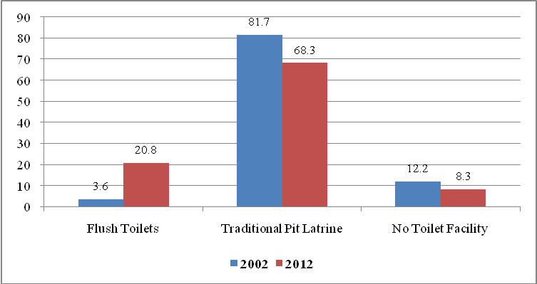
Source: NBS, Population and Housing Census, Mwanza Region Socio-economic Profile Report, 2012

The availability of toilets between rural and urban locations in the Region differs significantly. The distribution of the households with flush toilets within the region was higher in urban areas (49 percent) than rural areas (2.9 percent), while tradition pit latrines are more (83 percent) than urban (45.1 percent) as observed in Table 2.11.

Figure 2.11: Percentage Distribution of Households by Type of Toilet Facility and Location, Mwanza Region, 2012
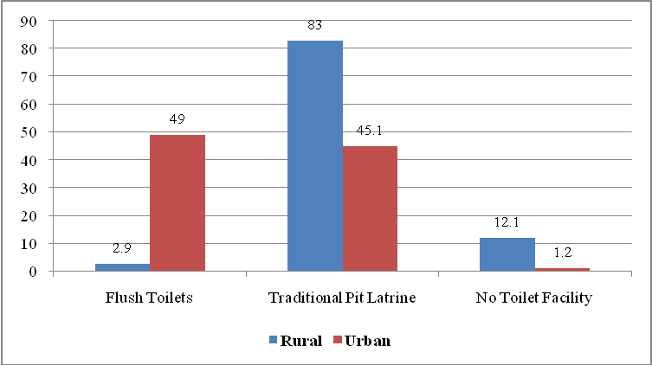
Source: NBS, Population and Housing Census, Mwanza Region Socio-economic Profile Report, 2012

2.3.6 Housing Condition
Analysis of the condition of the dwelling units, the durability and quality of the houses are looked at in terms of the building materials used for the main elements of houses, namely, the roof, the walls and the floor. The availability of social amenities in or around the house is also considered. It is evident from the census results that great improvement in housing condition has been made in Mwanza region between 2002 and 2012.

General observation made is that, there has been a rise in the proportion of households living in dwelling units built with modern or conventional building materials. The 2012 Population Census results shows that the use of iron sheets for roofing of the main building increased from 49 percent in 2002 to 72.2 percent, while there was a decline in the use of grass from 43.7 percent to 24.3 percent in the specified period. The use of mud and grass was also decreased by almost half, from 6.9 percent to 3.6 percent respectively (Figure 2.12).

Figure 2.12: Percentage of Households by Type of Roofing Materials, Mwanza Region, 2002 and 2012
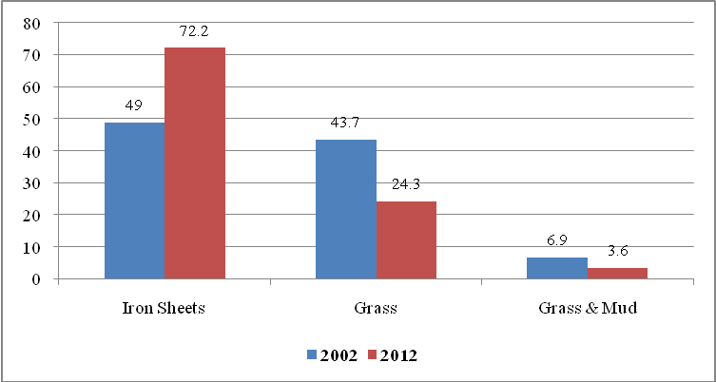
Source: NBS, Population and Housing Census, Mwanza Region Socio-economic Profile Report, 2012

Another notable feature concerning dwellings is that there was a remarkable rise in the use of modern wall materials in 2012 compared to 2002. Nonetheless, majority of dwelling units in Mwanza region are still constructed of walls materials made of sun-dried bricks, though there was a decline from 67.6 percent in 2002 to 52.4 percent in 2012. Whist, the use of modern (cement and baked) bricks increased from 13.4 percent in 2002 to 38.5 percent (cement, 18.9 percent and 19.6 percent backed bricks) and the use of mud and poles significantly dropped from 14.4 percent to 5.4 percent in the specified period (Figure 2.13).

Figure 2.13: Percentage of Households by Type of Wall Materials, Mwanza Region, 2002 and 2012
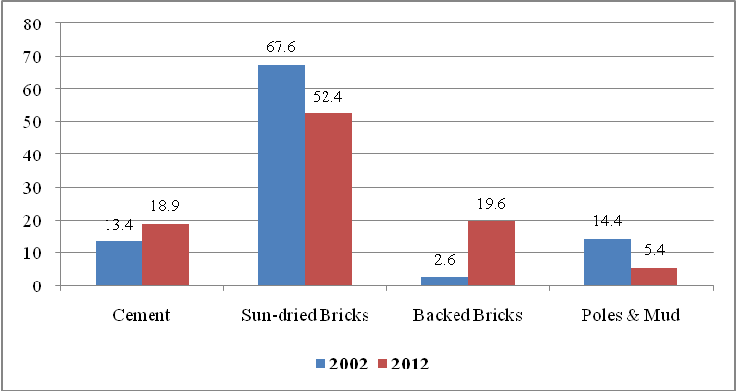
Source: NBS, Population and Housing Census, Mwanza Region Socio-economic Profile Report, 2012

Flooring is also an important indicator to the quality of dwellings on measuring poverty of private households. Figure 2.14 shows that flooring is still predominantly by soil or mud though there was a remarkable decline in the use from 73.9 percent in 2002 to 58.5 percent in 2012. However, the use of modern materials, including cement, tiles and other related materials increased to 40.3 percent in 2012 compared to 25.3 percent in 2002 (Figure 2.14).

Figure 2.14: Percentage of Households by Type of Flooring Materials, Mwanza Region, 2002 and 2012
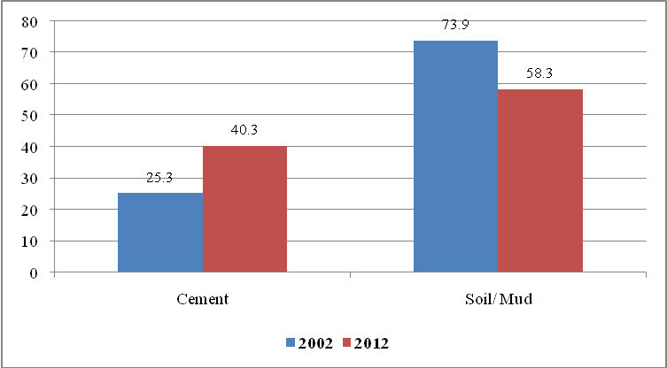
Source: NBS, Population and Housing Census, Mwanza Region Socio-economic Profile Report, 2012

Concerning social amenities, the 2012 Population Census results have revealed that there has been a significant improvement in the proportion of households with access to electricity as a source of energy for lighting: a remarkable increase from 5.6 percent in 2002 to 24.3 percent in 2012.It is also evident from the census results that the use of traditional sources of energy for lighting, particularly wick lump and hurricane lump declined from 66.6 percent in 2002 to 34.5 percent in 2012 and from 24.2 percent to 22.8 percent respectively in the specified period (Figure 2.15).

Figure 2.15: Percentage of Households by Main Source of Energy Used for Lighting, Mwanza Region, 2002 and 2012
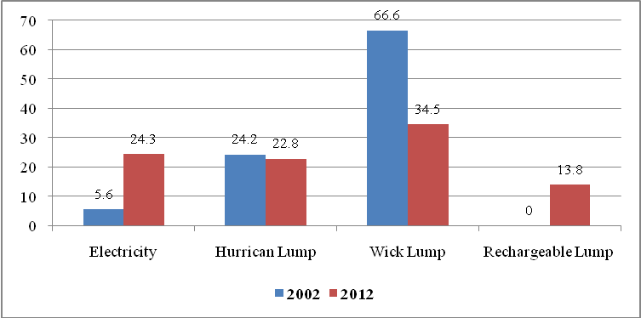
Source: NBS, Population and Housing Census, Mwanza Region Socio-economic Profile Report, 2012

Another observation made is that, there has been a rise in the proportion (13.8 percent) of households using modern facilities used for lighting, especially torch or rechargeable lump in Mwanza region as a new source of energy for lighting in the region (Figure 2.16). This has been possible due to the availability of electricity in both locations: rural and urban of Mwanza region. Figure 2.15 shows that the proportion of households using electricity as energy source of lighting in region increased on both locations. In 2002, the proportion of households with access to electricity used for lighting in rural and urban were 0.4 percent and 20.1 percent respectively. Number of households uses electricity as main source of lighting in urban areas were 12.7 percent and 42.5 percent in the specified period (Figure 2.16).

Figure 2.16: Percentage of Households by Location and Main Source of Energy Used for Lighting, Mwanza Region, 2002 and 2012
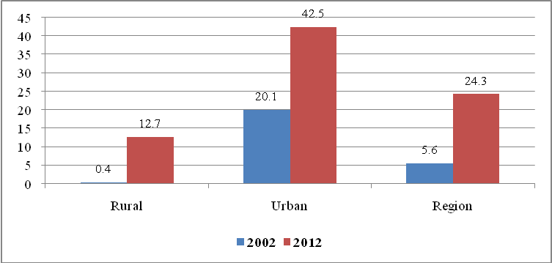
Source: NBS, Population and Housing Census, Mwanza Region Socio-economic Profile Report, 2012

Source of energy for cooking, among social amenities is also a key indicator used for monitoring poverty of the households. The 2012 Population Census results revealed that although the most prevalent source of energy for cooking was firewood, there is a slight decline in the use from 72 percent in 2002 to 61.8 percent in 2012. While, the use of modern and/or environmental friendly sources of energy for cooking such as electricity and gas reached 1.5 percent of private households of the region in 2012 (Figure 2.17). It is important to note that, if the current practice continues, deforestation and depletion of natural vegetation through using firewood and charcoal will destroy the nature and ecology of the region.

Figure 2.17: Percentage of Households by Main Source of Energy Used for Cooking, Mwanza Region, 2002 and 2012
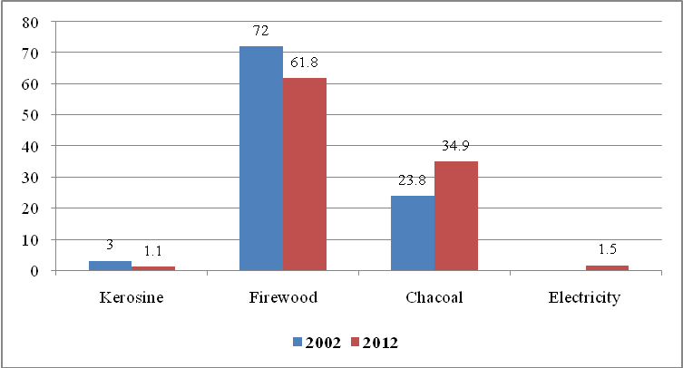
Source: NBS, Population and Housing Census, Mwanza Region Socio-economic Profile Report, 2012

Economic development in Mwanza region is also monitored by observing the ownership of assets including modern communication and transport facilities, home appliances and implements. Figure 2.16 shows that proportion of private households that owned telephone both land line and mobile as main communication facility increasedremarkably from 3.3 percent in 2002 to 70.6 percent in 2012, while proportion of households that owned radio slightly dropped from 63.4 percent in 2002 to 62.3 percent in 2012. However, the ownership of television and accessibility of internet facility rise to 15.5 percent and 4.2 percent respectively (Figure 2.18). However, a mobile phone was the most owned asset in Mwanza region with 70.6 percent of all private households having at least one.

Figure 2.18: Percentage of Households Owned Communication Facilities by Type, Mwanza Region, 2002 and 2012
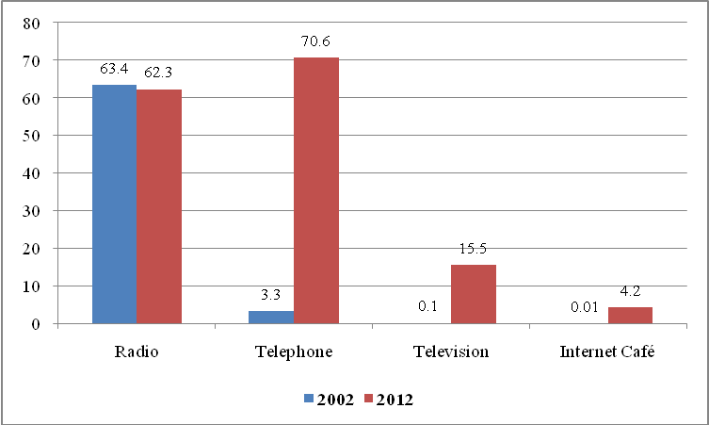
Source: NBS, Population and Housing Census, Mwanza Region Socio-economic Profile Report, 2012

Ownership of specified assets is a good indicator of household to monitor its economic status. Great achievement on ownership of modern home appliances in 2012 than it was in 2002. The 2012 population census results revealed that, 70.4 percent of households in Mwanzaregion owned land or farm and60.4 percent owned a house. The 2012 population censusresults also observe shifting of ownership of assets towards modern home appliances such as an electric or gas cooker (6.3 percent of households owned), fridge or refrigerators (3.1 percent) and an electric or charcoal iron(9.2 percent).

2.3.7 Land Development
The 2000 Land Policy recognize the importance of land as a key factor of production of goods and services in the country, has been prepared to suite the current and future demand of land in order to minimize if not finish land conflict within communities. Therefore, Land use planning is a key aspect for development of both urban and rural areas of any region in the country. The land needs in urban areas are dominated by the demand for building plots for residential, commercial, institutional and industrial purposes. In rural areas, major needs for land includecrop production, grazing land, building plots for residential, commercial, institutional and other production activities.Therefore, demands for surveyed land plots have been of great importance in recent times due to the increase of population in the country.

The 2012 Population and Housing census results reveals that majority of households owned land customary (54.5 percent) followed by those who had no legal (22.2 percent) right over the landwhere their main dwelling is built. Nonetheless, only 9.6 percent of households had title deed over the land where the main dwelling is located (Table 2.11).

General observation of census results shows that proportion of households in urban areas with title deed was(27.8 percent) highest followed by those with no legal right (24 percent) and households owned customary (19.5 percent). Table 2.11 also reveals that, majority of households in rural areas owned land customary (67.3 percent) followed by those which their land has no legal rights (21.5 percent), while households which owned land with title deed were almost three percent (2.9 percent).

Table 2.11: Percentage Distribution of Households by Residence and Type of Legal Rights over the Ownership of the Land where the Main Dwelling is Located; Mwanza Region, 2012
Location | Title Deed | Residential License | Offer | Customary Ownership | Contract | Registration | No Legal Right | Total
Rural | 2.9 | 0.9 | 1.0 | 67.3 | 6.3 | 0.0 | 21.5 | 247,262
Urban | 27.8 | 8.7 | 12.1 | 19.5 | 7.8 | 0.1 | 24.0 | 90,381
Total | 9.6 | 3.0 | 3.9 | 54.5 | 6.7 | 0.1 | 22.2 | 337,643
Source: NBS, Population and Housing Census, Mwanza Region Socio-economic Profile Report, 2012

It is obvious that lack of surveyed building plots in most cases create a problem of crowded environment and mushrooming of slums or shanty towns. Table 2.12 depicted that the demand for plots in Mwanza Region were about ………. Out of these, the surveyed plots were ……. equivalents to …..percent. The proportion of demand of plots was highest inMwanza City requested……… plotsand was also leading in surveyed plot (…….). However, Table 2.12 also shows that, ……………, ………..councils and ………….. had no demand for plots and there were no surveyed plots.

Table 2.12: The Demand and Supply of Building Plots in Urban Centers by Council, Mwanza Region, 2012
Council | No. of Mitaa | Demand for Plots | No. of Plots Surveyed | No. of Plots Allocated | Percent of Plots Allocated
Ukerewe | 7
Magu | 0
Mwanza City | 175
Kwimba | 14
Sengerema | 0
Ilemela | 171
Misungwi | 0
Buchosa | 0
Total | 367
Source: Compiled data from District Executive Directors Offices, Mwanza Region, 2016

Poor performance on the preparation of land use planning was also observed in rural areas, since all villages of Mwanza region had not yet prepare land use planning and only ….. percent of villages had offered certificates until end of 2015. Table 2.13 shows that out of 543 villages in Mwanza Region, only…..percent have been surveyed and demarcated. …………DC is leading with ….percent of their respective villages surveyed and demarcatedfollowed by ………….. DC (…. percent) and………….. (…. percent). Mwanza City and Nyamagana Municipal council have no villages.

Table 2.13: Village Land Use Planning in Rural Areas by Council, Mwanza Region, 2015
Council | No. of Wards | No. of Villages | Villages Surveyed and Demarcated |  | Villages Offered Certificates
Council | No. of Wards | No. of Villages | Number | Percent | Number | Percent
Ukerewe | 25 | 76
Magu | 25 | 82
Mwanza City | 18 | 0
Kwimba | 30 | 119
Sengerema | 26 | 71
Ilemela | 19 | 0
Misungwi | 27 | 113
Buchosa | 21 | 82
Total | 191 | 543
Source: Compiled data from District Executive Directors Offices, Mwanza Region, 2016

2.5 Policy Implication on Land sector
Availability of Land Use Planning in Mwanzaregion is not yet developed. The Region still has inadequate number of demarcated building plots, areas for business and social facilities, play grounds and investment areas. Moreover, inadequate number of villages demarcated and offered certificate limited residents to use their land as source of getting loans from financial institutions. Low performance on land management in the Region has created land conflict and disputes among residents in all councils of Mwanza Region. Implementation of Land policy is very crucial in order to reduce if not finish conflicts among people in the region. Likewise, the policy of surveying and demarcatingboundariesand preparing land use planning in every village for eachcouncil should be adhered to for increasing accessibility of land to rural population in order to reduce squatter areas in Mwanza region.

5.2.8 Investment Opportunities for Land Sector
This sector faces many problems including resources such as human, equipment and finance. These resources include, modern equipment for land surveying i.e. Geographical Positioning System (GPS), Geo system or program used for drowing maps, transport and other related equipment; shortage of workers especially land surveyors and quantity surveyors, a few to mention. Investment is needed regards to the demarcation of more building plots, grazing areas, commercial and business areas, village boundaries, areas for human activities including farms and investment areas.

3.0: CHAPTER THREE

Production Sectors

3.0 Overview
This Chapter presents the performance of productive sectors in the Region. The productive sectors include crop production, livestock keeping, natural resources, tourism, manufacturing, fishing and mining.

3.1 Agriculture
Agriculture is the back born of the Mwanza economy and about 85 percent of its residents depend on it as their main source of livelihood. In general, crop roduction levels per unit area are very low due to, among onther reasons, the use of out-dated, inferior agricultural implements, soil exhaustion and soil infertility. However, agriculture sector contributes over 60 percent of the region’s GDP and it is carried out by all councils in the region. According to UN classifications, agriculture comprises of crop production, livestock, forestry and hunting sub sectors. Others are fishing, beekeeping and tourism.

3.1.1 Distribution of ArableLand
The 2015 land use planning shows that Mwanza region has a total land area of 1,179,600 ha of which 913,852 hacters (75.7 percent) were classified as arable land which is suitable for crop farming.The remaining 265,748 hacters (24.3 percent) are used for other economic activities such as grazing and game reserves (Table 3.1). At council level, Table 3.1 shows that Sengerema and Buchosa district councils have shares of arable land (86.0 percent) of their land areas followed by Misungwi (78.5 percent), Magu (77.8 percent) and Kwimba (77.1 percent). Mwanza City has the smallest arable land covered only 20.1 percent of its land area.

Table 3.1 also shows that about 56.0 percent of region arable land (508,806 hacters) has being utilized for crop production in 2014/15 season. Ukerewe district council has managed to utilize larger part (86.3 percent) of its arable land in 2014/15 season followed by Magu (70.3 percent), Misungwi (59.9 percent), Sengerema 58 percent) and Kwimba (52.8 percent), while Buchosa and Sengerema utilized only 47 percent of their arable land each. However, although Mwanza city has arable land, the largest part of it has been used for human settlements since it is a purely urban council (Table 3.1).

Table 3.1: Percentage Distribution of Arable Land by Council; Mwanza Region, 2014/15
Council | Total land Area (ha) | Total Arable land (ha) | Percent of Council Arable land | Arable land Under Cultivation (ha) | Percent of Arable land under cultivation | Percent of Land Area to the Total Land Area
Ukerewe | 64,000 | 39,119 | 61.1 | 33,769 | 86.3 | 6.6
Magu | 154,600 | 120,260 | 77.8 | 84,501 | 70.3 | 16.5
Mwanza City | 17,300 | 3,473 | 20.1 | - | - | 0.6
Kwimba | 390,300 | 300,921 | 77.1 | 158,886 | 52.8 | 31.0
Sengerema | 179,990 | 154,791 | 86.0 | 72,752 | 47.0 | 14.2
Ilemela | 25,200 | 10,422 | 41.4 | 5,256 | 50.4 | 1.0
Misungwi | 194,700 | 152,847 | 78.5 | 91,593 | 59.9 | 17.9
Buchosa | 153,510 | 132,019 | 86.0 | 62,049 | 47.0 | 12.1
Total | 1,179,600 | 913,852 | 75.7 | 508,806 | 55.7 | 100
Source: Mwanza Region, Compiled Data from Councils (Agriculture Departments), 2016

Figure 3.1: Percentage Distribution of Arable Land by Council; Mwanza Region, 2014/15
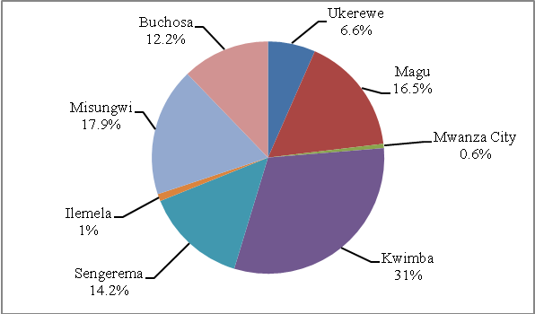
Source: Mwanza Region, Compiled Data from Councils (Agriculture Departments), 2016

3.1.2 Food Crops

3.1.2.1 Area under Food Crops Cultivation
With reference to Table 3.2, cassava, maize, paddy, sweet potatoes sorghum and bulrush millets are major food crops grown in Mwanza Region during the period of 2010/11to 2014/15. However, the best crop season out of five seasons referred was year 2013/14, of which more hectares were planted with major food crops than the region annual average of 253,535 hacters. Minimum hacters were grown in 2012/13 covered 240,776 hacters in the region. Table 3.2 also shows that maize was the dominant food crop grown in the region utilized an average of 51.8 percent of arable land in the specified seasons followed by cassava (29.9 percent) and paddy (7.5 percent). While bulrush millets grown in a smallest hacterage (0.4 percent) followed by sorghum (5.1 percent) and sweet potatoes (5.7 percent).

Table 3.2: Estimated Land Area (ha) under Major Food Crops by Council, Mwanza Region, 2010/11 – 2014/15
Crop | Estimated Land Area (ha) |  |  |  |  | Total Area | Annual Average
Crop | 2010/11 | 2011/12 | 2012/13 | 2013/14 | 2014/15 | Total Area | Annual Average
Maize | 128,949 | 125,818 | 123,274 | 168,118 | 110,891 | 657,049 | 131,410
Cassava | 71,567 | 75,876 | 73,183 | 80,590 | 77,262 | 378,478 | 75,696
Paddy | 20,615 | 20,813 | 15,819 | 15,393 | 21,965 | 94,605 | 18,921
Sweet potatoes | 11,355 | 12,579 | 14,367 | 11,428 | 18,342 | 68,072 | 13,614
Sorghum | 11,870 | 12,740 | 13,220 | 13,355 | 13,694 | 64,878 | 12,976
bulrush millets | 570 | 865 | 913 | 180 | 2,065 | 4,593 | 919
Regional Total | 244,926 | 248,691 | 240,776 | 289,063 | 244,219 | 1,267,675 | 253,535
Percentage of the Total Area(Annually)
Maize | 52.6 | 50.6 | 51.2 | 58.2 | 45.4 | 259.2 | 51.8
Cassava | 29.2 | 30.5 | 30.4 | 27.9 | 31.6 | 149.3 | 29.9
Paddy | 8.4 | 8.4 | 6.6 | 5.3 | 9 | 37.3 | 7.5
Sweet potatoes | 4.6 | 5.1 | 6 | 4 | 7.5 | 26.8 | 5.4
Sorghum | 4.8 | 5.1 | 5.5 | 4.6 | 5.6 | 25.6 | 5.1
Burlush millets | 0.2 | 0.3 | 0.4 | 0.1 | 0.8 | 1.8 | 0.4
Regional Total | 100 | 100 | 100 | 100 | 100 | 500 | 100
Source: Mwanza Region, Compiled Data from Councils (Agriculture Departments), 2016

- Maize
In terms of area under major food crop cultivation, Maize outweighs other food crops by occupying (51.8 percent, Table 3.2 above) of the total arable land area under main food crops cultivation in the region. Table 3.2a shows that at council level, Buchosa council with cumulative annual average of 34,741.1 hectares (27.3 percent) had the largest area under maize cultivation over the specified period, followed by Kwimba (26.7 percent), Misungwi (25.2 percent), Sengerema (11.8 percent), Magu (8.4 percent), Ilemela (0.4 percent), Ukerewe had the insignificant area under maize cultivation in the referred period and no cultivation area utlised in Mwanza city (Table 3.2a).
Table 3.2a: Estimated Area (Ha) Under Major Food Crops (Maize) by District; Mwanza Region, 2010/11– 2014/15.
Council | 2010/11 | 2011/12 | 2012/13 | 2013/14 | 2014/15 | Total Area (ha) | Annual Average Area (ha)
Buchosa | 24,260 | 25,715 | 25,108 | 69,721 | 28,902 | 173,706 | 34,741.1
Kwimba | 33,224 | 33,315 | 33,515 | 33,910 | 36,056 | 170,020 | 34,004.0
Misungwi | 40,132 | 34,456 | 34,298 | 34,822 | 16,888 | 160,595 | 32,119.1
Sengerema | 16,590 | 16,590 | 13,612 | 13,773 | 14,797 | 75,362 | 15,072.4
Magu | 10,641 | 11,118 | 11,831 | 11,365 | 8,723 | 53,677 | 10,735.5
Ilemela | - | 712 | 707 | 745 | 509 | 2,673 | 534.7
Mwanza City | - | - | - | - | - | - | -
Ukerewe | - | - | - | - | - | - | -
Total | 124,848 | 121,906 | 119,070 | 164,336 | 105,875 | 636,034 | 127,206.70
Percent of the Total Area (Annually)
Buchosa | 19.4 | 21.1 | 21.1 | 42.4 | 27.3 | 136.6 | 27.3
Kwimba | 26.6 | 27.3 | 28.1 | 20.6 | 34.1 | 133.7 | 26.7
Misungwi | 32.1 | 28.3 | 28.8 | 21.2 | 16 | 126.2 | 25.2
Sengerema | 13.3 | 13.6 | 11.4 | 8.4 | 14 | 59.2 | 11.8
Magu | 8.5 | 9.1 | 9.9 | 6.9 | 8.2 | 42.2 | 8.4
Ilemela | - | 0.6 | 0.6 | 0.5 | 0.5 | 2.1 | 0.4
Mwanza City | - | - | - | - | - | - | -
Ukerewe | - | - | - | - | - | - | -
Total | 100 | 100 | 100 | 100 | 100 | 500 | 100
Source: Mwanza Region, Compiled Data from Councils (Agriculture Departments), 2016

(ii) Cassava
Cassava is the second major food crop in terms of the area under main food crops cultivation. It covers about 29.9 percent (Table 3.2) of the regional total land area under major food crops. Table 3.2b shows that Kwimba district council with cumulative annual average area of 34,810.0 hectares (46.0 percent) under cassava cultivation led other councils in the region. The second council was Buchosa with cumulated annual average area of 20,203.2 hectares (26.7 percent) followed by Ukerewe DC (12,084.6 hectares, 16.0 percent), Magu (7,317.2 hectares, 1.7 percent), Mwanza City, Sengerema and Misungwi district councils had insignificant arable land used for growing cassava over the period of specified time.
Table 3.2b: Estimated Area (Ha) Under Major Food Crops (Cassava) by Council; Mwanza Region, 2010/11– 2014/15.
Council | 2010/11 | 2011/12 | 2012/13 | 2013/14 | 2014/15 | Total Area (ha) | Annual Average Area (Ha)
Kwimba | 34,148 | 34,258 | 34,205 | 34,568 | 36,871 | 174,050 | 34,810.00
Buchosa | 16,051 | 17,959 | 17,720 | 27,173 | 22,114 | 101,016 | 20,203.20
Ukerewe | 13,011 | 14,567 | 14,586 | 10,030 | 8,229 | 60,423 | 12,084.60
Magu | 8,357 | 7,257 | 5,194 | 6,765 | 9,013 | 36,586 | 7,317.20
Ilemela | - | 1,835 | 1,479 | 2,054 | 1,035 | 6,403 | 1,280.60
Mwanza City | - | - | - | - | - | - | -
Sengerema | - | - | - | - | - | - | -
Misungwi | - | - | - | - | - | - | -
Total | 71,567 | 75,876 | 73,183 | 80,590 | 77,262 | 378,478 | 75,695.70
Percent of the Total Area (Annually)
Kwimba | 47.7 | 45.1 | 46.7 | 42.9 | 47.7 | 229.9 | 46
Buchosa | 22.4 | 23.7 | 24.2 | 33.7 | 28.6 | 133.5 | 26.7
Ukerewe | 18.2 | 19.2 | 19.9 | 12.4 | 10.7 | 79.8 | 16
Magu | 11.7 | 9.6 | 7.1 | 8.4 | 11.7 | 48.3 | 9.7
Ilemela | - | 2.4 | 2 | 2.5 | 1.3 | 8.5 | 1.7
Mwanza City | - | - | - | - | - | - | -
Sengerema | - | - | - | - | - | - | -
Misungwi | - | - | - | - | - | - | -
Total | 100 | 100 | 100 | 100 | 100 | 500 | 100
Source: Mwanza Region, Compiled Data from Councils (Agriculture Departments), 2016

(iii) Paddy
According to Table 3.2, Paddy covered an annual average area of 18,921 hectares and ranked third among the major food crops in terms of area under cultivation. The crop had a percentage share of 7.5 percent of the region’s total land area under major food crop cultivation (Table 3.2). Table 3.2c shows that Magu district council with cumulative annual average area of 13,272.6 hectares (70.1 percent) under paddy cultivation led other councils in the region. The second council was Ukerewe DC cultivated cumulated annual average area of 4,829.0 hectares (25.5 percent), followed by Ilemela MC (819.4 hectares, 4.3 percent), the rest of councils had insignificant acreages of arable land used for growing paddy crop in the region during the refeerd growing seasons.

Table 3.2c: Estimated Area (Ha) Under Major Food Crops (Paddy) by Council; Mwanza Region, 2010/11– 2014/15.
Council | 2010/11 | 2011/12 | 2012/13 | 2013/14 | 2014/15 | Total Area (ha) | Annual Average Area (Ha)
Magu | 14,571 | 13,530 | 11,758 | 12,013 | 14,491 | 66,363 | 13,272.6
Ukerewe | 6,044 | 6,198 | 2,833 | 2,277 | 6,793 | 24,145 | 4,829.0
Ilemela | - | 1,085 | 1,228 | 1,103 | 681 | 4,097 | 819.4
Mwanza City | - | - | - | - | - | - | -
Sengerema | - | - | - | - | - | - | -
Misungwi | - | - | - | - | - | - | -
Buchosa | - | - | - | - | - | - | -
Kwimba | - | - | - | - | - | - | -
Total | 20,615 | 20,813 | 15,819 | 15,393 | 21,965 | 94,605 | 18,921.0
Percent of the Total Area (Annually)
Magu | 70.7 | 65 | 74.3 | 78 | 66 | 350.7 | 70.1
Ukerewe | 29.3 | 29.8 | 17.9 | 14.8 | 30.9 | 127.6 | 25.5
Ilemela | - | 5.2 | 7.8 | 7.2 | 3.1 | 21.7 | 4.3
Mwanza City | - | - | - | - | - | - | -
Sengerema | - | - | - | - | - | - | -
Misungwi | - | - | - | - | - | - | -
Buchosa | - | - | - | - | - | - | -
Kwimba | - | - | - | - | - | - | -
Total | 100 | 100 | 100 | 100 | 100 | 500 | 100
Source: Mwanza Region, Compiled Data from Councils (Agriculture Departments), 2016

(iv) Sweet Potatoes
According to Table 3.2, Sweet potatoes covered an annual average area of 13,614 hectares of area under cultivation among the major food crops in the region. The crop had a share of 5.4 percent of total arable land in the region. Table 3.2d shows that Ukerewe district council with cumulative annual average area of 9,441.4 hectares (69.3 percent) under sweet potatoes cultivation led other councils in the region. The second council was Buchosa DC cultivated cumulated annual average area of 3,571.2 hectares (26.2 percent) Ilemela had the least council with only 601.8 hectares, equivalent to 4.4 percent. The rest of councils had insignificant hacters utilized to grow this crop over the specified period of time.

Table 3.2d: Estimated Area (ha) Under Major Food Crops (Sweet potatoes) by Council; Mwanza Region, 2010/11– 2014/15.
Council | 2010/11 | 2011/12 | 2012/13 | 2013/14 | 2014/15 | Total Area (ha) | Annual Average Area (Ha)
Ukerewe | 8,652 | 9,024 | 10,344 | 7,504 | 11,683 | 47,207 | 9,441.4
Buchosa | 2,703 | 2,844 | 2,965 | 3,188 | 6,155 | 17,856 | 3,571.2
Ilemela | - | 711 | 1,058 | 736 | 504 | 3,009 | 601.8
Mwanza City | - | - | - | - | - | - | -
Sengerema | - | - | - | - | - | - | -
Misungwi | - | - | - | - | - | - | -
Buchosa | - | - | - | - | - | - | -
Kwimba | - | - | - | - | - | - | -
Total | 11,355 | 12,579 | 14,367 | 11,428 | 18,342 | 68,072 | 13,614.4
Percent of the Total Area (Annually)
Ukerewe | 76.2 | 71.7 | 72 | 65.7 | 63.7 | 346.7 | 69.3
Buchosa | 23.8 | 22.6 | 20.6 | 27.9 | 33.6 | 131.2 | 26.2
Ilemela | - | 5.7 | 7.4 | 6.4 | 2.7 | 22.1 | 4.4
Mwanza City | - | - | - | - | - | - | -
Sengerema | - | - | - | - | - | - | -
Misungwi | - | - | - | - | - | - | -
Buchosa | - | - | - | - | - | - | -
Kwimba | - | - | - | - | - | - | -
Total | 100 | 100 | 100 | 100 | 100 | 500 | 100
Source: Mwanza Region, Compiled Data from Councils (Agriculture Departments), 2016

(v) Paddy
According to Table 3.2, paddy covered an annual average area of 12,976 hectares among the major food crops in terms of area under cultivation. The crop had a percentage share of 5.1 of tatol arable land in the region. The available data shows that Buchosa with cumulative annual average area of 12,975.7 hectares (100 percent) was the only council in the region grow paddy in a large area of arable land utilized under cultivation. Ilemela, Mwanza City, Sengerema, Misungwi Kwimba, Ukerewe and Magu councils utilized insignificant hacters of arable land grown paddy over the specified period of time. Acreages utilized to grow paddy increased from 11,870 hacters was utilized in 2010/11 to 12,740 hacters in 2011/12 and reached 13,220 hacters in 2012/13, rose further to 13,694 hacters in 2014/15 (Agriculture Department, Buchosa district council).

(vi) Sorghum
Sorghum, like paddy covered an annual average area of 919 hectares and become one among the major food crops in terms of area under cultivation under the specified period of time. The crop had a share of 0.4 percent of arable land under cultivation in the region. Ukerewe district with cumulative annual average area of 918.6 hectares (100 percent) under sorghum cultivation was the only council in the region utilized significant share of its land. The remaining councils of the region (Buchosa, Ilemela, Mwanza City, Sengerema, Misungwi, Kwimba and Magu) were utilizing insignificant hectares of the regional total land area used for growing sorghum over given period of time. Acreages utilized to grow sorghum increased from 570 hacters was utilized in 2010/11 to 865 hacters in 2011/12 and reached 913 hacters in 2012/13, rose further to 2,065 hacters in 2014/15 (Agriculture Department, Ukerewe district council).

3.1.3 Cash Crops

3.1.3.1 Area under Cash Crops Cultivation
Table 3.3 shows that cotton is the major cash crops in Mwanza region followed by paddy, chick peas, maize, cassava, banana, coffee and green peas. On average, a total of 76,574 hacters are planted with these crops annually with cotton being the dominant crop. Land area planted with cotton was at the peak of 60,023 hacters in 2010/11. However, the areas planted with cash crops were below the annual average area of 76,574 hacters utilised in 2013/14 and 2014/15 crop seasons (Table 3.3). poor climate with low average rainfalls together with low prices were the major contributing factors with low acreages used in the specifiied seasons.

Table 3.3: Estimated Land Area (ha) under Major Cash Crops by Council, Mwanza Region; 2010/11 – 2014/15
Crop | Estimated Land Area (Ha) |  |  |  |  | Annual Average | Percent
Crop | 2010/11 | 2011/12 | 2012/13 | 2013/14 | 2014/15 | Annual Average | Percent
Cotton | 60,023 | 56,437 | 55,435 | 54,895 | 49,278 | 55,213 | 72.1
Paddy | 7,990 | 8,186 | 8,721 | 8,312 | 9,873 | 8,616 | 11.3
Chick peas | 5,310 | 5,344 | 5,959 | 4,865 | 6,143 | 5,524 | 7.2
Maize | 1,514 | 1,562 | 1,902 | 2,027 | 3,155 | 2,032 | 2.7
Cassava | 1,248 | 1,376 | 1,561 | 1,736 | 1,861 | 1,556 | 2.0
Banana | 1,505 | 2,139 | 1,447 | 1,179 | 1,073 | 1,469 | 1.9
Coffee | 1,212 | 1,874 | 1,260 | 994 | 869 | 1,242 | 1.6
Sorghum | 720 | 723 | 519 | 377 | 1,062 | 680 | 0.9
Green Peas | 116 | 230 | 118 | 80 | 126 | 134 | 0.2
Beans | 156 | 125 | 58 | 89 | 107 | 107 | 0.1
Total | 79,794 | 77,996 | 76,980 | 74,554 | 73,546 | 76,574 | 100

Source: Mwanza Region, Compiled Data from Councils (Agriculture Departments), 2016

3.1.3.2 Food Crop Production
Major cereals crops grown in Mwanza region are maize and paddy, but other cereals such sorghum and bulrush millets together with root tuber crops, including cassava and sweet potatoes are also considered as major food crops. Their total production during the period of 2010/11 to 2014/15 was 2,748,022 tonnes, at an average of at 549,604.4 tonnes per annual (Table 3.4). Maize with a share of 40.7 percent of the total production is the dominant food crop in the region followed by Cassava (27.7 percent) and Paddy (13.9 percent). Bulrush millet with a share of only 0.6 percent of total production is the least food crop in the region.

Regarding to production trend, regional production was at the peak in the season of 2014/15 at 651,800.7 tonnes which was above the annual average production by 18.6 percent or 102,196.3 tonnes. The worst harvests of 505,361 tonnes were in 2013/14 which was below the annual average production by 8.1 percent or 44,243.6 tonnes. The worse harvests in 2013/14 season were resulted by adverse weather condition because of too much dependence on rain fed agricultural.

Table 3.4: Estimated Production in tons of Major Food Crops; Mwanza Region; 2010/11 – 2014/15
Crop | Estimated Production in tons |  |  |  |  | Total Production | Annual Average | Percent
Crop | 2010/11 | 2011/12 | 2012/13 | 2013/14 | 2014/15 | Total Production | Annual Average | Percent
Major Cereals
Maize | 213,917 | 210,559 | 216,925 | 210,956 | 266,289 | 1,118,646 | 223,729 | 42.7
Paddy | 75,002 | 87,729 | 66,418 | 65,386 | 88,485 | 383,020 | 76,604 | 14.6
Sub – Total | 288,919 | 298,288 | 283,343 | 276,342 | 354,774 | 1,501,666 | 300,333 | 57.4
Other Cereals
Burlush Millets | 7,373 | 11,093 | 9,404 | 8,401 | 12,385 | 48,655 | 9,731 | 1.9
Pegion Peas | 3,227 | 3,872 | 3,176 | 3,215 | 3,598 | 17,088 | 3,418 | 0.7
Sub – Total | 10,600 | 14,965 | 12,580 | 11,616 | 15,983 | 65,744 | 13,149 | 2.5
Root Tuber Crops
Cassava | 148,509 | 161,094 | 143,421 | 142,282 | 164,623 | 759,928 | 151,986 | 29.0
Sweet potatoes | 46,369 | 54,937 | 53,203 | 48,285 | 87,975 | 290,770 | 58,154 | 11.1
Sub – Total | 194,878 | 216,030 | 196,624 | 190,567 | 252,598 | 1,050,697 | 210,140 | 40.1
Regional Total | 494,397 | 529,283 | 492,547 | 478,525 | 623,355 | 2,618,107 | 523,621 | 100
Percent | 18.9 | 20.2 | 18.8 | 18.3 | 23.8 | 100
Source: Compiled Data from Councils (Agriculture Departments), Mwanza Region, 2016.

(i) Production of Maize by Council
Maize is the leading food crop in the region which grows in both in lowlands and highlands areas. It accounts for about 40.7 percent of total tonnage of all major food crops produced in Mwanza (Table 3.4). Table 3.4a also shows that maize is grown in all district councils but at different production levels. Misungwi with total production of 359,076 tonnes and an average annual production of 71,815.1 tonnes was leading council in maize production in the region. It accounted for 32.1 percent of the region’s maize total production of 1,118,646 tonnes. Buchosa DC was the second (21.0 percent) producer followed by Kwimba DC (19.8 percent) and Sengerema (13.6 percent). Mwanza city and Ilemela by then Mwanza district council were the least maize producers in the region during the specified seasons (Table 3.4a).

Table 3.4a: Production of Maize tonne by Council, Mwanza Region; 2010/11 – 2014/15
Council | 2010/11 | 2011/12 | 2012/13 | 2013/14 | 2014/15 | Total Production | Annual Average | Percent
Misungwi | 65,622 | 57,128 | 64,495 | 61,343 | 110,488 | 359,076 | 71,815.1 | 32.1
Buchosa | 46,221 | 45,171 | 48,012 | 46,067 | 49,570 | 235,042 | 47,008.4 | 21.0
Kwimba | 43,191 | 43,310 | 43,570 | 44,083 | 46,873 | 221,026 | 44,205.2 | 19.8
Sengerema | 31,527 | 33,186 | 27,226 | 27,548 | 32,556 | 152,042 | 30,408.5 | 13.6
Magu | 19,154 | 20,012 | 21,295 | 20,457 | 15,702 | 96,620 | 19,323.9 | 8.6
Ukerewe | 8,201 | 7,827 | 8,409 | 7,570 | 9,957 | 41,964 | 8,392.8 | 3.8
Ilemela | - | 3,314 | 3,306 | 3,276 | 1,144 | 11,040 | 2,208.1 | 1,0
Mwanza City | - | 612 | 612 | 612 | - | 1,836 | 367.2 | 0.2
Regional Total | 213,917 | 210,559 | 216,925 | 210,956 | 266,289 | 1,118,646 | 223,729.2 | 100
Percent | 19.1 | 18.8 | 19.4 | 18.9 | 23.8 | 100
Source: Mwanza Region, Compiled Data from Councils (Agriculture Departments), 2016

Figure 3.2: Percentage Share of Average Productin of Maize (tons) by Council, Mwanza Region; 2010/11 – 2014/15
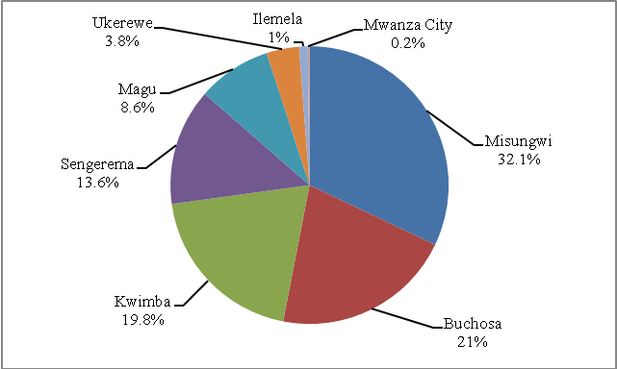
Source: Compiled Data from Councils (Agriculture Departments), Mwanza Region, 2016

(ii) Production of Cassava by Council
Cassava is the second most important food crop in terms of production in Mwanza region. Table 3.4b shows cassava production over the period of 2010/11 to 2014/15 of which the highest productions were recorded in 2014/15 and 2012/13 seasons, 21.7 percent and 21.1 percent of cumulative products harvested in the referred seasons. The worst season was 2013/14 of which only 18.7 percent of cumulative total products harvested. At council level, Sengerema DC leads with 24.6 percent of the region’s total production of 759,928 tonnes. Seecond and third councils were Magu and Ukerewe with 24.1 percent and 23.0 percent overall average production of cassava between 2010/11 and 2014/15 seasons in the region respectively. Mwanza City Council by then Mwanza district produced the smallest tonnage of cassava and its share was 0.6 percent of the region’s total production of 759,928 tonnes.

Table 3.4b: Production of Cassava tonnes by Council, Mwanza Region; 2010/11 – 2014/15
Council | 2010/11 | 2011/12 | 2012/13 | 2013/14 | 2014/15 | Total Production | Annual Average | Percent
Sengerema | 33,186 | 41,483 | 34,030 | 37,190 | 41,432 | 87,320 | 37,464.0 | 24.6
Magu | 41,785 | 36,285 | 25,969 | 33,825 | 45,065 | 182,929 | 36,585.8 | 24.1
Ukerewe | 37,093 | 42,258 | 42,306 | 29,087 | 23,685 | 174,429 | 34,885.8 | 23.0
Buchosa | 28,457 | 28,269 | 28,217 | 29,350 | 44,111 | 158,404 | 31,680.7 | 20.8
Kwimba | 7,988 | 8,093 | 8,201 | 8,373 | 8,493 | 41,147 | 8,229.3 | 5.4
Ilemela | - | 3,303 | 3,294 | 3,053 | 1,837 | 11,487 | 2,297.4 | 1.5
Mwanza City | - | 1,404 | 1,404 | 1,404 | - | 4,212 | 842.5 | 0.6
Regional Total | 148,509 | 161,094 | 143,421 | 142,282 | 164,623 | 759,928 | 151,985.5 | 100
Percent | 19.5 | 21.2 | 18.9 | 18.7 | 21.7 | 100
Source: Mwanza Region, Compiled Data from Councils (Agriculture Departments), 2016

Figure 3.3: Percentage Share of Average Production of Cassava (tons) by Council, Mwanza Region; 2010/11 – 2014/15
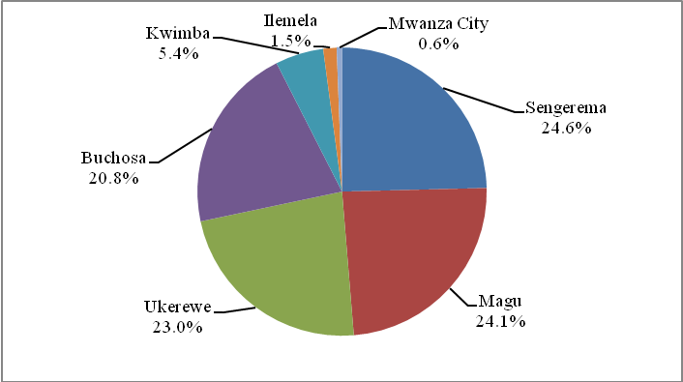
Source:Mwanza Region, Compiled Data from Councils (Agriculture Departments), 2016

(iii) Production of Paddy by Council
Paddy is grown in lowland areas of the region and is the third most important food crop in terms of production. According to Table 3.4c, from of 2010/11 to 2014/15, at a total of 383,020 tonnes of paddy were produced at an average 76,604 tonnes per season during the specified seasons. Paddy production was significant in five district councils led by Magu district council (43.3 percent) followed by, Sengerema (29.8 percent), Ukerewe (22.5 percent), Ilemela (3.5 percent) and Mwanza City (0.8 percent).

Table 3.4c: Production of Paddy (Tons) by Council, Mwanza Region; 2010/11 – 2014/15
Council | 2010/11 | 2011/12 | 2012/13 | 2013/14 | 2014/15 | Total Production | Annual Average | Percent
Magu | 36,428 | 33,825 | 29,393 | 30,033 | 36,228 | 165,908 | 33,181.7 | 43.3
Sengerema | 17,256 | 26,459 | 21,707 | 21,963 | 26,673 | 114,059 | 22,811.7 | 29.8
Ukerewe | 21,318 | 22,311 | 10,193 | 8,189 | 24,277 | 86,288 | 17,257.6 | 22.5
Ilemela | - | 4,070 | 4,061 | 4,138 | 1,307 | 13,576 | 2,715.1 | 3.5
Mwanza City | - | 1,063 | 1,063 | 1,063 | - | 3,189 | 637.9 | 0.8
Total | 75,002 | 87,729 | 66,418 | 65,386 | 88,485 | 383,020 | 76,604.0 | 100
Percent | 19.6 | 22.9 | 17.3 | 17.1 | 23.1 | 100
Source: Mwanza Region, Compiled Data from Councils (Agriculture Departments), 2016

Figure 3.4: Percentage Share of Average Production of Paddy (tons) by Council, Mwanza Region; 2010/11 – 2014/15
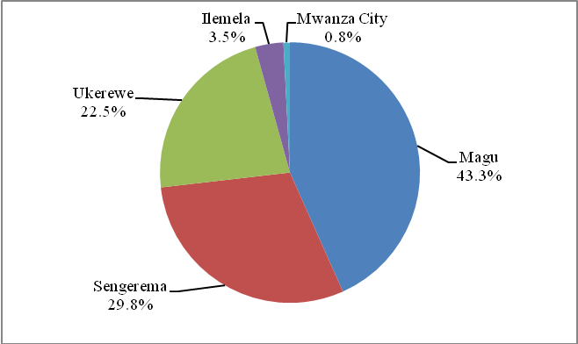
Source: Mwanza Region, Compiled Data from Councils (Agriculture Departments), 2016

(iv) Sorghum Production by Council
Sorghum is another important food crop grown in semi arid areas of Mwanza region. This is a drought - resistant grain crop capable of being grown in Mwanza region. Table 3.4d shows that cumulative total of 48,655 tonnes of sorghum was produced in over the period 2010/11 to 2014/15 and Sengerema district council had the largest lion share of 85.9 percent of overall average production. Ukerewe with 14.1 percent was the second and the third was Mwanza City with 0.04 percent. Other councils were not able to estimates their productions which has been produced significantly within councils.

Table 3.4d: Production of Sorghum (Tons) by Council, Mwanza Region; 2010/11 – 2014/15
Council | 2010/11 | 2011/12 | 2012/13 | 2013/14 | 2014/15 | Total Production | Annual Average | Percent
Sengerema | 6,525 | 9,788 | 8,030 | 8,124 | 9,310 | 41,776 | 8,355.3 | 85.9
Ukerewe | 848 | 1,298 | 1,367 | 270 | 3,075 | 6,858 | 1,371.6 | 14.1
Mwanza City | - | 7 | 7 | 7 | - | 21 | 4.2 | 0.04
Total | 7,373 | 11,093 | 9,404 | 8,401 | 12,385 | 48,655 | 9,731.1 | 100
Percent | 15.2 | 22.8 | 19.3 | 17.3 | 25.5 | 100.0
Source: Mwanza Region, Compiled Data from Councils (Agriculture Departments), 2016

Figure 3.5: Total SorghumProduction (tons) by Council, Mwanza Region; 2010/11 – 2014/15
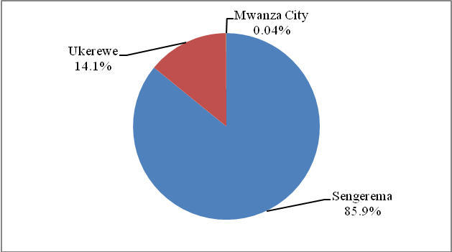
Source: Mwanza Region, Compiled Data from Councils (Agriculture Departments), 2016

3.1.3.3 Food Security
The 2007/8 Agriculture and Livestock Census shows that Mwanza is among other regions which have chronic and transitory food insecurity due to poor or no harvests due to inadequate moisture, the persistently delayed, uneven and erratic rains. The consequences of shortage of production is raising of food prices to record levels leaving vulnerable populations, agriculturists, pastoralists and hawkers without ability to purchase food during the critical period (i.e period after harvests). As stated in chapter two, majority of households end up having hardly two meals per day. Moreover, apart from shortage of agricultural produces, shortage of rainfall/draught has already caused unprecedented social havoc between pastoralist and peasant communities in Mwanza as well as other areas of Tanzania as they scramble for grazing land and water resources.

3.1.3: Major Cash Crops
Production of cash crops in Mwanza region fluctuated over the specified period as indicated in Table 3.5. Nevertheless, the region managed to harvest an average of 119,846.1tonnes of cash crops per season between 2010/11 and 20014/15. The best season was 2012/13 which produced 24.6 percent of cumulative cash crops produced in Mwanza region during specified period of seasons, while the worst season was 2014/15 produced only 17.6 percent of cumulative total products for referred years (Table 3.5). There are number of reasons for the amounts of cash crops harvested to fluctuate, among others, lack of insecticides, fertilizers, prices and cost of production against revenue.

Table 3.5: Estimated Production of Major Cash Crops (Tons), Mwanza Region; 2010/11 – 2014/15
Crop | Estimated Production in tons |  |  |  |  | Total Production | Annual Average | Percent
Crop | 2010/11 | 2011/12 | 2012/13 | 2013/14 | 2014/15 | Total Production | Annual Average | Percent
Cotton | 65,371.7 | 58,991.5 | 57,764.6 | 56,950.6 | 45,452.0 | 284,530.4 | 56,906.1 | 47.5
Paddy | 25,285.7 | 29,681.8 | 24,303.9 | 24,316.7 | 34,519.9 | 138,107.9 | 27,621.5 | 23.1
Green Peas | 2,942.4 | 4,089.6 | 44,434.2 | 27,007.2 | 961.0 | 79,434.4 | 15,886.9 | 13.3
Maize | 7,087.3 | 5,882.9 | 7,633.1 | 4,456.8 | 11,225.5 | 36,285.6 | 7,257.1 | 6.1
Cassava | 3,323.1 | 4,168.4 | 6,529.8 | 6,164.7 | 7,007.3 | 27,193.3 | 5,438.7 | 4.5
Chick peas | 3,235.5 | 3,178.7 | 3,583.7 | 3,646.9 | 3,564.8 | 17,209.6 | 3,441.9 | 2.9
Banana | 3,450.0 | 4,044.0 | 2,817.0 | 2,596.0 | 2,703.0 | 15,610.0 | 3,122.0 | 2.6
Beans | 198.1 | 158.8 | 73.7 | 113 | 56.7 | 600.3 | 120.1 | 0.1
Coffee | 104.6 | 47 | 20 | 31.9 | 55.4 | 258.9 | 51.8 | 0.04
Total | 110,998.4 | 110,242.7 | 147,160.0 | 125,283.8 | 105,545.5 | 599,230.4 | 119,846.1 | 100
Percent | 18.5 | 18.4 | 24.6 | 20.9 | 17.6 | 100
Source: Mwanza Region, Compiled Data from Councils (Agriculture Departments), 2016

Figure 3.6 shows that cotton is the major cash crop produced in the region accounted for 47.5 percent of cumulative cash crops produced in the referred years followed by paddy (23.1 percent), green peas (13.3 percent), maize (6.1 percent) and cassava (4.5 percent). Coffee was the least cash crop (0.04 percent) produced in the specified seasons (Figure 3.6).

Figure 3.6: Percentage of Average Production of Major Cash Crops, Mwanza Region; 2010/11 – 2014/15
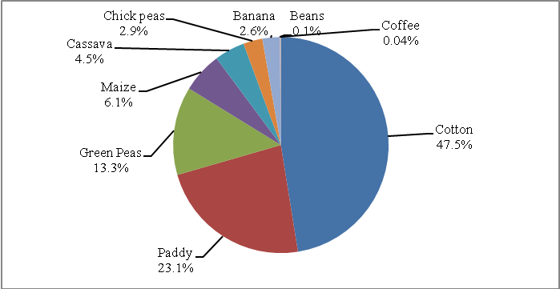
Source: Mwanza Region, Compiled Data from Councils (Agriculture Departments), 2016

3.1.4 Crop Marketing
Table 3.6 shows an indicative estimated amount of cash crops marketed and revenue earned in Mwanza region during the 2014/15 season. A total of 174,152,134 kilograms of maize, cotton, cassava, paddy, rice, chick peas, beans, green peas, banana, coffee and groundnuts were marketed in the region which earned a sum of Tshs. 149,622,253,324. Most of the revenue earned from maize which accounted for 37.7 percent of total revenue, followed by cotton (26.2 percent), cassava (20.02 percent) and paddy (6.9 percent). Others include rice (4.71 percent), chick peas (4.01 percent) and groundnuts was the least council earned only Tsh. 423,000 of the region’s revenue.

Table 3.6: Amount and Value of Cash Crops Purchased by Council; Mwanza Region, 2014/15
Crop | Amount Purchased (Kgs) | Average Price per Kg (Tshs.) | Revenue Earned in Tshs | Percent Earnings
Maize | 69,509,539 | 28,378 | 56,381,980,975 | 37.68
Cotton | 36,477,317 | 20,000 | 39,212,442,250 | 26.21
Cassava | 34,608,604 | 16,943 | 29,960,805,422 | 20.02
Paddy | 22,622,170 | 12,800 | 10,321,358,500 | 6.9
Rice | 5,447,498 | 15,975 | 7,044,066,777 | 4.71
Chick peas | 4,443,500 | 9,000 | 5,997,900,000 | 4.01
Beans | 110,452 | 34,000 | 324,464,000 | 0.22
Green peas | 554,400 | 4,250 | 184,500,000 | 0.12
Banana | 365,431 | 1,100 | 177,672,400 | 0.12
Coffee | 12,800 | 1,300 | 16,640,000 | 0.01
Ground nuts | 423 | 1,000 | 423,000 | 0.00
Total | 174,152,134 |  | 149,622,253,324 | 100
Source: Mwanza Region, Compiled Data from Councils (Agriculture Departments), 2016

Contrary to the fact that Misungwi DC is the main producer of maize in the region followed by Buchosa district, the situation happened to be opposite when considering marketing of such crop (Table 3.6a). Kwimba district was the first council in Mwanza region for marketing maize grains. The council marketed 46,872,800 kilogram of maize worth Tshs. 39,841,880,000, equivalent to 70.7 percent of total revenue earned by the region through selling of that crop. Never the less, Buchosa DC was the second by earning 25.0 percent of the region’s maize revenue obtained. Misungwi district earned 3.7 percent and was the third in maize marketing, Ilemela MC earning 0.7 percent in earning revenue for marketing of such crop in year 2014/15.

Table 3.6a: Amount of Maize Marketed and Revenue Earned by Council; Mwanza Region, 2014/15
Council | Amount Marketed (Kgs) | Percent Marketed | Price per Kg (Tshs.) | Revenue Earned in Tshs | Percent Earnings
Kwimba | 46,872,800 | 67.4 | 850 | 39,841,880,000 | 70.7
Buchosa | 17,335,338 | 24.9 | 14,928 | 14,081,239,975 | 25
Misungwi | 4,733,351 | 6.8 | 8,750 | 2,089,196,000 | 3.7
Ilemela | 568,050 | 0.8 | 3,850 | 369,665,000 | 0.7
Ukerewe | - | - | - | - | -
Magu | - | - | - | - | -
Mwanza City | - | - | - | - | -
Sengerema | - | - | - | - | -
Total | 69,509,539 | 100 | 28,378 | 56,381,980,975 | 100
Source: Mwanza Region, Compiled Data from Councils (Agriculture Departments), 2016

In 2014/15, cotton was the second cash crop marketed in the region after maize (refer Table 3.6 above). Cotton earned 26.21 percent of the region’s total revenue obtained from marketing of all types of cash crops. On the other hand, Table 3.6b shows that Kwimba council leading on the data of the amount of cotton sold. By comparing the revenue earned by councils, Kwimba earned almost 83.26 percent followed by Misungwi (15.96 percent) and Buchosa (0.77 percent), while Magu with only 0.005 percent was the least council which earned the minimum amount (Tsh. 1,902,010) of all revenue obtained from selling cotton in the region.

Table 3.6b: Amount of Cotton Marketed and Revenue Earned by Council; Mwanza Region, 2014/15
Council | Amount Marketed (Kgs) | Percent Marketed | Price per Kg (Tshs.) | Revenue Earned in Tshs | Percent Earnings
Kwimba | 34,368,000 | 94.22 | 950 | 32,649,600,000 | 83.26
Misungwi | 1,883,200 | 5.16 | 12,000 | 6,257,588,000 | 15.96
Buchosa | 224,215 | 0.61 | 6,050 | 303,352,240 | 0.77
Magu | 1,902 | 0.01 | 1,000 | 1,902,010 | 0.005
Ilemela | - | - | - | - | -
Mwanza City | - | - | - | - | -
Sengerema | - | - | - | - | -
Ukerewe | - | - | - | - | -
Total | 36,477,317 | 100 | 20,000 | 39,212,442,250 | 100
Source: Mwanza Region, Compiled Data from Councils (Agriculture Departments), 2016

Table 3.6 shows that cassava with 20.02 percent of earning in the region was the third valuable cash crop in the region. Table 3.6c shows the amount of cassava marketed in the crop season of 2014/15. Out of 34,608,604kg of cassava marketed in 2014/15 season, the region managed to earn a sum of Tshs. 29,960,805,422. Buchosa council was the first council in marketing of cassava by earning 34.1 percent of the region’s revenue obtained from selling of that crop. The second and third councils were Magu and Kwimba earned 33.8 percent and 28.3 percent of total earnings, while Ilemela council was the least by having 3.7 percent of the region’s revenue earned through marketing of cassava.

Table 3.6c: Amount of Cassava Marketed and Revenue Earned by Council; Mwanza Region, 2014/15
Council | Amount Marketed (Kgs) | Percent Marketed | Price per Kg (Tshs.) | Revenue Earned in Tshs | Percent Earnings
Buchosa | 13,294,504 | 38.4 | 10,943 | 10,218,195,422 | 34.1
Magu | 11,266,200 | 32.6 | 900 | 10,139,580,000 | 33.8
Kwimba | 8,493,000 | 24.5 | 2,000 | 8,493,000,000 | 28.3
Ilemela | 1,554,900 | 4.5 | 3,100 | 1,110,030,000 | 3.7
Misungwi | - | - | - | - | -
Mwanza City | - | - | - | - | -
Sengerema | - | - | - | - | -
Ukerewe | - | - | - | - | -
Total | 34,608,604 | 100 | 16,943 | 29,960,805,422 | 100
Source: Mwanza Region, Compiled Data from Councils (Agriculture Departments), 2016

Paddy with 6.90 percent of earnings was the fourth valuable cash crop in the region (Table 3.6 above). Table 3.6d shows marketing status of paddy in the crop season of 2014/15. The region marketed a total of 22,622,170kg of paddy and earned a sum of Tshs. 10,321,358,500 in 2014/15 season. Ukerewe council was the first council in marketing of paddy by earning 58.8 percent of the region’s revenue obtained from selling of that crop. Magu was the second (31.1 percent), Ilemela council was the third (6.8 percent) while Misungwi council was the least by having 3.4 percent of the region’s revenue earned through marketing of paddy.

Table 3.6d: Amount of Paddy Marketed and Revenue Earned by Council; Mwanza Region, 2014/15
Council | Amount Marketed (Kgs) | Percent Marketed | Price per Kg (Tshs.) | Revenue Earned in Tshs | Percent Earnings
Ukerewe | 15,169,500 | 67.1 | 400 | 6,067,800,000 | 58.8
Magu | 5,835,350 | 25.8 | 550 | 3,209,442,500 | 31.1
Ilemela | 523,170 | 2.3 | 6,600 | 697,304,000 | 6.8
Misungwi | 1,094,150 | 4.8 | 5,250 | 346,812,000 | 3.4
Mwanza City | - | - | - | - | -
Sengerema | - | - | - | - | -
Buchosa | - | - | - | - | -
Kwimba | - | - | - | - | -
Total | 22,622,170 | 100 | 12,800 | 10,321,358,500 | 100
Source: Mwanza Region, Compiled Data from Councils (Agriculture Departments), 2016

3.1.5 Irrigated Agriculture
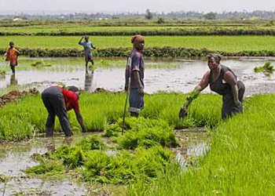
Mwanza region is endowed with a potential area for irrigation prospects of about 10,649 hectares due to its geographical location, topgraphy and ecological conditions. However, in 2014/15 season the region managed to utilize only 2,884.3 hectares, equivalent to 27.1 percent of the estimated irrigation area. The largest irrigated area was found in Magu (40.8 per cent) followed by Kwimba council (20.5 per cent). The smallest area cultivated in Ukerewe and Sengerema (0 per cent). Major crops irrigated were Paddy, Maize and Vegetables such as tomatoes, cabbage, Chinese cabbage, amaranths, egg plant, onion and watermelon (Table 3.7).

Table 3.7: Distribution of Irrigation Prospects and Crop Grown by Council, Mwanza Region; 2014/15
Council | Potential Area |  | Irrigated Area
Council | Area (Hacters) | Percent | Hacters | Major crops
Ukerewe | 1,160 | 10.9 | 0 | Paddy
Magu | 1,776 | 16.7 | 1,178 | Horticultural crops and paddy
Mwanza City | 550 | 5.2 | 82 | Paddy, Tomatoes, chinese Cabbage
Kwimba | 1,444 | 13.6 | 590 | Paddy
Sengerema | 1,200 | 11.3 | 0 | Paddy
Ilemela | 425 | 4.0 | 174 | Paddy
Ilemela | 130 | 1.2 | 40 | Vegetables
Misungwi | 2,525 | 23.7 | 295 | Paddy
Misungwi | 200 | 1.9 | 7.5 | Maize
Buchosa | 23 | 0.2 | 11 | Amaranths
Buchosa | 15 | 0.1 | 5.2 | Egg plant
Buchosa | 227 | 2.1 | 12.5 | Maize and Green vegetable
Buchosa | 318 | 3 | 210 | Rice
Buchosa | 45 | 0.4 | 30.6 | Tomato
Buchosa | 601 | 5.6 | 242 | Vagetables
Buchosa | 10 | 0.1 | 6.5 | Watermelon
Total | 10,649 | 100 | 2,884.30
Source: Mwanza Region, Compiled Data from Councils (Agriculture Departments), 2016

3.1.6: Farm inputs

3.1.6.1 Introduction
Reducing rural poverty by delivering appropriate agricultural inputs and improving output markets for Tanzanian farmers are among the objectives of "Kilimo Kwanza" (Agriculture First) in Tanzania. In Kilimo Kwanza, priority is given in transforming traditional agriculture which depends on hand hoe to mechanised agriculture and improving agriculture extension services through employing more extension officers. Further to that, distribution of chemical fertilizers including establishing credit facilities for farmers, and setting up storage through a warehouse receipt system was introduced to reinforce crops production.
Mwanza region like other regions in Tanzania, the implementation of ‘Kilimo Kwanza’ has led to the increase in availability of agricultural inputs especially chemical fertilizers and improved seeds among small scale farmers. However, scientific research is needed to investigate the impact of “Kilimo Kwanza” on crops productivity.

3.1.6.2 Chemical Fertilizers
Table 3.8 shows the distribution of chemical fertilizers to farmers for the year 2010/11to 2014/2015 in Mwanza region. The total chemical fertilizers distributed to farmers in 2010/11 to 2014/15 were 10,756,414 kilograms. In all agriculture seasons, under supply of chemical fertilizer was a big problem which resulted to poor harvesting in the region. There is a need, therefore, to review the distribution system used for the benefit of not only the farmers in Mwanza region but also farmers in other part of the regions and the country at large.

- Fungicides
Table 3.8 shows the distribution of different type of fungicides between 2010/11 and 2012/13 in Mwanza region. Out of 11 different types of fungicides fond in Mwanza region, Farmerzeb were the most distributed fungicide with total distribution of 38,060 litres (25.3 percent), followed by methane 36,047 litres, farmzeb 24,404 litres (16.2 percent) while Kalebezo Ascomil 244 litres (0.2 percent) and glinder 204 litres (0.1 percent) were the least important fungicides distributed in the region over the specified seasons (Table 3.8). One general observation from these data is that distribution of fungicides mostly depends on the demand from farmers and type of crops grown in a particular location.

Table 3.8: Type and Quantity of Fungicides (in Litres) Distributed to Farmers; Mwanza Region; 2010/11-2014/15
Type of Fungicides | Quantity Distributed (in Litres) |  |  |  |  | Total Distribution | Average Annual | Percent
Type of Fungicides | 2010/11 | 2011/12 | 2012/13 | 2013/14 | 2014/15 | Total Distribution | Average Annual | Percent
Linkomil | 4,779 | 8,148 | 8,435 | 7,158 | 9,541 | 38,060 | 7,612 | 25.3
Mithane | 5,312 | 5,995 | 7,220 | 8,480 | 9,040 | 36,047 | 7,209 | 23.9
Farmerzeb | 3,823 | 4,340 | 5,120 | 5,518 | 5,603 | 24,404 | 4,881 | 16.2
Victory | 3,619 | 3,692 | 3,811 | 4,069 | 4,310 | 19,501 | 3,900 | 12.9
Redomil gold | 3,420 | 3,340 | 3,220 | 2,480 | 3,000 | 15,460 | 3,092 | 10.3
Twigatharonil | 1,910 | 1,876 | 1,811 | 981 | 5,736 | 12,314 | 2,463 | 8.2
Chlorophis | - | - | - | - | 3,600 | 3,600 | 720 | 2.4
Dithane | 93 | 113 | 152 | 101 | 83 | 541 | 108 | 0.4
Braval | 50 | 60 | 90 | 70 | 80 | 350 | 70 | 0.2
Kalebezo Ascomil | 33 | 41 | 40 | 60 | 70 | 244 | 49 | 0.2
Glinder | 26 | 34 | 28 | 54 | 62 | 204 | 41 | 0.1
Total | 23,064 | 27,639 | 29,927 | 28,971 | 41,125 | 150,725 | 30,145 | 100
Source: Mwanza Region, Compiled Data from Councils (Agriculture Departments), 2016

- Insecticides/Pesticides
Table 3.9 shows distribution of insecticides in Mwanza region for the year 2010/11 to 2014/15. Probably, the low use of insecticides is due to low distribution of the chemicals. Of the listed insecticides in Table 3.7c, Ultracy A and Weedcron were the least distributed insecticides and are basically insecticides of less importance. On the other hand, bamethrine, farmgard and zetabestox 10%EC were highly distributed accounted for 47.8 percent, 28 percent and 20.5 percent of distributed insecticides in the region respectively (Table 3.9).

Table 3.9: Type and Quantity of Insecticides (in Litres) Distributed to Farmers, Mwanza Region; 2011-2015
Type of Insecticides | Quantity Distributed (in Litres) |  |  |  |  | Total Distribution | Average Annual | Percent
Type of Insecticides | 2010/11 | 2011/12 | 2012/13 | 2013/14 | 2014/15 | Total Distribution | Average Annual | Percent
Bamethrine | 2,715 | 6,018 | 9,127 | 39,665 | 410,919 | 468,444 | 93,688.80 | 47.8
Farmgard | 4,876 | 5,522 | 6,425 | 36,395 | 220,885 | 274,102 | 54,820.40 | 28.0
Zetabestox 10%EC | - | - | - | - | 200,975 | 200,975 | 40,195.00 | 20.5
Premethyl 0.5lt | 2,731 | 2,992 | 3,852 | 4,077 | 4,585 | 18,237 | 3,647.40 | 1.9
Supercron | 13 | 3,215 | 3,626 | 3,779 | 3,997 | 14,630 | 2,926.00 | 1.5
Actelic 50 EC | 527 | 634 | 700 | 741 | 1,104 | 3,705 | 741 | 0.4
Ultracy A | 51 | 48 | 46 | 35 | 41 | 221 | 44.1 | 0
Weedcron | 16 | 15 | 18 | 17 | 21 | 87 | 17.4 | 0
Total | 10,929 | 18,443 | 23,794 | 84,709 | 842,527 | 980,401 | 196,080.10 | 100
Source: Mwanza Region, Compiled Data from Councils (Agriculture Departments), 2016

3.1.13 Improved Seeds
Use of improved seeds is among important factors for inceasing agricultural productivity (output per unit of land). Maize is the leading crop in having a wide range of improved seeds in the region. Table 3.10 shows that seedco and situka are improved seeds for maize which were mostly distributed in the region during the referred seasons. Other improved seeds for cotton, sunflowers and vegitables were distributed in minimum quantities (Table 3.10).

Table 3.10: Type and Quantity of Improved seeds (Kgs) Distributed to Farmers; Mwanza Region; 2011-2015
Type of Improved Seeds | Quantity Distributed (in kgs) |  |  |  |  | Total Distribution | Average Annual | Percent
Type of Improved Seeds | 2010/11 | 2011/12 | 2012/13 | 2013/14 | 2014/15 | Total Distribution | Average Annual | Percent
Seedco | 436,700 | 564,700 | 639,000 | 444,000 | 237,000 | 2,321,400 | 464,280.00 | 30.3
Situka | 244,200 | 387,700 | 327,800 | 137,800 | 145,000 | 1,242,500 | 248,500.00 | 16.2
TMV 1 | 250,900 | 237,600 | 227,700 | 131,800 | 216,000 | 1,064,000 | 212,800.00 | 13.9
Maize | 92,972 | 131,943 | 182,590 | 207,862 | 183,515 | 798,881 | 159,776.30 | 10.4
Kilima | 142,000 | 139,800 | 137,000 | 79,500 | 134,000 | 632,300 | 126,460.00 | 8.3
SDK ( DK 8031) | - | 152,800 | 147,000 | 70,700 | 144,000 | 514,500 | 102,900.00 | 6.7
Kifaru | - | 123,400 | 116,000 | 62,000 | 112,000 | 413,400 | 82,680.00 | 5.4
Pannar 19 | 78,500 | 76,500 | 72,000 | 41,000 | 69,000 | 337,000 | 67,400.00 | 4.4
DH 04 | - | 47,000 | 44,500 | 21,400 | 43,000 | 155,900 | 31,180.00 | 2
Kitale seeds | - | 39,800 | 36,000 | 17,000 | 32,000 | 124,800 | 24,960.00 | 1.6
Saro5 | 262 | 615 | 464 | 12,263 | 8,776 | 22,380 | 4,476.00 | 0.3
Sunflower | - | - | 3,000 | 8,200 | 4,200 | 15,400 | 3,080.00 | 0.2
Cotton | - | 1,500 | 1,500 | 1,500 | 1,500 | 6,000 | 1,200.00 | 0.1
Cabbage | 457 | 505 | 572 | 700 | 770 | 3,004 | 600.8 | 0
Tomato | 275 | 315 | 385 | 735 | 910 | 2,620 | 524 | 0
Watermelon | 250 | 280 | 356 | 550 | 786 | 2,222 | 444.4 | 0
Amaranthus | 20 | 32 | 32 | 40 | 35 | 159 | 31.8 | 0
Okra | 8 | 12 | 20 | 20 | 5 | 65 | 13 | 0
Total | 1,246,544 | 1,904,501 | 1,935,919 | 1,237,070 | 1,332,497 | 7,656,531 | 1,531,306.30 | 100
Source: Mwanza Region, Compiled Data from Councils (Agriculture Departments), 2016

3.1.4: Agriculture Implements
The use of agriculture implements depend on the size of farms owned by households and or investors. The region is among regions in the country with largest population being peasant farmers, owning about 4 to 5 hacters of farm resulted to less demand of farm implements. Table 3.11 shows that the traditional implements were highly demanded compared with modern and sophisticated implements in the region. In 2014/15, a total of 201 tractors were distributed in the region against a demand of 497 tractors and only 202 power tillers were distributed which was less than the required 566. One general observation from these data is that local authorities in Mwanza region should educate their farmers on the need of changing farming system from tradition to mordernised agriculture in order to increase their productivities.

Table 3.11: Availability of Agriculture Implements, Mwanza Region;2015
Type of Implements | Demand | Supplied | Deficit (-) / Excess
Ox plough | 28,846 | 39,449 | 10,603
Ox harrow | 4,828 | 27 | -4,801
Oxridger | 4,696 | 44 | -4,652
Oxcart | 2,274 | 2,279 | 5
Ox cultivator | 4,872 | 109 | -4,763
Ox chain | 39,311 | 8,944 | -30,367
Ox shares | 19,846 | 5,833 | -14,013
Tractors | 497 | 201 | -296
Power tillers | 566 | 202 | -364
Ox-planters | 46 | 20 | -26
Total | 105,782 | 57,108 | -48,674
Source: Mwanza Region, Compiled Data from Councils (Agriculture Departments), 2016

Policy implication in Agriculture Sector
Agriculture sector performance in terms of food and cash crop production does not give a blight future on the status of food security as well as to the economy of the region which largely depends on agriculture. Contribution of the region to the nation food crops production stood at 22.7 percent in the agricultural year of 2002/03 and dropped to 20.7 percent in 2007/08. Likewise, region’s cash crops shares contributed to the Tanzania mainland decreased from 22.7 percent of 2002/03 to 3.0 percent of 2007/08 also evidenced poor performance of the sector. Limited access of agricultural inputs especially to peasant farmers, low price of agricultural produces against production, poor agricultural practices as well as adverse weather condition are the cause of the region’s agriculture poor performance. To revive the sector, the region need to stick on Kilimo Kwanza guidelines by improving extension services, ensure reliable supply of agricultural inputs through improving implementation procedures of National Agricultural Input Voutcher Scheme (NAIVS) policy.

Investment Opportunities in Agriculture Sector
Potential areas for investment in Agriculture include: crop production; Supply of agriculture inputs such as fertilizer, insecticides, seeds etc at affordable prices; Supply of farm implements such as power tillers, tractors, ox-cats etc at affordable prices; Agro- processing industries especially sorting and packaging industry for vegetables and fruits; and Irrigation farming by construction of irrigation infrastructures through utilizing lake Victoria water, seasonal rivers to harvest rain water and drilling of borehole wells for irrigation.

  - Livestock
Livestock keeping is the second most important economic activity after agriculture. Table 3.12 shows distribution of estimated livestock by species in each council of Mwanza region in 2015. Cattle were the leading in numbers for large and medium size livestock followed by goats and sheep, while pig and donkers are not commonly domesticated in the region (Table 3.12). Table 3.12 also shows that there was a large population of poultry especially indeginous chicken and significant population of improved checken for both broilers and layers.

Table 3.12: Estimated Livestock Population by Council, Mwanza Region; 2015
Council | Cattle | Goats | Sheep | Donkeys | Pigs | Indigenous chicken | Chicken (Broilers& Layers)
Ukerewe | 59,483 | 57,988 | 280 | 0 | 2,162 | 1,266,275 | 249
Magu | 204,250 | 61,007 | 38,645 | 318 | 1,603 | 385,557 | 18,397
Mwanza City | 15,913 | 12,678 | 1,536 | 33 | 3,664 | 145,617 | 195,418
Kwimba | 31,828 | 3 | 31,831 | 31,828 | 3 | 31,831 | 31,828
Sengerema | 93,519 | 39,427 | 8,795 | 223 | 2,884 | 148,459 | 13,623
Ilemela | 14499 | 7068 | 1369 | 246 | 1966 | 56879 | 66615
Misungwi | 131,250 | 34,214 | 10244 | 801 | 942 | 191,199 | 3357
Buchosa | 49,593 | 31,831 | 1,023 | 108 | 2,822 | 217,896 | 2,102
Total | 600,335 | 244,216 | 93,723 | 33,557 | 16,046 | 2,443,713 | 331,589
Source: Mwanza Region, Compiled Data from Councils (Agriculture Departments), 2016

- Cattle
Table 3.13 shows that indigenous cattle were the dominant type of livestock found in Mwanza region. They accounted for 99.5 percent of the region’s total cattle population while improved dairy and beef cattle contributed 0.2 percent and 0.01 percent respectively in 2015.

At council level, Kwimba district council had largest number (40.9 percent) of the region’s total cattle population followed by Magu (21.2 percent), Misungwi (13.6 percent), Sengerema (9.7 percent), Ukerewe (6.2 percent) and Buchosa (5.2 percent). Mwanza city and Ilemela municipal council were the least number (1.7 percent) and (1.5 percent) of cattle population in Mwanza region respectively (Table 3.13).

In the case of improved dairy cattle, most of them were recorded in Mwanza City (39 percent) followed by Ilemela (34.9 percent), Sengerema (16.6 percent), Magu (5 percent), Misungwi (2 percent), Kwimba and Ukerewe with 1.2 percent each and Buchosa district council had 0.2 percent of the region’s total dairy cattle population in 2015 (Table 3.13)

Furthermore, improved beef cattle were not common in Mwanza region as they only constituted 0.01 percent of the region’s total cattle population. Table 3.13 shows that majority of beef cattle were kept in Kwimba with only 39 beef cattle followed by Buchosa (37), Misungwi (17) and Ukerewe (13). The rest of councils, including Magu, Sengerema, Mwanza city and Ilemela did not have beef cattles (Table 3.13).

Figure 3.13: Population Distribution of Indigeneous Cattle by Council, Mwanza Region; 2015
Council | Indigenous Cattle | Percent of Indigeneous Cattle | Dairy Cattle | Percent of Dairy Cattle | Beef Cattle | Percent of Beef Cattle | Region Total | Percent of Region
Kwimba | 393,934 | 41.3 | 60 | 1.2 | 39 | 36.8 | 394,033 | 40.9
Magu | 203,991 | 21.4 | 259 | 5.0 | - | - | 204,250 | 21.2
Misungwi | 131,129 | 13.7 | 104 | 2.0 | 17 | 16 | 131,250 | 13.6
Sengerema | 92,648 | 9.7 | 858 | 16.6 | - | - | 93,506 | 9.7
Ukerewe | 56,764 | 5.9 | 61 | 1.2 | 13 | 12.3 | 59,483 | 6.2
Buchosa | 49,553 | 5.2 | 8 | 0.2 | 37 | 34.9 | 49,598 | 5.2
Mwanza City | 13,904 | 1.5 | 2,009 | 39 | - | - | 15,913 | 1.7
Ilemela | 12,712 | 1.3 | 1,797 | 34.9 | - | - | 14,499 | 1.5
Total | 954,635 | 100 | 5,156 | 100 | 106 | 100 | 962,532 | 100
Percent | 99.2 |  | 0.5 |  | 0 |  | 100
Source: Mwanza Region, Compiled Data from Councils (Agriculture Departments), 2016
Figure 3.12: Population Distribution of Cattle by Council, Mwanza Region;2015
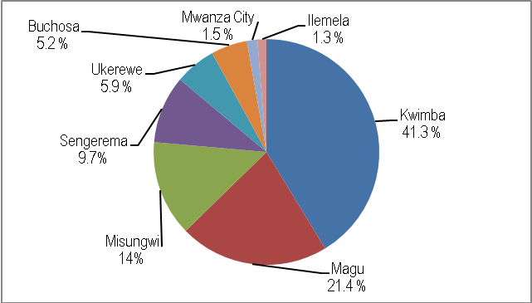
Source: Mwanza Region, Compiled Data from Councils (Agriculture Departments), 2016

- Goats
Table 3.14 shows that indigenous goats were the dominant type of goats (99.8 percent) in Mwanza region while dairy goats keeping are not common in the region accounted only 0.2 percent in 2015. At council level, Table 3.14 shows that Kwimba district council had the largest number (36.6 percent) of goats’ population in the region followed by Magu (16.4 percent), Ukerewe (13.2 percent) and Sengerema (10.6 percent). Ilemela and Ukerewe were the two councils in the region with largest number of dairy goats, 245 and 170 respectively (Table 3.14).

Table 3.14: Population Distribution of Goats by Type and by Council, Mwanza Region;2015
Council | Indigenous Goats | Percent | Dairy Goats | Percent | Total | Percent
Ukerewe | 48,810 | 99.7 | 170 | 0.3 | 48,980 | 13.2
Magu | 60,957 | 99.9 | 50 | 0.1 | 61,007 | 16.4
Mwanza City | 12,608 | 99.4 | 70 | 0.6 | 12,678 | 3.4
Kwimba | 135,710 | 100.0 | 11 | 0.0 | 135,721 | 36.6
Sengerema | 39,427 | 100.0 | 0 | 0.0 | 39,427 | 10.6
Ilemela | 7,127 | 96.7 | 245 | 3.3 | 7,372 | 2.0
Misungwi | 34,178 | 99.9 | 36 | 0.1 | 34,214 | 9.2
Buchosa | 31,828 | 100.0 | 3 | 0.0 | 31,831 | 8.6
Total | 370,645 | 99.8 | 585 | 0.2 | 371,230 | 100.0
Source: Mwanza Region, Compiled Data from Councils (Agriculture Departments), 2016

3.2.1 Grazing Area
Grazing land is defined as that land that is available for the grazing needs of livestock. It excludes all tsetse fly area, all wildlife and forest reserves also tree plantations, but it includes game controlled areas. Table 3.15 shows that in 2015 estimated land used for grazing area in the region was 172,977 hacters while the land used for grazing was 121,874 hacters. Data show there was no shortage of grazing area in the region and 51,103 hacters which are not used for grazing as planned at the same time the region has no tsetse fly infected area or land.

Table 3.15: Estimated Area for Grazing by Council, Mwanza Region; 2015
Council | Land fit for Grazing (Ha) | Land used for Grazing (Ha) | Percent Land Used | Tsetse Fly infected Area (Ha)
Ukerewe | 396 | 67 | 16.9 | -
Magu | 34,427 | 21,095 | 61.3 | -
Mwanza City | - | - | 0.0 | -
Kwimba | 46,616 | 46,616 | 100.0 | -
Sengerema | 19,584 | 19,584 | 100.0 | -
Ilemela | 11,074 | - | 0.0 | -
Misungwi | 46,619 | 23,541 | 50.5 | -
Buchosa | 14,261 | 10,972 | 76.9 | -
Total | 172,977 | 121,874 | 70.5 | -
Source: Mwanza Region, Compiled Data from Councils (Agriculture Departments), 2016

3.2.2 Livestock Infrastructure
Livestock quality improvement is limited by access to preventive and curative facilities capable of controlling or preventing their morbidities and mortalities. Diseases affect animal health and reduce both meat and milk production in terms of quality and quantity are prevented by the availabilities of livestock infrastructure including dips and vertenaries centres together with medicines, while crushes, abattoirs, hides and skin sheds, slaughter slabs, livestock market or auctions and accessibility of water improve the quality of livestock products. Table 3.17 indicates that out of 136 dips available in the region, 67 dips, equivalent to 49.3 percent are working, while only 10 out of 26 veterinary centres are working as of 2015. At council level, Ilemela was the most affected council because none of five dips working and no veterinary centre was operating in 2015 (Table 3.17). Ukerewe had serious shortages of dips while Sengerema and Buchosa had no veterinary centres that raise concern about the morbity and mortality of livestocks in these councils.

Table 3.17: Distribution of Livestock Infrastructure by Council, Mwanza Region; 2015
Council | Dips |  |  |  | Veterinary Centres
Council | Working | Not Working | Total | Percent | Working | Not Working | Total | Percent
Ukerewe | 0 | 16 | 16 | 0.0 | 1 | 3 | 4 | 25.0
Magu | 8 | 5 | 11 | 72.7 | 3 | 1 | 4 | 75.0
Mwanza City | 3 | 0 | 3 | 100.0 | 3 | 0 | 3 | 100.0
Kwimba | 14 | 18 | 32 | 43.8 | 1 | 6 | 7 | 14.3
Sengerema | 9 | 9 | 18 | 50.0 | 0 | 2 | 2 | 0.0
Ilemela | 0 | 5 | 4 | 0.0 | 0 | 1 | 1 | 0.0
Misungwi | 25 | 21 | 41 | 61.0 | 2 | 3 | 5 | 40.0
Buchosa | 8 | 9 | 11 | 72.7 | 0 | 0 | 0 | 0.0
Total | 67 | 83 | 136 | 49.3 | 10 | 16 | 26 | 38.5
Source: Mwanza Region, Compiled Data from Councils (Agriculture Departments), 2016

The quality of livestock products such as meat, milk, hide and skins and other related products mostly depend on availability, stutas and quality of infrastructure such as crushes, abattoirs, hides and skin sheds, slaughter slabs, livestock market or auctions and accessibility of water. Table 3.17a shows that Mwanza region had not yet well endowed with these facilities since most of infrastructures were concentrated in Kwimba and Misungwi district councils. Councils such as Mwanza city, Ilemela, Ukerewe and magu had limited numbers of facilities which also raise question on the quality of their livestock products.

Table 3.17: Distribution of Livestock Infrastructure by Council, Mwanza Region; 2015
Council | Crushes | Hides/Skin Sheds | Abattoirs | Slaughter Slab | Livestock Market/ Auction | Charco Dams
Ukerewe | 1 | 0 | 1 | 6 | 0 | 0
Magu | 3 | 3 | 2 | 9 | 3 | 8
Mwanza City | 0 | 0 | 0 | 1 | 0 | 1
Kwimba | 18 | 4 | 1 | 6 | 4 | 48
Sengerema | 3 | 3 | 1 | 7 | 5 | 11
Ilemela | 4 | 0 | 0 | 3 | 0 | 9
Misungwi | 19 | 5 | 3 | 9 | 4 | 36
Buchosa | 4 | 2 | 1 | 27 | 2 | 0
Total | 52 | 17 | 9 | 68 | 18 | 113
Source: Mwanza Region, Compiled Data from Councils (Livestock Departments), 2016

3.2.2.1 Causes of Livestock Morbidity and Mortality
Diseases, among other reasons, were the main causes of livestock morbidity and mortality in Mwanza region. Data provided by local authorities of Mwanza region shows different types of diseases for big, medium and small animals. The most common diseases in Mwanza region are east coast fever, anaplasmosis, babesiosis, heart water, trypasonomiasis, helminthiasis, and worms, CCPP, Mange, Pneumonia and Foot Mouth Disease. Others are new castle, coccidiosis, fowl coryza, fowl typhoid, fowl pox and gumboro.

- Causes of Cattle Morbidity and Mortality
Table 3.18 shows a list of common diseases which caused cattle morbidity in Mwanza region between 2013 and 2015. In 2013, Table 3.18 shows that east coast fever was the most common diseases caused highest cattle morbidity rate accounted 49.9 percent of reported 31,651 cases in the region. The second and third causes for cattle morbidities were anaplasmosis (21.1 percent) and babesiosis (10.1 percent) diseases and trypasonomiasis with 7.1 percent of total cases reported was the fourth disease and the fifthy disease was heart water (7.0 percent).

Similar observation was also experienced in 2015, of which east coast fever and anaplasmosis remained as the first and second common cattle diseases in the region. One general observation from these data is that there was an increase of cattle morbidity cases caused by heart water disease in 2015 than 2013. Regional authority, therefore, should examine these diseases in order to prevent them in the future.

Table 3.18: Nine Common Cattle Diseases Causes Morbidity, Mwanza Region; 2013 and 2015
Disease | 2013 |  | Disease | 2015
Disease | No. of Cases | Percent | Disease | No. of Cases | Percent
East Coast Fever | 15,803 | 49.9 | East Coast Fever | 15,200 | 49.2
Anaplasmosis | 6,684 | 21.1 | Anaplasmosis | 6,615 | 21.4
Babesiosis | 3,204 | 10.1 | Heart water | 2,569 | 8.3
Trypasonomiasi | 2,253 | 7.1 | Trypasonomiasi | 2,337 | 7.6
Heart water | 2,214 | 7.0 | Babesiosis | 2,234 | 7.2
Foot and Mouth Disease | 1,117 | 3.5 | Foot and Mouth Disease | 1,132 | 3.7
Pneumonia | 344 | 1.1 | Swine fever | 437 | 1.4
Mastitis | 32 | 0.1 | Pneumonia | 358 | 1.2
Swine fever | 0 | 0.0 | Mastitis | 31 | 0.1
Total | 31,651 | 100.0 | Total | 30,913 | 100.0
Source: Mwanza Region, Compiled Data from Councils (Livestock Departments), 2016

Table 3.18b shows death toll of cattle caused by different type of diseases in 2013 and 2015. In 2013, out of 3,777 cattle deaths, 97.7 percent were caused by east coast fever (50.1 ercent), anaplasmosis (22.1 percent), trypasonomiasi (12.3 percent), heart water (7.4 percent) and babesiosis (5.9 percent). Similar observations were experienced in 2015 with east coast fever being the number one killer disease (38 percent) followed by anaplasmoasis (26.4 percent). Swine fever which was the least disease in 2013 became third with 11.2 percent of mortality occurred in 2015. The fourth and fifth diseases were heart water (9.6 percent) and babesiosis (6.8 percent). One general observation from these data is that foot and mouth disease which was the most dangerous disease in last three decades has been controlled by regional authority (Table 3.18a).

Table 3.18a: Nine Common Cattle Diseases Causes Mortality, Mwanza Region; 2013 and 2015
Disease | 2013 |  | Disease | 2015
Disease | No. of Cases | Percent | Disease | No. of Cases | Percent
East Coast Fever | 1,891 | 50.1 | East Coast Fever | 1,486 | 38.0
Anaplasmosis | 834 | 22.1 | Anaplasmosis | 1,031 | 26.4
Trypasonomiasi | 464 | 12.3 | Swine fever | 437 | 11.2
Heart water | 279 | 7.4 | Heart water | 355 | 9.1
Babesiosis | 222 | 5.9 | Babesiosis | 264 | 6.8
Pneumonia | 56 | 1.5 | Trypasonomiasi | 241 | 6.2
FMD | 31 | 0.8 | Pneumonia | 69 | 1.8
Mastitis | 0 | 0.0 | FMD | 28 | 0.7
Swine fever | 0 | 0.0 | Mastitis | 0 | 0.0
Total | 3,777 | 100.0 | Total | 3,911 | 100.0
Source: Mwanza Region, Compiled Data from Councils (Agriculture Departments), 2016

- Causes of Goat Morbidity and Mortality
Table 3.19 shows nine common diseases that contributing to poor health of goats in Mwanza region between 2013 and 2015. The diseases were Helminthiasis, Babesiosis, worms, Anaplasmosis, CCPP, Mange, Pneumonia and Foot Mouth Disease. Table 3.18 also shows that, among all nine diseases, Pneumonia caused much illness to goats than any other diseases in both years, accounted for 35.7 percent of 11,819 morbidity cases in 2013 and 40.9 percent of 10,096 morbidity cases in 2015. It was followed by helmenthiasis 18.2 percent of reported morbidity cases in 2013 and 17.4 percent in 2015. However, foot and mouth disease has been controlled as result became the least disease that causes morbity in the region (Table 3.19). One general observation from these data is that councils have managed to control morbidity in the referred years as evidenced by the decline of number of occurances from 11,819 cases in 2013 to 10,096 cases in 2015.

Table 3.19: Nine Common Goat Diseases Causes Morbidity, Mwanza Region; 2013 and 2015
Disease | 2013 |  | Disease | 2015
Disease | No. of Cases | Percent | Disease | No. of Cases | Percent
Pneumonia | 4,222 | 35.7 | Pneumonia | 4,133 | 40.9
Helmenthiasis | 2,146 | 18.2 | Helmenthiasis | 1,759 | 17.4
Worms | 1,014 | 8.6 | CCPP | 832 | 8.2
Anaplasmosis | 968 | 8.2 | Worms | 750 | 7.4
CCPP | 901 | 7.6 | Mange | 727 | 7.2
Babesiosis | 859 | 7.3 | Foot Rot Disease | 673 | 6.7
Mange | 853 | 7.2 | Anaplasmosis | 631 | 6.3
Foot Rot Disease | 714 | 6.0 | Babesiosis | 493 | 4.9
Foot and Mouth Dis. | 142 | 1.2 | Foot and Mouth Dis. | 98 | 1.0
Total | 11,819 | 100.0 | Total | 10,096 | 100.0
Source: Mwanza Region, Compiled Data from Councils (Agriculture Departments), 2016

Out of nine common diseases tha causes deaths of goats, 83 percent of goat deaths were caused by the first four diseases. In 2013, Table 3.19a shows that 43.5 percent of 1,821 goat deaths were caused by pneumonia followed by helmenthiasis (18.1 percent), CCPP (11.7 percent) and foot rot diseases (9.7 percent). Out of 1,360 goat deaths recorded in 2015, about 80 percent of goat deaths were also caused by the first four illneses and pneumonia had the highest death rate (34 perccent) followed by helmenthiasis (21.1 percent), CCPP (17 percent) and foot rot disease (7.7 percent). One general observation from these data is that if regional authority can manage to prevent the first four diseases will able to reduce goat deaths by 80 percent.

Table 3.19a: Nine Common Goat Diseases Causes Mortality, Mwanza Region; 2013 and 2015
Disease | 2013 |  | Disease | 2015
Disease | No. of Cases | Percent | Disease | No. of Cases | Percent
Pneumonia | 792 | 43.5 | Pneumonia | 463 | 34.0
Helmenthiasis | 330 | 18.1 | Helmenthiasis | 287 | 21.1
CCPP | 213 | 11.7 | CCPP | 231 | 17.0
Foot Rot Disease | 176 | 9.7 | Foot Rot Disease | 172 | 12.6
Anaplasmosis | 136 | 7.5 | Babesiosis | 105 | 7.7
Babesiosis | 119 | 6.5 | Anaplasmosis | 44 | 3.2
Worms | 29 | 1.6 | Worms | 31 | 2.3
FMD | 26 | 1.4 | FMD | 27 | 2.0
Mange | 0 | 0.0 | Mange | 0 | 0.0
Total | 1,821 | 100.0 | Total | 1,360 | 100.0
Source: Mwanza Region, Compiled Data from Councils (Agriculture Departments), 2016

- Causes of Sheep Morbidity and Mortality
With reference to Table 3.20, similar diseases were also observed as contributing factors to poor health of sheep in Mwanza region between 2013 and 2015. The diseases were Helminthiasis, Babesiosis, worms, Anaplasmosis, Heart water, Pneumonia and Foot Mouth Disease. The leading cause of morbidity to sheep in 2013 was Helminthiasis which caused much illness (46.1 percent) than any other diseases, followed by pneumonia (32.9 percent) and Worms (8.2 percent). Again, Helminthiasis, pneumonia and worms were the main causes of sheep morbidity in 2015 accounted for 49.6 percent, 29.4 percent and 7.5 percent respectively (Table 3.20).

Table 3.20: Seven Common Sheep Diseases Causes Morbidity, Mwanza Region; 2013 and 2015
Disease | 2013 |  | Disease | 2015
Disease | No. of Cases | Percent | Disease | No. of Cases | Percent
Helminthiasis | 652 | 46.1 | Helminthiasis | 764 | 49.6
Pneumonia | 465 | 32.9 | Pneumonia | 453 | 29.4
Worms | 116 | 8.2 | Worms | 115 | 7.5
Anaplasmosis | 75 | 5.3 | Babesiosis | 86 | 5.6
Babesiosis | 61 | 4.3 | Anaplasmosis | 77 | 5.0
Foot rot Disease | 38 | 2.7 | Foot rot Disease | 34 | 2.2
Heartwater | 8 | 0.6 | Heartwater | 12 | 0.8
Total | 1,415 | 100.0 | Total | 1,541 | 100.0
Source: Mwanza Region, Compiled Data from Councils (Agriculture Departments), 2016

Similar observation was also experienced on causes of sheep deaths in the region, though there was a different in magnitude and ranking of diseases. Helmethiasis disease which was ranked second for goat deaths was number one killer of sheep in both years in 2015. Pneumonia which was highest mortality rate of sheep in 2013 became second in 2015. The third and fourth diseases for sheep deaths were anaplasimosis and babesiosis. Again, regional authority should find means to prevent these diseases in order to rescue sheep from deaths by more than 90 percent.

Table 3.20a: Seven Common Sheep Diseases Causes Mortality, Mwanza Region; 2013 and 2015
Disease | 2013 |  | Disease | 2015
Disease | No. of Cases | Percent | Disease | No. of Cases | Percent
Pneumonia | 91 | 32.7 | Helminthiasis | 107 | 54.3
Helminthiasis | 68 | 24.5 | Pneumonia | 38 | 19.3
Anaplasmosis | 53 | 19.1 | Anaplasmosis | 28 | 14.2
Babesiosis | 52 | 18.7 | Babesiosis | 18 | 9.1
Foot rot Disease | 9 | 3.2 | Worms | 2 | 1.0
Worms | 3 | 1.1 | Foot rot Disease | 2 | 1.0
Heartwater | 2 | 0.7 | Heartwater | 2 | 1.0
Total | 278 | 100.0 | Total | 197 | 100.0
Source: Mwanza Region, Compiled Data from Councils (Agriculture Departments), 2016

- Causes of Poultry Morbidity and Mortality
Apart from big and medium sizes livestock keeping, poultry keeping is another main economic activity done by the residents of Mwanza region. Unfortunately, among many factors which affect poultry industry in the region, diseases associated to poultry happened to be the leading factors. The most common poultry diseases include: new castle, coccidiosis, fowl coryza, fowl typhoid, fowl pox and gumboro. Table 3.21 shows that out of 108,050 reported cases of portly illnesses, new castle was the leading disease for both years accounted for 46.6 percent in 2013 and 47.9 percent in 2015. One general observation from these data is that ranking of diseases has remained the same for both years.

Table 3.21: Six Common Poultry Diseases Causes Morbidity, Mwanza Region; 2013 and 2015
Disease | 2013 |  | Disease | 2015
Disease | No. of Cases | Percent | Disease | No. of Cases | Percent
New castle | 50,326 | 46.6 | New castle | 51,252 | 47.9
Coccidiosis | 27,741 | 25.7 | Coccidiosis | 32,380 | 30.2
Fowl coryza | 13,608 | 12.6 | Fowl coryza | 11,746 | 11.0
Fowl pox | 9,623 | 8.9 | Fowl pox | 8,569 | 8.0
Fowl typhoid | 6,578 | 6.1 | Fowl typhoid | 2,671 | 2.5
Gumboro | 174 | 0.2 | Gumboro | 431 | 0.4
Total | 108,050 | 100.0 | Total | 107,049 | 100.0
Source: Mwanza Region, Compiled Data from Councils (Agriculture Departments), 2016

New castle, besides being the first causes of morbidity for poultry in the region, it aso the first disease for poultry deaths in both year, losted 62.1 percent of poultry lives in 2013 and 58.3 percent in 2015 (Table 3.21a). Second and third diseases were coccidiosis and fowl pox with death rate of 23.3 percent and 8.4 percent respectively in 2013. One geral observation from these data is that fowly typhoid which was one poultry killer disease in the last three decades has been prevented significantly in recent years.

Table 3.21a: Six Common Poultry Diseases Causes Mortality, Mwanza Region; 2013 and 2015
Disease | 2013 |  | Disease | 2015
Disease | No. of Cases | Percent | Disease | No. of Cases | Percent
New castle | 34,493 | 62.1 | New castle | 37,712 | 58.3
Coccidiosis | 12,955 | 23.3 | Coccidiosis | 19,158 | 29.6
Fowl pox | 4,685 | 8.4 | Fowl pox | 4,810 | 7.4
Fowl coryza | 2,722 | 4.9 | Fowl coryza | 2,349 | 3.6
Fowl typhoid | 628 | 1.1 | Fowl typhoid | 533 | 0.8
Gumboro | 43 | 0.1 | Gumboro | 179 | 0.3
Total | 55,526 | 100.0 | Total | 64,741 | 100.0
Source: Mwanza Region, Compiled Data from Councils (Agriculture Departments), 2016

3.2.3 Marketing Livestock and Their Products
Lack of proper procedure of marketing livestock have created a problem of geting actual number of livestock marketed and the amount of revenue collected from each type of livestock in the region and country at large. However, Table 3.22 shows indicative number and value of livestock marketed in Mwanza region between 2013 and 2015. In 2013, a total of 235,138 livestock valued at about Tshs. 54.4 billion were marketed in the region. The number of livestock increased to 331,065 with a total value of TZS. 118.1 bilion marketed in 2014 and reached 143,150,943 livestock valued at TZS. 1.3 trilion were marketed in 2015 (Table 3.22). Indigenous cattle, goat and poultry were the main contributors to the region’s total revenue obtained from marketing of livestock in all three years (Table 3.22). One general observation from these data is that contribution of improved cattle was insignificant because of their population in the region.

Table 3.22: Marketing of Major Livestock (Number and Revenue), Mwanza Region; 2013, 2014 and 2015
Livestock | 2013 |  | 2014 |  | 2015
Livestock | Number | Amount (000) | Number | Amount (000) | Number | Amount (000)
Indigenous Cattle | 27,477 | 10,240,972.1 | 41,845 | 21,997,779.6 | 35,818 | 126,016,028.0
Dairy Cattle | 12 | 5,663.0 | 18 | 9,282.4 | 18 | 5,761.3
Beef Cattle | 15 | 6,000.0 | 19 | 9,500.0 | 27 | 14,850.0
Goats | 20,707 | 1,590,547.1 | 21,387 | 1,149,220.5 | 1,427,836 | 1,408,230.0
Poultry | 178,725 | 41,927,740.0 | 256,696 | 93,513,060.0 | 321,307 | 117,839,495.0
Pig | 325 | 91,680.0 | 418 | 122,314.2 | 392 | 115,830,000.0
Sheep | 7,897 | 530,469.5 | 10,682 | 1,218,186.6 | 9,694 | 11,076,258.0
Region Total | 235,158 | 54,393,071.7 | 331,065 | 118,019,343.3 | 143,150,943 | 1,330,933,948.0
Source: Mwanza Region, Compiled Data from Councils (Agriculture Departments), 2016

(i) Cattle
Table 3.22b shows that in 2015, Indigenous Cattle which was a predominant livestock in the region was sold between Tshs. 172,104 in Ukerewe DC and Tshs. 550,000 in Sengerma district council. The data also shows that Misungwi district council had marketed the most herds of indigenous cattle (33.8 percent) and earned 38.8 percent of total earnings obtained in the region, while Ilemela MC was the least with 3.3 percent of marketed indigenous cattle and earned 4.6 percent of total revenue from marketed cattle (Table 3.22b).

Table 3.22b: Number of Indigenous Cattle Marketed and Revenue Earned by Council; Mwanza Region, 2015
Council | Number | Percent | Total Earnings (Tshs.) | Percent | Average Price
Ukerewe | 3,840 | 10.7 | 660,880,000 | 4.7 | 172,104
Magu | 2,097 | 5.9 | 855,138,750 | 6.1 | 407,791
Mwanza City | - | - | - | 0.0 | -
Kwimba | 8,364 | 23.4 | 3,024,000,000 | 21.6 | 361,549
Sengerema | 5,206 | 14.5 | 2,108,430,000 | 15.0 | 405,000
Ilemela | 1,199 | 3.3 | 640,750,000 | 4.6 | 534,404
Misungwi | 12,105 | 33.8 | 5,447,250,000 | 38.8 | 450,000
Buchosa | 3,007 | 8.4 | 1,289,050,112 | 9.2 | 428,683
Total | 35,818 | 100 | 14,025,498,862 | 100 | 351,823
Source: Compiled Data from the District Executive Directors’ Offices, Mwanza Region, 2016

(ii) Goat
Table 3.22e shows that selling of goats in Mwanza region increased significantly in 2015 than was before. Among other reasons, meat goat have been used mostly to the hotels and bars for roasting and was sold at the average price of between Tshs. 35,000 and Tshs. 55,000 in 2015. Kwimba district council was the leading other councils marketed 97.9 percent while Misungwi had the least marketed goats compared to other council in Mwanza region. No data was provided by Ukerewe district council was due lack of official markets in the council.

Table 3.22e: Number of Goats Marketed and Revenue Earned by Council; Mwanza Region, 2015
Council | Number | Percent Number | Total Revenue (Tshs.) | Percent Revenue | Average Price
Ukerewe | - | - | 960,000 | 0.1
Magu | 1,493 | 0.1 | 72,410,500 | 5.1 | 48,500
Mwanza City | - | 0.0 | - | 0.0 | -
Kwimba | 1,427,650 | 97.9 | 84,000,000 | 6.0 | 1
Sengerema | 12,660 | 0.9 | 512,730,000 | 36.4 | 40,500
Ilemela | 214 | 0.0 | 29,440,000 | 2.1 | 137,570
Misungwi | 11,321 | 0.8 | 566,050,000 | 40.2 | 50,000
Buchosa | 4,393 | 0.3 | 171,785,097 | 12.2 | 39,104
Total | 1,457,731 | 100.0 | 1,408,229,997 | 100.0
Source:Compiled Data from the District Executive Directors’ Offices, Mwanza Region, 2016

(iii) Sheep
Number of sheep and estimated earnings received by residents of Mwanza region are shown in Table 3.22g. In 2015, the region sold a total of 9,694 sheep at an average price of TZS. 48,830. At council level, Misungwi with 72.4 percent of all sheep sold in the region followed by as highest percent in relative to other district council on sheep sold in region while Magu had lowest number of sheep sold in region with 2.8 percent

Table 3.22g: Number of Sheep Marketed and Revenue Earned by Council; Mwanza Region, 2015
Council | Number | Percent | Total Revenue (Tshs.) | Percent | Average Price
Ukerewe | - | - | - | - | -
Magu | 267 | 2.8 | 9,945,750 | 2.1 | 37,250
Mwanza City | - | - | - | - | -
Kwimba | 1,056 | 10.9 | 42,240,000 | 8.9 | 40,000
Sengerema | 158 | 1.6 | 6,399,000 | 1.4 | 40,500
Ilemela | 1,199 | 12.4 | 64,075,000 | 13.5 | 53,440
Misungwi | 7,014 | 72.4 | 350,700,000 | 74.1 | 50,000
Buchosa | - | - | - | - | -
Total | 9,694 | 100 | 473,359,750 | 100 | 48,830
Source: Compiled Data from the District Executive Directors’ Offices, Mwanza Region, 2016

(iv) Pigs
Pig is not a common livestock in Mwanza region and mostly found Magu, Sengerema, Ilemela and Misungwi. In 2015, Table 3.22f shows that the region managed to sell 392 of which Sengerema council where leading with 45.9 percent of all pigs sold in the region while Ilemela municipal council had the lowest number of pigs sold in the region. The rest of councils were left out from the pig market.

Table 3.22f: Number of Pigs Marketed and Revenue Earned by Council; Mwanza Region, 2015
Council | Number | Percent | Total Revenue (Tshs.) | Percent | Average Price
Ukerewe | - | - | - | - | -
Magu | 142 | 36.2 | 3,834,000 | 33.1 | 27,000
Mwanza City | - | - | - | - | -
Kwimba | - | - | - | - | -
Sengerema | 180 | 45.9 | 7,290,000 | 62.9 | 40,500
Ilemela | 29 | 7.4 | 2,130,000 | 1.8 | 73,448
Misungwi | 41 | 10.5 | 2,460,000 | 2.1 | 60,000
Buchosa | - | - | - | - | -
Total | 392 | 100 | 15,714,000 | 100 | 40,087
Source: Compiled Data from the District Executive Directors’ Offices, Mwanza Region, 2016

(v) Poultry
Table 3.22c shows estimated poultry and amount of revenue earned by Mwanza residents in 2015. The region sold poultry amounted to 7,613,096 and contributed more than TZS. 117.839 billion, at an average price of TZS. 15,489 per poultry. Sengerema district council was leading with 7,576,536 marketed poultry amounted to 99.7 percent of total revenue earned in 2015 followed by Misungwi DC (0.2 percent) and Magu DC with 0.1 percent earnings. Absence or lack of official poultry markets causes unreliable and unrealistic data and information from other councils, including, Ukerewe, Mwanza city, Kwimba and Buchosa. As a result, no data were provided by these councils, although marketing of poultry is taken place in various areas of the councils (Table 3.22c).

Table 3.22c: Number of Poultry Marketed and Revenue Earned by Council; Mwanza Region, 2015
Council | Number | Percent | Total Revenue (Tshs.) | Percent | Average Price
Ukerewe | - | - | - | - | -
Magu | 5,879 | 0.1 | 58,790,000.00 | 0.0 | 10,000
Mwanza City | - | - | - | - | -
Kwimba | - | - | - | - | -
Sengerema | 7,579,536 | 99.6 | 117,482,805,000 | 99.7 | 15,500
Ilemela | 2,481 | 0.0 | 45,900,000.00 | 0.0 | 18,501
Misungwi | 25,200 | 0.3 | 252,000,000.00 | 0.2 | 10,000
Buchosa | - | - | - | - | -
Total | 7,613,096 | 100 | 117,839,495,000 | 100 | 15,479
Source: Compiled Data from the District Executive Directors’ Offices, Mwanza Region, 2016

(vi) Hides and Skins
Marketing hides and skin of livestock have been facing number of problems in Mwanza region as well as the country at large. Among others, participation of private sector due to free market, lack of official markets, lack of public hides and skin sheds, lack of veterinary officers and falling of prices of livestock products has an adverse impact on the flow of reliable data from the grassroots to the district council and regional levels. Nevertheless, Table 3.23 shows an indicative number of livestock hides and skins marketed by council in Mwanza region between 2013/14 and 2014/2015.

Generally, there was an increasing trend of both units marketed and the revenue obtained. The number of units marketed increased from 160,477 in 2013/14 to 170,832 in 2014/15. Also the value obtained decreased from Tshs. 612,853,000 in 2013/14 to Tshs.562,496,885 in 2015 since price of cattle hides decreased. Cattle hides being a dominant livestock product in both years were sold at an average price of Tshs. 7,500 per unit and Tshs. 5,500.

Table 3.23: The Number of Livestock Hides and Skins Marketed by Type; Mwanza Region, 2014 and 2015
Item | 2013/14 |  |  | 2014/15
Item | Number | Revenue (TShs.) | Average Price per Unit | Number | Revenue (TShs.) | Average Price
Cattle Hides | 71,750 | 523,948,900 | 7,302 | 72,932 | 403,453,350 | 5,532
Goat Skins | 62,733 | 62,828,000 | 1,002 | 60,633 | 104,009,135 | 1,715
Sheep Skins | 25,994 | 26,076,100 | 1,003 | 37,267 | 55,034,400 | 1,477
Total | 160,477 | 612,853,000 | 3,819 | 170,832 | 562,496,885 | 3,293
Source: Compiled Data from the District Executive Directors’ Offices, Mwanza Region, 2016

(a) Cattle Hides
Table 3.23a shows that the region received a total of TZS. 523,948,900 and 403,453,350 from 71,750 and 72,932 cattle hide marketed in the region in 2013/14 and 2014/15 respectively. In 2013/14, Table 3.23a shows that Ilemela municipal council was the dominant council marketed most of the cattle hides (9,764 pieces) in the region and also leads other councils in the collection of revenue (Tshs. 80,592,000) from hides. Again, Ilemela led other councils in 2014/15 after managed to collect a total sum of about TZS 80.2 milion from selling a total of 9,109 pieces of hides.
Table 3.23a: Number of Cattle Hides Marketed by Council; Mwanza Region, 2013 /2014 and 2014/2015
Council | 2013/2014 |  |  | 2014/2015
Council | Number | Revenue (TShs.) | Average Price per Kg | Number | Revenue (TShs.) | Average Price per Kg
Ukerewe | 6,418 | 24,087,000 | 3,753 | 5,103 | 18,495,000 | 3,624
Magu | 3,850 | 23,269,400 | 6,044 | 3,850 | 36,386,350 | 9,451
Mwanza City | 8,000 | 39,143,200 | 4,893 | 6,000 | 28,699,200 | 4,783
Kwimba | - | - | - | - | - | -
Sengerema | 6,500 | 59,351,500 | 9,131 | 4,500 | 35,910,000 | 7,980
Ilemela | 9,764 | 80,592,000 | 8,254 | 9,109 | 80,160,000 | 8,800
Misungwi | 6,000 | 9,858,000 | 1,643 | 6,000 | 11,376,000 | 1,896
Buchosa | 5,372 | 7,359,000 | 1,370 | 4,947 | 6,278,000 | 1,269
Total | 45,904 | 243,660,100 | 5,308 | 39,509 | 217,304,550 | 5,500
Source: Compiled Data from the District Executive Directors’ Offices, Mwanza Region, 2016

(b) Goat Skins
Table 3.23b shows that revenue earned from marketed goat skins increased from 62.8 milion TZS in 2013/14 to 110.0 milion TZS in 2014/15 after selling 62,733 and 60,633 goat skins respectively in the region of the specified seasons. Most of goat skins were sold in Mwanza city for both years: 50277 pieces of skins in 2013/14 and 48,229 pieces of skins in 2014/15 seasons. Ilemela municipal council a sister twin of Mwanza city was the least council for both years (Table 3.23b).

Table 3.23b: Number of Goat Skins Marketed by District; Mwanza Region, 2013/2014 and 2014/2015
Council | 2013/2014 |  |  | 2014/2015
Council | Number | Revenue (TShs.) | Average Price per Kg | Number | Revenue (TShs.) | Average Price per Kg
Ukerewe | 633 | 633,000 | 1,000 | 712 | 521,335 | 732
Magu | 1,150 | 1,035,000 | 900 | 1,669 | 1,835,900 | 1,100
Mwanza City | 50,277 | 50,277,000 | 1,000 | 48,229 | 96,458,000 | 2,000
Kwimba | - | - | - | - | - | -
Sengerema | 4,389 | 7,461,300 | 1,700 | 3,682 | 7,841,000 | 2,130
Ilemela | 227 | 371,400 | 1,636 | 227 | 294,400 | 1,297
Misungwi | 4,321 | 2,160,000 | 500 | 4,241 | 2,120,500 | 500
Buchosa | 1,736 | 890,300 | 513 | 1,873 | 938,000 | 501
Total | 62,733 | 62,828,000 | 1,002 | 60,633 | 110,009,135 | 1,715
Source: Compiled Data from the District Executive Directors’ Offices, Mwanza Region, 2016

(c) Sheep Skins
According to Table 3.23c, number of sheep skins marketed increased by 11,273 pieces from 25,994 pieces in 2013/2014 to 37,267 pieces in 2014/2015. However, despite of the increase in number of the pieces sold, the revenue collected increased by Tshs. 29,958,300 from Tshs. 26,076,100 in 2013/2014 to Tshs. 55,034,400 in 2014/2015 respectively. Mwanza city council which was the first council in marketing of sheep skins also happened to be the first in number of sheep skins marketed and revenue collected. The council sold 23,052and 34,292 pieces of sheep skins in 2013/2014 and 2014/2015 to collect a sum total of Tshs. 23,052,000 and 51,438,000 in those years.

Table 3.23c: Number of Sheep Skins Marketed by Council; Mwanza Region, 2013/2014 and 2014/2015
Council | 2013/2014 |  |  | 2014/2015
Council | Number | Revenue (TShs.) | Average Price per Kg | Number | Revenue (TShs.) | Average Price per Kg
Ukerewe | - | - |  | - | - | -
Magu | 546 | 273,000 | 500 | 728 | 364,000 | 500
Mwanza City | 23,052 | 23,052,000 | 1,000 | 34,292 | 51,438,000 | 1,500
Kwimba | - | - | - | - | - | -
Sengerema | 154 | 277,200 | 1,800 | 140 | 70,000 | 500
Ilemela | 320 | 182,000 | 569 | 320 | 213,000 | 666
Misungwi | 2,134 | 621,500 | 291 | 1,999 | 999,500 | 500
Buchosa | 76 | 32,400 | 426 | 76 | 32,900 | 433
Total | 25,994 | 26,076,100 | 1,003 | 37,267 | 55,034,400 | 1,477
Source: Compiled Data from the District Executive Directors’ Offices, Mwanza Region, 2016

(vii) Milk Production
Table 3.24 shows that although milk production in Mwanza region decreased from 30,095,614 litres in 2013/2014 to 29,226,404 litres in 2014/2015. But, revenue collected increased from Tshs.30.3 milion in 2013/2014 to Tshs. 32.6 milion in 2014/2015. Among other things, increase of revenue was influenced by high average price rates of 2014/15 than were before (Table 3.24). However, more than half of revenue earned in both years was due to selling of indigenous cattle than improved cattle due to the population size and not because high productivity.

Table 3.24: Number of Litres of Milk Marketed by Type of Livestock; Mwanza Region, 2013/2014 and 2014/2015
Livestock | 2013/2014 |  |  | 2014/2015
Livestock | Number of Litres | Revenue (TShs.) | Average price per litre | Number | Revenue (TShs.) | Average Price per Litre
Indigenous Cattle | 23,323,936 | 23,236,632,800 | 996 | 23,773,512 | 24,838,357,900 | 1,045
Diary Cattle | 6,669,024 | 6,923,378,000 | 1,038 | 5,369,973 | 7,597,277,706 | 1,415
Diary Goats | 102,654 | 108,041,500 | 1,052 | 82,919 | 112,977,500 | 1,363
Total | 30,095,614 | 30,268,052,300 | 100 | 29,226,404 | 32,548,613,106 | 100
Source: Compiled Data from the District Executive Directors’ Offices, Mwanza Region, 2016

- Indigenous Cattle
Table 3.24a shows amount of milk produced by indigenous cattle and number of litres marketed at council level for 2013/14 and 2014/15 seasons in Mwanza region. The amount of milk produced and the corsponding revenue earned have improved in recent year than in 2013/14, Sengerema district council ranked number one in both two years, 2013/2014 and 2014/2015, followed by Magu and Mwanza city (Table 3.24a). Misungwi though is purely rural district council was the least in the production of milk for both years, while no data were provided by Ukerewe and Kwimba district councils. Shortage of data created a problem of understated actual production of milk and this can have negative impact on investment in this sub-sector to the future as well as development of the sector.

Table 3.24a: Number of Litres of Milk from Indigenous Cattle Marketed by Council; Mwanza Region, 2013/2014 and 2014/2015
Council | 2013/2014 |  |  | 2014/2015
Council | Number of Litres | Revenue (TShs.) | Average price per litre | Number | Revenue (TShs.) | Average Price per Litre
Ukerewe | - | - |  | - | - | -
Magu | 7,155,162 | 7,155,162,000 | 1,000 | 7,013,361 | 7,013,360,500 | 1,000
Mwanza City | 2,658,240 | 2,658,240,000 | 1,000 | 2,032,352 | 2,845,292,800 | 1,400
Kwimba | - | - |  | - | - | -
Sengerema | 12,232,561 | 12,232,561,000 | 1,000 | 13,524,600 | 13,524,600,000 | 1,000
Ilemela | 706,500 | 830,070,000 | 1,175 | 673,500 | 799,650,000 | 1,187
Misungwi | 16,430 | 9,858,000 | 600 | 18,960 | 11,376,000 | 600
Buchosa | 569,830 | 350,741,800 | 616 | 527,803 | 644,078,600 | 1,220
Total | 23,338,723 | 23,236,632,800 | 996 | 23,773,512 | 24,838,357,900 | 1,045
Source: Compiled Data from the District Executive Directors’ Offices, Mwanza Region, 2016

(ii) Dairy Cattle
Table 3.24b reveals that Mwanza city council was number one council in milk production from diary cattle in specified years, 2013/2014 and 2014/2015. The city produced 89.6 percent and 87.4 percent of regional total litres in each year respectively. Ilemela municipal council ranked the second producer by producing 8.9 percent of total litres of milk in 2013/2014 as well as 10 percent in 2014/2015. Misungwi district council was the last producer of diary cattle milk by producing 4321 litres in 2013/2014 and 4241 litres in 2014/2015.

Table 3.24b: Number of Litres of Milk from Dairy Cattle Marketed by Council, Mwanza Region, 2013/2014 and 2014/2015
Council | 2013/2014 |  |  | 2014/2015
Council | Number of Litres | Revenue (TShs.) | Average price per litre | Number | Revenue (TShs.) | Average Price per Litre
Ukerewe | 9,500 | 7,215,000 | 759 | 10,500 | 8,400,005.50 | 800
Magu | 87,149 | 87,149,000 | 1,000 | 190,704 | 190,704,000 | 1,000
Mwanza City | 6,201,760 | 6,201,760,000 | 1,000 | 4,742,188 | 6,639,063,200 | 1,400
Kwimba | 9,254 | 9,254,000 | 1,000 | - | - | -
Sengerema | - | - | - | - | - | -
Ilemela | 357,040 | 615,840,000 | 1,725 | 422,340 | 756,990,000 | 1,792
Misungwi | 4321 | 2,160,000 | 500 | 4241 | 2,120,500 | 500
Buchosa | - | - |  | - | -
Total | 6,669,024 | 6,923,378,000 | 1,038 | 5,369,973 | 7,597,277,705.50 | 1,415
Source: Compiled Data from the District Executive Directors’ Offices, Mwanza Region, 2016

(iii) Dairy Goat
Table 3.24c indicates number of milk in litres produced by dairy goats in 2013/2014 and 2014/15. Though production of goat milk and litres marketed was not significant as cow milk, Mwanza city council led other two councils of Mwanza region. This council contributed 97,520 litres and 70,020 litres of marketed milk in 2013/2014 and 2014/2015 respectively. Table 3.24c also indicates that Ilemela and Misungwi were the second and third producers, while Ukerewe, Magu, Kwimba, Sengerma and Buchosa did not participated in marketing of goat milk in both years.

Table 3.24c: Number of Litres of Milk from Dairy Goat Marketed by Council, Mwanza Region, 2013/2014 and 2014/2015
Council | 2013/2014 |  |  | 2014/2015
Council | Amount of Litres | Revenue (TShs.) | Average price per litre | Amount of Litres | Revenue (TShs.) | Average Price per Litre
Ukerewe | - | - |  | - | - | -
Magu | - | - |  | - | - | -
Mwanza City | 97,520 | 97,520,000 | 1,000 | 70,020 | 98,028,000 | 1,400
Kwimba | - | - | - | - | - | -
Sengerema | - | - | - | - | - | -
Ilemela | 3,000 | 9,900,000 | 3,300 | 10,900 | 13,950,000 | 1,280
Misungwi | 2,134 | 621,500 | 291 | 1,999 | 999,500 | 500
Buchosa | - | - | - | - | - | -
Total | 102,654 | 108,041,500 | 1,052 | 82,919 | 112,977,500 | 1,363
Source: Compiled Data from the District Executive Directors’ Offices, Mwanza Region, 2016

3.2.4 Establishment and Personnel
Table 3.25 reflects availability of livestock personnel by Council in Mwanza region. Ukerewe had a critical shortage of staff than any other council. The council had only 9 livestock field officers with no veterinary officer, livestock officer and pests and tsetse field officer in 2015. It was followed by Mwanza city and Ilemela municipal council with only 5.9 percent and 7 percent of 187 livestock personnel in the region. Misungwi, Magu and Kwimba district councils had enough livestock personnel accounted for 34.6 percent, 22.5 percent and 15.5 percent respectively.

It is obvious that, poor performance of this sub sector to the large extent have influenced by shortages of livestock personnel such as veterinary officers, livestock officers and pests and tsetse field officers in all councils of Mwanza region. There is a need therefore, to recruit more staff in order to increase productivity of the sector and finally increase its contribution to the council and regional GDP.

Table 3.25: Availability of Livestock Personnel by Council, Mwanza Region; 2015
Council | Veterinary Officers | Livestock Officers | Livestock Field Officers | Pests and Tsetse Field Officers | Livestock Auxiliary | Total
 |  |  |  |  |  | Number | Percent
Ukerewe | 0 | 0 | 9 | 0 | 0 | 9 | 4.8
Magu | 0 | 4 | 38 | 0 | 0 | 42 | 22.5
Mwanza City | 0 | 0 | 11 | 0 | 0 | 11 | 5.9
Kwimba | 0 | 5 | 20 | 1 | 3 | 29 | 15.5
Sengerema | 0 | 0 | 18 | 0 | 0 | 18 | 9.6
Ilemela | 2 | 0 | 11 | 0 | 0 | 13 | 7.0
Misungwi | 1 | 2 | 41 | 0 | 2 | 46 | 24.6
Buchosa | 0 | 0 | 16 | 0 | 3 | 19 | 10.2
Total | 3 | 11 | 164 | 1 | 8 | 187 | 100.0
Percent | 1.6 | 5.9 | 87.7 | 0.5 | 4.3 | 100.0
Source:Compiled Data from the District Executive Directors’ Offices, Mwanza Region, 2016

3.2.5 Policy Implication
Mwanza region, like other regions in central, northern and lake zones, has larger livestock population, including cattle, goats, sheep and poultry and consider the second economic activity that can employed ignificant number of people and contributes large share to the GDP of the region and country at large. Unfortunately, its contribution to the regional GDP is very low and so far employed only 3.3 percent of people in the region. Main reason for poor performance of this sector has been influenced by poor or traditional practice of livestock keeping with no regular treatment, absence of livestock infrastructure and medicine.

3.2.5 Investment Opportunities in Livestock Subsector
Mwanza region has inadequate livestock infrastructure that are working such as dips, veterinary centres, water points, abattoirs etc. Therefore, construction of livestock infrastructures might be a priority area for investing in livestock sub sector. Other areas which highly need investors are dairy farming and livestock processing industries such as milk processing, leather tanning and meat canning; specifically the region needs to look at the following possibilities:
- Meat processing: Mwanza is strategically located in the zone to house a modern meat processing plant. There is a need for building abattoirs in councils which could process and add value and serve as a local market for livestock keepers.
- Tanneries: For adding value to the hides and skins by fully processing them or semi processed (wet blue) before export.
- Chicken – Meat processing industry
In Tanzania, Mwanza is very prominent in the production of traditional chicken. Chicken meat of this region is unique and has a palatable taste which attracts the market within and outside the region. Due to reliable source of chicken; the region is a good strategic area for investing in chicken-meat processing industry.
- Animal feeds:
Supplement feeds can be manufactured and sold to farmers. Fodder can also be planted and so is the selling of hay or seeds that can improve range land in the region.
- Livestock services and pharmaceuticals:
Establishment of livestock pharmaceutical shops and veterinary clinics where qualified veterinary and livestock officers can offer consultancy services especially in remote areas.
- Livestock Auctions markets: There is a need for improvement of available livestock markets by establishing all necessary facilities such as dips, slaughter slabs crushers, skin and hide shed as well as necessary offices and equipment related to the sector.

3.4 Natural Resources
Natural resources sector is comprised of various sub-sectors including forestry, bee-keeping, fisheries and wildlife. The sector plays an important role in promoting climate stability, conservation of water sources, soil fertility, controlling land erosion, and providing source of wood fuel, and industrial materials

3.4.1 Forestry
Table 3.26 presents forest reserves by councils in Mwanza region in 2015. Eight councils in the region comprising of Ukerewe, Magu, Mwanza city, Kwimba, Sengerema, Ilemela MC, Misungwi and Buchosa had a total of 32,901hectares of natural forest reserves which is equivalent to 2.8 percent of the regional land area of 1,179,600 hectares. Buchosa District Coucil has the largest area, (14,964 hectares) of natural forest reserves followed by Magu district council with 5,549 hectares. Nevertheless, Kwimba possesses the smallest area (954 hectares) under forest reserves.

Table 3.26: Status of Forest Cover by Council, Mwanza Region; 2015
Council | Total Land Area (ha) | Natural Forest Eeserve Area (ha) | Percent Foresty | Forest Plantation area (ha) | Percent Foresty Plantation
Ukerewe | 64,000 | 1,165 | 1.8 | - | 0.0
Magu | 154,600 | 5,549 | 3.6 | 437 | 0.3
Mwanza City | 17,300 | 1,253 | 7.2 | - | 0.0
Kwimba | 390,300 | 954 | 0.2 | 583 | 0.1
Sengerema | 179,990 | 2,233 | 1.2 | 1,242 | 0.7
Ilemela | 25,200 | 1,461 | 5.8 | 39.9 | 0.2
Misungwi | 194,700 | 5,322 | 2.7 | 332 | 0.2
Buchosa | 153,510 | 14,964 | 9.7 | 33,000 | 21.5
Total | 1,179,600 | 32,901 | 2.8 | 35,634 | 3.0
Source: Compiled Data from the District Executive Directors’ Offices, Mwanza Region, 2016

Though the region is endowed with adequate forestry resources, but due to increasing human activities such as cutting trees for fire wood, charcoal, timber polesand agriculture activities, the region has taken necessary initiatives of tree planting in order to prevent critical deforestation that might happen in the near future.

Table 3.26 indicates that in five years period from 2010/11 to 2014/15 the region raised a total of 21,372,627 tree seedlings. By raising a total of 6,827,129tree seedlings (31.9 percent of the total tree seedlings raised in the region), Sengerema district council was number one district followed by Kwimba district council (3,707,016 seedlings, 17.3 percent), Ukerewe district council (3,636,500 seedlings, 17.0 percent), Ilemela municipal council (3,439,000seedlings, 16.1 percent), Buchosa district council (2,823,497 seedlings, 13.2 percent), Misungwi district council (722,120 seedlings, 3.4 percent) and Mwanza city council raised the least (217,365 seedlings, 1.0 percent). Magu district council did not involve in tree seedlings raised for the five years 2010/11 to 2014/15. A remarkable number of 4,812,913seedlings, equivalent to 22.5 percent of the total seedlings raised in the region, were raised in the season of 2013/14 while the smallest number of 3,262,653 (15.3 percent) were raised in the season of 2010/11.
Insert a photo for tree seedlings

Table 3.26: Number of Tree Seedlings Raised by Council, Mwanza; 2010/11 – 2014/15
Council | Number of Tree Seedlings Raised |  |  |  |  | Total
Council | 2011 | 2012 | 2013 | 2014 | 2015 | Number | Percent
Ukerewe | 700,680 | 784,000 | 678,750 | 681,780 | 791,290 | 3,636,500 | 17.0
Magu | - | - | - | - | - | - | 0.0
Mwanza City | 207,365 | - | 10,000 | - | - | 217,365 | 1.0
Kwimba | 461,281 | 1,305,051 | 832,024 | 556,340 | 552,320 | 3,707,016 | 17.3
Sengerema | 1,536,477 | 1,101,308 | 1,208,913 | 1,653,293 | 1,327,138 | 6,827,129 | 31.9
Ilemela | - | 675,000 | 978,000 | 898,000 | 888,000 | 3,439,000 | 16.1
Misungwi | 97,000 | 127,020 | 160,300 | 129,800 | 208,000 | 722,120 | 3.4
Buchosa | 259,850 | 262,555 | 515,500 | 893,700 | 891,892 | 2,823,497 | 13.2
Total | 3,262,653 | 4,254,934 | 4,383,487 | 4,812,913 | 4,658,640 | 21,372,627 | 100.0
Percent | 15.3 | 19.9 | 20.5 | 22.5 | 21.8 | 100
Source: Compiled Data from the District Executive Directors’ Offices, Mwanza Region, 2016

Public awareness of environmental issues and the importance of trees is the key to sustainability of various afforestation programmes. Planted forests have been and are being established in the region in order to offset deforestation from indiscriminate tree cutting for various reasons including-farm expansion and fuel wood utilization.

Table 3.27 shows for five years, 2011 to 2015, various institutions were involved in both raising and planting trees in adversely affected areas. A total of 1,220,531 tree seedlings averaging to 244,106 annualy were planted in Mwanza region. Magereza Ngudu by planting 45.1 percent of all tree seedlings was the leading institution followed by Nyakaliro primary school (1.8 percent). Dunda ward planted a total of 588,050 tree seedlings (17 percent) was the third. There was no data for Magu, Mwanza city and Misungwi councils.

Table 3.27: Number of Tree Seedlings Raised by Institution Mwanza Region; 2011 - 2015
Council | Institution | Cumulative Total | Annual Average | Percent
Ukerewe | - | 641,416 | 128,283 | 52.6
Magu | - | - | - | -
Mwanza City | - | - | - | -
Kwimba | Magereza Ngudu | 550,500 | 110,100 | 45.1
Sengerema | Ngweli S/School | 1,300 | 260 | 0.1
Sengerema | Nyamprukano S/School | 950 | 190 | 0.1
Sengerema | Kasungamile S/School | 1,500 | 300 | 0.1
Sengerema | Igogo P/School | 1,520 | 304 | 0.1
Sengerema | Nyamatongo S/School | 400 | 80 | 0
Ilemela | - | 990 | 198 | 0.1
Misungwi | - | - | - | -
Buchosa | Nyakaliro P/School | 21,955 | 4,391 | 1.8
Total |  | 1,220,531 | 244,106 | 100
Source: Compiled Data from the District Executive Directors’ Offices, Mwanza Region, 2016

3.4.2: Environmental Conservation
Table 3.27 shows the number of NGOs and Number of Development Partners that have been involved in environmental conservation through different approaches. To alleviate the shortage of clean and safe water as well as inadequate number of health facilities in the region, most of the NGO’s have been involved in construction of water infrastructures as well as construction of health facilities, provision of agriculture inputs and implements in order to improve the socio well being of Mwanza residents. Tree planting were also given priority as the table shows that the NGO so called adverse was keen in tree planting activities.

Table 3.28: Name of NGOs and Number of Development Partners Involved in Environmental Conservation by Council, Mwanza Region; 2015
Council |  | Number of NGOs |  | Number of Development Partners |  | Percent NGOs
 | Ukerewe |  | 2 |  | 3 |  | 8.3
 | Magu |  | 3 |  | 3 |  | 12.5
 | Mwanza City |  | 11 |  | 0 |  | 45.8
 | Kwimba |  | 2 |  | 0 |  | 8.3
 | Sengerema |  | 1 |  | 4 |  | 4.2
 | Ilemela |  | 2 |  | 2 |  | 8.3
 | Misungwi |  | 3 |  | 6 |  | 12.5
 | Buchosa |  | 0 |  | 0 |  | 0.0
 | Total |  | 24 |  | 18 |  | 100.0
Source: Compiled Data from the District Executive Directors’ Offices, Mwanza Region, 2016

    - Forest Products – Logs and Chacoal
Mwanza is one of the regions in Tanzania where only a small portion of their forest resources have been used to support the regional economic development. Data from Buchosa District executive director shows that for five recent years (2010/11 to 2014/15) the council collected only a total sum of Tshs.700,425,765 (Volume of logs 23,800 cubic metres) being an average of Tshs.140,085,153 per year. Buchosa district council was the only council receiving a total of Tshs.671,000,000 (100 percent). Unfortunately, Ukerewe district council provided estimated revenue collected (TZS. 29,425,765/=) from logs without estimated valume of logs harvested.

The use of charcoal and firewood as the source of energy for cooking is very common to rural areas like Mwanza region. Protection of forest to be harvested has resulted to illegal business of harvesting logs and production of charcoal in the region. However, it is estimated that charcoal worth Tshs 62,425,000 (from number of bags 137,900) was produced in the whole period of five years. The readily available forests available in Buchosa, made the district to be the number one producer of charcoal. So far; the district council earned 95.1 percent of the total revenue earned by the whole region. Kwimba council earned the least (2 percent). Unfortunately, Ukerewe, Magu, Mwanza city, Sengerema and Ilemela did not keep track on the number of bags and the value charcoal harvested and sold in the council.

3.4.4 Beekeeping

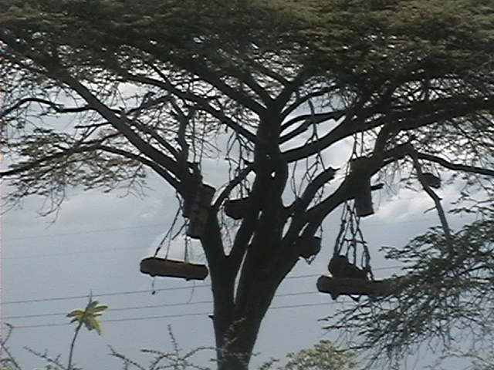
Production of honey and wax is another sector which has not been fully utilised by residents of Mwanza region. Besides having conducive environment for modern bee keeping the region had only 3,648 cumulative traditional beehives in the last five years period, 2011/12 to 2014/15 (Table 3.29). Table 3.29 also shows that Misungwi district had the highest (76.3 percent) number of traditional beehives followed by Ukerewe (9.5 percent) and Sengerema (4.1 percent). Buchosa district council which has largest forest reserve in the region had less than a percent of total beehives in the region for the specified period of time (Table 3.29). There is a need for the council management to raise awareness of this opportunity for Buchosa residents in order to eliviate porvety levels for those living along these forests.

Table 3.29: Number of Traditional Beehives by Council, MwanzaRegion; 2011 -2015
Council | 2010/11 | 2011/12 | 2012/13 | 2013/14 | 2014/15 | Total | Percent of the Total
Ukerewe | 89 | 82 | 61 | 70 | 45 | 347 | 9.5
Magu | 0 | 24 | 22 | 22 | 7 | 75 | 2.1
Mwanza City | 0 | 0 | 0 | 0 | 12 | 12 | 0.3
Kwimba | 70 | 0 | 0 | 0 | 0 | 70 | 1.9
Sengerema | 0 | 0 | 0 | 0 | 149 | 149 | 4.1
Ilemela | 0 | 0 | 0 | 0 | 0 | 0 | 0.0
Misungwi | 450 | 600 | 562 | 574 | 597 | 2783 | 76.3
Buchosa | 25 | 33 | 38 | 46 | 70 | 212 | 0.1
Sub-Total | 634 | 739 | 683 | 712 | 880 | 3,648 | 94.3
Source: Compiled Data from the District Executive Directors’ Offices, Mwanza Region, 2016

Implementation of modern bee keeping is yet to be achieved in Mwanza region due to the shortages of using modern beehives. This is evidenced by the number of modern beehives found in the last five years. Table 3.30 shows that Mwanza reion had cumulative total of 14,588 beehivesfor the specified years. In 2011, the region had only 374 modern beehives, it was increased to 3,042 in 2013 and reached 5,618 in 2015. Misungwi had the largest percentage (27.2 percent) of beehives in the region followed by Ukerewe (19.3 percent) and Kwimba (11.1 percent). Again, Buchosa district council though has good environment for bee keeping was the least with only 3.7 percent of modern beehives in the region (Table 3.30). One general observation from these data is that there is a high expectation on the improvement of bee keeping in future due to a significant increase on the use of modern beehives in recent years.

Table 3.30: Number of Modern Beehives by Council, MwanzaRegion; 2011 -2015
Council | 2010/11 | 2011/12 | 2012/13 | 2013/14 | 2014/15 | Total | Percent of the Total
Ukerewe | 108 | 351 | 362 | 513 | 1484 | 2,818 | 19.3
Magu | 0 | 748 | 743 | 738 | 730 | 2,959 | 20.3
Mwanza City | 6 | 107 | 149 | 291 | 328 | 881 | 6.0
Kwimba | 92 | 695 | 752 | 78 | 0 | 1,617 | 11.1
Sengerema | 0 | 0 | 0 | 0 | 765 | 765 | 5.2
Ilemela | 0 | 0 | 282 | 362 | 404 | 1,048 | 7.2
Misungwi | 164 | 367 | 575 | 1125 | 1732 | 3,963 | 27.2
Buchosa | 4 | 4 | 179 | 175 | 175 | 537 | 3.7
Sub-Total | 374 | 2,272 | 3,042 | 3,282 | 5,618 | 14,588 | 100.0
Source: Compiled Data from the District Executive Directors’ Offices, Mwanza Region, 2016

3.4.4 Fishery
Tanzania is one of the largest fishing country in Africa. According to FAO; it is ranked in the top ten countries in terms of total capture fisheries production. Inland production is from water bodies which Lake Victoria is the largest in Africa and the major source for fishing in Mwanza region. The main location of fishing activities in the region is Ukerewe, Magu, Mwanza city, Sengerema, Ilemela, Misungwi and Buchosa council. Table 3.32 shows fishery resource facilities and production in 2015. Mwanza region has large share of lake Victoria water body but has not yet utilised due to absence of official fish market centres which resulted to the improvement of well being of fishermen and population of Mwanza region as a whole.

Table 3.31 shows that the region had 32,706 fishing licences, 26,586 fishermen and 6,737 registered fishing vessels. Table 3.31 also shows that a total of 38,165.6 milion tons of fishs were catched in 2015 and total of TZS 1.7 trilion were earned by Mwanza region residents. Ilemela MC, Sengerema DC and Ukerewe were the three giant councils which performance of the sector was significantly observed. While Kwimba district council had no fishing activity due to absence of water body.

Table 3.31: Fishery Resources and Production by Council, Mwanza Region; 2015
Council | No. of Fishing licenses | No. of Fishermen | No. of Registered Fishing Vessels | No. of Unregistered Fishing Vessels | Fish Production
 |  |  |  |  | Weight (Tons) | Value (TSHS "000")
Ukerewe | 3,569 | 14,348 | 3,587 | - | 4,774,800 | 8,718,200.0
Magu | 1,665 | 1,665 | 446 | - | 404,972 | 2,632,318.7
Mwanza City | 359 | 1,077 | 359 | - | 105,470 | 3,323,500.0
Kwimba | - | - | - | - | - | -
Sengerema | 678 | 2,058 | 623 | 55 | 2,157,480 | 9,469,386.0
Ilemela | 2,296 | 5,004 | 574 | 230 | 28,558,305 | 157,070,677.5
Misungwi | 1,131 | 840 | 279 | 13 | 884,084 | 3,658.0
Buchosa | 23,008 | 1,594 | 869 | 228 | 1,280,503 | 4,788,917.0
Total | 32,706 | 26,586 | 6,737 | 526 | 38,165,614 | 186,006,657.2
Source: Compiled Data from the District Executive Directors’ Offices, Mwanza Region, 2016

From Table 3.32 shows the stimated eamount of revenues collected from selling fish products in Mwanza region for 2011, 2013 and 2015. There is improvement of revenue earned by fishermen in the region when comparing 2011 and 2015 seasons. The revenue earned by fishermen increased by 36.1 percent between 2011 and 2015, though there were some variations among councils. Misungwi district council had the highest revenue change (828.0 percent) between 2011 and 2015 followed by Misungwi (170.2 percent) and Sengerema (39.2 percent). Table 3.32 also shows that Mwanza city did not have data for revenue collection from fishermen and Kwimba council observed not practising fishing activities due to absence of water body.

Table 3.33: Revenue Collection from Fishermen (Tshs “000”) by Council, Mwanza Region; 2011, 2013 and 2015
Council | 2010/2011 | 2012/13 | 2014/15 | Revenue Change between 2011 and2015
 |  |  |  | Number | Percent
Ukerewe | 692,002 | 646,642 | 646,974 | -45,028 | -6.5
Magu | 33,588 | 28,484 | 43,391 | 9,803 | 29.2
Mwanza City | - | - | - | -
Kwimba | - | - | - | -
Sengerema | 42,000 | 46,822 | 58,455 | 16,455 | 39.2
Ilemela | 25,200 | 31,200 | 32,400 | 7,200 | 28.6
Misungwi | 6,463 | 9,697 | 17,465 | 11,002 | 170.2
Buchosa | 36,537 | 302,933 | 339,072 | 302,535 | 828.0
Total | 835,789 | 1,065,777 | 1,137,756 | 301,967 | 36.1
Source: Compiled Data from the District Executive Directors’ Offices, Mwanza Region, 2016

3.4.5 Historical Site Viewing Tourism
According to the national industry’s mission statement that forms the basis of the tourism policy is develop sustainable quality tourism that is ecologically friendly to the conservation and restoration of the environment and its people’s culture. Mwanza is one of the unique destination in the Tanzania that has yet been discovered by many. It is a land of much wonder holding an unparalleled diversity of fauna, flora and many natural features. The wonders of rocks, the scenery, topography and very friendly people, harbour, the growth of excellent cultural tourism beach holidays, game hunting, infrastructure ventures, historical and archaeological ventures and certainly the best wildlife photographic safaris on the continent. Table 3.33 shows the historical sites potential for tourism in Mwanza region

Table 3.33: Historical sites potential/attractive for Tourism, Mwanza Region; 2015
Council | Type of historical site available | Village/Mitaa | Ward | District
Ukerewe | - | - | - | -
Magu | Sukuma Museums | Bujora | Bujora | Magu
Magu | Slave Trade | Kageye | Lutale | Magu
Mwanza City | Gunzet House |  | Nyamagana | Nyamagana
Mwanza City | Bismark Rock | Capripoint | Nyamagana | Nyamagana
Mwanza City | Rock Beach Garden | Capripoint | Nyamagana | Nyamagana
Mwanza City | Ghandi Hall | Nyamagana Mashariki | Nyamagana | Nyamagana
Mwanza City | Mwawasa/Old Prison | Nyamagana Mashariki | Nyamagana | Nyamagana
Mwanza City | Grave Yard/Makaburi Capripoint | Idara Ya Maji | Nyamagana | Nyamagana
Mwanza City | MV Bukoba Grave Yard |  |  | Nyamagana
Mwanza City | Central Market | Pamba A | Pamba | Nyamagana
Mwanza City | Igogo Caves | Jiwe | Igogo | Nyamagana
Mwanza City |  | Malulu
Mwanza City | Saanane Island | Capripoint | Nyamagana | Nyamagana
Mwanza City | HinduTemples Swamirayan,Sikh,Ariyan Temle | Nyamagana Magharibi | Nyamagana | Nyamagana
Mwanza City | Fish Monument | Nyamagana Magharibi | Nyamagana | Nyamagana
Mwanza City | Uhuru Monument |  | Nyamagana | Nyamagana
Mwanza City | Kemondo Garden | Nyamagana Mashariki | Nyamagana | Nyamagana
Mwanza City | European Cemetery | Nyamaghana Magharibi | Nyamagana | Nyamagana
Mwanza City | Nyerere Monument | Pamba B | Pamba | Nyamagana
Mwanza City | Nyamagana Stadium | Nyamagana Magharibi | Nyamagana | Nyamagana
Kwimba | Mwanamalundi Footsteps Left On Rock. He Was The Most Famous People In Sukuma Land. | Mwakubilinga | Mwakilyambiti | Kwimba
Kwimba | Caves Where Chief’s Beds And Chairs That Are In Forms Of Rocks Are Found. | Mhande Hill | Mhande | Kwimba
Kwimba | Place Where The Famous People- Mwanamalundi Nailed The Rock With His Hands. | Nyambiti Njia Panda | Nyambiti | Kwimba
Kwimba | Sukuma’s Chief House Of Assembly. | Malya | Malya | Kwimba
Kwimba | Place Where Kwimba Chiefs Are Buried. This Area Is Reserved As Natural Forest (Ngitiri). | Jojolo | Ng’hundi | Kwimba
Kwimba | Place Where Tradition Hillers Are Trained For 5 Years. | Ilamba | Ngudu | Kwimba
Kwimba | Place where miracle wells are found. | Ngudulugulu | Ngudu | Kwimba
Kwimba | Mwanamalundi Footsteps left on rock. He was the most famous people in Sukuma land. | Mwakubilinga | Mwakilyambiti | Kwimba
Sengerema | - | - | - | -
Ilemela | Great stone (Jiwe Kuu) |  | Kitangiri | Ilemela
Misungwi | Ntulya sliding stone | Ntulya | Mondo | Misungwi
Misungwi | Bujingwa carve | Bujingwa | Fella | Misungwi
Misungwi | Mwamagoke Crocodile breeding site | Mwajombo | Igokelo | Misungwi
Misungwi | Barabara ya Mjerumani | Nange | Igokelo | Misungwi
Misungwi | Ihelele water intake/treatment | Nyang`omango | Ilujamate | Misungwi
Misungwi | Fish breeding sites | Chole,Nyahiti | Igokelo | Misungwi
Misungwi | Njimu spring | Nyang`omango | Ilujamate | Misungwi
Buchosa | - | - | - | -
Source: Compiled Data from the District Executive Directors’ Offices, Mwanza Region, 2016

3.4.6: Eco Tourism
Availability of good infrastructure such as accommodation facilities, telecommunication services, roads, banking/bureau de change services and tour operators are essential tools in the development of competitive tourism industry. Dar es Saalam to Mwanza road plays a key role in the eco-tourism development of the region. The road provides easy communication between the region and other big commercial cities in Tanzania like Dar es Salaam and Mwanza which encourage more people to come in search of business opportunities, mining activities as well as those who come for tourism purposes.

The available accommodation facilities which range from hotels to guest houses are to a large extent located at the centre of the region (Mwanza city council). In this regards, construction of new accommodation facilities become a pressing issue. There is also a need of increasing the number of financial services such as banks, bureu de change etc so as to meet the higher demand of these services in the near future. Table 3.35 show accommodation facilities by council in Mwanza region for the year 2015. According to Table 3.34, the region had 986 guest houses and 56 hotels by the end of 2015. Most of the guest houses (24.6 percent) and hotels (76.8 percent) were concentrated in Mwanza city which is the headquarters of the region. Ilemela municipal council was second council in number of guest houses (262) and there was no hotel while Madu had the few number guest houses (98, equivalent to 9.9 percent) and number of hotels 10 (17.9 percent) and Ukerewe had 79 number of guest houses (8 percent).

Table 3.34: Accommodation facilities by Council, Mwanza Region; 2015
Council | No. of Guest houses | Percent | Number of Hotels | Percent
Ukerewe | 79 | 8 | 3 | 5.4
Magu | 98 | 9.9 | 10 | 17.9
Mwanza City | 243 | 24.6 | 43 | 76.8
Kwimba | 69 | 7 | - | -
Sengerema | 149 | 15.1 | - | -
Ilemela | 262 | 26.6 | - | -
Misungwi | 15 | 1.5 | - | -
Buchosa | 71 | 7.2 | - | -
Total | 986 | 100 | 56 | 100
Source: Compiled Data from the District Executive Directors’ Offices, Mwanza Region, 2016

3.5. Mining Sector
Mining though is an economic activity, so far is not well implemented in the region. Currently, there are lot of surveys and researches going on in search of existence of mineral deposits in terms of quantity and quality. These surveys and researches are done heavily by foreign companies while local companies are invested in small scales. However, there are small scale extractions of mineral at Misungwi, Ilemela and Mwanza city council, mostly extracted mineral includes gold, quarying and sand minerals. There was no data on distribution of existing mineral deposits in Misungwi and Ilemela. These minerals are mostly purchased by brokers and dealers in Mwanza City.

3.5.1 Industrial Production
Industries all over Tanzania are known to play a major role in socio-economic development. This is also the case in Mwanza region, where industries, mostly small scale contribute significantly to jobs creation, inc’;io821 zome generation and stimulation of growth in both urban and rural areas of the region.

3.5.2 Commerce and Manufacturing Industries
Mwanza region is well endowed with small and medium scale industries ranging from agro-processing industries, fishing and manufacturing of different products. Table 3.35 gives a number of small industries which where available in the region in 2015. The distribution of industries by council were as follows: Ukerewe district council (31.5 percent), Magu (6.7 percent), Mwanza city (17.8 percent), Kwimba (8.8 percent), Sengerema (4.5 percent), Ilemela (23.9 percent), Misungwi (6.8 percent) and Buchosa did not have small scale industries data due to new council.

Table 3.35 further shows that among the total of 2,420 i
nd ustries which were available in the region in 2015, 708 industries (29.3 percent of the total industries) were maize milling, 374 industries (1 cx5.5 percent) were carpentry, 328 industries (13.6 percent) were service industries, 239 industries (9.9 percent) were welding, 165 industries (6.8 percent) were timber processing, 24 industries (1.0 percent) were food processing and the remaining 5 industries (0.2 percent) were sunflower oil processing industries.

Table 3.35: Type of Small Scale Industries by Council, Mwanza Region; 2015
Council | Type of Industries |  |  |  |  |  |  | Total | Total percent of regional total
Council | Sunflower Oil processing | Service industry | Carpentry | Food processing | Welding | Maize milling | Timber processing | Total | Total percent of regional total
Ukerewe | - | 148 | 155 | 0 | 149 | 157 | 154 | 763 | 31.5
Magu | - | 11 | 45 | 6 | 31 | 64 | 6 | 163 | 6.7
Mwanza City | 1 | 101 | 124 | 15 | 29 | 157 | 4 | 431 | 17.8
Kwimba | 2 | 56 | 10 | 0 | 5 | 139 | - | 212 | 8.8
Sengerema | 2 | 4 | 11 | 1 | 8 | 82 | - | 108 | 4.5
Ilemela | - | 64 | 131 | 4 | 64 | 165 | 150 | 578 | 23.9
Misungwi | - | 8 | 29 | 2 | 17 | 109 | - | 165 | 6.8
Buchosa | - | - | - | - | - | - | - | - | -
Total | 5 | 328 | 374 | 24 | 239 | 708 | 165 | 2420 | 100
Percent | 0.2 | 13.6 | 15.5 | 1 | 9.9 | 29.3 | 6.8 | 100
Source: Compiled Data from the District Executive Directors’ Offices, Mwanza Region, 2016

Table 3.36 gives a number of medium scale industries which were available in the region in 2015. The distribution of medium scale industries by council were as follows: Mwanza city (60.2 percent), Ilemela (18.2), Magu (13.6 percent) and Misungwi (8.0 percent) of the total of 88 industries which were available in the region in 2015.

Table 3.36: Type of Medium Scale Industries by Council, Mwanza Region; 2015
Council | Type of Industry | Number of industries
Ukerewe | - | -
Magu | Manufacturing | 4
Magu | Processing/Manufacturing | 5
Magu | Processing/Manufacturing | 1
Magu | Meat processing | 1
Magu | Cotton Sorting | 1
Mwanza City | Pharmaceutical | 1
Mwanza City | Bricks | 1
Mwanza City | Local soap | 1
Mwanza City | SGS Mining | 1
Mwanza City | Publisher | 1
Mwanza City | Maize Milling | 2
Mwanza City | Timber processing | 2
Mwanza City | Service industry- garage | 30
Mwanza City | Carpentry | 7
Mwanza City | Mwanza Fishing | 1
Mwanza City | Eincher Mwanza Branch | 3
Mwanza City | Mabati chapa Kiboko | 3
Kwimba | - | -
Sengerema | - | -
Ilemela | Fish Processing Industy | 5
Ilemela | Marine vessel Manufacturing Industry | 1
Ilemela | Steel Industry | 1
Ilemela | Textile Industry | 1
Ilemela | Soft Drink Industry | 2
Ilemela | Mineral Processing | 3
Ilemela | Plastic Industry | 2
Ilemela | Breweries | 1
Misungwi | KASCO - Crushing | 1
Misungwi | Nyanza Road – Crushing | 1
Misungwi | Chobo Investment – Meat | 1
Misungwi | Production | 1
Misungwi | Mwanza Gas – Gas | 1
Misungwi | JASCO – Crushing | 1
Misungwi | Manawa – Cotton ginning | 1
Buchosa | - | -
Total |  | 88
Source: Compiled Data from the District Executive Directors’ Offices, Mwanza Region, 2016

Table 3.37 gives a number of large scale industries which were available in the region in 2015. The distribution of large scale industries by council were as follows: Mwanza city (12 ndustries), Ilemela (7industries) and Misungwi (1 industry) which were available in the region in 2015.

Table3.40: Number of Large Scale Industries by Council, Mwanza Region; 2015
Council | Type of Industry | Number of industries
Magu | Manufacturing | 1
Magu | Manufacturing/Sampling | 3
Magu | Plywood/Steel processing | 2
Magu | Meat processing | 1
Mwanza City | Fishing prod | 1
Mwanza City | Poly bags | 1
Mwanza City | Vegetable oil industry | 1
Mwanza City | Gas plant | 1
Mwanza City | Marine service | 1
Mwanza City | Mattress | 1
Mwanza City | Fishing Processing | 2
Mwanza City | TANESCO Plant | 1
Mwanza City | Serengeti Breweries Ltd | 1
Mwanza City | Nyanza Bottling Ltd | 1
Mwanza City | Food processing Biscut | 1
Misungwi | Sayona Steel | 1
Total |  | 20
Source: Compiled Data from the District Executive Directors’ Offices, Mwanza Region, 2016

CHAPTER FOUR
Economic Infrastructure
4.0 Introduction
Chapter four explains the existing economic infrastructure in Mwanza Region. It covers the road network development in terms of road classification, type of road surface and pass-ability. It also covers railways, air, marine and postal services including radio and television facilities. In the energy sector developments in regards to hydro-electricity, biogas, solar energy, fuel wood and fossil fuels are discussed.

However, the region is only integrated into the national road network. The major problem area is the absence of a national link to the north-eastern area of Arusha, Moshi and Tanga and the extremely bad conditions of the present gravel roads. The above situation has fraught the development of the region. The remote location of the region compared to the country's market centres of gravity means long and costly transport. This fact, in one way or another, has negatively influenced the growth rate of industrial expansion compared to regions like Arusha, Morogoro and Mbeya which are well connected.

Table 4.1 shows that the trunk roads account for 3.3 percent of the road network of Mwanzaregion, about 21.1 percent road network are regional roads while district roads and the feeder roads covers 36.4 percent and 39.8 percent of the network. Out of 6,354.5 kilometers road network found in the region, Sengerema district council had the longest network (1724.4 kilometers) followed by Misungwi (924 kms), Kwimba (861.4 kms) and Buchosa (728.9 kms). Ukerewe since is an island in Lake Victoria had the shortest road network (484.2 kms) in the region.

Table 4.1: Length of Road Network by Council (in km), Mwanza Region, 2015
Council | Type of Road (in km) |  |  |  | Total
Council | Trunk | Regional | District/Urban | Feeder | Total
Ukerewe | 0 | 92.0 | 147.5 | 244.7 | 484.2
Magu | 56.0 | 77.3 | 175.7 | 204.4 | 513.4
Mwanza City | 30.0 | 0 | 547.0 | 0 | 577.0
Kwimba | 40.3 | 234.1 | 197.1 | 389.9 | 861.4
Sengerema | 47.0 | 1050.3 | 344.41 | 282.5 | 1,724.2
Ilemela | - | - | 398.4 | 143.0 | 541.4
Misungwi | 53.0 | 167.0 | 287.1 | 416.9 | 924.0
Buchosha | 0 | 22.3 | 79.4 | 627.2 | 728.9
Total | 226.3 | 1643.0 | 2176.6 | 2308.6 | 6354.5
Percent | 3.6 | 25.9 | 34.3 | 36.3 | 100
Source: Compiled data from Districts Directors Offices, Mwanza Region, 2016.

4.1 Road Passability
Out of 6,354.5 kilometers road network of Mwanza Region, 227.6 kilometers (4.4 percent of the road network) is tarmac. The 2,472 km (40.2 percent) are gravel road and the remaining 3,604.2 kms, equivalent to 56.9 percent of the road network are earth roads. Tarmac and gravel roads make up 44.6 percent of the network and since there is a close affinity between road worthiness and tarmac/gravel surfaces, it can generally be said that 44.6 percent of the region’s road network is passable throughout the year (Table 4.2).

At council level, Magu DC has the longest kilometers of tarmac (67.7 kilometers) in Mwanza region. It was followed by Misungwi DC (53 kilometers) while Sengerema DC has the longest gravel roads at 1,092.7 kms (Table 4.2). Buchosa DC has the largest earth roads (728.9 kms) which are impassable during the rainy season. One general observation from these data is that rural part of the region has a problem of communication due to poor condition of road surface as 569 percent are earth road classification.

Table 4.2: Length of Road Network by Type of Road Surface by Council, Mwanza Region; 2015
Council | Type of Surface (in Km) |  |  | Total
Council | Tarmac | Gravel | Earth | Total
Ukerewe | 4.2 | 185.7 | 294.3 | 484.2
Magu | 67.7 | 183.4 | 262.3 | 513.4
Mwanza City | 36.9 | 98.3 | 441.8 | 577.0
Kwimba | 42.3 | 512.1 | 307.0 | 861.4
Sengerema | 49.0 | 1,092.7 | 582.5 | 1,724.4
Ilemela | 24.5 | 64.9 | 452 | 541.4
Misungwi | 53.0 | 335.6 | 535.4 | 924.0
Buchosha | 0 | 0 | 728.9 | 728.9
Total | 277.6 | 2,472.7 | 3,604.2 | 6,354.5
Percent | 4.4 | 40.2 | 56.9 | 100
Source: Compiled data from Districts Directors Offices, Mwanza Region, 2016

  - Railway Transport
Mwanza region is served by the central line railway system that connects Mwanza with Tabora, Kigoma and Dar es Salaam. The importance of the Central Railway system to the region is felt in hauling agricultural and industrial goods to and from the region. Goods transport from the region is to a great magnitude dominated by cotton. This smears for all the railway stations within the region. Railway stations within the region which serves embarking and disembarking stations are: Mwanza Town Station, Bukwimba, Mantale, Fela and Malya. However, only three of these were active in 2015 which are Mwanza Town, Bukwimba and Malya where passengers are also ferried by this Central Railway System. The information provided by Tanzania Railway Limited shows that a total of 12,169 passengers used the line while as much as 21,767 tons of cargo was ferried. Mwanza Town station had many passengers while Malya and Bukwimba stations carried more cargo than passengers.

4.3 Marine Transport
Mwanza region is well served with marine transport. Public marine vessels are the major carriers of both passengers and cargoes destined for the neighboring lake zone regions - Kagera and Mara. There are also marine transport facilities connecting Mwanza lake port with other lake ports of Kenya and Uganda. The significance of this mode of transport on Lake Victoria is well highlighted by Table 4.3.There are private marine vessels also mainly ferries which move passengers to and from Sengerema landing ports to Mwanza city and Misungwi DC(Busisi port) landing areas, Ukerewe landing port and Mwanza City. Kome and Kahunda stations which are located at Buchosa DC lead to carry big number of passengers about 88.2 percent of the total passengers ferried in the region in 2015. Also Busisi station from Sengerma landing area to Misungwi landing area with 9.6 pecent of passengers, Bulogora Ukara/Kisorya station in Ukerewe DC with 1.9 percent of passengers and Shinembo/Ijinga stations in Magu DC with 0.3 percent.

Moreover Kome and Kahunda stations also lead to ferry big quantity of cargo paralleling to other stations, where by 91.9 percent of cargo were ferried through these stations. Shinembo/Ijinga 5.6 percent, Bugolora Ukara and Kisorya stations 2.3 percent of the cargo and 0.2 percent by Busisi station (Table 4.3).

Table 4.4: Marine Services by Council, Mwanza Region; 2015
 | Name of station | Number of Passengers | Quantity of cargo | Percent of passengers | Percent of cargo
Council | Name of station | Number of Passengers | (Tones)
Ukerewe | Bugolora Ukara /Kisorya | 489,062 | 75.4 | 1.9 | 2.3
Magu | Shinembo/Ijinga | 73,000 | 182.5 | 0.3 | 5.6
Mwanza City | - | - | - | - | -
Kwimba | - | - | - | - | -
Sengerema/Misungwi | Busisi | 2,448,894 | 6.9 | 9.6 | 0.2
ilemela
Buchosa | Kome/Kahunda | 22,494,105 | 3014 | 88.2 | 91.9
Total |  | 25,505,061 | 3,278.8
Source: Compiled data from District Directors Offices, Mwanza Region, 2016

4.4 Air Transport
Mwanza region is served by one major airport which is on the outskirt of the town.It is located in Ilemela district about 10 kilometres (6.2 mi) from the city.The capacity of Mwanza Airport is at present well utilized and there is a high demand for air transport particularly among businessmen. The demand sometimes exceeds the supply. Though the number of flights has been increased total demand is still unmet. Air Tanzania a Public airline has currently started its routes again to meet the demand of the customers at an affordable price.

The main scheduled airline operating daily between Mwanza and Dar es Salaam, Mwanza and Kilimanjaro Airport, Mwanza to Kigali Rwanda and Mwanza to Nairobi. In addition to Air Tanzania domestic flights, private sector companies also operate regularly from Mwanza to places like Dodoma, Bukoba and Seronera. Information received from Airport Authority declared that a total of 444,215 passengers and 1,961 tons of cargo were handled by the Mwanza airport in 2015.

  - Telecommunication Services
Mwanza region enjoys internet and telephone services (both cellular phone and land line based telephone services) and postal services. All councils are well accessed to the above mentioned telecommunications services. The region is very fortunate as it has enough number of radios and television stations transmitting from Jembe FM, Radio Free Africa, Metro Fm, HHC Alive Fm, Passion Fm. Famous Tanzania local television channels are Star Tv, Independent Television(ITV),Channel Ten, Clouds TV, Tanzania Broadcasting Corporation(TBC) all these can be accessed (Table 4.5). There are also several internet cafes in the region Sengerema DC and Mwanza City leads with 4 internet centres, Ukerewe DC 2 cafes, Magu and Kwimba DC with one internet café each while other councils had no internet centres but number of these internet centres decreases as time goes due to improvement of technology (Table 4.5). Postal services were found in only five councils which are Ukerewe DC, Magu DC, Mwanza City DC, Kwimba DC and Sengerema DC.

Table 4.5: Communications Facilities and Services by Council, Mwanza Region; 2015
Council | No. of Tel. Lines (land Lines) | No. of Television Stations | No. of Radio Stations | No. of Internet Centres | No. of Post Offices | No. of Sub-Post Offices
Ukerewe | 80 | 0 | 0 | 2 | 1 | 0
Magu | 290 | 0 | 0 | 1 | 1 | 0
Mwanza City | 4,249 | 0 | 6 | 4 | 1 | 4
Kwimba | 0 | 0 | 0 | 1 | 3 | 1
Sengerema | 130 | 0 | 1 | 4 | 1 | 0
Ilemela | 1,480 | 1 | 6 | 0 | 0 | 0
Misungwi | 4 | 0 | 0 | 0 | 0 | 0
Buchosa | 0 | 0 | 0 | 0 | 0 | 0
Total | 6,233 | 1 | 13 | 12 | 7 | 5
Source: Compiled data from Telecommunication Offices, Mwanza Region, 2016.

Besides land lines provided by TTCL, The region has a very good network for private mobile phones, including Tigo, Vodacom, Airtel, Zantel, Halotel and TTCL Mobile. Table 4.6 shows that Halotel has the highest average coverage in the region (71 percent) followed by Tigo (55 percent) and Airtel (35 percent). Other mobile companies including TTCL mobile, Vodacom and zantel were not able to specify their coverate rates.

Table 4.6: Telecommunications (Mobile) Services by Council, Mwanza Region; 2015
Council | Tigo | Vodacom | Airtel | Zantel | Halotel | TTCL (Mobile)
Ukerewe | 85 | n.a | 41.7 | n.a | 0 | n.a
Magu | 45 | n.a | 33.6 | n.a | 95 | n.a
Mwanza City | 84 | n.a | 68.5 | n.a | 100 | n.a
Kwimba | 46 | n.a |  | n.a | 90 | n.a
Sengerema | 63 | n.a | 44.3 | n.a | 90 | n.a
Ilemela | 68 | n.a | 47.6 | n.a | 100 | n.a
Misungwi | 50 | n.a | 41.2 | n.a | 90 | n.a
Buchosa | 0 | n.a | 0 | n.a | 0 | n.a
Average Coverage | 55 | n.a | 35 | n.a | 71 | n.a
Source: Compiled data from Telecommunication Offices, Mwanza Region, 2016.

  - Energy Sector Development
Energy is a prerequisite for proper functioning of nearly all sectors in the economy. It is an essential service whose availability and quality determines success or failure of development endeavours. As such, the importance of energy as a sector in the regional economy cannot be over-emphasized. The main sources of energy in Mwanza region are electricity, gas, paraffin, solar, firewood and charcoal. Electricity is commonly used in urban and rural areas.

4.6.1 Electricity
Electricity supply stimulates development, both social and economic. It improves ease and generally improves the quality of life. Like other parts of the country, TANESCO is the sole supplier of electricity in the region. Electricity supply in the region is not yet stable and faces a number of problems such as intermittent power supply, low voltage, rationing, and outages. In one way or another, these problems affect production of goods and services in the region. Table 4.7 shows different type of customers supplied electricity by TANESCO in 2011, 2013 and 2015. Number of institutions connected with electricity in the region increased from 114 in 2011 to 166 in 2013 and reached 292 in 2015. Number of domestic installation increased from 6,012 customers in 2011 to 8,007 in 2013 and reached 12,281 customers in 2015 while commercial segment of customers increased from 305 in 2011 to 509 in 2013 and reached 954 in 2015. One general observation from these data is that no data were provided by twin urban councils where most of all type customers are found.

Table 4.8: Number of Customers using/connected to Electricity, Mwanza Region; 2011, 2013 and 2015
Council | Institution |  |  | Domestic |  |  | Commecial
Council | 2011 | 2013 | 2015 | 2011 | 2013 | 2015 | 2011 | 2013 | 2015
Ukerewe | 65 | 72 | 110 | 1,987 | 2,210 | 3,361 | 108 | 120 | 183
Magu | 46 | 82 | 123 | 3,966 | 4,880 | 6,990 | 167 | 346 | 586
Mwanza City | n.a | n.a | n.a | n.a | n.a | n.a | n.a | n.a | n.a
Kwimba | 1 | 3 | 42 | 42 | 292 | 804 | 20 | 20 | 102
Sengerema | n.a | n.a | n.a | n.a | 590 | 340 | 10 | 10 | 10
Ilemela | n.a | n.a | n.a | n.a | n.a | n.a | n.a | n.a | n.a
Misungwi | n.a | n.a | n.a | n.a | n.a | n.a | n.a | n.a | n.a
Buchosa | 2 | 9 | 17 | 17 | 35 | 786 | 0 | 13 | 73
Total | 114 | 166 | 292 | 6,012 | 8,007 | 12,281 | 305 | 509 | 954
Source: TANESCO, Mwanza Region, 2016

4.6.2 Source of Energy for Cooking
The 2012 population and housing census collected information on households’ main source of energy for cooking. Results show that most of the private households used firewood as source of energy for cooking (62 percent), followed by charcoal (34.9 percent). Paraffin accounted for about 1.1 percent while other sources like electricity, solar, gas and other sources accounted for less than one percent each. (Table 4.9)

Table 4.9: Number of Private Households by Main Sources of Energy for cooking, Mwanza Region 2012 Census
Council | Electricity | Paraffin | Gas | Firewood | Charcoal | Solar | Others | Total
Ukerewe | 118 | 354 | 59 | 48,911 | 9,322 | 0 | 413 | 59,177
Magu | 308 | 462 | 103 | 39,990 | 10,062 | 51 | 411 | 51,386
Mwanza City | 1,287 | 1,590 | 1,287 | 8,937 | 61,800 | 76 | 682 | 75,659
Kwimba | 62 | 187 | 62 | 56,718 | 4,986 | 0 | 249 | 62,266
Sengerema | 109 | 875 | 109 | 84,953 | 22,741 | 109 | 328 | 109,225
Ilemela | 1,815 | 1,536 | 1,257 | 11,799 | 5,2850 | 70 | 628 | 69,955
Misungwi | 107 | 321 | 107 | 46,383 | 6320 | 0 | 321 | 53,560
Buchosha | - | - | - | - | - | - | - | -
Total | 3,807 | 5,325 | 2,985 | 297,690 | 168,081 | 306 | 3,032 | 481,228
Percent | 0.8 | 1.1 | 0.6 | 61.9 | 34.9 | 0.1 | 0.6 | 100.0
Source: NBS Census Report, 2012

  - Agricultural Productivity Road Network
Agricultural productivity road network give indication of intensity of road network into agriculture development by establishing tonnage of crops per kilometre. Table 4.10 shows that Mwanza Region had agricultural production of total tonnes 452,642.28 in the 2014/15 which covered 664.06 Tonnes/Km for both food and cash crops production. At council level, Sengerema DC had the highest agricultural production with 144,572.43 tonnes and covered 61.4 Tonnes/Km while Ilemela MC had lowest agricultural production of 5,229.35 tonnes which covered 9.66 tonnes/km. However, no data were provided by Mwanza city and Buchosa DC. (Table 4.10)

Table 4.10: Agricultural Productivity of the Road Network, Mwanza Region; 2014/15
Council | Total Road Length (kms) | Agricultural Production (tonnes) |  |  | Tonnes/km
Council | Total Road Length (kms) | Food crops | Cash Crops | Total | Tonnes/km
Ukerewe | 480.2 | 86515.0 | 873.0 | 87,388.0 | 182.0
Magu | 513.4 | 78741.4 | 4948.5 | 83,689.9 | 163.0
Mwanza City | - | - | - | - | -
Kwimba | 861.4 | 55365.8 | 35477.5 | 90,843.3 | 105.5
Sengerema | 2353.0 | 137671.4 | 6901.0 | 144,572.4 | 61.4
Ilemela | 541.3 | 5229.4 | 0.0 | 5,229.4 | 9.7
Misungwi | 287.1 | 32601.7 | 8317.7 | 40,919.3 | 142.5
Buchosa | - | - | - | - | -
Total | 5,036.4 | 396,124.7 | 56,517.7 | 452,642.3 | 664.1
Source: Compiled data from Districts Directors Offices, Mwanza Region, 2016.

CHAPTER FIVE

Social Services

5.0 An Overview
Chapter Five discusses status of social services in Mwanza region and covers the health sector, education sector, water and sanitation. In the health sector, the discussion covers improvement of health facilities and staff, morbidity and mortality status and mother and child health. It also covers the prevalence of HIV/AIDS and related diseases as well as its impact to the community.

Education is the second sector discussed in this chapter. It highlights education performance based on the increase of school facilities; pre-primary, primary, secondary education, colleges/universities and vocational training, enrolment performance, school infrastructure and quality of education are also discussed.

Water supply and sanitation is also discussed in this chapter. Performance of water supply for both rural and urban areas of Mwanza region highlighted in terms of sources, technology and capacity of water supply. However, sanitation level at the Region is also briefly explained.

5.1 Health Sector
The status of public health services can be visualized through the health infrastructure, availability and commitment of health practitioners, implementation of preventive and curative measures and availability of medicine. Among others, the region experiences shortages of health practitioners such as medical specialists, radiographers, doctors, pharmacists, assistant medical officers (AMOs) and nursing officers (NOs); and medicines. This causes unnecessary loss of peoples’ lives due to preventable diseases. The major killer diseases in Mwanza region include: Malaria, Anemia, Pneumonia, Clinical AIDS and other communicable diseases.

5.1.1 Health Facilities
Mwanza region has done great achievements in the health sector by constructing new facilities, from 327 health facilities in 2009 to 353 facilities (14 hospitals, 55 health facilities and 284 dispensaries) in 2012 and reached 369 facilities (17 hospitals, 53 health centres and 299 dispensaries) in 2015. One general observation is that, the Region also managed to have even distribution of health facilities among councils, ranging from 8.1 percent (Buchosa DC) to 17.3 percent in Mwanza city (Table 5.1).

Figure 5.1: Availability of Health Facilities by Type, Mwanza region; 2009, 2012 and 2015
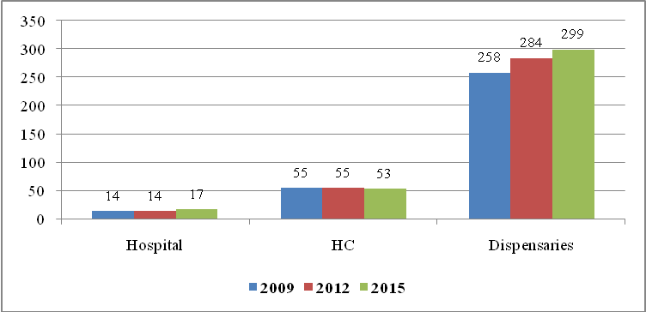
Source: Compiled data from District Executive Directors’ Offices, Mwanza region, 2016

Looking at ownership, private participation in the provision of health services as emerged by the health policy is significant in the region. Figure 5.2 sows that, out of 369 health facilities, 109 facilities, equivalent to 28.7 percent are privately owned; 10 are hospitals, 23 health centers and 73 dispensaries.

Figure 5.2: Availability of Health Facilities by Ownership, Mwanza region; 2015
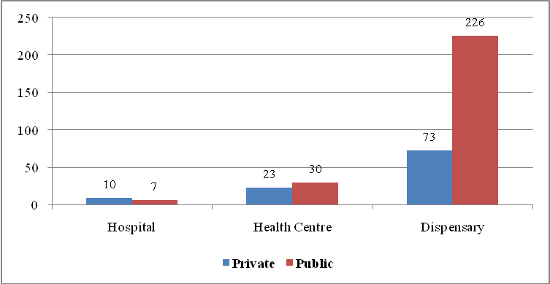
Source: Compiled Data from District Executive Directors’ Offices, Mwanza region, 2016

Besides achievement reached so far in health sector, the region is still lagging behind in the implementation of health policy under which each ward has to have a health center and have a dispensary in each village or mtaa. Table 5.1 shows that among eight councils given in the region, none of the council managed to implement the policy of one health centre per ward and one dispensary for each village/Mtaa. Mwanza city has the biggest shortages of both health centers and dispensaries, as of now one health centre servicing 9 wards and each dispensary facilitating 16 mitaa. While Buchosa has the lowest ratio of 4 wards per health centre and Magu and Sengerema councils have the lowest ratio of dispensary per 2 villages (Table 5.1). One general observation in this sector is that, although they are in shortage, dispensaries were allocated in every ward and participation of private sector in the provision of health services to the great extent has reduced shortages.

Table 5.1: Distribution of Public Health Facilities by Administrative Unit and by Council, Mwanza region; 2015
Council | No. of Wards | No. of Health Centers | Health Centre Wards Ratio | No. of Village/ Mitaa | No of Dispensaries | Dispensary Villages/ Mitaa Ratio
Ukerewe | 25 | 3 | 8 | 76 | 28 | 3
Magu | 25 | 4 | 6 | 82 | 34 | 2
Mwanza City | 18 | 2 | 9 | 175 | 11 | 16
Kwimba | 30 | 5 | 6 | 119 | 44 | 3
Sengerema | 26 | 4 | 7 | 71 | 38 | 2
Ilemela | 19 | 3 | 6 | 172 | 12 | 14
Misungwi | 27 | 4 | 7 | 113 | 37 | 3
Buchosa | 21 | 5 | 4 | 82 | 22 | 4
Total | 191 | 30 | 6 | 890 | 226 | 4
Source: Compiled Data from District Executive Directors’ Offices, Mwanza region, 2016

5.1.1.1 Health Facility Ratios
The availability of health facilities in Mwanza region falls within WHO standards. The average coverage of the population by health facilities in Mwanza region was 1.3 facilities per 10,000 people in both years 2002 and 2015. At council level, Table 5.2 shows that the best population coverage in 2015 was Mwanza city and Magu district council. Looking at health facilities per 10,000 people in 2002, the best average was 2.1 facilities per 10,000 persons recorded at Magu district council followed by Mwanza city (1.9) and Misungwi (1.2). In 2015, Mwanza city and Magu continued to be the best councils with averages of 1.6 and 1.6 facilities per 10,000 persons each. However, Sengerema and Buchosa district councils had the worst coverage with averages of 0.8 and 0.9 facilities per 10,000 persons in 2002 and 2015 respectively (Table 5.2).

Table 5.6: Relating Health Facilities to the Population by Council, Mwanza region; 2002 and 2015
Council | 2002 |  |  |  | 2015
Council | Total Population | Total No. of h.f.s | Mean Average Population Per h.f.s | H.f.s per 10,000 people | Total Population | Total No. of h.f.s | Mean Average Population Per h.f.s | H.f.s per 10,000 people
Ukerewe | 260,831 | 27 | 9,660 | 1.0 | 345,147 | 37 | 9,328 | 1.1
Magu | 244,356 | 51 | 4,791 | 2.1 | 299,759 | 47 | 6,378 | 1.6
Mwanza City | 474,679 | 90 | 5,274 | 1.9 | 411,101 | 64 | 5,679 | 1.6
Kwimba | 314,925 | 35 | 8,998 | 1.1 | 449,098 | 57 | 7,132 | 1.3
Sengerema | 498,993 | 42 | 11,881 | 0.8 | 335,267 | 46 | 7,288 | 1.4
Ilemela* |  |  |  |  | 343,001 | 43 | 7,977 | 1.3
Misungwi | 256,133 | 31 | 8,262 | 1.2 | 351,607 | 45 | 7,813 | 1.3
Buchosa* |  |  |  |  | 327,767 | 30 | 10,926 | 0.9
Total | 2,049,917 | 276 | 7,427 | 1.3 | 2,862,747 | 369 | 7,514 | 1.3

* Ilemela municipal Council was part of Mwanza City and Buchosa was part of Sengerema district council.
H.f.s: means Health facilities
Source: Compiled Data from District Executive Directors’ Offices, Mwanza region, 2016

5.1.1.2 Population per Doctor Ratio
Table 5.3 shows that the distribution of doctors for the 2011 was uneven and in favour of Mwanza city which is the headquarters of the Region. The Regional average population per doctor was 13,225 in 2002 and decreased to 6, in 2015. A similar trend is observed at council level but more so in Mwanza city compared to the rest of council. One general observation is that, Mwanza city be a headquarters of the region has more referral hospitals, of which doctors and specialist doctors are found compared to other health facilities. Table 5.3 also reveals that Magu district council had the highest average population per doctor in 2002, while Buchosa district council was recorded with the highest average population per doctor in 2015.

Table 5. 6: Distribution of Doctors Among Population by Council, Mwanza region; 2002 and 2015
Council | 2002 |  |  | 2015
Council | Total Population | No. of Doctors | Average Population per Doctor | Total Population | No. of Doctors | Average Population per Doctor
Ukerewe | 260,831 | 22 | 11,856 | 345,147 | 48 | 7,191
Magu | 244,356 | 7 | 34,908 | 299,759 | 18 | 16,653
Mwanza City | 474,679 | 57 | 8,328 | 411,101 | 101 | 4,070
Kwimba | 314,925 | 18 | 17,496 | 449,098 | 53 | 8,474
Sengerema | 498,993 | 21 | 23,762 | 335,267 | 47 | 7,133
Ilemela* |  |  |  | 343,001 | 84 | 4,083
Misungwi | 256,133 | 30 | 8,538 | 351,607 | 75 | 4,688
Buchosa* |  |  |  | 327,767 | 10 | 32,777
Total | 2,049,917 | 155 | 13,225 | 2,862,747 | 436 | 6,566
Note:* Ilemela municipal Council was part of Mwanza City and Buchosa was part of Sengerema district council.
Source: Compiled Data from District Executive Directors’ Offices, Mwanza region; 2016

The available official health facilities were not enough to serve the ever growing population of Mwanza region, the local authorities have made significant efforts in the establishment of primary rural health centres to complement the existing facilities in all councils. Table 5.4 shows the efforts made so far by the local authorities in the region. The region has recognised 111 trained traditional birth attendants allocated in Kwimba, Sengerema and Buchosa district councils and establish 102 village health posts in Kwimba and Buchosa councils where significant shortages of health facilities observed.

Table 5.3 Distribution of Rural Health Facilities by Council, Mwanza Region, 2015
Council | No. of TBAs (Trained) | No. of VHWs | No. of VHP | No. of TMP (Registered)
Ukerewe | 0 | 1,078 | 0 | 0
Magu | 0 | 98 | 0 | 0
Mwanza City | 0 | 368 | 0 | 113
Kwimba | 49 | 246 | 67 | 0
Sengerema | 36 | 370 | 0 | 200
Ilemela | 0 | 73 | 4 | 3
Misungwi | 0 | 333 | 0 | 0
Buchosa | 26 | 176 | 31 | 31
Total | 111 | 2,742 | 102 | 347
Source: Compiled data from District Executive Directors’ Offices, Mwanza region; 2016

5.1.1.3 Status of Health Personnel
Table 5.4 shows that in 2015, the region was still experiencing a significant shortage of health personnel in regard to specialised doctors, medical doctors, dental surgeon, radiologists, dental therapists and pharmacists. In 2015, health personnel were dominated by trained nurses - NM/PHN (31.4 percent), medical attendants (26.2 percent) and clinical officers (10.8 percent). Looking at sex difference, Table 5.4 also shows that, out of 2,501 medical personnel, 63.9 percent were female, while only 36.1 percent were male. There is a need for regional authority to ensure good working conditions for specialists and doctors in order to motivate them to work in Mwanza region.

Table 5. 6: Type and Number of Medical Personnel by Council, Mwanza region; 2015
Medical Personnel | Male | Percent | Female | Percent | Total | Percent
Specialist Doctors | 2 | 100.0 | 0 | 0.0 | 2 | 0.1
Medical doctors | 35 | 71.4 | 14 | 28.6 | 49 | 2.0
Ass. Medical Officers | 40 | 81.6 | 9 | 18.4 | 49 | 2.0
Clinical Officers | 184 | 68.1 | 86 | 31.9 | 270 | 10.8
Ass. Clinical Officers | 59 | 80.8 | 14 | 19.2 | 73 | 2.9
Dental Surgeon | 1 | 100.0 | 0 | 0.0 | 1 | 0.0
Ass. Dental Officer | 8 | 100.0 | 0 | 0.0 | 8 | 0.3
Dental Therapist | 6 | 75.0 | 2 | 25.0 | 8 | 0.3
Pharmacists | 13 | 81.3 | 3 | 18.8 | 16 | 0.6
Pharmaceutical Technicians | 15 | 51.7 | 14 | 48.3 | 29 | 1.2
Pharmaceutical Assistant | 3 | 60.0 | 2 | 40.0 | 5 | 0.2
Laboratory Technicians | 20 | 51.3 | 19 | 48.7 | 39 | 1.6
Laboratory Ass. | 41 | 57.7 | 30 | 42.3 | 71 | 2.8
Radiologist | 0 | 0.0 | 0 | 100.0 | 0 | 0.0
Radiographer | 8 | 72.7 | 3 | 27.3 | 11 | 0.4
Radiographic Assistant | 0 | 0.0 | 0 | 100.0 | 0 | 0.0
Nursing Officers | 30 | 34.1 | 58 | 65.9 | 88 | 3.5
Ass. Nursing Officer | 21 | 21.6 | 76 | 78.4 | 97 | 3.9
Trained Nurse/NM/PHN | 200 | 25.5 | 585 | 74.5 | 785 | 31.4
MCHA | 0 | 0.0 | 7 | 100.0 | 7 | 0.3
Medical Attendants | 88 | 13.4 | 567 | 86.6 | 655 | 26.2
Health Officers | 37 | 72.5 | 14 | 27.5 | 51 | 2.0
Health Assistants | 40 | 48.2 | 43 | 51.8 | 83 | 3.3
Health Secretaries | 9 | 56.3 | 7 | 43.8 | 16 | 0.6
Other Medical Carders | 43 | 48.9 | 45 | 51.1 | 88 | 3.5
Total | 903 | 36.1 | 1598 | 63.9 | 2,501 | 100.0
Source: Compiled Data from District Executive Directors’ Offices, Mwanza region, 2016
At council level, health personnel were unevenly distributed, ranging from 6.8 percent (Buchosa DC) to 20.5 percent in Sengerema district council. One general observation in Figure 5.3 is that Mwanza city, which is the regional headquarters, had the second lowest percentage of health personnel after Buchosa followed by Misungwi district council (9.4 percent).

Figure 5.3: Percentage Distribution of Medical Personnel by Council, Mwanza region; 2015
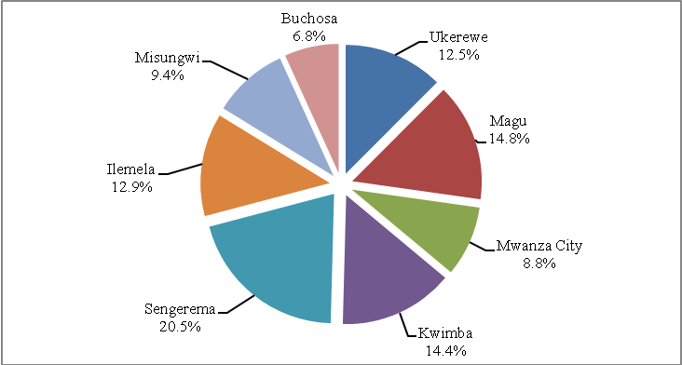
Source: Compiled Data from District Executive Directors’ Offices, Mwanza region, 2016

5.1.2 Morbidity
The health service aims at solving the problems of morbidity or sicknesses as well as mortality. However, in order to take care of morbidity, the government needs an inventory of these health problems. The inventory shows that the ten most common causes of illnesses are as shown in Table 5.5.

Out-patients
Out of 1,767,802 out patients recorded in 2011, 83.6 percent were suffering from one or the other of the first five illnesses. In 2012 the first five causes of morbidity applied to 1,049,714 out-patients. Table 5.5 shows that the first illness of out-patients in 2011 was malaria as a cause of morbidity in Mwanza region. Acute respiratory infections (ARI) ranked second and the third was other diagnosis. The fourth and fifth diseases were pneumonia and skin infection, respectively.
The observations in 2015 were similar to those of 2011 except for the magnitude of cases (Table 5.5). Again malaria ranked first with a total of 461,721 (44 percent of out patients) followed by ARI (14.9 percent) and diarrhea (10.3 percent). The Fourth and fifth diseases were UTI (7.6 percent) and intestine worms (7.2 percent).

Table 5. 6: Ten Most Commonly Reported Causes of Morbidity (Out Patients), Mwanza region; 2011 and 2015
Number | 2011 |  |  | 2015
Number | Disease | No. of Occurrences | Percent | Disease | No. of Occurrences | Percent
1 | Malaria | 719,927 | 40.7 | Malaria | 461,721 | 44.0
2 | ARI | 335,927 | 19.0 | ARI | 156,110 | 14.9
3 | Other Diagnosis | 154,644 | 8.7 | Diarrhoea | 108,516 | 10.3
4 | Pneumonia | 151,337 | 8.6 | UTI | 79,519 | 7.6
5 | Skin infection | 116,460 | 6.6 | Intestinal worms | 75,699 | 7.2
 | Sub total | 1,478,295 | 83.6 | Sub Total | 881,565 | 84.0
6 | Intestinal worms | 112,329 | 6.4 | Pneumonia | 61,970 | 5.9
7 | Diarrhoea | 103,581 | 5.9 | Skin Diseases | 37,847 | 3.6
8 | Eye Infection | 40,874 | 2.3 | Other Diagnosis | 36,677 | 3.5
9 | Ear Conditions | 17,787 | 1.0 | Eye infection | 18,645 | 1.8
10 | UTI | 14,936 | 0.8 | Anemia | 13,010 | 1.2
 | Total | 1,767,802 | 100 |  | 1,049,714 | 100
Source: Complied Data from District Executive Directors’ Offices, Mwanza region, 2016

In-patients
In 2011, malaria was the first cause of illness for inpatients recorded in Mwanza region, followed by diarrhea, pneumonia, Other Cardiovascular Diseases (Table 5.6). Similar observations were also made for in patients in 2012 when malaria, diarrhea and pneumonia were the first, second and third causes of morbidity in Mwanza region. The fourth and fifth causes of illnesses were clinical AIDs and anemia (Table 5.6).

Two general observations have been drawn in this analysis. The first one is that over 96 percent of patients recorded in both years were suffering the first five illnesses described above. The second is that though the data recorded in Table 5.6 ranked illnesses at regional level, variations in magnitude and ranking among illnesses observed among the councils in the regions.

Table 5. 6: Ten Most Commonly Reported Causes of Morbidity (In Patients), Mwanza region; 2011 and 2015
No. | 2011 |  |  | 2015
No. | Disease | No. of Occurrences | Percent | Disease | No. of Occurrences | Percent
1 | Malaria | 157,482 | 59.0 | Malaria | 140,180 | 66.2
2 | Diarrhoea | 39,976 | 15.0 | Diarrhoea | 33,405 | 15.8
3 | Pneumonia | 33,930 | 12.7 | Pneumonia | 23,270 | 11.0
4 | Other Cardiovascular Dis. | 14,753 | 5.5 | Clinical Aids | 5,389 | 2.5
5 | Tuberculosis | 12,059 | 4.5 | Anaemia | 4,667 | 2.2
 | Sub Total | 258,200 | 96.8 | Sub Total | 206,911 | 97.8
6 | Anaemia | 6,169 | 2.3 | UTI | 3,057 | 1.4
7 | UTI | 1,615 | 0.6 | Accident | 725 | 0.3
8 | Clinical Aids | 508 | 0.2 | Hypertension | 434 | 0.2
9 | Hypertension | 223 | 0.1 | PID | 258 | 0.1
10 | Diabetes Mellitus | 126 | 0.05 | Cholera | 263 | 0.12
 | Total | 266,841 | 100 |  | 211,648 | 100
Source: Complied Data from District Executive Directors’ Offices, Mwanza region, 2016

5.1.3 Mortality
The available data does not give the true picture of the mortality level in Mwanza region. However, the medical records indicate that a dominant cause of mortality for inpatients of all ages in 2011 was malaria (Table 5.7). Table 5.7 shows that out of 134,407 reported deaths in 2011, 70,602 (52.5 percent) were caused by malaria, followed by ARI (22.4 percent), diarrhea (10.7 percent), pneumonia (8.1 percent), and anemia (5 percent). Other diseases were UTI, tuberculosis, Clinical AIDs, hypertension and diabetes.

Likewise, among the causes of mortality for inpatients of all ages in 2015 were malaria (44.1 percent) followed by other diagnosis (9.7 percent), diarrhea (13.9 percent), intestine worms (7.5 percent) and pneumonia (6.8 percent). Other diseases were anemia, UTI, hypertension, road accidents and clinical AIDs (Table 5.7). These data portray a new picture of illnesses that rise concerned about the imaging of modern diseases in the region, including hypertension, diabetes and road accidents.

Table 5. 6: Ten Most Commonly Reported Causes of Mortality (In Patients), Mwanza region; 2011 and 2015
Number | 2011 |  |  | 2015
Number | Disease | No. of Occurrences | Percent | Disease | No. of Occurrences | Percent
1 | Malaria | 70,602 | 52.5 | Malaria | 72,216 | 44.1
2 | ARI | 30,149 | 22.4 | Other Diagnosis | 36,605 | 22.4
3 | Diarrhoea | 14,388 | 10.7 | Diarrhoea | 22,692 | 13.9
4 | Pneumonia | 10,890 | 8.1 | Intestine Worms | 12,239 | 7.5
5 | Anaemia | 6,701 | 5.0 | Pneumonia | 11,062 | 6.8
 | Sub Total | 132,730 | 98.8 | Sub Total | 154,814 | 94.6
6 | UTI | 714 | 0.5 | Anaemia | 7,510 | 4.6
7 | Tuberculosis | 398 | 0.3 | UTI | 1,090 | 0.7
8 | Clinical AIDs | 337 | 0.3 | Hypertension | 153 | 0.1
9 | Hypertension | 128 | 0.1 | Road Accidents | 114 | 0.1
10 | Diabetes | 100 | 0.1 | Clinical AIDs | 28 | 0.0
 | Total | 134,407 | 100.0 |  | 163,709 | 100.0
Source: Complied Data from District Executive Directors’ Offices, Mwanza region, 2016

5.1.4 HIV/AIDS Infections
Mwanza region, like other regions in the country, uses three approaches to measure the extent and trend of the HIV prevalence among its people. These approaches are testing family blood donors, prevalence among VCT volunteers and expected mothers participating in the PMTCT service.

Though family blood donation is not a reliable indicator of the extent and the trend of the problem, Table 5.8 shows that out of 7,079 (5,009 males and 2,070 females) blood donors screened in 2011, 211 (127 males and 84 females) were identified to be HIV positive, but the number increased to 232 (140 males and 92 females) in 2012 from 16,932 (13,823 males and 3,109 females) blood donors tested. General observation from these data is that the proportion of HIV incidences was highest in 2014 with 4.1 percent for males and 5.1 percent for females from 6,765 males and 3,061 females donated blood during the specified year. However, the absence of data from Mwanza city and Ilemela municipal council makes it difficult to make a firm conclusion on HIV/AIDS through the blood donors.

Table 5. 6: HIV Infections among Family Blood Donors and Old AIDS Cases, Mwanza region; 2011 - 2015
Year | No. of Blood Donors |  |  | No. of HIV+ |  |  | Percent of HIV+
Year | Male | Female | Total | Male | Female | Total | Male | Female | Total
2011 | 5,009 | 2,070 | 7,079 | 127 | 84 | 211 | 2.5 | 4.1 | 3.0
2012 | 13,823 | 3,109 | 16,932 | 140 | 92 | 232 | 1.0 | 3.0 | 1.4
2013 | 8,356 | 4,556 | 12,912 | 228 | 133 | 361 | 2.7 | 2.9 | 2.8
2014 | 6,765 | 3,061 | 9,826 | 279 | 177 | 456 | 4.1 | 5.8 | 4.6
2015 | 7,178 | 4,027 | 11,205 | 217 | 153 | 370 | 3.0 | 3.8 | 3.3
Cumulative Total | 41,131 | 16,823 | 57,954 | 991 | 639 | 1630 | 2.4 | 3.8 | 2.8
Source: Complied Data from District Executive Directors’ Offices, Mwanza region, 2016

Table 5.9 shows that the rates of blood donors who are HIV positive differ from council to council in Mwanza region. Magu district council had the highest rates of 15.1 percent male and 15.2 percent females, while Kwimba DC reported the lowest rates (0.2 percent males and 1.3 percent females). These variations were among other things, attributed to the absence of blood bank service in each council and absence of information from Mwanza city and Ilemela municipal council.

Table 5.9 HIV Infections among Family Blood Donors and New AIDS Cases, by Council; Mwanza Region, 2015
Council | No. of Blood Donors |  | No. of HIV+ |  | Percent of HIV+ |  | No. of New Cases
Council | M | F | M | F | M | F | M | F
Ukerewe | 1,704 | 1,511 | 46 | 61 | 2.7 | 4.0 | 1,704 | 1,511
Magu | 199 | 145 | 30 | 22 | 15.1 | 15.2 | 30 | 22
Mwanza City | n.a | n.a | n.a | n.a | n.a | n.a | n.a | n.a
Kwimba | 502 | 76 | 3 | 1 | 0.2 | 1.3 | 0 | 0
Sengerema | 3,833 | 2,129 | 92 | 53 | 2.4 | 2.5 | 987 | 1,785
Ilemela | n.a | n.a | n.a | n.a | n.a | n.a | n.a | n.a
Misungwi | 940 | 166 | 46 | 16 | 4.9 | 9.6 | 690 | 882
Buchosa* | - | - | - | - | - | - | - | -
Total | 7,178 | 4,027 | 217 | 153 | 3.0 | 3.8 | 3,411 | 4,200
Source: Complied Data from District Executive Directors’ Offices, Mwanza region, 2016

The prevalence of HIV/AIDS can also be learnt from reports from PMTCT service for 2011. Table 5.10 reveals that out of 75,457 expectant mothers who participated in that service and hence screened, 3.3 percent of them were found to be HIV positive and 90.4 percent were given Niverapine. The results from medical records also show that Buchosa district council had the highest rate of infection of 5.4 percent followed by Mwanza city (4.1 percent) in all eight councils, although they differ in their rate of infections (Table 5.10).

One general observation from these data shows that not all expectant mothers who are HIV positive attend clinics and receive ARVs. The most affected council was Kwimba with only 20.3 percent of HIV positive expectant mothers who received Niverapine, followed by Buchosa (88.2 percent) and Mwanza city (86.5 percent). Misungwi was the only council, of which all expectant mothers with HIV positive received Niverapine in the region (Table 5.10).

Table 5.10: Number of Expectant Mothers Who were Screened for HIV Through PMTCT Service and Those Received ARVs by Council, Mwanza Region; 2015
Concil | No. of AN Attendants | No. Screened | No. HIV+ | Percent of HIV+ | No. of Given Niverapine | Percent of Given Niverapine
Ukerewe | 36,866 | 8,266 | 131 | 1.6 | 129 | 98.5
Magu | 13,076 | 12,319 | 406 | 3.3 | 376 | 92.6
Mwanza City | 19,825 | 12,729 | 525 | 4.1 | 454 | 86.5
Kwimba | 2,371 | 2,205 | 74 | 3.4 | 15 | 20.3
Sengerema | 33,922 | 11,033 | 365 | 3.3 | 360 | 98.6
Ilemela | 16633 | 10363 | 355 | 3.4 | 317 | 89.3
Misungwi | 31,837 | 13,542 | 349 | 2.6 | 349 | 100.0
Buchosa | 9,932 | 5,000 | 271 | 5.4 | 239 | 88.2
Total | 164,462 | 75,457 | 2,476 | 3.3 | 2,239 | 90.4
Source: Complied Data from District Executive Directors’ Offices, Mwanza region, 2016

The government initiatives of protecting a child from HIV infection has to a large extent been effected by large number of expectant mothers who were receiving ARVs in Mwanza region. Table 5.11 shows that out of 15,349 children born in 2015, only 1.5 percent was infected with HIV virus. The most affected council was Magu with 6.1 percent of HIV positive children, followed by Ukerewe (4.8 percent) and Sengerema (3.3 percent). On the hand, Kwimba district council had the best results with only 1.1 percent of children with HIV positive expectant mothers followed by Buchosa (2.2 percent), while no data were provided by Mwanza city although it has a lot of health facilities.

Table 5.11 Respective HIV/AIDS Status of Children Born with HIV+ Expectant Mothers by Council, Mwanza region; 2015
Concil | Total no. of Expectant mothers | Number of Expectant mothers with HIV+ | Percent of Expectant mothers with HIV+ | Number of Children Born
 |  |  |  | With Negative HIV status | With Positive HIV status | With Positive HIV status
Ukerewe | 36,866 | 8,266 | 22.4 | 125 | 6 | 4.8
Magu | 13,076 | 406 | 3.1 | 393 | 24 | 6.1
Mwanza City | n.a | n.a | n.a | n.a | n.a | n.a
Kwimba | 18,171 | 750 | 4.1 | 12,513 | 137 | 1.1
Sengerema | 5,663 | 380 | 6.7 | 423 | 14 | 3.3
Ilemela | 16,633 | 355 | 2.1 | 365 | 11 | 3.0
Misungwi | 16,782 | 722 | 4.3 | 224 | 6 | 2.7
Buchosa | 11,681 | 278 | 2.4 | 1,306 | 28 | 2.2
Total | 118,872 | 11,157 | 9.4 | 15,349 | 226 | 1.5
Source: Complied Data from District Executive Directors’ Offices, Mwanza region, 2016

Establishment of VCT services in remote areas to a great extent enabled the Region to establish a reliable source of data on the extent and significant of HIV prevalence since it managed to raise confidence and willingness of people to examine their health. Figure 5.4 shows a decline of prevalence rate of persons with HIV positive from 8.3 percent in 2011 to 7.1 percent in 2013, but rose slightly to 7.2 in 2015. General observation from the data is that the proportion of female volunteers who affected by HIV were more than male in all three years (Figure 5.4).

Figure 5.4: HIV Prevalence Rates of VCT Volunteers who screened for HIV by Sex, Mwanza Region, 2011, 2013 and 2015
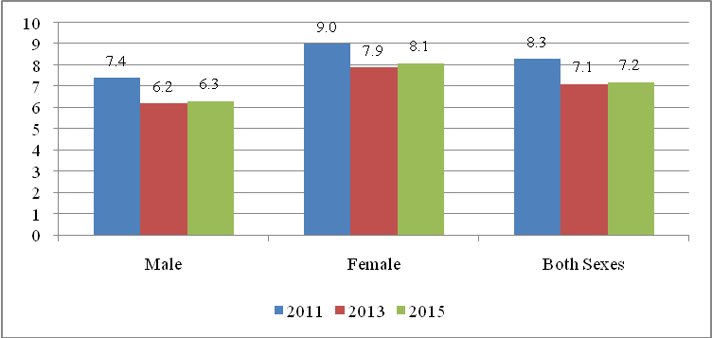
Source: Complied Data from District Executive Directors’ Offices, Mwanza region, 2016

Looking at council level, Table 5.12 reveals that Misungwi was the worst council in the region since 11.7 percent of VCT volunteers who screened were found to be HIV positive in 2011, while Ukerewe was the worst in 2013 with prevalence rate of 8.0 percent and Ilemela (11.6 percent) in 2015. Councils with low prevalence rates of VCT volunteers who screened in the specified period were Sengerema, Misungwi and Sengerema again in the respective years (Table 5.12). No data were provided by Magu and Buchosa councils.

Table 5.12: Percentage of VCT Volunteers who screened for HIV by Council, Mwanza Region, 2011, 2013 and 2015
Council | 2011 |  |  | 2013 |  |  | 2015
Council | No. Screened | No. of HIV+ | Percent HIV+ | No. Screened | No. of HIV+ | Percent HIV+ | No. Screened | No. of HIV+ | Percent HIV+
Ukerewe | 2,797 | 239 | 8.5 | 1,786 | 142 | 8.0 | 1,159 | 99 | 8.5
Magu | n.a | n.a | n.a | n.a | n.a | n.a | n.a | n.a | n.a
Mwanza City | 39,235 | 3,620 | 9.2 | 13,703 | 991 | 7.2 | 15,785 | 1,457 | 9.2
Kwimba | 12,025 | 1,174 | 9.8 | 14,327 | 1,374 | 9.6 | 21,100 | 1,434 | 6.8
Sengerema | 27,110 | 1,550 | 5.7 | 29,549 | 1,776 | 6.0 | 27,550 | 1,168 | 4.2
Ilemela | n.a | n.a | n.a | 10,862 | 754 | 6.9 | 11,714 | 1,355 | 11.6
Misungwi | 4,022 | 469 | 11.7 | 3,346 | 159 | 4.8 | 1,805 | 197 | 10.9
Buchosa | n.a | n.a | n.a | n.a | n.a | n.a | n.a | n.a | n.a
Total | 85,189 | 7,052 | 8.3 | 73,573 | 5,196 | 7.1 | 79,113 | 5,710 | 7.2
Source: Complied Data from District Executive Directors’ Offices, Mwanza region, 2016

5.1.4.1 The Impact of HIV/AIDS
The socio-economic assessment of Mwanza region is not complete without addressing the extreme challenges caused by the HIV/AIDS and the efforts so far made by various local and international organisations to combat the epidemic. HIV/AIDS is highlighted in this document, because it has been a major health problem since its advent at the end of 1987. The other reason for addressing the epidemic stems from the role it plays in impoverishing families and generating widows, orphans and vunerable children due to the loss of bread-winers in their families.

The report from the HIV and Malaria Survey and medical record provided by councils qualifies Mwanza as among the few regions with ever increasing rates of HIV/AIDS prevalence in the country. Economically, Mwanza people are migrant labours who migrate to various parts of the country and with its status, being a center for business in east and central Africa has attaracted businesmen from Uganda, DRC, Rwanda, Burundi, South Sudan and Kenya, which makes it easy for them to be engage in sexual relationships. Other reasons include the traditional practice of prolonged drinking and unsafe sexual practices, poligamy as well as poverty. The poor, especially young girls who migrate to urban centres end up being domestic workers for sometime before resorting to prostituion for better survival.

- The Increase of Widows
Understanding the status of HIV/AIDS prevelance in Mwanza is very difficult since the most of people are considering HIV/AIDs as a shamefull disease to the extent many people die at home. With the exception of 2007, the lack of VCT in remote areas where people could be tested in order to know their health status was a problem. Therefore, there are people who live with the HIV/AIDS virus without knowing that they have it.

One of the indication of the high prevelance rate in the region is the rates of widowhood and orphans. The data gathered in 2012 population census shows that the proportion of the widows was higher for women (3.8 percent) than men (1.8 percent) in 2012, while 2.9 percent was for both sexes (Figure 5.5). There is a need of conducting a study that will gather current information of widowed and their problems in order to come up with appropriate measures and solutions.

Figure 5.5: The Percentage of the Widowed by Sex, Mwanza region; 2012
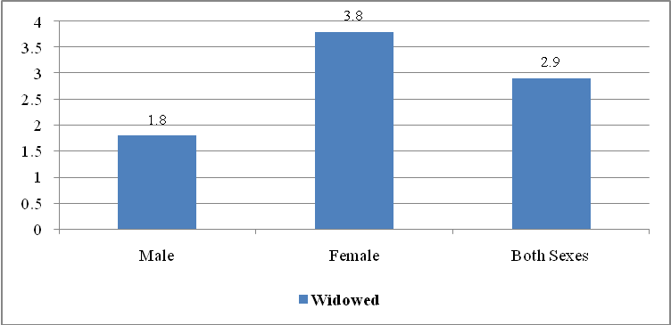
Source:NBS, 2012 Population and Housing Census Report (Mwanza Profile), 2015

The proportion of widowed between rural and urban differs signifantly, higher in rural areas (3.2 percent) than urban (2.9 percent). Similar observation experienced between sexes. Figure 5.6 shows that the proportion of female widows were higher than male widows in both locations. In rural areas, female widows was 4.3 percent and 2.9 percent compared with 2.1 percent and 2.9 percent for male widows in rural and urban areas respectively.

Figure 5.6: The Percentage of the Widowed by Sex, Mwanza region; 2012
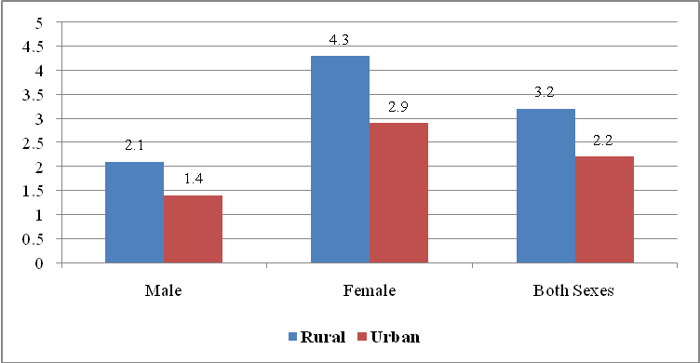
Source: NBS, Population Census Reports, 2012, Mwanza Region Socio-Economic Report, 2015.

(ii) The Increase of Orphaned Children
An orphan is a child under the age of 18 years who has lost one or both parents. Figure 5.7 shows that about one percent (0.99 percent) of persons below 18 years had lost both parents and about seven (7) percent of all children below 18 years were orphans due to the loss of one or both parents. The incidence of orphan hood is slightly higher for female children (7.19 percent) than male children (7.07 percent).

Figure 5.7: Percentage Distribution of Orphans by Sex; Mwanza Region, 2012 Census
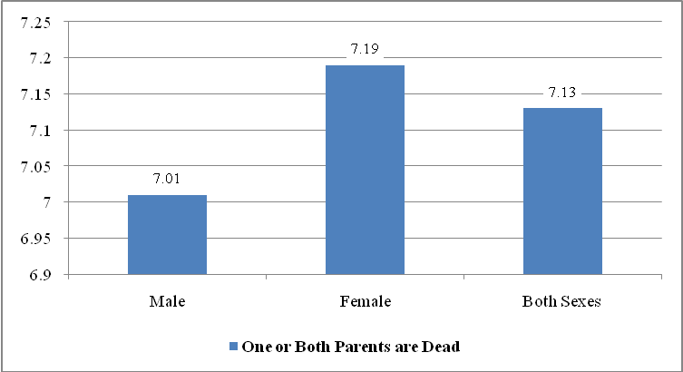
Source: NBS, Population Census Reports, 2012, Mwanza Region Socio-Economic Report, 2015.

Table 5.13 shows variations of orphan hood among councils by sex. The highest incidence of orphan hood observed in Ilemela Municipal council (8.3 percent) followed by Mwanza city (8.0 percent), Kwimba district council had the lowest incidences of orphan hood (6.0 percent) in Mwanza region. Table 5.13 also shows that the proportion of female orphans was slightly (7.3 percent) higher than male orphans (7.1 percent), but varies among councils. Geographically, urban areas were slightly more child orphans (8.1 percent) compared to rural areas (6.7 percent). This incidence resulted to have significant number of vulnerable children in Mwanza city and Ilemela municipal council than other rural districts in the Region. Unfortunately, the Region do not have current data on magnitude and distribution of orphan hood and particularly, vulnerable children.
Therefore, there is a need of conducting a survey by the regional authority to identify the number and actual status of the most vulnerable children in the region as it has been done in other regions in the country. Understanding the status of orphans and most vulnerable children will enable the regional authority to adopt policies and strategies that will reduce street children and improve their welfare.

Table 5.13: Percentage Distribution of Orphans by Council and Sex; Mwanza Region, 2012 Census
Council | Male |  | Female |  | Both Sexes
Council | 0 – 17 Years | Percent Orphans | 0 – 17 Years | Percent Orphans | 0 – 17 Years | Percent Orphans
Ukerewe | 92,179 | 7.2 | 90,692 | 6.9 | 182,871 | 7.0
Magu | 82,047 | 7.8 | 81,435 | 7.6 | 163,482 | 7.7
Mwanza City | 80,113 | 7.4 | 85,710 | 8.5 | 165,823 | 8.0
Kwimba | 114,255 | 6.0 | 113,505 | 6.1 | 227,760 | 6.1
Sengerema | 183,816 | 7.1 | 180,833 | 6,9 | 364,649 | 7.0
Ilemela | 76,063 | 8.0 | 81,818 | 8.7 | 157,881 | 8.3
Misungwi | 98,266 | 6.6 | 95,628 | 6.4 | 193,894 | 6.5
Buchosa*
Total | 726,739 | 7.1 | 729,621 | 7.2 | 1,456,360 | 7.1
*Buchosa data is inclusive in Sengerema DC
Source: NBS, Population Census Reports, 2012, Mwanza Region Socio-Economic Report, 2015.

5.1.4 Child Nutrition
Children, from the stage of foetuses to under - five years and their mothers are the most vulnerable group in the society. Therefore, reproductive and child health services are the most vital services. Besides vaccination programme, children are also weighed to reveal how prevalent underweight is among them and hence the extent of child malnutrition. Nutritional food intake is associated with child health and therefore, poor diet can result into severe malnutrition which in turn manifests itself in high infant and child mortality rates.

5.1.5.1 Mother and Child Health Care
Protection of expectant/lactating mothers and children from measles, tuberculosis, etc through immunisation programme (CSPD) which is supported by development partners has to a large extent reduced the risk of their being infected. This is evidenced by the decline of infant and children under five years’ mortality rates in Mwanza region by 2012. The 2012 population census results shows that the proportion of Infant Mortality rate declined from 115 per 1,000 infants in 1988 to 87 in 2002 and dropped further to 44.3 per 1,000 infants in 2012. The proportion rate of deaths of children under five years dropped from 192 per 1,000 children to 139 in 2002 and reached 63.8 in 2012 (Figure 5.8).

Figure 5.8: Trend of Infant and Under Five Years Mortality Indicators, Mwanza region; 1978, 1988, 2002 and 2012
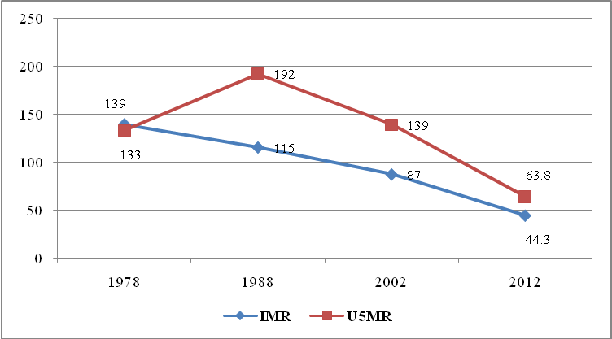
Source: NBS, Population Census Reports, 2012, Mwanza Region Socio-Economic Report, 2015.

Reduction of deaths among children and their mothers is attributed to the wide coverage of immunisation campaigns in the region. The proportion of expectant mothers vaccinated with TT2 in Mwanza region was very high in all three years, 80.9 percent in 2011, 95.1 percent in 2013 and 85.6 percent in 2015 (Figure 5.8). General observation on these results is that, one among reasons, were influenced by the accessibility of health facilities in most part of the region and understanding of expectant mothers on the need of vaccination to their children.

Figure 5.8: Percentage of Expectant Mothers Vaccinated TT2, Mwanza region; 2011, 2013 and 2015
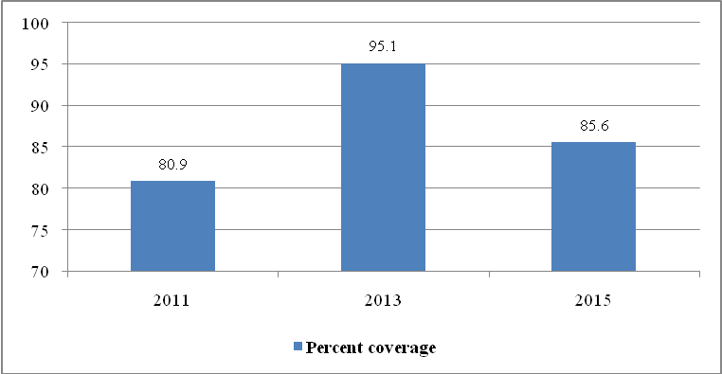
Source: Complied Data from District Executive Directors’ Offices, Mwanza region, 2016

At council level, in 2011, Ilemela municipal council had the best coverage of 111.7, while Mwanza city was the best council in 2013 and 2015 years, vaccinated 128.1 percent and 100 percent of targeted expectant mothers respectively. In 2011, 2013 and 2015 the council with the lowest coverage was Sengerema vaccinated only 59.1 percent, 61.1 percent and 61.7 percent in the specified years. Unfortunately, Kwimba and Misungwi district councils could not provide data which causes the aggregate immunization coverage for Mwanza region in the specified years to be not properly reflected.

Table 5.6: Percentage of Expectant Mothers Vaccinated TT2 by Division, Mwanza region; 2011, 2013 and 2015

Council | 2011 |  |  | 2013 |  |  | 2015
Council | Total Targeted | Total Vaccinated | Percent Coverage | Total Targeted | Total Vaccinated | Percent Coverage | Total Targeted | Total Vaccinated | Percent Coverage
Ukerewe | 14,025 | 10,730 | 76.5 | 12,780 | 10,668 | 83.5 | 15,174 | 11,927 | 78.6
Magu | 11,300 | 11,300 | 100.0 | 11,337 | 11,110 | 98.0 | 13,204 | 12,842 | 97.3
Mwanza City | 13,325 | 13,325 | 100.0 | 14,896 | 19,085 | 128.1 | 18,141 | 18,141 | 100.0
Kwimba | 67,488 | 52,795 | 78.2 | n.a | n.a | n.a | n.a | n.a | n.a
Sengerema | 14,168 | 8,378 | 59.1 | 14,409 | 8,809 | 61.1 | 14,506 | 8,954 | 61.7
Ilemela | 9,328 | 10,416 | 111.7 | 12,549 | 12,977 | 103.4 | 12,551 | 12,211 | 97.3
Misungwi | n.a | n.a | n.a | n.a | n.a | n.a | n.a | n.a | n.a
Buchosa | 9,075 | 5,235 | 57.7 | 7,158 | 6,889 | 96.2 | 9,345 | 6,879 | 73.6
Total | 138,709 | 112,179 | 80.9 | 73,129 | 69,538 | 95.1 | 82,921 | 70,954 | 85.6
Source: Complied Data from District Executive Directors’ Offices, Mwanza region, 2016

The trend of BCG vaccination for children under one year shows an increase in the number of children vaccinated in 2013 and 2015, although there was a decline in percentages compared with 2011. In 2011, out of 75,351 targeted children under one years 123.1 percent were vaccinated, while 108.6 percent of 87,701 targeted children were vaccinated with BCG in 2013 and 101.5 percent out of 116,210 of targeted children were vaccinated in 2015. This is a very good picture for the region on the extent of immunizing children under one year. The council with the highest coverage in 2011 was Ilemela (141.5 percent) but in 2013 Ukerewe (142.6 percent) had the highest coverage and again Misungwi had highest coverage of 126.1 percent for children under one year in 2015 (Table 5.13). One general observation from these data is that most of councils were under estimated their targets of children under one year as a result the vaccinated children surpassed their targets.

Table 5.6: Percentage of Children Under One Year Vaccinated BCG by Council, Mwanza region; 2011, 2013 and 2015
Council | 2011 |  |  | 2013 |  |  | 2015
Council | Total Targeted | Total Vaccinated | Percent Coverage | Total Targeted | Total Vaccinated | Percent Coverage | Total Targeted | Total Vaccinated | Percent Coverage
Ukerewe | 14,025 | 15,702 | 112.0 | 12,780 | 18,225 | 142.6 | 15,174 | 10,739 | 70.8
Magu | 11,300 | 10,328 | 91.4 | 11,317 | 11,166 | 98.7 | 13,204 | 14,637 | 110.9
Mwanza City | n.a | n.a | 0.0 | 6,737 | 6,737 | 100.0 | 24,524 | 24,524 | 100.0
Kwimba | 6,694 | 6,498 | 97.1 | 6,341 | 6,321 | 99.7 | 8,099 | 6,746 | 83.3
Sengerema | 12,002 | 14,495 | 120.8 | 13,068 | 12,958 | 99.2 | 15,370 | 17,699 | 115.2
Ilemela | 9,328 | 13,195 | 141.5 | 12,005 | 11,394 | 94.9 | 13,226 | 14,441 | 109.2
Misungwi | 11,500 | 23,415 | n.a | 13,705 | 17,631 | 128.6 | 16,196 | 20,420 | 126.1
Buchosa | 10,502 | 9,140 | 87.0 | 11,748 | 10,774 | 91.7 | 10,417 | 8,798 | 84.5
Total | 75,351 | 92,773 | 123.1 | 87,701 | 95,206 | 108.6 | 116,210 | 118,004 | 101.5
Source: Complied Data from District Executive Directors’ Offices, Mwanza region, 2016

In regard to DPT3, the coverage of immunisation in the region is good, the growth has been steady although declined in percentage. The number of vaccinated children increased from 81,895, equivalent to 110.5 percent of targeted children in 2011 to 88,638 (94.7 percent) of target children in 2013 and reached 129,169 (95.2 percent) in 2015. In 2011, Misungwi was the best vaccinated council (147.5 percent of its target) and Ilemela municipal council with 113.7 percent of vaccinated children was the best council in 2013. Again Ilemela council was the best in 2015 by covering 107.9 percent of the 12,551 targeted children, at the same time Kwimba was the worst performer as the coverage was 83.3 percent in the same year (Table 5.14).

Table 5.14: Percentage of Children under One Year Vaccinated DPT3 by Council, Mwanza Region; 2011, 2013 and 2015

Council | 2011 |  |  | 2013 |  |  | 2015
Council | Total Targeted | Total Vaccinated | Percent Coverage | Total Targeted | Total Vaccinated | Percent Coverage | Total Targeted | Total Vaccinated | Percent Coverage
Ukerewe | 14,025 | 15,086 | 107.6 | 12,780 | 10,741 | 84.0 | 15,174 | 15,570 | 102.6
Magu | 10,904 | 9,947 | 91.2 | 11,317 | 10,731 | 94.8 | 13,204 | 11,450 | 86.7
Mwanza City | n.a | n.a | 0.0 | 16,215 | 15,715 | 96.9 | 43,390 | 41,370 | 95.3
Kwimba | 6,694 | 6,498 | 97.1 | 6,341 | 6,321 | 99.7 | 8,099 | 6,746 | 83.3
Sengerema | 11,450 | 12,903 | 112.7 | 12,485 | 12,027 | 96.3 | 14,903 | 14,422 | 96.8
Ilemela | 9,328 | 11,883 | 127.4 | 9,652 | 10,973 | 113.7 | 12,551 | 13,541 | 107.9
Misungwi | 11,500 | 16,968 | 147.5 | 13,705 | 13,234 | 96.6 | 15,572 | 14,381 | 92.4
Buchosa | 10,480 | 8,610 | 82.2 | 11,141 | 8,896 | 79.8 | 12,778 | 11,689 | 91.5
Total | 74,381 | 81,895 | 110.1 | 93,636 | 88,638 | 94.7 | 135,671 | 129,169 | 95.2
Source: Complied Data from District Executive Directors’ Offices, Mwanza region, 2016

Coverage of the region under one year children for OPV3 vaccination depicts similar trend Portrayed by other medicines, it increased in magnitude but decreases their proportions of vaccinated children. In 2011, 80,954 (111.8 percent) out of 72,390 targeted children were vaccinated but significantly increased to 94,052 (100 percent) in 2013 and reached 142,305 (99.2 percent) in 2015. At council level, Table 5.15 also shows that with coverage of 145 percent and 118.9 percent, Misungwi was the best council in 2011 and 2013 respectively, while Ilemela was the best council in 2015 viccinated 111.7 percent of targeted children in the council. The worst council in 2011 and 2013 was Buchosa (92.2 percent and 83.2 percent) respectively and Magu council with 92.1 percent coverage was the worst in 2015.

Table 5.15: Percentage of Children under One Year Vaccinated OPV3 by Council, Mwanza region; 2011, 2013 and 2015

Council | 2011 |  |  | 2013 |  |  | 2015
Council | Total Targeted | Total Vaccinated | Percent Coverage | Total Targeted | Total Vaccinated | Percent Coverage | Total Targeted | Total Vaccinated | Percent Coverage
Ukerewe | 14,025 | 15,086 | 107.6 | 12,780 | 11,241 | 88.0 | 15,174 | 15,167 | 100.0
Magu | 11,940 | 11,300 | 94.6 | 12,383 | 11,317 | 91.4 | 13,204 | 12,157 | 92.1
Mwanza City | n.a | n.a | 0.0 | 18,164 | 18,164 | 100.0 | 55,301 | 55,301 | 100.0
Kwimba | 6,694 | 6,659 | 99.5 | 6,341 | 6,805 | 107.3 | 8,099 | 7,404 | 91.4
Sengerema | 12,002 | 12,561 | 104.7 | 13,068 | 13,313 | 101.9 | 14,388 | 14,604 | 101.5
Ilemela | 9,328 | 12,306 | 131.9 | 9,652 | 10,335 | 107.1 | 12,551 | 14,023 | 111.7
Misungwi | 11,500 | 16,679 | 145.0 | 13,705 | 16,298 | 118.9 | 15,572 | 14,679 | 94.3
Buchosa | 6,901 | 6,363 | 92.2 | 7,912 | 6,579 | 83.2 | 9,231 | 8,970 | 97.2
Total | 72,390 | 80,954 | 111.8 | 94,005 | 94,052 | 100.0 | 143,520 | 142,305 | 99.2
Source: Complied Data from District Executive Directors’ Offices, Mwanza region, 2016

Measles vaccination is performed to protect children against measles. The 201/14 Demographic and Health Survey conducted by the NBS reported that the proportion of children with measles vaccination records was 87.8 percent of children under one years in Mwanza region. However, medical records from all councils of Mwanza region for year 2011, 2013 and 2015 show similar observations. Out of 64,894 targeted children 72,831 equivalent to 112.3 percent were vaccinated in 2011, 79,439 (equivalent to 107.5 percent) out of 73,921 targeted children vaccinated in 2013 and 104,652 children, equivalent to 93.1 percent of targeted children were vaccinated in 2015 (Figure 5.9).
Figure 5.9: Number of Children under One Year Targeted and Vaccinated Measles by Council, Mwanza region; 2011, 2013 and 2015
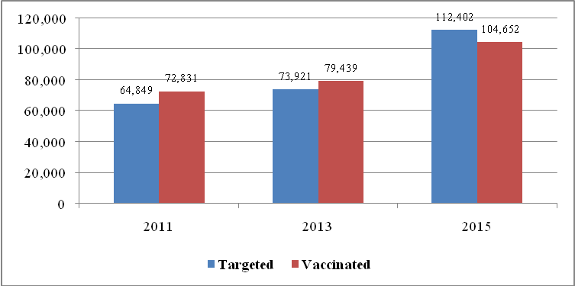
Source: Complied Data from District Executive Directors’ Offices, Mwanza region, 2016

At the council level coverage for both targeted and vaccinated defers among and councils and specified years. In 2011, the proportion of vaccinated children, ranged from 92 percent (Ukerewe) to 142.5 percent (Misungwi) in 2013 it was ranged from 94.5 percent in Misungwi to 136.1 percent in Ilemela council. In 2015, the best performer was again Ilemela with coverage of 124.1 percent and the worst performer was Sengerema with coverage of 59.3 percent of targeted children only (Table 5.16).

Table 5.16: Number of Children under One Year Vaccinated Measles by Council, Mwanza region; 2011, 2013 and 2015
Council | 2011 |  |  | 2013 |  |  | 2015
Council | Total Targeted | Total Vaccinated | Percent Coverage | Total Targeted | Total Vaccinated | Percent Coverage | Total Targeted | Total Vaccinated | Percent Coverage
Ukerewe | 14025 | 12899 | 92.0 | 12,780 | 14,027 | 109.8 | 15,174 | 13,978 | 92.1
Magu | 11300 | 10569 | 93.5 | 11609 | 11866 | 102.2 | 13204 | 13249 | 100.3
Mwanza City | n.a | n.a | 0.0 | 6,766 | 6,766 | 100.0 | 23,446 | 23,446 | 100.0
Kwimba | 6,694 | 6,322 | 94.4 | 6,341 | 7,301 | 115.1 | 7,754 | 8,812 | 113.6
Sengerema | 12002 | 14154 | 117.9 | 13068 | 13394 | 102.5 | 24701 | 14640 | 59.3
Ilemela | 9328 | 12507 | 134.1 | 9652 | 13137 | 136.1 | 12551 | 15570 | 124.1
Misungwi | 11500 | 16380 | 142.4 | 13705 | 12948 | 94.5 | 15572 | 14957 | 96.1
Buchosa | n.a | n.a | 0.0 | n.a | n.a | 0.0 | n.a | n.a | 0.0
Total | 64,849 | 72,831 | 112.3 | 73,921 | 79,439 | 107.5 | 112,402 | 104,652 | 93.1
Source: Complied Data from District Executive Directors’ Offices, Mwanza region, 2016

5.1.7 Policy Implication on Health sector
Provisions of health services in Mwanza region are still below the nation and international standards requirements. The region still has inadequate number of doctors, health infrastructure and facilities. Moreover, inadequate number of doctors limited provision of curative and preventive health services such as operations, professional assistance and advices, mother and child health facilities, diagnosis of illness due to shortage or lack of medical machines and equipment, to mention a few. This is evidenced by high rates of infant and child mortality as well as maternal mortality rate as indicated in this report. However, health services can be improved through formulating incentives which will motivate doctors and other health workers to work in rural areas. Likewise, the strategy of constructing dispensaries in every village and one health centre in every ward by both public and private sectors should be adhered to for increasing accessibility of health services to rural population.

5.1.8 Investment Opportunities for Health Sector
This sub-sector faces many challenges including prevalence of diseases such as malaria, ARI, pneumonia, diarrhea, clinical Aids, etc; shortage of workers especially nurses and medicines. Investment is needed regards to the construction of more health facilities e.g. health centers, instruments/medicines and training of health/medical personnel.

5.2 The Education Sector

5.2.0 An Overview
Development of Education sector examine the quantity and quality of entire education system covering pre-primary, primary, secondary, tertiary education which includes vocational education, colleges, and higher learning institutions as well as adult education. Therefore, the development of the sector in Mwanza region involves improving in all the above mentioned areas. This understanding has been evidenced by steps so far taken by individuals and the local government authorities to increase the intake of children to pre-primary, primary, secondary and tertiary schools in recent years.

5.2.1 Pre-Primary Education
The condition set by the Ministry of Education and Vocational Training that all children who start standard one must have undergone pre-primary education, accelerated the establishment of pre-primary schools all over the country including Mwanza region. Pre-schools are meant for children aged 3-6 years.

As Table 5.17 shows the region managed to increase the number of pre-primary schools from 848 in 2011 to 873 in 2013 and reached 926 in 2015 (Table 5.17). Looking at ownership, most of these schools annexed to government primary school compounds, as a result 90.3 percent of pre-primary schools in 2011 was publically owned, 88.9 percent in 2013 and 89.0 percent in 2015 (Table 5.17). At council level, Kwimba district council had the highest number of pre-primary schools in the region followed by Misungwi for all three years. Whist, Mwanza city had lowest number of pre-primary classes in the region followed by Ilemela municipal council (Table 5.17).

Table 5.17: Number of Pre-Primary Schools by Council; Mwanza Region, 2011, 2013 and 2015
Council | 2011 |  |  | 2013 |  |  | 2015
Council | Public | Private | Total | Public | Private | Total | Public | Private | Total
Ukerewe | 122 | 1 | 123 | 122 | 1 | 123 | 122 | 1 | 123
Magu | 103 | 8 | 111 | 103 | 8 | 111 | 103 | 9 | 112
Mwanza City | 31 | 38 | 69 | 34 | 44 | 78 | 43 | 54 | 97
Kwimba | 151 | 0 | 151 | 151 | 0 | 151 | 151 | 0 | 151
Sengerema | 97 | 3 | 100 | 98 | 3 | 101 | 98 | 5 | 103
Ilemela | 48 | 29 | 77 | 50 | 36 | 86 | 63 | 42 | 105
Misungwi | 136 | 2 | 138 | 137 | 4 | 141 | 138 | 6 | 144
Buchosa | 78 | 1 | 79 | 81 | 1 | 82 | 88 | 3 | 91
Total | 766 | 82 | 848 | 776 | 97 | 873 | 806 | 120 | 926
Percent | 90.3 | 9.7 | 100 | 88.9 | 11.1 | 100 | 87 | 13 | 100
Source: Compiled Data from District Executive Directors’ Offices, Mwanza Region, 2016

The motive behind introducing pre-primary schools classes in government primary schools all over the country was to increase enrolment of children aged 3-6 years in such schools. Table 5.18 shows that total enrolment in pre-primary schools has increased by 27.9 percent in the region during the last five years (Table 5.18). In Mwanza region enrolment increased by 27.9 percent from 49,362 pupils in 2011 to 56,843 in 2015 and Ilemela municipal council had the highest percentage increase (64.8 percent) followed by Mwanza city (53 percent) and Magu (32.8 percent). The lowest increase of enrolment was Sengerema district council (19.5 percent). Two general observations from these data is that the noted change does not include Ukerewe and Misungwi district councils since no data were provided and significant increase in enrolment is attributed to the increase in the awareness of education among parents and also easy accessibility of pre-primary schools.

Table 5.18:Total Enrolment in Pre-Primary Schools by Council, Mwanza Region, 2011 and 2015
Council | 2011 |  |  | 2015 |  |  | Increase 2011 - 2015
Council | Public | Private | Total | Public | Private | Total | Number | Percent
Ukerewe | - | - | - | - | - | -
Magu | 9,395 | 165 | 9,560 | 12,375 | 324 | 12,699 | 3,139 | 32.8
Mwanza City | 1,900 | 1,634 | 3,534 | 3,299 | 2,107 | 5,406 | 1,872 | 53.0
Kwimba | 7,147 | - | 7,147 | 8,980 | - | 8,980 | 1,833 | 25.6
Sengerema | 10,732 | 149 | 10,881 | 12,546 | 458 | 13,004 | 2,123 | 19.5
Ilemela | 2,373 | 1,045 | 3,418 | 3,661 | 1,971 | 5,632 | 2,214 | 64.8
Misungwi | 6,297 | - | 6,297 | n.a | n.a | - | - | -
Buchosa | 8,467 | 58 | 8,525 | 11,087 | 35 | 11,122 | 2,597 | 30.5
Total | 46,311 | 3,051 | 49,362 | 51,948 | 4,895 | 56,843 | 13,778 | 27.9
Source: Compiled Data from District Executive Directors’ Offices, Mwanza Region, 2016

5.2.2 Primary Education
Education is a basic right of every Tanzanian child of school going age (7-13). To render this possible the Government of Tanzania put in place the policy of Universal Primary Education (UPE) in 1974 making such education compulsory and setting out to make enrolment increase possible. To achieve this goal, the first task was to have enough primary schools that would ensure enrolment of all school going age children in the region.

By increasing number of primary schools from 898 in 2011 to 1,051 in 2015 the region showed positive attitude by giving every child of school going age has a chance of being enrolled into standard one. Table 5.17 shows that, on average, each ward had at least 4 public primary schools and a primary school in each village/mtaa as region had 191 wards, 910 villages/mitaa and 854 public primary schools in 2015. Furthermore, Table 5.17 also reveals that Kwimba district council had the largest number of public primary schools (151), whilst Ilemela municipal council had the least with 74 schools.

Table 5.17: Distribution of Primary Schools by Council; Mwanza Region, 2015
Council | No. of Ward | No. of Villages | No. of Mitaa | Total Village/ Mitaa | No. of Schools | Schools Ward Ratio | Schools Village Ratio
Ukerewe | 25 | 76 | 7 | 83 | 123 | 4.9 | 1.5
Magu | 25 | 82 | 0 | 82 | 103 | 4.1 | 1.3
Mwanza City | 18 | 0 | 175 | 175 | 81 | 4.5 | 0.5
Kwimba | 30 | 119 | 14 | 133 | 151 | 5.0 | 1.1
Sengerema | 26 | 71 | 0 | 71 | 98 | 3.8 | 1.4
Ilemela | 19 | 0 | 171 | 171 | 73 | 3.8 | 0.4
Misungwi | 27 | 113 | 0 | 113 | 138 | 5.1 | 1.2
Buchosa | 21 | 82 | 0 | 82 | 87 | 4.1 | 1.1
Total | 191 | 543 | 367 | 910 | 854 | 4.5 | 0.9
Source: Compiled Data from District Executive Directors’ Offices, Mwanza Region, 2016

Looking at ownership, out of 898 primary schools recorded in 2011, only 5.6 percent was privately owned. In 2013, private primary schools was only 12.1 percent out of 968 schools and 8.7 percent of 1,050 primary schools were privately owned in 2015 (Table 5.18).

Table 5.18: Number of Primary Schools by Ownership and by Council; Mwanza Region, 2011, 2013 and 2015
Council | 2011 |  |  | 2013 |  |  | 2015 |  |  | Percent Share
Council | Public | Private | Total | Public | Private | Total | Public | Private | Total | Percent Share
Ukerewe | 123 | 1 | 124 | 123 | 1 | 124 | 123 | 1 | 124 | 11.8
Magu | 103 | 8 | 111 | 103 | 9 | 112 | 103 | 10 | 113 | 10.8
Mwanza City | 77 | 18 | 95 | 77 | 85 | 162 | 81 | 145 | 226 | 21.5
Kwimba | 151 | 0 | 151 | 151 | 0 | 151 | 151 | 0 | 151 | 14.4
Sengerema | 97 | 3 | 100 | 98 | 3 | 101 | 98 | 5 | 103 | 9.8
Ilemela | 67 | 27 | 94 | 67 | 25 | 92 | 73 | 29 | 102 | 9.7
Misungwi | 136 | 2 | 138 | 137 | 4 | 141 | 138 | 5 | 143 | 13.6
Buchosa | 85 | 0 | 85 | 85 | 0 | 85 | 87 | 2 | 89 | 8.5
Total | 839 | 59 | 898 | 841 | 127 | 968 | 854 | 197 | 1,051 | 100
Percent | 79.8 | 5.6 | 85.4 | 80.0 | 12.1 | 92.1 | 81.3 | 18.7 | 100
Source: Compiled Data from District Executive Directors’ Offices, Mwanza Region, 2016

5.2.2.1 Standard One Enrolment
Over the period of five years, 2011 to 2015, Mwanza region implemented successfully the call of the government to increase enrolment in primary school. Table 5.19 shows enrolments of standard I in primary schools for each council in 2011, 2013 and 2015. Standard One enrolment in the region increased from 84,290 pupils in 2011 to 88,326 pupils in 2013 and reached 95,640 in 2015. Table 5.19 also shows that the proportion of enrolments in public schools was higher than private schools; 97.1 percent in 2011, 96.5 percent in 2013 and 96.6 percent in 2015.

Table 5.19: Standard I Enrolment by School Ownership and by Council; Mwanza Region, 2011, 2013 and 2015
Council | 2011 |  |  | 2013 |  |  | 2015
Council | Public | Private | Total | Public | Private | Total | Public | Private | Total
Ukerewe | 0 | 0 | 0 | 0 | 0 | 0 | 0 | 0 | 0
Magu | 11557 | 303 | 11,860 | 12054 | 342 | 12,396 | 13867 | 368 | 14,235
Mwanza City | 10625 | 792 | 11,417 | 11477 | 954 | 12,431 | 12791 | 1152 | 13,943
Kwimba | 15,819 | - | 15,819 | 15,786 | - | 15,786 | 15,852 |  | 15,852
Sengerema | 11186 | 224 | 11,410 | 12777 | 460 | 13,237 | 12792 | 290 | 13,082
Ilemela | 10154 | 1042 | 11196 | 9905 | 1216 | 11,121 | 9446 | 1299 | 10,745
Misungwi | 12254 | 86 | 12340 | 12025 | 114 | 12,139 | 14355 | 111 | 14,466
Buchosa | 10248 | 0 | 10,248 | 11216 | 0 | 11,216 | 13317 | 0 | 13,317
Total | 81,843 | 2,447 | 84,290 | 85,240 | 3,086 | 88,326 | 92,420 | 3,220 | 95,640
Percent | 97.1 | 2.9 | 100 | 96.5 | 3.5 | 100 | 96.6 | 3.4 | 100
Source: Compiled Data from District Executive Directors’ Offices, Mwanza Region, 2016

The enrolment into standard one, according to the education policy, though is for children aged seven years, it has been expanded to cover between 7 to 13 years due to culture and norms of the people of Tanzania. Table 5.20 shows that the proportion of children enrolled in standard one at the age of seven years in the last five years varies between 61.4 percent in 2014 and 79.1 percent in 2015, while pupils for eight and more years ranged from 20.9 percent in 2015 to 38.6 percent in 2014. Great achievement has been observed in standard one enrolment was caused by the community participation in school committees and through MEMM and MEMKWA which motivate parents in the region to enroll their children as per policy instruction.

Table 5.20: Distribution of Standard I Enrolment by Age Group, Mwanza Region; 2011 - 2015
Years | Seven Years |  | Eight to Ten Years |  | Total Enrolment | Enrolment Change
Years | Number | Percent | Number | Percent | Total Enrolment | Number | Percent
2011 | 99,794 | 76.4 | 30,828 | 23.6 | 130,622
2012 | 105,107 | 77.8 | 29,974 | 22.2 | 135,081 | 4,459 | 3.4
2013 | 72,324 | 76.2 | 22,546 | 23.8 | 94,870 | -40,211 | -29.8
2014 | 81,554 | 61.4 | 51,290 | 38.6 | 132,844 | 37,974 | 40.0
2015 | 88,240 | 79.1 | 23,306 | 20.9 | 111,546 | -21,298 | -16.0
Cumulative Total | 447,019 | 73.9 | 157,944 | 26.1 | 604,963 | -19,076
Source: Compiled Data from District Executive Directors’ Offices, Mwanza Region, 2016

Looking and sex difference, Table 2.21 shows that the proportion of girls enrolled standard one at age seven were more than boys in the specified period, while more boys were enrolled at age eight to ten years. The cumulative enrolment between 2011 and 2015 shows that out of 447,019 Standard One pupils aged seven years, 51.6 percent were girls, while only 48.3 percent of 157,944 pupils aged eight to 10 years were girls. One general observation from these data is that Mwanza region had successively achieved the national objective of ensuring girls get equal opportunity as boys in standard one enrolment for the respective years (Table 5.21).

Table 5.21: Standard I Enrolment by Age and by Sex, Mwanza Region, 2011 - 2015
Years | Seven Years |  |  | Eight to Ten Years |  |  | Total Enrolment
Years | Boys | Percent Girls | Total | Boys | Percent Girls | Total | Boys | Percent Girls | Total
2011 | 48,558 | 51.3 | 99,794 | 15,994 | 48.1 | 30,828 | 64,552 | 50.6 | 130,622
2012 | 50,578 | 51.9 | 105,107 | 15,823 | 47.2 | 29,974 | 66,401 | 50.8 | 135,081
2013 | 35,494 | 50.9 | 72,324 | 11,733 | 48.0 | 22,546 | 47,227 | 50.2 | 94,870
2014 | 38,242 | 53.1 | 81,554 | 25,874 | 49.6 | 51,290 | 64,116 | 51.7 | 132,844
2015 | 43,548 | 50.6 | 88,240 | 12,266 | 47.4 | 23,306 | 55,814 | 50.0 | 111,546
Cumulative Total | 216,420 | 51.6 | 447,019 | 81,690 | 48.3 | 157,944 | 298,110 | 50.7 | 604,963
Source: Compiled Data from District Executive Directors’ Offices, Mwanza Region, 2016

With reference to Table 5.22, total enrolment for girls in 2011 was slightly higher than that of boys, though there some variations among councils. At council level, girl’s enrolment in standard one ranged between 49.5 percent in Buchosa district council to 51.2 percent in Ilemela municipal council. Table 5.22 further indicates that primary schools located in Misungwi council lead in girl’s enrolment at age seven in region, while Buchosa council registered the least number of girls at age seven, hence, the council need to find strategies that will improve girl’s enrolment in primary schools at age seven.

Table 5.22: Standard I Enrolment by Council and by Sex, Mwanza Region, 2011
Council | Seven Years |  |  | Eight to Ten Years |  |  | Total Enrolment
Council | Boys | Percent Girls | Total | Boys | Percent Girls | Total | Boys | Percent Girls | Total
Ukerewe | 4,557 | 51.6 | 9,416 | 1,384 | 47.8 | 2,653 | 5,941 | 50.8 | 12,069
Magu | 4,517 | 51.0 | 9,218 | 1,039 | 48.2 | 2,006 | 5,556 | 50.5 | 11,224
Mwanza City | 4,424 | 51.0 | 9,026 | 860 | 49.7 | 1,709 | 5,284 | 50.8 | 10,735
Kwimba | 5,365 | 50.6 | 10,870 | 2,771 | 47.3 | 5,261 | 8,136 | 49.6 | 16,131
Sengerema | 4,109 | 51.7 | 8,516 | 1,356 | 49.2 | 2,670 | 5,465 | 51.1 | 11,186
Ilemela | 18,569 | 51.7 | 38,483 | 4,549 | 48.7 | 8,868 | 23,118 | 51.2 | 47,351
Misungwi | 3,285 | 52.0 | 6,839 | 2,094 | 45.3 | 3,825 | 5,379 | 49.6 | 10,664
Buchosa | 3,694 | 49.9 | 7,371 | 1,941 | 48.9 | 3,798 | 5,635 | 49.5 | 11,169
Total | 48,520 | 51.4 | 99739 | 15,994 | 48.1 | 30790 | 64,514 | 50.6 | 130,529
Source: Compiled Data from District Executive Directors’ Offices, Mwanza Region, 2016

Table 5.23 show similar results were also observed in 2015, overall girl’s enrolment in standard one was slightly higher (50.1 percent) than boys, but proportion of girl’s enrolment at council level ranged between 47.9 percent (Misungwi) and 51.4 percent (Ilemela). One general observation from these records is that more girls again were enrolled standard one at age of seven years than boys and more boys were enrolled at age eight to ten years in 2015.

Table 5.23: Standard I Enrolment by Council and by Sex, Mwanza Region, 2015
Council | Seven Years |  |  | Eight to Ten Years |  |  | Total Enrolment
Council | Boys | Percent Girls | Tota | Boys | Percent Girls | Total | Boys | Percent Girls | Total
Ukerewe | 7,383 | 50.2 | 14,826 | 164 | 46.8 | 308 | 7,547 | 50.1 | 15,134
Magu | 5,737 | 49.9 | 11,457 | 1,462 | 50.3 | 2,939 | 7,199 | 50.0 | 14,396
Mwanza City | 5,566 | 51.2 | 11,409 | 784 | 50.9 | 1,598 | 6,350 | 51.2 | 13,007
Kwimba | 6,083 | 49.7 | 12,092 | 3,135 | 47.1 | 5,931 | 9,218 | 48.9 | 18,023
Sengerema | 5,106 | 51.5 | 10,533 | 1,260 | 44.2 | 2,259 | 6,366 | 50.2 | 12,792
Ilemela | 3,873 | 51.5 | 7,984 | 856 | 48.8 | 1,673 | 4,729 | 51.0 | 9,657
Misungwi | 4,994 | 50.9 | 10,173 | 2,376 | 44.1 | 4,249 | 7,370 | 48.9 | 14,422
Buchosa | 4,806 | 50.6 | 9,728 | 2,229 | 48.3 | 4,309 | 7,035 | 49.9 | 14,037
Total | 43,548 | 50.6 | 88,202 | 12,266 | 47.3 | 23,266 | 55,814 | 49.9 | 111,468
Source: Compiled Data from District Executive Directors’ Offices, Mwanza Region, 2016
Table 5.24 portrays similar experience observed on standard one enrolment in Mwanza region, total enrolment in public primary school for girls was slightly higher than boys in the specified years. Insignificant difference in the number of boys and girls enrolled was a result of the region’s efforts to implement national objective of ensuring girls get equal opportunity as boys in primary school education. Table 5.24 further indicates that, besides achieving the national objective of equal opportunity for girls and boys, it has also manage to increase 13,625 pupils of total (STD I – VII) enrolment in the last five years.

Table 5.24: Total (STD I – VII) Enrolment of Public Primary Schools by Sex; Mwanza Region, 2011 - 2015
Year | Boys |  | Girls |  | Both Sexes | Enrolment Change
Year | Number | Percent | Number | Percent | Both Sexes | Number | Percent
2011 | 278,630 | 49.1 | 288,936 | 50.9 | 567,566
2012 | 279,859 | 49.5 | 286,055 | 50.5 | 565,914 | -1,652 | -0.3
2013 | 280,570 | 48.7 | 295,409 | 51.3 | 575,979 | 10,065 | 1.8
2014 | 279,629 | 47.4 | 310,384 | 52.6 | 590,013 | 14,034 | 2.4
2015 | 283,424 | 48.8 | 297,767 | 51.2 | 581,191 | -8,822 | -1.5
Cumulative Total | 1,402,112 | 48.7 | 1,478,551 | 51.3 | 2,880,663 | 13,625
Source: Compiled Data from District Executive Directors’ Offices, Mwanza Region, 2016

Over the period of three years 2011, 2013 and 2015 the local councils of Mwanza region implemented successfully the call of the government to increase enrolment in primary school. As Table 5.24 indicates, the enrolment increased from 567,566 in 2011 to 575,979 in 2013 and reached 581,191 in 2015. In regard to sex difference at council level, Magu and Ilemela did well in 2011 as girl’s enrolment accounted for 51.1 and were the highest among councils. Likewise, Kwimba council did well in 2013 with 54 percent in girl’s enrolment and again Ilemela with girl’s enrolment of 53 percent did well in 2015. Buchosa district council had the least girl’s enrolment in all three years with only 49.4 percent in 2011, 50.1 percent in 20013 and 50.3 percent in 2015.

Table 5.25: Total (STD I – VII) Enrolment of Public Primary Schools by Council and Sex; Mwanza Region, 2011, 2013 and 2015
Council | 2011 |  |  | 2013 |  |  | 2015
Council | Boys | Percent Girls | Total | Boys | Percent Girls | Total | Boys | Percent Girls | Total
Ukerewe | 39,308 | 50.5 | 79,458 | 40,079 | 50.1 | 80,330 | 40,109 | 50.2 | 80,582
Magu | 30,927 | 51.8 | 64,185 | 31,208 | 51.1 | 63,763 | 32,970 | 52.3 | 69,110
Mwanza City | 32,018 | 51.5 | 65,963 | 32,510 | 51.6 | 67,182 | 35,349 | 51.4 | 72,698
Kwimba | 40,670 | 51.3 | 83,528 | 39,561 | 54.0 | 86,051 | 40,671 | 51.0 | 83,008
Sengerema | 36,610 | 50.3 | 73,604 | 39,514 | 50.2 | 79,423 | 37,227 | 50.9 | 75,834
Ilemela | 28,704 | 51.8 | 59,581 | 29,912 | 51.7 | 61,947 | 28,873 | 53.0 | 61,374
Misungwi | 34,858 | 50.9 | 70,952 | 32,662 | 51.2 | 66,924 | 33,482 | 51.2 | 68,656
Buchosa | 35,535 | 49.4 | 70,295 | 35,124 | 50.1 | 70,359 | 34,743 | 50.3 | 69,929
Total | 278,630 | 50.9 | 567,566 | 280,570 | 51.3 | 575,979 | 283,424 | 51.2 | 581,191
Source: Compiled Data from District Executive Directors’ Offices, Mwanza Region, 2016

5.2.2.2 Completion Rate of Primary School
The rate of completion of the primary education cycle in Mwanza region, improved slightly due to the improvement of school environment such as provision of meals and parent’s involvement through school committees. The completion rate is an indicator of the efficiency of the school system that shows the extent to which a cohort of pupils admitted in class one complete the primary education cycle irrespective of whether they sit for the final examination or not.

Table 5.26 shows the performance of two cohorts. The average completion rate for cohort one was 71.1 percent (66.1 percent for boys and 77.0 percent for girls). This cohort was enrolled in 2008 and finished in 2014. The average completion for the second cohort was 72.6 percent (67.4 percent boys and 77.6 percent girls) and this cohort was enrolled in 2009 and finished in 2015. Looking at sex difference, there was an improvement in girls’ retention than boys. In first cohort, completion rate for girls was 77.0 percent compared to 66.1 percent boys, while girls’ retention in cohort two stood at 77.1 percent compared to 67.4 percent boys as indicated in Table 5.26.

Table 5.26: Number of Pupils Who Enrolled in STD I in 2008 and Completed STD VII in 2014 and those Who Enrolled in 2009 and Completed STD VII in 2015; Mwanza Region
Sex | 2008 to 2014 |  |  | 2009 to 2015
Sex | Enrolled 2008 | Completed 2014 | Completion Rate | Enrolled 2009 | Completed 2015 | Completion Rate
Boys | 31275 | 23,984 | 76.7 | 30,509 | 22,017 | 72.2
Girls | 32890 | 25,505 | 77.5 | 31,224 | 23,709 | 75.9
Total | 64,165 | 49,489 | 77.1 | 61,733 | 45,726 | 74.1
Source: Compiled Data from District Executive Directors’ Offices, Mwanza Region, 2016

At council level, councils like Ukerewe, Sengerema and Ilemela had insignificant differences in the proportion of boys and girls who completed primary school education cycle one. Sengerema council had the highest rate of pupils who completed primary school education who enrolled in 2008 and complete 2014 cycle, while Magu had the least (Table 5.27). Poor completion rate observed in some councils are due to the fact that most households living in those councils are livestock keepers who have no permanent residence leading to internal migration which cause pupils drop out.

Table 5.27: Number of Pupils Who Enrolled in STD I in 2008 and Completed STD VII in 2014 by Council and by Sex, Mwanza Region
Council | Enrolled 2008 |  |  | Completed 2014 |  |  | Completion Rates
Council | Boys | Girls | Total | Boys | Girls | Total | Boys | Girls | Total
Ukerewe | 4,933 | 4,970 | 9,903 | 4,430 | 4,474 | 8,904 | 89.8 | 90.0 | 89.9
Magu | 4,960 | 5,070 | 10,030 | 3,128 | 3,157 | 6,285 | 63.1 | 62.3 | 62.7
Mwanza City | 4,724 | 5,328 | 10,052 | 3,765 | 4,230 | 7,995 | 79.7 | 79.4 | 79.5
Kwimba | 6,883 | 6,564 | 13,447 | 3,542 | 4,012 | 7,554 | 51.5 | 61.1 | 56.2
Sengerema | 3,422 | 3,693 | 7,115 | 3,183 | 3,442 | 6,625 | 93.0 | 93.2 | 93.1
Ilemela | 4,261 | 4,522 | 8,783 | 3,443 | 3,853 | 7,296 | 80.8 | 85.2 | 83.1
Misungwi | 4,213 | 4,656 | 8,869 | 2,854 | 3,292 | 6,146 | 67.7 | 70.7 | 69.3
Buchosa | 4,762 | 4,651 | 9,413 | 3,181 | 3,057 | 6,238 | 66.8 | 65.7 | 66.3
Total | 31,275 | 32,890 | 64,165 | 23,984 | 25,505 | 49,489 | 76.7 | 77.5 | 77.1
Source: Compiled Data from District Executive Directors’ Offices, Mwanza Region, 2016

Performance of primary schools in terms of completion rate was better in 2014 than 2015. Proportion of pupils who completed primary school education cycle in 2014 exceeded those of 2015 year. This was a 77.1 percent of 49,489 total pupils who completed primary education in 2014 compared with 74.1 percent of 45,761 pupils of 2015. Moreover, more girls (23,709) completed education cycle than boys in 2015. This indicates that school dropout problem was more serious for boys than for girls during that education cycle (table 2.28).

Table 5.28: Number of Pupils Who Enrolled in STD I in 2009 and Completed STD VII in 2015 by Council and by Sex, Mwanza Region
Council | Enrolled 2009 |  |  | Completed 2015 |  |  | Completion Rates
Council | Boys | Girls | Total | Boys | Girls | Total | Boys | Girls | Total
Ukerewe | 4715 | 4603 | 9,318 | 3762 | 3665 | 7,427 | 79.8 | 79.6 | 79.7
Magu | 4688 | 4867 | 9,555 | 2751 | 3020 | 5,771 | 58.7 | 62.1 | 60.4
Mwanza City | 4907 | 5054 | 9,961 | 3706 | 4284 | 7,990 | 75.5 | 84.8 | 80.2
Kwimba | 6,610 | 6,731 | 13,341 | 3,167 | 3,698 | 6,865 | 51.2 | 64.5 | 57.5
Sengerema | 3195 | 3444 | 6,639 | 2961 | 3194 | 6,155 | 92.7 | 92.7 | 92.7
Ilemela | 4284 | 4553 | 8,837 | 3127 | 3508 | 6,635 | 73.0 | 77.0 | 75.1
Misungwi | 3945 | 4303 | 8,248 | 2860 | 3426 | 6,286 | 72.5 | 79.6 | 76.2
Buchosa | 4775 | 4400 | 9,175 | 2850 | 2612 | 5,462 | 59.7 | 59.4 | 59.5
Total | 30,509 | 31,224 | 61,733 | 22,017 | 23,709 | 45,726 | 72.2 | 75.9 | 74.1
Source: Compiled Data from District Executive Directors’ Offices, Mwanza Region, 2016

5.2.2.3 Drop- out Rate in Primary Schools
Figure 5.10 portrays the situation of primary school pupil’s dropout in three consecutive years; 2012, 2013 and 2014 in Mwanza region. General observation from the information recorded is that proportion of drop out of primary schools’ pupils has been increasing in recent years. It increases from 0.8 percent in 2012 to 1.4 percent in 2013 and reached 1.7 percent in 2014. Dropout was so on for girls than boys; 0.6 percent dropout for boys compared to 1.3 percent girls in 2012, 1.4 percent boys against 1.7 percent girls in 2014 (Figure 5.10). This means that in each year there was a slight difference in number of boys and girls who dropped out from schools.

Figure 5.10: Percentage Drop Outs by Sex; Mwanza Region; 2012 - 2014
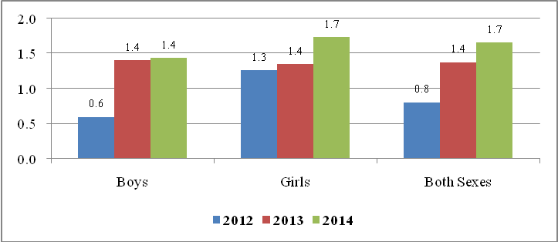
Source: Compiled Data from District Executive Directors’ Offices, Mwanza Region, 2016

Table 5.29 shows the out of the total 418,861 pupils enrolled into primary school education in 2012, 3,370 pupils (0.8 percent) failed to complete standard seven due to truancy, pregnancy, death or other reasons. Causing 70.9 percent of the total dropouts, truancy happened to be the most serious problem for primary school pupils in completing standard seven in Mwanza region. Table 5.29 also shows that boys were the most affected (50.9 percent) than girls (49.1 percent).

Table 5.29: Primary School Drop Outs by Reasons and by Sex; Mwanza Region; 2012
Reason | Boys |  | Girls |  | Total
Reason | Number | Percent | Number | Percent | Number | Percent
Truancy | 1,229 | 51.4 | 1,162 | 48.6 | 2,391 | 70.9
Pregnancy |  |  | 45 | 100.0 | 45 | 1.3
Death | 65 | 55.6 | 52 | 44.4 | 117 | 3.5
Other | 780 | 52.4 | 709 | 47.6 | 1,489 | 44.2
Total dropouts | 1,716 | 50.9 | 1,654 | 49.1 | 3,370 | 100.0
Total Enrolment | 287,932 | 0.6 | 130,929 | 1.3 | 418,861 | 0.8
Source: Compiled Data from District Executive Directors’ Offices, Mwanza Region, 2016

Similar trend on causes and rate of drop outs were observed in 2013. Table 5.30 shows that truancy continued be a main cause of school dropouts in Mwanza region followed by other reasons (38 percent), including transferring to other schools outside respective council and discontinues due to illnesses. Deaths and pregnancy were the least causes of dropouts accounted for 5.8 percent and 3.8 percent respectively.

Table 5.30: Primary School Drop Outs by Reasons and by Sex; Mwanza Region; 2013
Reason | Boys |  | Girls |  | Total
Reason | Number | Percent | Number | Percent | Number | Percent
Truancy | 1400 | 51.8 | 1302 | 48.2 | 2702 | 74.0
Pregnancy |  |  | 52 | 100.0 | 52 | 3.8
Death | 114 | 53.8 | 98 | 46.2 | 212 | 5.8
Other | 648 | 46.8 | 737 | 53.2 | 1385 | 38.0
Total dropouts | 1793 | 49.1 | 1856 | 50.9 | 3649 | 100.0
Total Enrolment | 127629 | 1.4 | 137266 | 1.4 | 264895 | 1.4
Source: Compiled Data from District Executive Directors’ Offices, Mwanza Region, 2016

Out of the total 456,395 pupils enrolled into standard I-VII in all primary schools in Mwanza region in 2014, about 1.7 percent of pupils failed to complete standard seven due to truancy, pregnancy, death or other reasons. Total number of dropouts for girls’ pupils was the higher at 5,760 which is equivalent to 76.2 percent of total dropouts in 2014. Boys’ dropouts constituted only 23.8 percent. By being the source of 57.3 percent of the total dropouts, ‘other’ reasons which might be due to illness, poverty and so forth happened to be the most common problem for primary school pupils in completing standard seven. It was followed by truancy at 33.4 percent, death (1.5 percent) and pregnancy (0.4 percent).

Table 5.30: Primary School Drop Outs by Reasons and by Sex; Mwanza Region; 2014
Reason | Boys |  | Girls |  | Total
Reason | Number | Percent | Number | Percent | Number | Percent
Truancy | 1273 | 50.4 | 1253 | 49.6 | 2526 | 33.4
Pregnancy |  |  | 30 | 100.0 | 30 | 0.4
Death | 62 | 55.9 | 49 | 44.1 | 111 | 1.5
Other | 827 | 14.7 | 4785 | 85.3 | 5612 | 74.3
Total dropouts | 1796 | 23.8 | 5760 | 76.2 | 7556 | 100.0
Total Enrolment | 124732 | 1.4 | 331663 | 1.7 | 456395 | 1.7
Source: Compiled Data from District Executive Directors’ Offices, Mwanza Region, 2016

5.2.2.4 Pass Rate in Primary schools
Pass rate refers to the percentage of pupils who passed standard seven examinations out of the total pupils who sat for the examinations. Figure 5.11 shows that pass rate for standard seven pupils was increasing though poor performance was observed in 2013. It decreased from 62.5 percent in 2011 to 56.4 percent in 2013, before rose significantly to 80.2 percent in 2015. One general observation from these data is that girls had lower pass rates than boys in all three years. The lower pass rate for girls is associated with the tendency of girls spending most of their time attending home affairs rather than engaging more in self study.

Figure 5.11: Pass rates of Pupils Who Sat for STD VII Examinations, Mwanza Region; 2011, 2013 and 2015

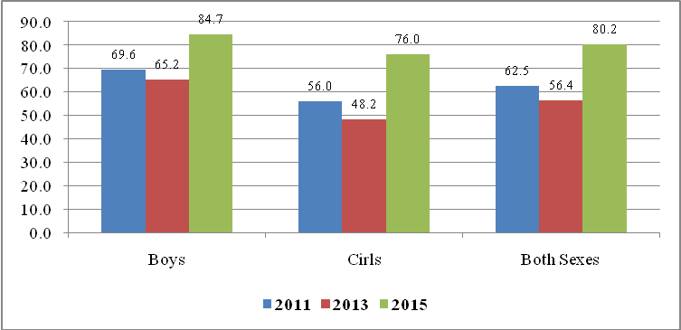
Source: Compiled Data from District Executive Directors’ Offices, Mwanza region, 2016

At district level, Table 5.31 shows examination performance by council in Mwanza region. In 2011, Mwanza city had the highest pass rate (76.8 percent) in the region followed by Ilemela (72.7 percent) and Ukerewe (67.1 percent). Buchosa council had the lowest pass rate (53.5 percent) followed by Kwimba (55.3 percent). Looking at sex differences, Table 5.35 also shows that overall pass rate for girl was lower (56 percent) than boy (69.6 percent) in 2011. Similar trend was also observed in all councils, although there were differences in magnitudes and proportions between boys and girls (Table 5.31).

Table 5.31: Number of Pupils Who Sat and Passed STD VII Examinations, Mwanza Region; 2011
Council | Pupils sat for STD VII Examinations |  |  | Pupils Passed STD VII Examinations |  |  | Percent of Pupils Passed STD VII Examinations
Council | Boys | Girls | Total | Boys | Girls | Total | Boys | Girls | Total
Ukerewe | 4828 | 4851 | 9679 | 3580 | 2918 | 6498 | 74.2 | 60.2 | 67.1
Magu | 3706 | 4028 | 7734 | 2629 | 2083 | 4712 | 70.9 | 51.7 | 60.9
Mwanza City | 3735 | 4381 | 8116 | 3060 | 3171 | 6231 | 81.9 | 72.4 | 76.8
Kwimba | 4153 | 5184 | 9337 | 2668 | 2493 | 5161 | 64.2 | 48.1 | 55.3
Sengerema | 4218 | 4631 | 8849 | 2933 | 2350 | 5283 | 69.5 | 50.7 | 59.7
Ilemela | 3652 | 4274 | 7926 | 2819 | 2947 | 5766 | 77.2 | 69.0 | 72.7
Misungwi | 3939 | 3861 | 7800 | 2190 | 2035 | 4225 | 55.6 | 52.7 | 54.2
Buchosa | 4029 | 4092 | 8121 | 2584 | 1757 | 4341 | 64.1 | 42.9 | 53.5
Total | 32260 | 35302 | 67562 | 22463 | 19754 | 42217 | 69.6 | 56.0 | 62.5
Source: Compiled Data from District Executive Directors’ Offices, Mwanza region, 2016
Table 5.32 shows trend of performance of primary schools examination in Mwanza region in 2013. There was a variation of overall performance on the results of standard seven examinations among councils, ranged from 21.4 percent (Misungwi DC) to 75.3 percent (Mwanza city). Again boys’ performances were higher than girls in all councils. These results portray the importance of launching a massive campaign on raising the importance of education for girls in the region in order to improve their performances. One general observation from these data is that the overall performance for 2013 was lower than it was in 2011.

Table 5.32: Number of Pupils Who Sat and Passed STD VII Examinations, Mwanza Region; 2013
Council | Pupils sat for STD VII Examinations |  |  | Pupils Passed STD VII Examinations |  |  | Percent of Pupils Passed STD VII Examinations
Council | Boys | Girls | Total | Boys | Girls | Total | Boys | Girls | Total
Ukerewe | 4281 | 4349 | 8630 | 2836 | 1873 | 4709 | 66.2 | 43.1 | 54.6
Magu | 2869 | 3140 | 6009 | 2118 | 1560 | 3678 | 73.8 | 49.7 | 61.2
Mwanza City | 3625 | 4026 | 7651 | 2928 | 2831 | 5759 | 80.8 | 70.3 | 75.3
Kwimba | 3473 | 3963 | 7436 | 2120 | 1783 | 3903 | 61.0 | 45.0 | 52.5
Sengerema | 3183 | 3442 | 6625 | 2020 | 1433 | 3453 | 63.5 | 41.6 | 52.1
Ilemela | 3458 | 3868 | 7326 | 2720 | 2696 | 5416 | 78.7 | 69.7 | 73.9
Misungwi | 2854 | 3289 | 6143 | 821 | 495 | 1316 | 28.8 | 15.1 | 21.4
Buchosa | 3254 | 3009 | 6263 | 2048 | 1354 | 3402 | 62.9 | 45.0 | 54.3
Total | 26997 | 29086 | 56083 | 17611 | 14025 | 31636 | 65.2 | 48.2 | 56.4
Source: Compiled Data from District Executive Directors’ Offices, Mwanza region, 2016

In 2015, the region made great achievement on standard seven examination performances. Table 5.33 shows that the overall performance was 80.2 percent of 50,095 examinees. Again similar performance differences between boys and girls observed; 84.7 percent boys compared to 76 percent for girls. With exception of Ilemela municipal council, rest of councils recorded higher performances for boys than girls (Table 5.33).

Table 5.33: Number of Pupils Who Sat and Passed STD VII Examinations, Mwanza Region; 2015
Council | Pupils sat for STD VII Examinations |  |  | Pupils Passed STD VII Examinations |  |  | Percent of Pupils Passed STD VII Examinations
Council | Boys | Girls | Total | Boys | Girls | Total | Boys | Girls | Total
Ukerewe | 3,712 | 3,626 | 7,338 | 3,477 | 3,202 | 6,679 | 93.7 | 88.3 | 91.0
Magu | 2,394 | 2,803 | 5,197 | 2,068 | 2,110 | 4,178 | 86.4 | 75.3 | 80.4
Mwanza City | 3,567 | 3,809 | 7,376 | 3,216 | 3,112 | 6,328 | 90.2 | 81.7 | 85.8
Kwimba | 2,954 | 3,564 | 6,518 | 2,347 | 2,273 | 4,620 | 79.5 | 63.8 | 70.9
Sengerema | 2,961 | 3,194 | 6,155 | 2,540 | 2,331 | 4,871 | 85.8 | 73.0 | 79.1
Ilemela | 3,218 | 3,642 | 6,860 | 2,589 | 3,072 | 5,661 | 80.5 | 84.3 | 82.5
Misungwi | 2,477 | 2,921 | 5,398 | 1,906 | 2,060 | 3,966 | 76.9 | 70.5 | 73.5
Buchosa | 2,712 | 2,456 | 5,168 | 2,180 | 1,612 | 3,792 | 80.4 | 65.6 | 73.4
Total | 23,995 | 26,015 | 50,010 | 20,323 | 19,772 | 40,095 | 84.7 | 76.0 | 80.2
Source: Compiled Data from District Executive Directors’ Offices, Mwanza region, 2016

Table 5.34 shows the ability of the region to accommodate all pupils who passed standard VII examinations to the secondary education. It also reflects the capacity of secondary education provided in the region. In a period of three years, 2011, 2013 and 2015 a total of 123,262 pupils were selected to join Form One, 90.4 percent of them joined Form One in the region (Table 5.34). Number of pupils joined Form One decreased drastically from 40,370 in 2011 to 32,119 pupils in 2013, but again rose significantly to 39,001 in 2015.

Table 5.34 also shows that of the selected pupils, the proportions of boys were higher than girls in all respective years (Table 5.34). Among other factors, income poverty from which parents/guardians suffer, some pupils, although were selected to join form one, are forced by their parents/guardians to participate in income generating activities in order to raise income of their families.

Table 5.34: Number of Pupils Who Selected and Joined Form I in Public Secondary Schools by Sex, Mwanza Region; 2011, 2013 and 2015
Years | Pupils Selected to Join Form I |  |  | Pupils Joined Form I |  |  | Percent of Pupils Joined Form I
Years | Boys | Girls | Both Sexes | Boys | Girls | Both Sexes | Boys | Girls | Both Sexes
2011 | 23,295 | 21,872 | 45,167 | 21,307 | 19,063 | 40,370 | 91.5 | 87.2 | 89.4
2013 | 19,687 | 16,961 | 36,648 | 18,004 | 14,115 | 32,119 | 91.5 | 83.2 | 87.6
2015 | 20,858 | 20,589 | 41,447 | 20,118 | 18,883 | 39,001 | 96.5 | 91.7 | 94.1
Cumulative Total | 63,840 | 59,422 | 123,262 | 59,429 | 52,061 | 111,490 | 93.1 | 87.6 | 90.4
Source: Compiled Data from District Executive Directors’ Offices, Mwanza Region, 2016

At council level, Ukerewe and Kwimba lead other councils since all pupils who were selected to join Form One were accommodated in their secondary schools in all reffered years. Table 5.35 also shows that Magu and Ilemela managed to accommodate all pupils into secondary schools in 2015, while Misungwi and Sengerema had lowest absorption rates to accommodate selected pupils in their secondary schools. Initiatives are however needed to increase number of classrooms or build more secondary schools in order to provide chances for all selected pupils to joined Form One.

Table 5.35: Number of Pupils Who were Selected and Joined Form I in Public Secondary Schools by Council, Mwanza Region, 2011, 2013 and 2015
Council | Pupils Selected to Join Form I |  |  | Pupils Joined Form I |  |  | Percent of Pupils Joined Form I
Council | 2011 | 2013 | 2015 | 2011 | 2013 | 2015 | 2011 | 2013 | 2015
Ukerewe | 6,036 | 4,709 | 6,679 | 6,036 | 4,709 | 6,679 | 100.0 | 100.0 | 100.0
Magu | 5,110 | 4,026 | 4,479 | 4,766 | 3,785 | 4,505 | 93.3 | 94.0 | 100.0
Mwanza City | 6,346 | 5,919 | 6,412 | 6,292 | 5,790 | 6,265 | 99.1 | 97.8 | 97.7
Kwimba | 5,161 | 3,749 | 4,674 | 5,161 | 3,749 | 4,674 | 100.0 | 100.0 | 100.0
Sengerema | 8,849 | 6,625 | 6,155 | 5,283 | 3,453 | 4,871 | 59.7 | 52.1 | 79.1
Ilemela | 5,199 | 4,973 | 5,001 | 5,091 | 4,787 | 5,001 | 97.9 | 96.3 | 100.0
Misungwi | 4,023 | 2,774 | 4,109 | 3,714 | 2,404 | 3,234 | 92.3 | 86.7 | 78.7
Buchosa | 4,443 | 3,873 | 3,938 | 4,027 | 3,442 | 3,772 | 90.6 | 88.9 | 95.8
Total | 45,167 | 36,648 | 41,447 | 40,370 | 32,119 | 39,001 | 89.4 | 87.6 | 94.1
Source: Compiled Data from District Executive Directors’ Offices, Mwanza Region, 2016

5.2.2.5 Transition to Secondary Education
Transition rate refers to the proportion of pupils who graduated primary education joining secondary education. It also reflects the capacity of secondary education provided in the region or council. In all three years, a cumulative total of 173,655 pupils who completed primary education only 64.2 percent joined secondary education in public schools and the remaining 35.8 percent of children enter into labour market (Table 5.35). Table 5.35 also shows that children absorbed into secondary education in public schools were 59.8 percent of 67,562 pupils completed primary education in 2011, 57.3 percent from 32,119 graduates in 2013 and 78 percent out of 50,010 graduates in 2015. One general observation from these results is that region should improve its transition rate in order to reduce number of children who entering labour market without having enough education.

Table 5.35: Number of Pupils Who Completed Primary Education and Joined Secondary Education in Public Secondary Schools by Sex, Mwanza Region; 2011, 2013 and 2015
Years | Pupils Completed Primary Education |  |  | Pupils Joined Secondary Education |  |  | Transition Rates
Years | Boys | Girls | Both Sexes | Boys | Girls | Both Sexes | Boys | Girls | Both Sexes
2011 | 32,260 | 35,302 | 67,562 | 21,307 | 19,063 | 40,370 | 66.0 | 54.0 | 59.8
2013 | 26,997 | 29,086 | 56,083 | 18,004 | 14,115 | 32,119 | 66.7 | 48.5 | 57.3
2015 | 23,995 | 26,015 | 50,010 | 20,118 | 18,883 | 39,001 | 83.8 | 72.6 | 78.0
Cumulative Total | 83,252 | 90,403 | 173,655 | 59,429 | 52,061 | 111,490 | 71.4 | 57.6 | 64.2
Source: Compiled Data from District Executive Directors’ Offices, Mwanza Region, 2016

5.2.2.6
Primary schools Facilities
A teacher may be the single most important factor in the development of primary education. But after the teacher, primary school facilities are the most important factor. School facilities include but not confined to classrooms, toilet facilities, teachers’ houses, desks, teachers’ offices, and miscellaneous school furniture and water sources.

- Classrooms
According to education Policy, the use of each classroom in primary and secondary schools should follow the national standard of accommodating 45 pupils/students only. If it happens a classroom accommodates more than 45 pupils is an indication that there is a shortage of classrooms in that particular school.

Table 5.36 shows that Mwanza region had inadequate classrooms since most of schools failed to meet the requirement of pupils classroom ratio of one classroom per 45 pupils (CPR 1:45). At CPR of 1:91 in 2015, the region experienced a shortage of classrooms in primary schools which led to the demand of 8,078 classrooms.

Table 5.36 also shows that all councils of the region experienced shortages of classrooms because their classroom pupils’ ratios were far above the national standard (CPR of 1:45). With a ratio of 127 pupils per classroom, Ilemela municipal council had largest classroom pupils ratio in the region followed by Buchosa (CPR of 1:126) and Mwanza city (CPR of 1:104). However, Buchosa, Ukerewe, Sengerema and Mwanza city had critical shortage number of classrooms of 1,289, 1,142, 1,128 and 1,107 respectively (Table 5.36). For improving learning environment in primary schools in the region, more classrooms are therefore needed in primary schools to enable the pupils to sit more comfortably and enhance teaching effectiveness of the teachers.

Table 5.36: Availability of Classrooms in Public Primary Schools by Council, Mwanza Region; 2015
Council | No. of Schools | Total Pupils | Available Classrooms | Classroom Pupils Ratio | Required Classrooms | Deficit of Classrooms
 |  |  |  |  |  | Number | Percent
Ukerewe | 123 | 80,636 | 952 | 85 | 2,094 | 1,142 | 120.0
Magu | 102 | 71,823 | 901 | 80 | 1,651 | 750 | 83.2
Mwanza City | 80 | 69,766 | 673 | 104 | 1,780 | 1,107 | 164.5
Kwimba | 151 | 84,261 | 1,098 | 77 | 2,000 | 902 | 82.1
Sengerema | 98 | 75,834 | 768 | 99 | 1,896 | 1,128 | 146.9
Ilemela | 74 | 66,267 | 523 | 127 | 1,473 | 950 | 181.6
Misungwi | 138 | 68,656 | 1,028 | 67 | 1,838 | 810 | 78.8
Buchosa | 87 | 80,408 | 637 | 126 | 1,926 | 1,289 | 202.4
Total | 853 | 597,651 | 6,580 | 91 | 14,658 | 8,078 | 122.8
Source: Compiled Data from District Executive Directors’ Offices, Mwanza Region, 2016

- Pit Latrine
All primary schools in the region had 3,835 pit-latrines for boys and 3,994 for girls in 2012 (Table 5.37). Basing on the standard set by the Government of Tanzania, the standard pupils pit-latrine ratio is 1:20 for girls and (1:24) for boys. Table 5.37 indicates that there was a serious shortage of pit-latrines in primary schools as one pit-latrine was used by 78 and 77 boys and girls pupils respectively in 2015. Mwanza city and Buchosa council experienced remarkable shortages of pit latrines for boys (CPR of 1:101) and girls (CPR of 1:445) respectively. The region should make sure that councils follow ratios of Pit-latrine per girls and boys in order to provide environment and hygiene of pupils.

Table 5.37: Availability of Pit Latrine in Public Primary Schools by Council, Mwanza Region; 2015
Council | Total Pupils |  | Available Pit Latrine |  | Hole Pupils Ratio |  | Required Pit Latrines |  | Deficit of Latrine
Council | Boys | Girls | Boys | Girls | Boys | Girls | Boys | Girls | Boys | Girls
Ukerewe | 40,109 | 40,473 | 466 | 473 | 86 | 86 | 1,671 | 2,024 | 1,205 | 1,551
Magu | 34,550 | 37,012 | 531 | 520 | 65 | 71 | 1,440 | 1,851 | 909 | 1,331
Mwanza City | 37,824 | 40,112 | 375 | 415 | 101 | 97 | 1,576 | 2,006 | 1,201 | 1,591
Kwimba | 40,438 | 42,857 | 457 | 676 | 88 | 63 | 1,685 | 2,143 | 1,228 | 1,467
Sengerema | 37,227 | 38,607 | 591 | 599 | 63 | 64 | 1,551 | 1,930 | 960 | 1,331
Ilemela | 33,339 | 35,606 | 347 | 365 | 96 | 98 | 1,389 | 1,780 | 1,042 | 1,415
Misungwi | 35,174 | 33,482 | 632 | 506 | 56 | 66 | 1,466 | 1,674 | 834 | 1,168
Buchosa | 39,598 | 40,051 | 436 | 440 | 90 | 445 | 1,650 | 2,003 | 1,214 | 1,563
Total | 298,259 | 308,200 | 3,835 | 3,994 | 78 | 77 | 12,427 | 15,410 | 8,592 | 11,416
Source: Compiled Data from District Executive Directors’ Offices, Mwanza Region, 2016

- Staff Houses
Of the various teaching incentives, the provision of staff quarters is very crucial as it facilitates the retention of teachers and also promotes teaching morale. Table 5.38 reveals that Mwanza region had a total of 2,197 teachers’ houses and if we consider the required official House Teacher Ratio (HTR) of 1:1, the region had a remarkable shortage of 10,278 houses in 2015.

Table 5.38 also shows that there is no council with a surplus of houses. It is important to note that all councils suffered from a critical shortage of houses ranging from 862 (Buchosa) to 1,943 (Mwanza city). With its urban nature and being the headquarters of the region, Mwanza city had biggest shortage in absolute numbers since most of the teachers prefer to work in this council rather than other councils in the region.

Table 5.38: Availability of Primary School Teachers' Houses by Council, Mwanza Region; 2015
Council | No. of Schools | Available Teachers | Available Houses | House Teachers Ratio | Required Houses | Deficit of Houses
 |  |  |  |  |  | Number | Percent
Ukerewe | 123 | 1,677 | 582 | 3 | 1,677 | 1,095 | 188.1
Magu | 102 | 1,322 | 272 | 5 | 1,322 | 1,050 | 386.0
Mwanza City | 80 | 1,943 | 61 | 32 | 1,943 | 1,882 | 3085.2
Kwimba | 151 | 1,653 | 329 | 5 | 1,653 | 1,324 | 402.4
Sengerema | 98 | 1,797 | 230 | 8 | 1,797 | 1,567 | 681.3
Ilemela | 74 | 1,452 | 69 | 21 | 1,452 | 1,383 | 2004.3
Misungwi | 138 | 1,492 | 377 | 4 | 1,492 | 1,115 | 295.8
Buchosa | 87 | 1,139 | 277 | 4 | 1,139 | 862 | 311.2
Total | 853 | 12,475 | 2,197 | 6 | 12,475 | 10,278 | 467.8
Source: Compiled Data from District Executive Directors’ Offices, Mwanza Region, 2016

- Furniture(Desks)
The average number of pupils per desk is an important indicator of the provision of favourable and conducive learning environment for the pupils. With 606,459 pupils registered in 2015, Mwanza region needed about 202,153 desks so as to comply with the official Desk Pupils Ratio of 1:3. The region, therefore, had acute shortage of 77,651 in 2015. All councils experience shortages of desks, but Magu and Buchosa were the most affected councils which shortages stood at 87.6 percent and 82.6 percent of desks respectively (Table 5.39).

Table 5.39: Availability of Desks in Public Primary Schools Council, Mwanza Region; 2015
Council | No. of Schools | Total Pupils | Available Desks | Desk Pupils Ratio | Required Desks | Deficit of Desks
 |  |  |  |  |  | Number | Percent
Ukerewe | 123 | 80,582 | 16,413 | 5 | 26,861 | 10,448 | 63.7
Magu | 102 | 71,562 | 12,713 | 6 | 23,854 | 11,141 | 87.6
Mwanza City | 80 | 77,936 | 15,529 | 5 | 25,979 | 10,450 | 67.3
Kwimba | 151 | 83,295 | 22,416 | 4 | 27,765 | 5,349 | 23.9
Sengerema | 98 | 75,834 | 16,030 | 5 | 25,278 | 9,248 | 57.7
Ilemela | 74 | 68,945 | 13,122 | 5 | 22,982 | 9,860 | 75.1
Misungwi | 138 | 68,656 | 12,536 | 5 | 22,885 | 10,349 | 82.6
Buchosa | 87 | 79,649 | 15,743 | 5 | 26,550 | 10,807 | 68.6
Total | 853 | 606,459 | 124,502 | 5 | 202,153 | 77,651 | 62.4
Source: Compiled Data from District Executive Directors’ Offices, Mwanza Region, 2016

(v) Accessibility of Water
Mwanza region has managed to supply water to some of its primary schools through water tanks, water wells and tap water. Table 5.40 shows that tape water was the major source of water supply in primary schools in Mwanza region followed by water tanks and water well was the least common source water in primary schools in 2015. However, not all schools in the region had water facilities in their compounds. The councils should consider accessibility of water supply in their primary schools as pre-condition of protecting waterborne diseases and influence reduction of pupil’s drop out caused by deaths.

Table 5.40: Accessibility of Water in Public Primary Schools by Council, Mwanza Region, 2013 and 2015
Council | Total No. of Schools | 2013 |  |  | Total No. of Schools | 2015
Council | Total No. of Schools | No. of Primary Schools with working |  |  | Total No. of Schools | No. of Primary Schools with working
Council | Total No. of Schools | Water Tanks | Water wells | Tape water | Total No. of Schools | Water Tanks | Water wells | Tape water
Ukerewe | 122 | 21 | 0 | 0 | 123 | 21 | 0 | 4
Magu | 99 | 33 | 16 | 3 | 102 | 38 | 16 | 7
Mwanza City | 76 | 12 | 6 | 59 | 80 | 14 | 6 | 59
Kwimba | 151 | 1 | 0 | 1 | 151 | 2 | 0 | 1
Sengerema | 98 | 2 | 16 | 5 | 98 | 2 | 27 | 11
Ilemela | 74 | 12 | 5 | 40 | 74 | 13 | 5 | 68
Misungwi | 138 | 17 | 3 | 4 | 138 | 23 | 6 | 5
Buchosa | 87 | 18 | 11 | 4 | 87 | 18 | 12 | 4
Total | 845 | 116 | 57 | 116 | 853 | 131 | 72 | 159
Source: Compiled Data from District Executive Directors’ Offices, Mwanza Region, 2016

(vi) Teachers
The teacher to pupil ratio is an important indicator which shows the quality of education provided in schools. The standard requirement is that one teacher should serve a class of 45 pupils (1:45). Mwanza region had an average TPR of 1:49 in 2015 causes a shortage of teachers in the region. Table 5.41 also shows that primary schools in two councils comply with the required national standard of TPR of 1:45 in 2015. Those were primary school in Mwanza city with TPR of 1:40 and Sengerema (1:42). The negative percentage deficit of 211 in Mwanza city and 112 in Sengerema implies that there was no teacher’s shortage in these councils as the available number of primary school teachers were more than the required. However, the Region should take initiative to reallocate teachers to these wards to alleviate the shortage.

Table 5.41: Number of Public Primary School’s Teachers by Council, Mwanza Region; 2015
Council | No. of Schools | Total Pupils | Available Teachers | Teacher Pupils Ratio | Required Teachers | Defficit of Teachers
 |  |  |  |  |  | Number | Percent
Ukerewe | 123 | 80,582 | 1,677 | 48 | 1,791 | 114 | 6.8
Magu | 102 | 71,562 | 1,322 | 54 | 1,590 | 268 | 20.3
Mwanza City | 80 | 77,936 | 1,943 | 40 | 1,732 | -211 | -10.9
Kwimba | 151 | 83,295 | 1,653 | 50 | 1,851 | 198 | 12.0
Sengerema | 98 | 75,834 | 1,797 | 42 | 1,685 | -112 | -6.2
Ilemela | 74 | 68,945 | 1,452 | 47 | 1,532 | 80 | 5.5
Misungwi | 138 | 68,656 | 1,492 | 46 | 1,526 | 34 | 2.3
Buchosa | 87 | 79,649 | 1,139 | 70 | 1,770 | 631 | 55.4
Total | 853 | 606,459 | 12,475 | 49 | 13,477 | 1,002 | 8.0
Source: Compiled Data from District Executive Directors’ Offices, Mwanza Region, 2016

Figure 5.12 shows that out of 12,475 available primary school teachers in the region, 79.2 percent (41.4 percent male and 37.9 percent female teachers) had a certificate qualifications, three (3) percent (2.2 percent male and 0.8 percent female) were diploma holders and only 2.2 percent had degree or masters qualifications. General observation from these data is that, in 2015, the proportion number of males in all levels of qualifications exceeded female teachers in the region.

Figure 5.12: Availability of Public Primary School’s Teachers by Qualification by Council, Mwanza Region; 2015
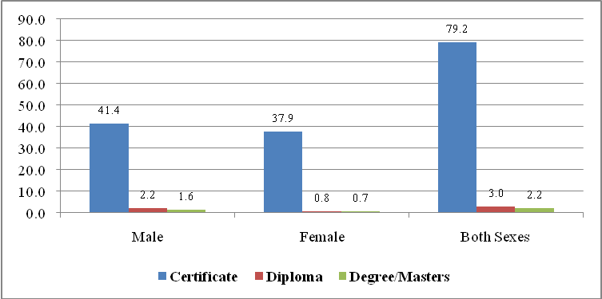
Source: Compiled Data from District Executive Directors’ Offices, Mwanza Region, 2016

At council level, primary schools in Ilemela was the most privileged as 80 out of 281 teachers with degree holders allocated in this council, followed by Misungwi (46) and Sengerema (37). Buchosa was the most disadvantaged council with only 17 degree teachers (Table5.42).

Table 5.42: Availability of Public Primary School’s Teachers by Qualification by Council, Mwanza Region; 2015
Council | Certificate |  |  | Diploma |  |  | Degree and Masters |  |  | Total Teachers
Council | Male | Female | Total | Male | Female | Total | Male | Female | Total | Male | Female | Total
Ukerewe | 1,009 | 597 | 1,606 | 40 | 5 | 45 | 24 | 5 | 29 | 1,073 | 607 | 1,680
Magu | 593 | 650 | 1,243 | 36 | 28 | 64 | 22 | 9 | 31 | 651 | 687 | 1,338
Mwanza City | n.a | n.a | n.a | n.a | n.a | n.a | n.a | n.a | n.a | n.a | n.a | 1,943
Kwimba | 862 | 638 | 1,500 | 47 | 17 | 64 | 35 | 6 | 41 | 944 | 661 | 1,605
Sengerema | 897 | 821 | 1,718 | 37 | 16 | 53 | 36 | 1 | 37 | 970 | 838 | 1,808
Ilemela | 277 | 984 | 1,261 | 75 | 26 | 101 | 31 | 49 | 80 | 383 | 1,059 | 1,442
Misungwi | 771 | 686 | 1,457 | 0 | 0 | 0 | 33 | 13 | 46 | 804 | 699 | 1,503
Buchosa | 761 | 355 | 1,116 | 41 | 4 | 45 | 14 | 3 | 17 | 816 | 362 | 1,178
Total | 5,170 | 4,731 | 9,901 | 276 | 96 | 372 | 195 | 86 | 281 | 5,641 | 4,913 | 12,497
Percent | 52.2 | 47.8 | 79.2 | 74.2 | 25.8 | 3.0 | 69.4 | 30.6 | 2.2 | 60.7 | 39.3 | 100.0
Source: Compiled Data from District Executive Directors’ Offices, Mwanza Region, 2016

5.2.2.7 Adult Education
Along with the expansion of primary and secondary education, the region has also expanded adult education using primary schools as centres with head teachers being in charge of adult education campaigns through MUKEJA and MEMKWA programs. Table 5.43 shows that in 2013 and 2015 the region had 495 and 555 centres for MUKEJA programme respectively. Enrolment of MUKEJA and MEMKWA programs in 2013 were 6,762 and 15,723 respectively. However, in 2015 adult enrolments in the two programs decreased to 4,422 and 4,198. Lack of sensitization campaigns to adults is the reason for the decrease in the number of adults who joined such programs in 2015. Moreover, the council should have regular sensitization campaigns for sustainability of the two programs.

Table 5.43: Number of Adult Education Centers and Enrolments by Council, Mwanza Region; 2013 and 2015
Council | No. of Centres (MUKEJA) - ICBAE |  | Centre Enrolment (MUKEJA) - ICBAE |  | MEMKWA (Colbert) enrolment
Council | 2013 | 2015 | 2013 | 2015 | 2013 | 2015
Ukerewe | 21 | 19 | 533 | 491 | 110 | 331
Magu | 111 | 106 | 2,117 | 2,398 | 269 | 434
Mwanza City | 11 | 15 | 8 | 37 | 438 | n.a
Kwimba | 114 | 104 | 114 | 114 | 15 | n.a
Sengerema | 87 | 58 | 1,745 | 1,585 | 269 | 184
Ilemela | 8 | 8 | 27 | 6,640 | 3,114 | 2,964
Misungwi | 123 | 209 | 2,325 | 4,446 | 205 | 211
Buchosa | 20 | 36 | 7 | 12 | 2 | 74
Total | 495 | 555 | 6762 | 15723 | 4422 | 4198
Source: Compiled Data from District Executive Directors’ Offices, Mwanza Region, 2016

5.2.2.8 Special Education
The issue of disability of late has been gaining recognition worldwide. This is due to the fact that the level of disability appears to be on the increase in most societies. Hence, it is important to prepare programme for the disabled pupils to get special education according to their type of impairment. Table 5:44 shows that the number of pupils enrolled in special education had increased from 799 in 2013 to 1,049 in 2015. Most of pupils (192 in 2013 and 355 in 2015) were intellectual impaired followed by physical impaired and deaf (Table 5.44). Furthermore, of the impaired pupils, girls outnumbered boys pupils in 2015.

Table 5.6: Number of Pupils Enrolled by Type of Impairment; Mwanza Region; 2013 and 2015
Type of Impairment | 2013 |  |  | 2015
Type of Impairment | Male | Female | Total | Male | Female | Total
Intellectual Impairment | 112 | 80 | 192 | 133 | 129 | 355
Physical Impairment | 121 | 68 | 189 | 69 | 68 | 137
Albinism | 30 | 27 | 57 | 43 | 51 | 94
Deaf | 52 | 52 | 104 | 63 | 70 | 133
Visual Impairment | 45 | 29 | 74 | 62 | 70 | 132
Autism | 68 | 42 | 110 | 6 | 7 | 13
Blindness | 24 | 18 | 42 | 8 | 14 | 22
Other Impairment | 0 | 1 | 1 | 8 | 6 | 119
Mental Impairment | 20 | 10 | 30 | 25 | 19 | 44
Total | 472 | 327 | 799 | 417 | 434 | 1049
Source: Compiled Data from District Executive Directors’ Offices, Mwanza Region, 2016

5.2.3 Secondary Education
The development of secondary education in Mwanza region improved very recent due to its historical context and the poor infrastructure. The colonialists concentrated at the regional headquarters and leave rural part of the region as a reserve area for cheap labour to work in cash crop plantations at Morogoro, Tanga and Kilimanjaro. As a result, until 1970s, the region had only ….. public secondary schools. The number of public secondary schools increased since 1990s and reached 162 in 2011. In 2015 the number of secondary schools reached 197 (Figure 5.13). Private sector had also contributed significantly in the provision of secondary education in the region. In 2011, private secondary schools were 41 increased to 72 in 2013 and reached 76 in 2015. The tremendous achievement reached by the Region to the large extent was due to the government campaign of establishing at least a secondary school in each ward and participation of private sector on the need of having enough secondary facilities for their children.

Figure 5.13: Distribution of Secondary Schools by Ownership, Mwanza Region; 2011 - 2015
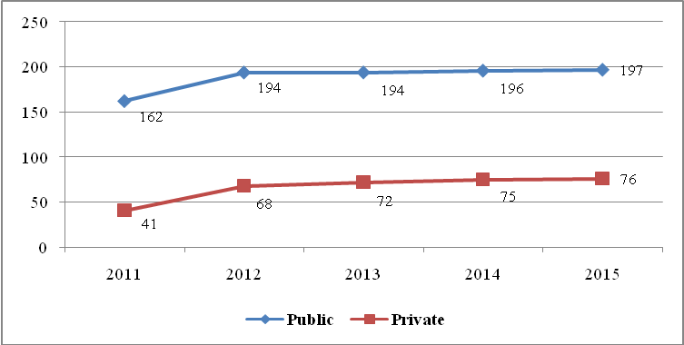
Source: Compiled Data from District Executive Directors’ Offices, Mwanza Region, 2016

Table 5.53 also shows that on average each ward in the region had at least a secondary school and each secondary schools serving at least 4 villages. Mwanza city had highest ratio of 1.7 secondary schools per ward followed by Ilemela MC (1:1.3) and Sengerema (1:1.1), while Magu, Ukerewe, Misungwi and Buchosa had lowest ratios of a secondary school per ward in 2015 (Table 5.53). The Government campaign of establishing at least one secondary school in each ward should continue to meet the demand for secondary school enrolment in the region.

Table 5.43: Distribution of Public Secondary Schools by Administrative Units, Mwanza Region; 2015
Council | No. of Ward | No. of Villages/ Mitaa | No. of Schools | School Ward Ratio | Average No. of Villages/ Mitaa per School
Ukerewe | 25 | 83 | 22 | 0.9 | 3.8
Magu | 25 | 82 | 19 | 0.8 | 4.3
Mwanza City | 18 | 175 | 30 | 1.7 | 5.8
Kwimba | 30 | 133 | 31 | 1.0 | 4.3
Sengerema | 26 | 71 | 29 | 1.1 | 2.4
Ilemela | 19 | 171 | 24 | 1.3 | 7.1
Misungwi | 27 | 113 | 23 | 0.9 | 4.9
Buchosa | 21 | 82 | 19 | 0.9 | 4.3
Total | 191 | 910 | 197 | 1.0 | 4.6
Source: Compiled Data from District Executive Directors’ Offices, Mwanza Region, 2016

General observation drawn from these data is that the effect of government campaign to establish at least one secondary school in each ward had enabled an even distribution of secondary schools in the region. By the end of 2015 the region had 197 public schools distributed evenly among the councils, ranging from 19 schools in Magu and Buchosa each to 31 schools in Kwimba district council (Table 5.54). Table 5.44 also shows that the contribution of private sector in establishing secondary schools improved from 20.2 percent of all schools in 2011 to 27.1 percent in 2013 and reached 27.8 percent in 2015.

Table 5.54: Distribution of Secondary Schools by Council and Ownership, Mwanza Region; 2011, 2013 and 2015
Council | 2011 |  |  | 2013 |  |  | 2015 |  |  | Percent Share
Council | Public | Private | Total | Public | Private | Total | Public | Private | Total | Percent Share
Ukerewe | 21 | 3 | 24 | 21 | 3 | 24 | 22 | 3 | 25 | 9.2
Magu | 19 | 2 | 21 | 19 | 4 | 23 | 19 | 7 | 26 | 9.5
Mwanza City | 28 | 23 | 51 | 30 | 25 | 55 | 30 | 25 | 55 | 20.1
Kwimba | 31 | 2 | 33 | 31 | 2 | 33 | 31 | 2 | 33 | 12.1
Sengerema | 25 | 6 | 31 | 28 | 8 | 36 | 29 | 8 | 37 | 13.6
Ilemela | n.a | n.a | 0 | 24 | 25 | 49 | 24 | 26 | 50 | 18.3
Misungwi | 22 | 4 | 26 | 23 | 4 | 27 | 23 | 4 | 27 | 9.9
Buchosa | 16 | 1 | 17 | 18 | 1 | 19 | 19 | 1 | 20 | 7.3
Total | 162 | 41 | 203 | 194 | 72 | 266 | 197 | 76 | 273 | 100.0
Total | 79.8 | 20.2 | 100 | 72.9 | 27.1 | 100 | 72.2 | 27.8 | 100
Source: Compiled Data from District Executive Directors’ Offices, Mwanza Region, 2016

5.2.3.1 Secondary School Enrolment
The enrolment of students in Mwanza region increased with the increase of school infrastructure constructed through community participation. Over the period given in Table 5.45, enrolments in secondary schools increased by 12.1 percent from 25,652 students in 2011 to 29,173 students in 2015. General observation shown by these data is that, with exception of Magu, Sengerema nad Ilemela, rest of councils had decreased their enrolment with more so on at Ukerewe and Kwimba district councils. Further Table 5.44 shows that enrolment at council level fluctuated due to income poverty from which parents/guardians suffer, some students, although were selected to join form one, forced by their parents/guardians to participate in income generating activities in order to raise income of their families. This however, was the main reason for the decrease in pupils who joined form one in 2015 for the rural councils.

Table 5.45: Total Form 1 Enrolment in Public Secondary Schools by Council and Sex, Mwanza Region; 2011 and 2015
Council | 2011 |  |  | 2015 |  |  | Increase 2011 - 2015
Council | Boys | Girls | Total | Boys | Girls | Total | Number | Percent
Ukerewe | 2,741 | 2,229 | 4,962 | 2,261 | 2,808 | 4,109 | -853 | -24.2
Magu | 2,025 | 1,256 | 3,281 | 1,794 | 1,600 | 3,374 | 93 | 2.6
Mwanza City | 3,214 | 2,848 | 6,061 | 2,701 | 2,636 | 5,377 | -684 | -19.4
Kwimba | 2,416 | 1,893 | 4,309 | 2,045 | 1,844 | 3,548 | -761 | -21.6
Sengerema | 153 | 229 | 382 | 1,905 | 1,409 | 3,314 | 2,932 | 83.3
Ilemela | 0 | 0 | 0 | 1,705 | 1,766 | 3,471 | 3,471 | 100.0
Misungwi | 1,844 | 1,729 | 3,573 | 1,601 | 1,479 | 3,080 | -493 | -14.0
Buchosa | 1,823 | 1,261 | 3,084 | 1,779 | 1,121 | 2,900 | -184 | -5.2
Total | 14,216 | 11,445 | 25,652 | 15,791 | 14,663 | 29,173 | 3,521 | 12.1
Source: Compiled Data from District Executive Directors’ Offices, Mwanza Region, 2016

Sex imbalance was observed in a specified period as more boys were enrolled than girls (Figure 5.14). Of the selected pupils, more boys (55.4 percent) than girls (44.6 percent) joined form one in 2011. Similar trend observed in 2013 and 2015 which was caused by, among other factors, poor performance in standard seven examinations and lack of awareness on the importance of education for girls children.

Figure 5.14: Percentage Distribution of Form 1 Enrolment in Public Secondary Schools Sex, Mwanza Region; 2011, 2013 and 2015
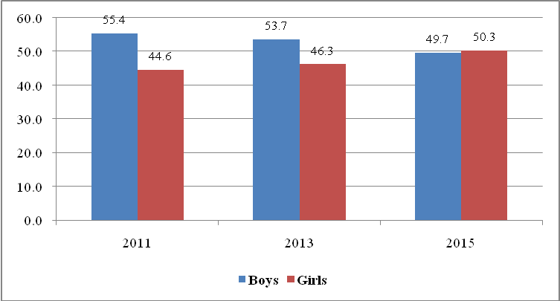
Source: Compiled Data from District Executive Directors’ Offices, Mwanza Region, 2016

Table 5.46 shows the cohort of students who enrolled Form I in 2011 and completed secondary school education in 2014 by council and sex in Mwanza region. In 2014, out of 25,193 students who enrolled in 2011, only 8,126, equivalent to 32.3 percent completed form IV in 2014. More effort is needed to ensure that more boys and girls complete secondary education.

Table 5.46: Number of Students Registered in 2011 and Completed Form IV in 2014 by Council and Sex in Public Secondary Schools, Mwanza Region.
Council | Enrolled 2011 |  |  | Completed 2014 |  |  | Completion Rates
Council | Boys | Girls | Total | Boys | Girls | Total | Boys | Girls | Total
Ukerewe | 2,879 | 2,360 | 5,239 | 839 | 318 | 1,157 | 29.1 | 13.5 | 22.1
Magu | 2,107 | 1,329 | 3,436 | 991 | 418 | 1,409 | 47.0 | 31.5 | 41.0
Mwanza City | 750 | 549 | 1,299 | 387 | 177 | 564 | 51.6 | 32.2 | 43.4
Kwimba | 2,416 | 1,893 | 4,309 | 800 | 397 | 1,197 | 33.1 | 21.0 | 27.8
Sengerema | n.a | n.a | n.a | n.a | n.a | n.a | n.a | n.a | n.a
Ilemela | 2,403 | 2,009 | 4,412 | 1320 | 733 | 2,053 | 54.9 | 36.5 | 46.5
Misungwi | 1,844 | 1,729 | 3,573 | 652 | 314 | 966 | 35.4 | 18.2 | 27.0
Buchosa | 1,722 | 1,203 | 2,925 | 562 | 218 | 780 | 32.6 | 18.1 | 26.7
Total | 14,121 | 11,072 | 25,193 | 5,551 | 2,575 | 8,126 | 39.3 | 23.3 | 32.3
Source: Compiled Data from District Executive Directors’ Offices, Mwanza Region, 2016

Table 5.47 shows the second cohort of students who were enrolled in 2012 and completed in 2015. Great achievement was done by the local government authorities to a large extent had improved the number of form IV leavers in the region. The completion rate increased significantly from 32.3 percent in 2014 (cohort one) to 93.3 percent in 2015 (Table 5.47). At council, similar experience was observation among councils, although variations occurred between them. One general observation from Table 5.47 is that councils, including Ukerewe, Magu, Ilemela and Buchosa had more students who completed Form IV than those enrolled in 2012. This was attributed by students transferred from other councils to their schools.

Table 5.47: Number of Students Registered in 2012 and Completed Form IV in 2015 by Council and Sex in Public Secondary Schools, Mwanza Region.
Council | Enrolled 2012 |  |  | Completed 2015 |  |  | Completion Rates
Council | Boys | Girls | Total | Boys | Girls | Total | Boys | Girls | Total
Ukerewe | 2,402 | 2,081 | 2,081 | 1,544 | 1,083 | 2,627 | 64.3 | 52.0 | 126.2
Magu | 2,135 | 1,688 | 1,688 | 1,367 | 1,089 | 2,456 | 64.0 | 64.5 | 145.5
Mwanza City | 784 | 553 | 1,337 | 617 | 510 | 1,127 | 78.7 | 92.2 | 84.3
Kwimba | 2,234 | 1,892 | 4,126 | 1,019 | 1,926 | 2,945 | 45.6 | 101.8 | 71.4
Sengerema | n.a | n.a | n.a | n.a | n.a | n.a | n.a | n.a | n.a
Ilemela | 2,661 | 2,400 | 5,053 | 1,840 | 3,685 | 5,525 | 69.1 | 153.5 | 109.3
Misungwi | 1,844 | 1,729 | 3,573 | 880 | 782 | 1,662 | 47.7 | 45.2 | 46.5
Buchosa | 1,701 | 1,306 | 1,306 | 926 | 608 | 1,534 | 54.4 | 46.6 | 117.5
Total | 13,761 | 11,649 | 19,164 | 8,193 | 9,683 | 17,876 | 59.5 | 83.1 | 93.3
Source: Compiled Data from District Executive Directors’ Offices, Mwanza Region, 2016

5.2.3.2 Pass Rates
Table 5.48 shows students performance in form IV examinations in public secondary schools. Pass rate in form IV examinations is divided into divisions with division I being the highest pass. Pass rate reflects the quality of secondary education provided in the region. Generally the performances of Form IV examinations in Mwanza region for 2011, 2013 and 2015 were not good. There were only 0.5 percent of boy students and 0.1 girl students who attained division One (I), only 2.5 percent of boy students and 0.5 percent girl students who attained division II. Unfortunately, 58.6 percent of students (39.0 percent of boys and 19.2 percent of girls) failed completely. The Region Authority should take this performance matter seriously.

Table 5.48: Students Performance in Form IV Examinations in Public Secondary Schools by Sex, Mwanza Region; 2011, 2013 and 2015
Division | 2011 |  |  | 2013 |  |  | 2015 |  |  | Total |  | Percent
Division | Boys | Girls | Total | Boys | Girls | Total | Boys | Girls | Total | Boys | Girls | Boys | Girls | Total
I | 45 | 10 | 55 | 141 | 15 | 156 | 88 | 21 | 109 | 274 | 46 | 0.5 | 0.1 | 0.6
II | 256 | 72 | 328 | 619 | 101 | 720 | 583 | 140 | 723 | 1,458 | 313 | 2.5 | 0.5 | 3.1
III | 881 | 448 | 1,329 | 1,448 | 484 | 1,932 | 1,105 | 533 | 1,638 | 3,434 | 1,465 | 6.0 | 2.6 | 8.5
IV | 4,643 | 2,120 | 6,763 | 3,535 | 2,456 | 5,991 | 1,105 | 3,129 | 4,234 | 9,283 | 7,705 | 16.2 | 13.4 | 29.6
0 | 4,348 | 3,373 | 7,721 | 15,442 | 3,771 | 19,213 | 2,561 | 3,832 | 6,393 | 22,351 | 10,976 | 39.0 | 19.2 | 58.2
Total | 10,173 | 6,023 | 16,196 | 21,185 | 6,827 | 28,012 | 5,442 | 7,655 | 13,097 | 36,800 | 20,505 | 64.2 | 35.8 | 100
Source: Compiled Data from District Executive Directors’ Offices, Mwanza Region, 2016

Criteria sat by the Ministry of Education and Vocational Training Centre recognize any student has passed his or her Form IV examinations if will attain any division between one and four and failure if he/she attained zero division. Figure 5.14 show that the region has been improving its performance in recent years. Out of 16,196 examinees, 8,475 passed their Form IV examinations in 2011. With exception of 2012, pass rates have increased in the rest of referred years (Figure 5.14). Figure 5.14 also shows that number of students attained division zero decreased, although was increased from 7,721 students in 2011 to 11,495 in 2012, but decreased significantly to 6,393 students in 2015.

Figure 5.14: Students Performance in Form IV Examinations in Public Secondary Schools, Mwanza Region; 2011 - 2015
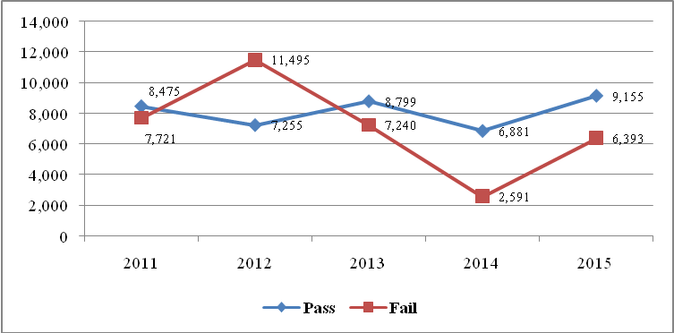
Source: Compiled Data from District Executive Directors’ Offices, Mwanza Region, 2016

Looking at sex, Figure 5.15 shows that boys’ students performed better than girls in all referred period, 5,825 and 5,332 boys in 2011 and 2015 compared with 2,650 and 3,823 girls respectively. One general observation from these data is that girl’s performance had improved in recent years and managed to narrow the gap with boy’s performance. For example, the performance gap between sexes had been narrowed in 2015 (5,332 boys against 3,823 girls) than it was in 2011 (Figure 5.15). However, more strategies are needed to be formulated in order to improve more girls’ performance in the region. These strategies include, construction of dormitories for girls, provision of food and other performance incentives for girls’ students.

Figure 5.14: Students Performance in Form IV Examinations in Public Secondary Schools by Sex, Mwanza Region; 2011 - 2015
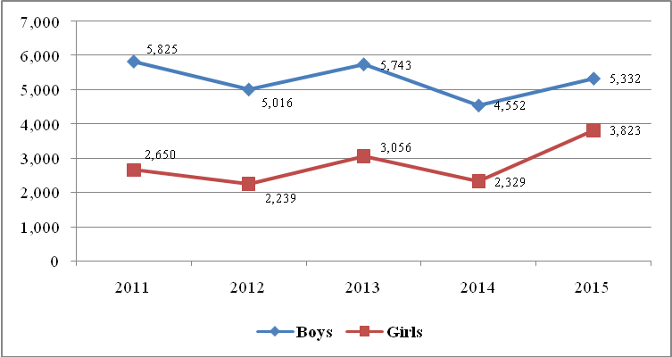
Source: Compiled Data from District Executive Directors’ Offices, Mwanza Region, 2016

5.2.3.3 Form V Enrolment
The enrolment of students in high schools in Mwanza region increased with the increase of school infrastructure constructed through people’s participation due to parents’ awareness of the importance of education to their children. Table 5.49 shows that student’s enrolment increased by 31.5 percent from 2011 to 2013, and then grew at a faster rate of almost 60 percent between 2013 and 2015. Enrolment of girls in high schools rose slightly from 35.4 percent in 2011 to 35.6 percent in 2013 and reached 43.8 percent in 2015. The boys’ enrolment fell from 64.6 to 64.5 percent between 2011 and 2013 then fell further to 56.2 percent in 2015 (Table 5.49).

Table 5.49: Total Form V Enrolment in Public High Schools by Sex, Mwanza Region; 2011, 2013 and 2015
Year | Boys | Percent | Girls | Percent | Total | Enrolment Change
 |  |  |  |  |  | Number | Percent
2011 | 1,045 | 64.6 | 573 | 35.4 | 1,618
2013 | 1,372 | 64.5 | 756 | 35.5 | 2,128 | 510 | 31.5
2015 | 1,804 | 56.2 | 1,408 | 43.8 | 3,212 | 1,084 | 50.9
Cumulative Total | 4,221 | 60.7 | 2,737 | 39.3 | 6,958 | 1,594
Source: Compiled Data from District Executive Directors’ Offices, Mwanza Region, 2016

Table 5.50 shows the number of students who completed high school education by sex in Mwanza region. In 2011, out of 1,270 students who completed form VI, 493 of them or 38.8 percent were girls and 61.2 percent boys. The percentage of girls increased to 38 percent in 2013 and reached 42.3 percent in 2015. The situation was deferent for boys’ students, while completion rate for girls increased that of boys decreased from 61.2 percent in 2011 to 36.5 percent in 2013 and reached 42.3 in 2015. Unlike in completion of secondary education, the situation in this case is a bit good. Overall, the number of form VI leavers has been increasing year after year in the region.

Table 5.50: Number of Students Who Completed ‘’A’’-Level Secondary School Education by Sex, Mwanza Region; 2011, 2013 and 2015
Year | Boys | Percent | Girls | Percent | Total | Change of Students
 |  |  |  |  |  | Number | Percent
2011 | 777 | 61.2 | 493 | 38.8 | 1,270
2013 | 1,270 | 63.5 | 731 | 36.5 | 2,001 | 731 | 57.6
2015 | 1,331 | 57.7 | 975 | 42.3 | 2,306 | 305 | 15.2
Cumulative Total | 3,378 | 60.6 | 2,199 | 39.4 | 5,577 | 1,036
Source: Compiled Data from District Executive Directors’ Offices, Mwanza Region, 2016

5.2.3.4 Form VI Pass Rate
Table 5.51 shows student’s performance in Form VI examinations. Unlike form IV examinations performance, performance in Mwanza region for Form VI examinations over the period from 2011, 2013 and 2015 is encouraging. Out of 4,617 boy students and 1,001 girl students who did examinations in 2011, only 150 boys and 154 girls fail their examinations. Similar trends have observed in 2013 and 2014 examination results. One general observation experienced in these data is that, only 10.1 percent of boy students and 7.6 of girl students failed completely. About 21.3 percent of boy students and 16.2 percent of girl students attained division II. Student Performance for both boys and girls increased with time over the period from 2011 to 2015(Table 5.51).

Table 5.51: Students Performance in Form VI Examinations in Public Secondary Schools by Sex, Mwanza Region; 2011, 2013 and 2015
Division | 2011 |  |  | 2013 |  |  | 2015 |  |  | Total |  | Percent
Division | Boys | Girls | Total | Boys | Girls | Total | Boys | Girls | Total | Boys | Girls | Boys | Girls | Total
I | 59 | 40 | 99 | 36 | 4 | 40 | 146 | 100 | 246 | 241 | 144 | 3.1 | 1.8 | 4.9
II | 193 | 141 | 334 | 294 | 74 | 368 | 351 | 231 | 582 | 838 | 446 | 10.7 | 5.7 | 16.4
III | 569 | 431 | 1000 | 453 | 452 | 905 | 643 | 382 | 1025 | 1665 | 1265 | 21.3 | 16.2 | 37.4
IV | 338 | 235 | 573 | 385 | 229 | 614 | 358 | 300 | 658 | 1081 | 764 | 13.8 | 9.8 | 23.6
0 | 150 | 154 | 304 | 440 | 219 | 659 | 202 | 223 | 425 | 792 | 596 | 10.1 | 7.6 | 17.7
Total | 1,309 | 1,001 | 2,310 | 1,608 | 978 | 2,586 | 1,700 | 1,236 | 2,936 | 4,617 | 3,215 | 59.0 | 41.0 | 100
Source: Compiled Data from District Executive Directors’ Offices, Mwanza Region, 2016

5.2.3.5 Secondary school Facilities
The quantity and quality of facilities for the secondary school system in Mwanza region are yet to attain the standards set by the educational authorities. Besides the capability of students themselves, lack of school facilities play significant role in improving quality of education in any region. The most common facilities that play major role on improving the quality of education include classrooms, toilets, staff quarters, libraries, laboratories, dormitories, desks and teachers, availability of electricity and clean and safe water.

(i) Teachers
Expansion of secondary education has a direct related to the increase in the number of teaching staff. This is very crucial for the sustainable improvement of education quality. Table 5.52 shows distribution of teachers in each council of Mwanza region between 2011, 2013 and 2015. In 2011, Mwanza region had a total of 5,417 teachers distributed in 192 public secondary schools. This gives an average School Teachers Ratio of 1:27. At council level, Mwanza city, Magu, Ilemela and Ukerewe councils had secondary schools had more than 27 teachers per school. The rest had few teacher which causes shortage in the region. According to the acceptable teacher student’s ratio of 1:45, the required teachers were 7,095. Therefore, the Region experienced a shortage of 1,678 teachers or 31 percent. Table 5.52 also shows that Kwimba with 292.4 percent shortage was the most affected council followed by Buchosa (63.7 percent) and Misungwi (41.4 percent). Ukerewe, Mwanza city and Ilemela had minimum percentage of shortages (Table 5.52).

Table 5.52: Availability of Public Secondary School’s Teachers by Council, Mwanza Region; 2015
Council | No. of Schools | Available Teachers | School Teachers Ratio | Required Teachers | Deficit of Teachers
 |  |  |  |  | Number | Percent
Ukerewe | 22 | 611 | 28 | 623 | 12 | 2.0
Magu | 19 | 712 | 37 | 887 | 175 | 24.6
Mwanza City | 30 | 1431 | 48 | 1485 | 54 | 3.8
Kwimba | 31 | 251 | 8 | 985 | 734 | 292.4
Sengerema | 29 | 773 | 27 | 978 | 205 | 26.5
Ilemela | 24 | 776 | 32 | 846 | 70 | 9.0
Misungwi | 23 | 546 | 24 | 772 | 226 | 41.4
Buchosa | 19 | 317 | 17 | 519 | 202 | 63.7
Total | 197 | 5,417 | 27 | 7,095 | 1,678 | 31.0
Source: Compiled Data from District Executive Directors’ Offices, Mwanza Region, 2016

Table 5.52a shows that, out of 5,411 Public Secondary school teachers available in Mwanza region by 2015, 32.2 percent were diploma holders, 56.5 percent degree holders and only 2 percent were masters’ holders. At council level, secondary schools in Mwanza city was the most privileged as 1,015 and 55 teachers were degree and masters holders respectively, followed by Magu (457 degree and 12 masters) and Ilemela (453 degree and 13 masters). One general observation from these data is that the region has more qualified teachers because over 58 percent have degree and above and those with diploma.

Table 5.52a: Availability of Public Secondary School’s Teachers by Council and Qualification, Mwanza Region; 2015
Council | Diploma |  |  | Degree |  |  | Masters and Others |  |  | Total Teachers
Council | Male | Female | Total | Male | Female | Total | Male | Female | Total | Male | Female | Total
Ukerewe | 150 | 80 | 230 | 202 | 172 | 374 | 0 | 1 | 1 | 352 | 253 | 605
Magu | 152 | 70 | 222 | 292 | 165 | 457 | 10 | 2 | 12 | 454 | 237 | 691
Mwanza City | 222 | 144 | 366 | 522 | 493 | 1,015 | 28 | 27 | 55 | n.a | n.a | 1,943
Kwimba | 0 | 0 | 0 | 0 | 0 | 0 | 0 | 0 | 0 | 0 | 0 | 0
Sengerema | 204 | 59 | 263 | 174 | 70 | 244 | 4 | 3 | 7 | 382 | 132 | 514
Ilemela | 209 | 119 | 328 | 263 | 190 | 453 | 10 | 3 | 13 | 482 | 312 | 794
Misungwi | 130 | 70 | 200 | 208 | 122 | 330 | 12 | 4 | 16 | 350 | 196 | 546
Buchosa | 105 | 28 | 133 | 139 | 43 | 182 | 2 | 1 | 3 | 246 | 72 | 318
Total | 1,172 | 570 | 1,742 | 1,800 | 1,255 | 3,055 | 66 | 41 | 107 | 2,266 | 1,202 | 5,411
Percent | 67.3 | 32.7 | 32.2 | 58.9 | 41.1 | 56.5 | 61.7 | 38.3 | 2.0 | 77.8 | 22.2 | 100.0
Source: Compiled Data from District Executive Directors’ Offices, Mwanza Region, 2016

Campaigns for increasing the number of Science Teachers in Mwanza region should be enhanced by the Regional Authority, since among 5,035 available teachers; only 916 are Science teachers and the rest of them are arts’ teachers. Buchosa council was the most affected with only 209 teachers whom they taught science subjects. The most privileged council was Mwanza city (269), followed by Ilemela MC (172) and Sengerema (135) as shown in Table 52b.

Table 5.52b: Number of Science and Arts Teachers in Public Secondary Schools by Council and Sex; 2015
Council | Available Science Teachers |  |  | Required Teachers | Available Arts Teachers |  |  | Required Teachers
Council | Male | Female | Total | Required Teachers | Male | Female | Total | Required Teachers
Ukerewe | 64 | 11 | 75 | 318 | 349 | 188 | 536 | 360
Magu | 87 | 20 | 107 | 217 | 356 | 210 | 565 | 364
Mwanza City | 192 | 76 | 269 | 416 | 539 | 573 | 1079 | 497
Kwimba | n.a | n.a | n.a | n.a | n.a | n.a | n.a | n.a
Sengerema | 101 | 34 | 135 | 338 | 405 | 233 | 638 | 328
Ilemela | 125 | 47 | 172 | 259 | 334 | 271 | 604 | 292
Misungwi | 81 | 23 | 104 | 220 | 269 | 173 | 442 | 252
Buchosa | 47 | 7 | 54 | 209 | 175 | 80 | 255 | 245
Total | 697 | 218 | 916 | 1,977 | 2,427 | 1,728 | 4,119 | 2,338
Source: Compiled Data from District Executive Directors’ Offices, Mwanza Region, 2016

(ii) Administration blocks
Administration blocks are important facilities for provision of enabling environment to the teachers to provide quality education. Therefore inadequacy of administration blocks is a one among challenges that needed to be resolved by the regional authority. Table 5.53 shows that the region had very few public secondary schools with administration blocks, only 39.6 percent. Out of 197 public secondary schools, only 78 schools had administration blocks in 2015. Ilemela municipal council was the most affected with only 3 out of 24 schools had administration blocks followed by Kwimba (4) and Sengerema (5). However, Magu district council had the best coverage with 18 out of 19 schools had this facility (Table 5.53).

Table 5.53: Availability of Administration blocks in Public Secondary Schools by Council, Mwanza Region; 2015
Council | No. of Schools | Available Administration Block | Percent of Schools with Admin Block | Required Teachers | Deficit of Admin.
 |  |  |  |  | Number | Percent
Ukerewe | 22 | 11 | 50.0 | 22 | 11 | 50.0
Magu | 19 | 18 | 94.7 | 19 | 1 | 5.3
Mwanza City | 30 | 8 | 26.7 | 30 | 22 | 73.3
Kwimba | 31 | 4 | 12.9 | 31 | 27 | 87.1
Sengerema | 29 | 5 | 17.2 | 29 | 24 | 82.8
Ilemela | 24 | 3 | 12.5 | 24 | 21 | 87.5
Misungwi | 23 | 19 | 82.6 | 23 | 4 | 17.4
Buchosa | 19 | 10 | 52.6 | 19 | 9 | 47.4
Total | 197 | 78 | 39.6 | 197 | 119 | 60.4
Source: Compiled Data from District Executive Directors’ Offices, Mwanza Region, 2016

(ii) Teachers’ Houses
Besides the shortage of teachers, the Region also experienced a shortage of staff quarters in all councils. Table 5.54 shows that, the Region House Teachers Ratio was 1:8. The required staff quarters were 5,417. Therefore, the Region experienced a shortage of 4,718 houses or six time the available houses. Table 5.54 also shows that though all councils experienced shortage of staff quarters, Mwanza city was the most affected council followed by Ilemela municipal council and Sengerema (Table 5.54).

The Region Authority together with individual local government authorities should take into account the fact that the provision of staff houses is a basic incentive for teacher retention and promotion of effective teaching. Therefore, more effort should also be directed towards building staff houses together with other facilities.

Table 5.54: Availability of Teachers Houses in Public Secondary Schools by Council, Mwanza Region; 2015
Council | No. of Schools | Available Teachers | Available Houses | House Teachers Ratio | Required Houses | Deficit of Teachers' Houses
 |  |  |  |  |  | Number | Percent
Ukerewe | 22 | 611 | 84 | 7 | 611 | 527 | 627.4
Magu | 19 | 712 | 69 | 10 | 712 | 643 | 931.9
Mwanza City | 30 | 1431 | 80 | 18 | 1431 | 1,351 | 1688.8
Kwimba | 31 | 251 | 133 | 2 | 251 | 118 | 88.7
Sengerema | 29 | 773 | 96 | 8 | 773 | 677 | 705.2
Ilemela | 24 | 776 | 86 | 9 | 776 | 690 | 802.3
Misungwi | 23 | 546 | 88 | 6 | 546 | 458 | 520.5
Buchosa | 19 | 317 | 63 | 5 | 317 | 254 | 403.2
Total | 197 | 5,417 | 699 | 8 | 5,417 | 4,718 | 675.0
Source: Compiled Data from District Executive Directors’ Offices, Mwanza Region, 2016

(iv) Classrooms
Table 5.55 shows that the required number of classrooms at the Region had 22.7 percent deficit in 2015. Table 5.55 also shows that, the classroom students ratio, according to the available classrooms and students was 1:49. The observation from this ratio is that there more students in a classroom than the acceptable number of 40 students per class approved by education authorities. At council level, all councils registered shortages ranging from 1.5 percent to 45 percent. Mwanza city and Buchosa were the most affected with shortages of 45 percent and 36.8 percent, respectively. Magu council had lowest shortage of 1.5 percent of the required number of classrooms in 2015.

Table 5.55: Availability of Classrooms in Public Secondary Schools by Counci, Mwanza Region; 2015
Council | No. of Schools | Total Pupils | Available Clasrooms | Classroom Pupils Ratio | Required Classrooms | Deficit of Classrooms
 |  |  |  |  |  | No. | Percent
Ukerewe | 22 | 13,314 | 267 | 50 | 333 | 66 | 24.7
Magu | 19 | 10,066 | 248 | 41 | 252 | 4 | 1.5
Mwanza City | 30 | 23,484 | 405 | 58 | 587 | 182 | 45.0
Kwimba | 31 | 12,002 | 261 | 46 | 300 | 39 | 15.0
Sengerema | 29 | 12,168 | 244 | 50 | 304 | 60 | 24.7
Ilemela | 24 | 15,484 | 320 | 48 | 387 | 67 | 21.0
Misungwi | 23 | 10,643 | 253 | 42 | 266 | 13 | 5.2
Buchosa | 19 | 8,755 | 160 | 55 | 219 | 59 | 36.8
Total | 197 | 105,916 | 2,158 | 49 | 2,648 | 490 | 22.7
Source: Compiled Data from District Executive Directors’ Offices, Mwanza Region, 2016

- Toilets
All public secondary schools in the region had a total of 2,533 pit latrines (1,276 for boys and 1,257 girls) in 2015 (Table 5.56). Basing on the standard set by the education authorities, the standard pupils pit latrine ratio is 1:20 for girls and (1:25) for boys .Table 5.56 indicates that there was a serious shortage of pit latrines in secondary schools as it was for primary schools with one pit latrine was used by 45 boys and 39 girls students in 2015. Table 5.56 also shows that none of the council had enough toilets in 2015. Mwanza city was the most affected followed by Ukerewe and Kwimba district councils.

Table 5.56: Availability of Pit Latrine in Public Secondary Schools by Council and Sex, Mwanza Region 2015
Council | Total Pupils |  | Available Pit Latrine |  | Hole Pupils Ratio |  | Required Pit Latrines |  | Deficit of Latrine (No.)
Council | Boys | Girls | Boys | Girls | Boys | Girls | Boys | Girls | Boys | Girls
Ukerewe | 7,698 | 5,616 | 113 | 114 | 68 | 49 | 321 | 281 | 208 | 167
Magu | 5,465 | 4,601 | 130 | 131 | 42 | 35 | 228 | 230 | 98 | 99
Mwanza City | 11,790 | 11,512 | 223 | 278 | 53 | 41 | 491 | 576 | 268 | 298
Kwimba | 6,345 | 5,657 | 146 | 171 | 43 | 33 | 264 | 283 | 118 | 112
Sengerema | 7,308 | 4,860 | 187 | 171 | 39 | 28 | 305 | 243 | 118 | 72
Ilemela | 8,159 | 7,325 | 247 | 129 | 33 | 57 | 340 | 366 | 93 | 237
Misungwi | 5,173 | 5,470 | 142 | 184 | 36 | 30 | 216 | 274 | 74 | 90
Buchosa | 5,358 | 3,395 | 88 | 79 | 68 | 50 | 223 | 170 | 135 | 91
Total | 57,296 | 48,436 | 1,276 | 1,257 | 45 | 39 | 2,387 | 2,422 | 1,111 | 1,165
Source: Compiled Data from District Executive Directors’ Offices, Mwanza Region, 2016

- Dormitories
Construction of dormitories in schools is essential due to the geographical location of wards in and distribution of human settlements Mwanza region. The availability of dormitories can help students solve the problem of walking long distances and reduce the rates of drop outs, pregnancies and truancy. Unfortunately, all councils had shortage of dormitories at the end of 2015. This implies that all students are attending day school or are renting to near school.

In ranking of councils in terms of the level of deficit, Mwanza city ranked first since shortage of dormitory was at the highest (199 dormitories) in the Region (Table 5.57). It was followed by Ilemela (63), Ukerewe DC (54) and Buchosa (51). Lack of dormitories especially in rural areas has causes the increase of dropout rate and poor examination performances in the region.

Table 5.57: Availability of dormitories/hostels in Public Secondary Schools by Council, Mwanza Region; 2015
Council | No. of Schools | Available Dormitories | School Dormitories Ratio | Required Dormitories | Deficit of Dormitory
 |  |  |  |  | Number | Percent
Ukerewe | 22 | 8 | 0.4 | 62 | 54 | 245.5
Magu | 19 | 8 | 0.4 | 14 | 6 | 31.6
Mwanza City | 30 | 21 | 0.7 | 220 | 199 | 663.3
Kwimba | 31 | 12 | 0.4 | 54 | 42 | 135.5
Sengerema | 29 | 3 | 0.1 | 8 | 5 | 17.2
Ilemela | 24 | 27 | 1.1 | 90 | 63 | 262.5
Misungwi | 23 | 26 | 1.1 | 69 | 43 | 187.0
Buchosa | 19 | 1 | 0.1 | 52 | 51 | 268.4
Total | 197 | 106 | 0.5 | 197 | 91 | 46.2
Source: Compiled Data from District Executive Directors’ Offices, Mwanza Region, 2016

- Libraries
The library facility is considered essential but not crucial for the development of knowledge and skills of a student. According to the standards set by the Ministry of Education and Vocation Training, every secondary school should have a library to enable students borrow and use supplementary books besides textbooks. Table 5.58 shows that only 15 out of 197 public secondary schools had library facility in the region. Furthermore, three councils had no libraries at the end of 2015. This implies that no supplementary books were available for renting to students in Magu, Kwimba and Misungwi councils and the rest of councils had significant shortage of libraries.

There is no excuse in this regard since it is pre-request for secondary school education system in the Region. So it is important for the local authorities to include the provision of libraries in their school development plans in the near future (Table 5.58).

Table 5.58: Availability of Libraries in Public Secondary Schools by Council, Mwanza Region; 2015
Council | No. of Schools | Available Libraries | Percent of Schools with Libraries | Required Libraries | Deficit of Libraries
 |  |  |  |  | Number | Percent
Ukerewe | 22 | 2 | 9.1 | 22 | 20 | 90.9
Magu | 19 | 0 | 0.0 | 19 | 19 | 100.0
Mwanza City | 30 | 4 | 13.3 | 30 | 26 | 86.7
Kwimba | 31 | 0 | 0.0 | 31 | 31 | 100.0
Sengerema | 29 | 2 | 6.9 | 29 | 27 | 93.1
Ilemela | 24 | 3 | 12.5 | 24 | 21 | 87.5
Misungwi | 23 | 0 | 0.0 | 23 | 23 | 100.0
Buchosa | 19 | 4 | 21.1 | 19 | 15 | 78.9
Total | 197 | 15 | 7.6 | 197 | 182 | 92.4
Source: Compiled Data from District Executive Directors’ Offices, Mwanza Region, 2016

- Furniture (Tables and Chairs)
Table 5.59 shows that the region had a shortage of 2,977 tables and 4,744 chairs out of the required 57,296 tables and chairs each. The ratios computed in Table 5.59 give an indication of critical shortages of furniture since facility student ratio was 1:06 for both table and chair in 2015. At district level, General observation from these data is that there was a shortage of furniture in all schools except schools from three councils which had extra furniture as follows; Magu (661 tables and 688 chairs), Mwanza city (1,412 tables only) and Misungwi (162 tables and chairs each). The critical shortages were in Ilemela MC (2,240 tables and 1,947 chairs) and Buchosa (1,531 tables and 1,836 chairs), whereas, the less affected council was Sengerema with shortages of 315 tables and chairs each (Table 5.59).

Table 5.59: Availability of Tables and chairs in Public Secondary Schools by Council, Mwanza Region; 2015
Council | Total Students | Available |  | Facility Pupils Ratio |  | Required |  | Deficit of
Council | Total Students | Tables | Chairs | Tables | Chairs | Tables | Chairs | Tables | Chairs
Ukerewe | 7,698 | 13,314 | 13,314 | 0.6 | 0.6 | 13,314 | 13,314 | 0 | 0
Magu | 5,465 | 11,898 | 11,925 | 0.5 | 0.5 | 11,237 | 11,237 | -661 | -688
Mwanza City | 11,790 | 21,873 | 21,731 | 0.5 | 0.5 | 20,461 | 21,916 | -1,412 | 185
Kwimba | 6,345 | 10,604 | 10,419 | 0.6 | 0.6 | 11,730 | 11,730 | 1,126 | 1,311
Sengerema | 7,308 | 12,285 | 12,285 | 0.6 | 0.6 | 12,600 | 12,600 | 315 | 315
Ilemela | 8,159 | 14,433 | 14,726 | 0.6 | 0.6 | 16,673 | 16,673 | 2,240 | 1,947
Misungwi | 5,173 | 10,805 | 10,805 | 0.5 | 0.5 | 10,643 | 10,643 | -162 | -162
Buchosa | 5,358 | 7,291 | 6,996 | 0.8 | 0.8 | 8,822 | 8,832 | 1,531 | 1,836
Total | 57,296 | 102,503 | 102,201 | 0.6 | 0.6 | 57,296 | 57,296 | 2,977 | 4,744
Source: Compiled Data from District Executive Directors’ Offices, Mwanza Region, 2016

- Laboratories
The laboratory is a necessary facility for students taking science subjects. The specifications set by the government is that each school should have at least three laboratories for physics, chemistry and biology subjects. In 2015, Mwanza region had a total of 330 laboratories in 197 the public secondary schools compared to the required 591, resulted to significant shortage of 79.1 percent. This implies that few particle exercises for science subjects done in most of secondary schools in the region (Table 5.60). At council level, with exception of Mwanza city and Magu district council rest of councils had shortage of laboratories ranging from 9 (Buchosa) to 70 (sengerema) laboratories (Table 5.60).

The observed situation is probably due to the fact that the Region is in the transition period of building secondary education system. But it is important for the local authorities to include the provision of laboratories in their school development plans for the future.

Table 5.60: Availability of Laboratories in Public Secondary Schools by Council, Mwanza Region; 2015
Council | No. of Schools | Available Laboratories | Laboratory Schools Ratio | Required Laboratories | Deficit of Laboratories
 |  |  |  |  | Number | Percent
Ukerewe | 22 | 15 | 0.7 | 66 | 51 | 340.0
Magu | 19 | 57 | 3.0 | 57 | 0 | 0.0
Mwanza City | 30 | 93 | 3.1 | 90 | -3 | -3.2
Kwimba | 31 | 27 | 0.9 | 93 | 66 | 244.4
Sengerema | 29 | 17 | 0.6 | 87 | 70 | 411.8
Ilemela | 24 | 59 | 2.5 | 72 | 13 | 22.0
Misungwi | 23 | 14 | 0.6 | 69 | 55 | 392.9
Buchosa | 19 | 48 | 2.5 | 57 | 9 | 18.8
Total | 197 | 330 | 1.7 | 591 | 261 | 79.1
Source: Compiled Data from District Executive Directors’ Offices, Mwanza Region, 2016

(xi) Electricity
Table 5.61 shows various sources of electricity used in secondary schools in Mwanza region at the end of 2015. About 81 percent of 197 schools had electricity facility and Tanesco continued to be the main supplier of electricity in 94 secondary schools in the region. Solar energy was the second source of Electricity, used by 62 schools and others including generators covered only 15 schools. The remaining schools had no electric power. One general observation from these data is that the availability of national grid managed by TANESCO has enabled significant number of public secondary schools to have electricity facility in all councils of Mwanza region.

Table 5.61: Availability of Electricity Power in Public Secondary Schools by Council, Mwanza Region; 2015
Council | No. of Schools | Source of Electricity |  |  |  |  | Total Schools With Electricity
Council | No. of Schools | National Grid | Biogas | Solar | Generator | Others | No. | Percent
Ukerewe | 22 | 5 | 0 | 4 | 1 | 0 | 10 | 45.5
Magu | 19 | 9 | 0 | 2 | 0 | 0 | 11 | 57.9
Mwanza City | 30 | 25 | n.a | n.a | n.a | n.a | 25 | 83.3
Kwimba | 31 | 7 | 0 | 31 | 0 | n.a | 31 | 100.0
Sengerema | 29 | 14 |  | 13 | 1 | n.a | 28 | 96.6
Ilemela | 24 | 13 | 0 | 3 | 0 | 1 | 17 | 70.8
Misungwi | 23 | 11 | 0 | 5 | 1 | 10 | 23 | 100.0
Buchosa | 19 | 10 | 0 | 4 | 1 | 0 | 15 | 78.9
Total | 197 | 94 | 0 | 62 | 4 | 11 | 160 | 81.2
Source: Compiled Data from District Executive Directors’ Offices, Mwanza Region, 2016

(xii) Water
Availability of adequate supply of clean and safe potable water for the secondary school students is of utmost importance for their heath. In 2013, Table 5.62 shows that Mwanza region had managed to establish water sources in 144 out of 197 secondary schools. Out of those schools, 51 schools used water tanks, 34 water wells and 59 tape water. In 2015, number of schools getting water remained the same and tape water continued to be the main source of water (62 schools) followed by water tanks (48) and water wells continues to be the least used by only 32 schools (Table 5.62). At council level, variations observed in the use of water sources to their secondary schools. One general observation portrayed by these data is that most of rural councils use water tanks and the urban councils use piped water as their main sources of water supply to their schools (Table 5.62).

Table 5.62: Accessibility of Water in Public Secondary Schools by Council, Mwanza Region; 2013 and 2015
Council | Total No. of Schools | 2013 |  |  | Total No. of Schools | 2015
Council | Total No. of Schools | No. of Schools with working |  |  | Total No. of Schools | No. of Schools with working
Council | Total No. of Schools | Water Tanks | Water wells | Tape water | Total No. of Schools | Water Tanks | Water wells | Tape water
Ukerewe | 22 | 10 | 11 | 1 | 22 | 11 | 12 | 1
Magu | 19 |  | 9 | 3 | 19 | 1 | 7 | 4
Mwanza City | 30 | 4 | - | 28 | 30 | 3 | - | 28
Kwimba | 31 | 18 | 2 | 7 | 31 | 18 | 2 | 7
Sengerema | 29 | 2 | 1 | 7 | 29 | 2 | 2 | 7
Ilemela | 24 | 4 | 1 | 11 | 24 | 4 | 2 | 14
Misungwi | 23 | 0 | 2 | 1 | 23 | 1 | 1 | 1
Buchosa | 19 | 13 | 8 | 1 | 19 | 8 | 8 | 0
Total | 197 | 51 | 34 | 59 | 197 | 48 | 34 | 62
Source: Compiled Data from District Executive Directors’ Offices, Mwanza Region, 2016

5.2.4 Colleges/Universities
Mwanza Region is well endowed with both public and private universities, colleges and vocational training centres. Until 2015, the Region had six university colleges and seven colleges offering different courses at certificate, diploma and degree levels. Main courses offered by these institutions ranged from social sciences or humanities, laws, computer sciences, information and technologies courses, commerce, marketing, procurement and accounting, banking and insurance, medicine and related courses, marine sciences and related courses. Other courses include social and science education courses as well as agriculture sciences.

Table 5.63 shows that the number of students enrolled at universities and colleges has decreased from 2013 to 2015. The number decreased from 15,994 students in 2013 to 12,488 students in 2015, equivalent to 21.0 percent decline. Butimba Education College (-76.7 percent), Open University (44 percent) and SAUT University (30.1 percent) were the most affected institutions for the decline of student enrolment in 2015.
Looking at sex difference, overall enrolment shows male students were enrolled more than female students in both years. This imbalance appeared at higher learning institutions between sexes has been influenced by low pass rates of girls obtained at junior secondary schools as observed above.

Table 5.63: List of Registered Colleges/Universities in Mwanza Region; 2013 and 2015
Name of University/ College | Programme Offered | No. of Students in 2013 |  |  | No. of Students in 2015 |  |  | Percent Change
Name of University/ College | Programme Offered | Male | Female | Total | Male | Female | Total | Percent Change
SAUT | Social Science Studies, Commerce, ICT and Laws | 5,954 | 4,118 | 10,072 | 4,373 | 2,664 | 7,037 | -30.1
WEILL Bugando school of Medicine | Medicine and Related Courses | 976 | 564 | 1,540 | 1,330 | 809 | 2,139 | 38.9
UDSM Computing Centre | ICT and Related Courses | 193 | 128 | 321 | 139 | 93 | 232 | -27.7
Mount MERU | Social Science Studies, Commerce and Education | 126 | 76 | 202 | 192 | 131 | 323 | 59.9
Open University | Social Science Subjects, Law and Education Courses | 318 | 155 | 473 | 76 | 189 | 265 | -44.0
Institute of Finance management (IFM) | Accountancy, Banking and Insurance Courses | 54 | 42 | 96 | 144 | 150 | 294 | 206.3
College of Business Education | Accountancy, Marketing, Business management, Finance management and Procurement Courses | 1,026 | 887 | 1,913 | 500 | 450 | 950 | -50.3
Fisheries | Marine and Related Courses | 369 | 151 | 520 | 330 | 137 | 467 | -10.2
BUTIMBA | Education Courses | 328 | 101 | 544 | 95 | 32 | 127 | -76.7
MWEAS | Education Courses | 81 | 47 | 128 | 168 | 163 | 331 | 158.6
Sengerema Nursing Institute | Diploma in Nursing Course | n.a | n.a | n.a | n.a | n.a | n.a | n.a
Sengerema COTC | Diploma in Clinical Officer Course | n.a | n.a | n.a | n.a | n.a | n.a | n.a
Murutunguru | Education Courses | 220 | 80 | 300 | 241 | 82 | 323 | 7.7
Total Students |  | 9,645 | 6,349 | 15,994 | 7,588 | 4,900 | 12,488 | -21.9
Percent |  | 60.3 | 39.7 | 100 | 60.8 | 39.2 | 100

5.2.5 Vocational Training School/Centre
Mwanza Region is not well endowed with vocational training schools. Until 2015, the Region had only three vocational training centres, located in Sengerema DC, and Mwanza city (Karumo FDC and Royal Prince). The courses offered include, Motor vehicle mechanics, electrical installation and auto electrical, agriculture and animal husbandry, carpentry, journalism, tailoring and masonry, to mention a few.

5.2.6 Policy Implication on Education Sector
Athough there is recognizable development in both primary and secondary education, policy intervention need to take place to alleviate the few challenges observed. The Region need to put more effort in construction of girls’ dormitories which will help to prevent or reduce girls’ dropout due to pregnancy and also increasing pass rate for girls pupils/students. In addition to that, the on-going programme of constructing laboratories in secondary schools should be accomplished in order to provide opportunity of conducting practical of science subjects and school feeding programme is of paramount important for learning improvement in primary schools.

Since both primary and secondary schools in the Region have a critical shortage of toilet holes, more toilet holes should be constructed to satisfy the education policy of one toilet hole for 20 girls and one toilet hole for 24 boys. Likewise, the number of furniture such as desks, tables and chairs in some of primary and secondary schools should be increased to meet education targets of one desk per three pupils and one table per one student respectively.

Most of primary and secondary schools in Mwanza region have no access to clean and safe water. Therefore, initiatives are needed to supply the schools with clean and safe water through tap water or construction of boreholes. Rain water harvest technology can also help to alleviate the water shortage problem. Moreover, if not all, boarding schools should be supplied with electricity to enhance learning environment.

5.2.7 Investment Opportunities in Education.
The challenges facing the development of education sector include; inadequacy of pre-primary schools, primary schools and secondary schools as well as school facilities like classrooms, textbooks, laboratories, toilets, learning and teaching materials and inadequacy of teachers. Therefore, investment in the supply of textbooks, laboratory equipment and materials and building materials is needed.

5.3 WATER SUPPLY AND SANITATION

5.3.0 Water Supply
Water Supply and Sanitation Sector cover rural and urban water supply in terms of water sources, schemes and technology used to supply water. Besides that, staffing situation is also highlighted especially the work of the districts’ water and sanitations engineers/technicians in providing sustainable water and sanitation services. Sustainable access to clean and safe water is essential for reducing poverty and health problems. The largest use of water is for domestic purpose but due to the increase economic activities and delivery of social services both of which utilize water in one way or another, supply of water has become a burden which the government cannot meet without participation of the private sector.

5.3.1 Rural Water Supply
The Water policy requires every person to get water within short distance and source of water being improved ones, such as piped water, protected boreholes, dug wells and springs. The 2012 Population and Housing Census shows that almost 57 percent of households have access clean and safe drinking water from improved sources in Mwanza region.The region, therefore mainly uses different type of water sources shallow wells, bore holes, charcoal dams and surface water such as springs, lake, river and rain water harvesting.

Table 5.64 shows that in 2015 the main source of water for the rural population in Mwanza Region was the shallow well (64.2 percent) followed by bore hole (19.4 percent), rain water (4.9 percent), Springs(4.3 percent), piped scheme(3.2 percent), Charcoal dam(1.5 percent) and dams(1.2 percent). Other sources such as River and Lake occupy less than one percent among the sources of water .However, Shallow wells and Boreholes were the most common sources of water for the largest population of Mwanza region.

Table 5.64: Number and Type of Rural Water Sources by Council, Mwanza Region; 2015
Water Source | Working | Percent Working | Not Working | Percent Not Working | Total | Percent Source
Charcoal | 49 | 84.5 | 9 | 15.5 | 58 | 1.5
Spring | 148 | 87.1 | 22 | 12.9 | 170 | 4.3
Shallow wells | 1683 | 65.6 | 884 | 34.4 | 2567 | 64.2
Rain Water Harvesting | 190 | 97.4 | 5 | 2.6 | 195 | 4.9
Bore Holes | 635 | 82 | 139 | 17.96 | 774 | 19.4
Piped Scheme | 68 | 52.7 | 61 | 47.3 | 129 | 3.2
 | Permanent | Percent | Season | Percent
River water | 13 | 35.1 | 24 | 64.9 | 37 | 0.9
Lake | 24 | 100 | 0 | 0 | 24 | 0.6
Dam | 36 | 78.3 | 10 | 21.7 | 46 | 1.2
Total | 2846 | 71.2 | 1154 | 28.9 | 4000 | 100
Source: Compiled Data from District Offices, Water Supply and Sanitation Department, Mwanza Region, 2016.

In order to make sure that there is a fairly sufficient supply of water to the rural residents of Mwanza Region; different types of water technologies are used. Table 5.64 shows that hand pump is the leading technology used in the region with 98 percent of working sources followed by gravity piped and electrical pump by 0.7 percent each, Diesel pump by 0.4 percent while wind mill was 0.1 percent. Electrical pump water delivery technology is used more in urban areas while hand pump is of more rural place.

Table 5.65: Number and Type of Water Delivery Technology Used in Rural Water Schemes by Council, Mwanza Region; 2015
Technology | Working | Percent Working | Not Working | Percent Not Working | Total | Percent Source
Wind Mill | 1 | 33.3 | 2 | 66.7 | 3 | 0.1
Electrical Pump | 14 | 82.4 | 3 | 17.6 | 17 | 0.7
Diesel Pump | 5 | 50.0 | 5 | 50.0 | 10 | 0.4
Hand Pump | 1517 | 65.4 | 804 | 34.6 | 2321 | 98.0
Gravity Piped | 15 | 88.2 | 2 | 11.8 | 17 | 0.7
Total | 1552 | 65.5 | 816 | 34.5 | 2368 | 100
Source: Compiled Data from District Offices, Water Supply and Sanitation Department, Mwanza Region, 2016.

However, there is a great achievement in provision of safe drinking water in the Region compared to 2002. Overall, 35 percent of private households in Mwanza Region had access to piped water as the main source of drinking water in 2012 compared to 20 percent in 2002. The proportion of rural households increased from 5.1 percent in 2002 to 8.9 percent in 2012.

The percentage of people getting clean water differs from council to another. Ukerewe, a typical rural council had the highest percent of the people getting clean water at 60 percent followed by Mwanza city with 52 percent, Kwimba and Ilemela with 45.1 percent and 45.4 percent respectively, Buchosa DC 41.2 percent, Magu DC had 30.7 percent and Sengerema being the least with 5.3 percent only (Table 5.66).

Table 5.66: Rural Population Served with Clean Water by Council; Mwanza Region 2015
Council | Total Rural | Population Served with Clean Water | Percent Population Served with Clean Water
Ukerewe | 369,137 | 222,678 | 60.3
Magu | 323,706 | 99,500 | 30.7
Mwanza City | 174,913 | 90,953 | 52.0
Kwimba | 449,097 | 202,600 | 45.1
Sengerema | 1,020,236 | 54,372 | 5.3
Ilemela | 151,357 | 68,734 | 45.4
Misungwi | n.a | n.a | n.a
Buchosa | 166,947 | 68,780 | 41.2
Total | 2,655,393 | 807,617 | 30.4
Source: Compiled Data from District Offices, Water Supply and Sanitation Department, Mwanza Region, 2016.

The 2015 Ex-post evaluation report of Japanese Grant Aid project for rural water supply in Mwanza region among other results, shows that there was poor collection of user fees because users were extremely reluctant to pay in cash the use of water, as a result most of the shallow wells and springs has been used free of charge. However, the management of water schemes in rural areas is the responsibility of village/mtaa water user groups (WUGs). However, councils had managed to establish 930 water user groups with 673 being active groups. Table 5.67 also shows that only eight out of 13,046 WUGs’ accounts were dormant and a total amount of TZS. 9,232,000 from the water user groups were in 2015.

Table 5.67: Number of Water User Groups (WUGs) and Operation and Maintenance Accounts (O&M) by Council, Mwanza Region 2015
Council | Number of Groups | WUGs |  | O&M |  | Total Funds (TShs) as per 31/12/2015
Council | Number of Groups | Active | Inactive | Operate | Dormant | Total Funds (TShs) as per 31/12/2015
Ukerewe | 457 | 305 | 152 | - | - | -
Magu | 60 | 59 | 1 | 59 | 1 | 3,935,000.00
Mwanza City | - | - | - | - | - | -
Kwimba | - | - | - | - | - | -
Sengerema | - | 29 | - | - | - | 2,630,000
Ilemela | 10 | 3 | 7 | 0 | 0 | 0
Misungwi | 364 | 246 | 243 | - | - | -
Buchosa | 39 | 31 | 38 | 12,979 | 7 | 2667000
Total | 930 | 673 | 441 | 13,038 | 8 | 9,232,000
Source: Compiled Data from District Offices, Water Supply and Sanitation Department, Mwanza Region, 2016.

Table 5.68 shows that the rural councils in Mwanza region had managed to establish water committees and water user’s groups by 2015. A total number of WUG or VWF members was 2,355 and men’s participation was higher (1,336) than female (1,310). In 2015, a total of TZS. 46,079,448 were collected from water use fee by these groups in the region. Kwimba District had collected a largest amount (Tzs.38,762,448) of water fee; followed by Magu District (Tzs. 4,700,000) and Buchosa District with total of 2,617,000. One general observation from these data is that Mwanza city has no rural component since it is purely urban council and no data was provided by Sengerema district council.

Table 5.68: Number of Rural Village Water Committees, Village Water Funds and Funds in the VWCs by Council, Mwanza Region at 31.12 2015
Council | No. of Villages | Village water Committee Members |  |  | No. of WUG/ VWF | Total Funds (TZS)
Council | No. of Villages | Male | Female | Total | No. of WUG/ VWF | Total Funds (TZS)
Ukerewe | 67 | 460 | 351 | 811 | 305 | -
Magu | 4 | 22 | 14 | 36 | 4 | 4,700,000
Mwanza City | - | - | - | - | - | -
Kwimba | 32 | 190 | 168 | 358 |  | 38,762,448
Sengerema | n.a | n.a | n.a | n.a | n.a | n.a
Ilemela | 10 | 84 | 71 | 142 |  | -
Misungwi | 86 | 504 | 504 | 1008 |  | -
Buchosa | 126 | 76 | 202 |  | 35 | 2,617,000
Total | 325 | 1,336 | 1,310 | 2,355 | 344 | 46,079,448
Source: Compiled Data from District Offices, Water Supply and Sanitation Department, Mwanza Region, 2016.

5.3.2 Urban Water Supply
Urban water supply in Mwanza region is still under construction of its facilities. Though district councils develop and maintain rural water supply even at their headquarters. The 2012 Population and Housing Census shows that access of safe and clean drinking water in Mwanza region is higher (85.6 percent) in urban areas than rural areas (38.6 percent).
Sources of urban water supply operating in urban centres of Mwanza region, coverage all type of water sources found in rural areas. Most of the people use shallow wells (68.4 percent) followed by bore holes 17.3 percent, rain water tanks 5.8 percent, Dams with (2.9 percent), River with(1.9 percent), Springs with (1.5 percent), Piped scheme by (1.4 percent). Charcoal dams and lake are the least sources of urban water supply with 0.3 percent and 0.5 percent respectively (Table 5.69).
Table 5.69: | Number and Type of Urban Water Sources by Council, Mwanza Region; 2015
Water Source | Working | Percent Working | Not Working | Percent Not Working | Total | Percent Source
Charcoal dams | 3 | 75 | 1 | 25 | 4 | 0.3
Spring | 16 | 94.1 | 1 | 5.9 | 17 | 1.5
Shallow wells | 435 | 55.2 | 353 | 44.8 | 788 | 68.4
Bore Holes | 183 | 92.0 | 16 | 8.0 | 199 | 17.3
Rain water tank | 65 | 97.0 | 2 | 3.0 | 67 | 5.8
Piped Scheme | 8 | 50 | 8 | 50 | 16 | 1.4
 | Permanent | Percent Permanent | Seasonal | Percent Seasonal
River | 10 | 45.5 | 12 | 54.5 | 22 | 1.9
Lake | 6 | 100.0 | 0 | 0.0 | 6 | 0.5
Dam | 27 | 81.8 | 6 | 18.2 | 33 | 2.9
Total | 753 | 65.4 | 399 | 34.6 | 1152 | 100
Source: Compiled Data from District Offices, Water Supply and Sanitation Department, Mwanza Region, 2016.

Looking on technology used to ensure sufficient water supply in urban areas, the existing water sources in the region were mostly use (97.6 percent) hand pump machines followed by gravity piped (1.5 percent) while wind mill, electricity pump and diesel pump are less than one percent. The most interesting finding is their strategy to reach the efficiency of Mwanza region in maintenance of its water sources and technology since 58.3 percent which is more than half percent of these water facilities were working very well in 2015 (Table 5.70).

Table5.70: Number of Water Schemes by Type of Technology and by Council, Mwanza Region; 2015
Technology | Working | Percent Working | Not Working | Percent Not Working | Total | Percent Source
Wind mill | 1 | 100 | 0 | 0 | 1 | 0.1
Electricity Pump | 4 | 100 | 0 | 0 | 4 | 0.4
Diesel pump | 3 | 75 | 1 | 25 | 4 | 0.4
Hand Pump | 570 | 57.5 | 421 | 42.5 | 991 | 97.6
Gravity Piped | 14 | 93.3 | 1 | 6.7 | 15 | 1.5
Total | 592 | 58.3 | 423 | 41.7 | 1015 | 100
Source: Compiled Data from District Offices, Water Supply and Sanitation Department, Mwanza Region, 2016.

Nonetheless, the Region has done a great achievement in provision of safe drinking water in recent years compared to 2002. The 2012 population census report show that overall, 35 percent of private households in Mwanza Region had access to piped water as the main source of drinking water in 2012 compared to 20 percent in 2002. Access to piped water in urban areas increased from 62.2 in 2002 to 75.5 percent in 2012.

It is obvious the number of urbanites getting clean and safe water in Mwanza region has increased than it was in 2012 due the initiatives and efforts made by international organizations such as BTC, JICA, WATER AID, SAWA, UNICEF and religions institutions. Table 5.71 shows that the percentage of urban people served with clean water increased to …….. in 2015. Variations in percentage of people served with safe and clean water occur as observed in Table 5.72 due to different initiatives and investments implemented in each council. Mwanza city had the largest percentage of people served with clean and safe water followed by Ilemela municipal council and Kwimba district council was the least (… percent). Other councils do not have urban areas since they are typical rural councils.

Table 5.71: Urban Population Served with Clean Water by Council, Mwanza Region; 2015
Council | Estimated Demand in cubic Meters per day | Actual Supply in cubic Meters per day | % Population Served
Ukerewe
Magu | 6,512 | 1,990 | 31
Mwanza City
Kwimba | 1,348 | 1,045 | 61
Sengerema | 6643 | 2785 | 42
Ilemela
Misungwi | 4565 | 600 | 38
Buchosa | 0 | 0 | 0
Total | 19,068 | 6,420
Source: Compiled Data from District Offices, Water Supply and Sanitation Department, Mwanza Region, 2016.

5.3.3 Sanitation
Mwanza region does not have good waste disposal system; therefore there are no proper ways of disposing solid and water waste. Very few households have septic tanks and the most common way of disposing human waste is through pit latrines. Moreover, with lack of cesspool emptier and inadequate solid waste dump trucks, over flooding sewage and uncollected garbage pollute the environment of the City.

However, the 2012 Population and Housing Census Report shows a slight decrease in households with no toilet facility from 12.2 percent in 2002 to eight (8.3) percent in 2012. Also the use of traditional pit latrines in Mwanza region decreased from 81.7 percent in 2002 to 68.3 percent in 2012, while households with flush toilets increased from 3.6 percent to 20.8 percent in the same period.
Table 5.72 shows the status of sanitation in the region at the end of 2015. Though data are not exhaustive due lack of information from Buchosa and Sengerema district councils, 283,260 out of 306,515 households had toilet facilities, equivalent to 92.6 of the total households in the region and 7.2 percent were households without toilets.
Table 5.72: Total Number of Households with Toilet Facilities by Council, Mwanza Region; 2015
Council | Total Number of Households | Total Number of Households with Toilets | % of Households with Toilets | Total Number of Households without Toilets | % of Households without Toilets
Ukerewe | 77783 | 72957 | 93.8 | 4,826 | 6.2
Magu | 93,769 | 91,721 | 97.8 | 2,048 | 2.18
Mwanza City | 121,268 | 112,733 | 97 | 8,608 | 7
Kwimba | 48,591 | 43,298 | 89.1 | 5,293 | 10.89
Sengerema
Ilemela | 76,297 | 71,559 | 93.8 | 4,738 | 6.21
Misungwi | 10,075 | 3,725 | 37 | 6,350 | 63.03
Buchosa | 0 | 0 | 0 | 0
Total | 427783 | 395993 | 92.6 | 31,863 | 7.4
Source: Compiled Data from District Offices, Water Supply and Sanitation Department, Mwanza Region, 2016.

5.3.4 Water Supply Personnel
According to the setup, all personnel for the water sector are located at the district headquarters. In 2015 the region had total of 86 water supply personnel. The personnel consisted of 13 engineers, 44 technicians, 14 plumbers, 7 pump attendants and 8 pump mechanics. At council level, water supply personnel distributed unevenly based on the existing category and type of water supply. According to the recording provided by local authorities, Sengerema DC had the largest number (20) of water personnel, while Ilemela MC have insufficient number of personnel as it had only four of them for the whole council.

5.3.5 Policy Implication on Water sector

Poor accessibility of clean and safe water is a very common problem in Mwanza region. Lack of reliable and enough permanent water sources is believed to be the corner stone of the problem. To alleviate the situation, extensive research is needed to make sure the problem is alleviated by investing heavily to tape lake water or by drilling boreholes and taping rain water harvesting.

5.3.6 Investment Opportunities in Water Supply
Mwanza Region is endowed with various types of water sources. However, the region has very few piped water sources. In this regard, investment is needed in the supply of pipes, drilling, charcoal dam and pumping equipment and increase the capacity of water storage. Investment is also needed for the supply of electricity to be used in electricity pumps.

CHAPTER SIX
Other Development Issues
6.1 Introduction
This chapter explains other development issues including gender development such day care centre, number of most vulnerable children, women and youth economic groups, cooperative development (SACCOS), other cooperative activities, women’s participation in managerial, political, professional and technical fields as well as crime statistics.

6.2 Gender Empowerment

Gender empowerment aims at ensuring that all sexes, particularly women, fully participate in policy and decision making processes and in all aspects of economic, socio-cultural and political life. Various measures had already been taken to minimize time spent by women and girls in attending to home activities and thus countenance them more time to be used in the above mentioned activities. These measures include the use of family planning, opening and operating of day care centres, establishment of women economic groups, participation in SACCOs, CBOs and other cooperative activities. These initiatives are also implemented in Mwanza region.

6.3 Day Care Centres
Running of day care centres enables mothers to participate in various economic activities which contribute significantly to the socio economic growth of the region. Day care centres are meant for children of age 3 to 4 years. These are young ones who are not yet qualified for pre-primary education. Table 6.1 shows that there were 72 centres in Mwanza Region in 2013. Ilemela district was the leading with 34 centres followed by Mwanza city and Magu DC with 11 centres respectively. The number of centres increased to 98 in 2015 with Ilemela district leading with 44 centres followed by Magu District with 23 centres. Regarding the number of pupils and day care centres in 2013 and 2015, Kwimba District had 48.3 per cent difference in number of pupils followed by Misungwi DC, Ilemela MC, Sengerema DC, Mwanza City and Magu DC with 38.2, 20.1, 19.3, 2.3 and 1.1 per cent difference in number of pupils respectively amongst 2013 and 2015.

Table 6.1: Distribution of Day Care Centers by Council; Mwanza Region, 2013 and 2015
Council | 2013 |  | 2015 |  | Change of Pupils
Council | No. of Centres | No. of pupils | No. of Centres | No. of pupils | Number | Percent
Ukerewe | 0 | 0 | 0 | 0 | 0 | 0
Magu | 11 | 606 | 23 | 620 | 14 | 1.1
Mwanza City | 11 | 624 | 10 | 596 | 28 | 2.3
Kwimba | 2 | 93 | 3 | 180 | 87 | 48.3
sengerema | 9 | 511 | 9 | 756 | 245 | 19.3
ilemela | 34 | 1,275 | 44 | 1,915 | 640 | 20.1
Misungwi | 5 | 147 | 9 | 329 | 182 | 38.2
Buchosha | 0 | 0 | 0 | 0 | 0 | 0
Total | 72 | 3256 | 98 | 4396 | 1,196 | 15.6
Source: Compiled data from Districts Directors Offices, Mwanza Region, 2016.

6.4 Vulnerability
Vulnerability refers to exposure to contingencies and stress and difficult in coping with them. It is the result of not only individual mishap, but also the social condition which follow from systematic differences in the flow of resources and opportunities which themselves influences capabilities. However, all children and especially young children are vulnerable simply because of their ages depend on others to provide for their basic needs.

Increasing physical and mental maturity usually leads to growing capability for self-provisioning, but during the period of childhood and adolescence, children and young people continue to need special care and support.While most children in Tanzania are cared for and protected by their families and communities, many are not so fortunate. Aspects of child vulnerability include: Child mortality and malnutrition; Children in household headed by children or household with elderly adults only; Orphan hood and HIV/AID; Education and child labour; and gender abuse,

Various research results indicate that, orphaned children are poorer than children who are not orphaned. Table 6.2 shows the situation of most vulnerable children aged 0 – 17, categorized as orphans and non-orphans in Mwanza region. Results show that there are high percentages of most vulnerable children who are orphans in all councils as compared to most vulnerable children who are non-orphans. Table 6.2 shows that the Region had 590,223 non orphans compared to 26,295 orphans categorized as the most vulnerable children. The table also shows that out of 26,295 orphans, girls’ orphans were more (52.9 percent) than boys (47.1 percent) indicating that special care is needed for girls who are most vulnerable than boys.

Table 6.2: Number of Most Vulnerable Children by Council, Mwanza Region; 2015
Council | Total Children Aged 0 - 17 Years | Most Vulnerable Children
Council | Total Children Aged 0 - 17 Years | Orphans |  |  |  | Non Orphans
Council | Total Children Aged 0 - 17 Years | No. of Girls | Girls Percent | No. of Boys | Total | No. of Girls | Girls Percent | No. of Boys | Total
Ukerewe | 4,522 | 300 | 47.7 | 329 | 629 | 1,992 | 51.9 | 1,848 | 3,840
Magu | 165,038 | 3,010 | 56.1 | 2,358 | 5,368 | 85,626 | 53.8 | 73,565 | 159,191
Mwanza City | 90,223 | 4,451 | 50.1 | 4,442 | 8,893 | 666 | 54.2 | 563 | 1,229
Kwimba | 11,035 | 1,516 | 14 | 1,241 | 2,757 | 4,549 | 41.2 | 3,723 | 8,272
sengerema | 405,379 | 75 | 0.02 | 41 | 116 | 200,893 | 50 | 204,370 | 405,263
ilemela | 160,290 | 1,795 | 50.5 | 1,759 | 3,554 | 2,443 | 48.7 | 2,573 | 5,016
Misungwi | 195,959 | 2751 | 55.3 | 2,227 | 4,978 | 3,732 | 50.4 | 3,680 | 7412
Buchosa | 0 | 0 | 0 | 0 | 0 | 0 | 0 | 0 | 0
Total | 1,032,446 | 13,898 | 52.9 | 12,397 | 26,295 | 299,901 | 50.8 | 290,322 | 590,223
Source: Compiled data from Districts Directors Offices, Mwanza Region, 2016.

6.5 Women Groups
The establishment of women groups for economic emancipation also provides fora for women solidarity and the discussion of gender issues which affect the development of women. In long run society has to accord women their rightful role as independent and equal decision maker.

In order to help the development of women each district council has established a Women Loan Fund to assist women economic groups. However this will be a catalyst to the growth of region’s economy. Mwanza region had 905 economic groups in 2013 and increased up to 4554 economic groups in 2015 distributed in all of its councils. Most economic groups were in Mwanza City Council with 135 groups received the largest loan of Tsh.22,900,000 followed by Magu DC 95 groups received loan of Tsh.19,400,000, Ilemela MC (65) received loan of Tsh. 15,500,000, Ukerewe DC (60) received loan of Tsh.12,000,000, Sengerema DC (57) had received loan Tsh.18,000,000, Buchosa DC (51) had received loan Tsh.3,000,000, Kwimba DC (14) had received loan Tsh.6,200,000 and finally Misungwi DC with 12 groups received loan of Tsh.21,000,000 in 2015.(Table 6.3)

Table 6.3: Number of Women Economic Groups by Council Mwanza Region; 2013 and 2015
Council | 2013 |  |  |  | 2015
Council | No. of Registered Group | Total Members | No. of Groups Assisted | Total Loaned Tshs (000) | No. of Groups | Total Members | No. of Groups Assisted | Total Loaned Tshs. (000)
Ukerewe | 18 | 90 | 5 | 2,600 | 60 | 320 | 11 | 12,000
Magu | 86 | 440 | 25 | 13,670 | 95 | 485 | 24 | 19,400
MwanzaCity | 54 | 40 | 8 | 8,600 | 135 | 95 | 19 | 22,900
Kwimba | 638 | 3,828 | 0 | 0 | 14 | 157 | 14 | 6,200
sengerema | 27 | 135 | 10 | 6,100 | 57 | 285 | 16 | 18,000
ilemela | 56 | 990 | 0 | 0 | 65 | 1,118 | 10 | 15,500
Misungwi | 3 | 116 | 3 | 1,500 | 12 | 266 | 8 | 21,000
Buchosha | 24 | 429 | 6 | 5,750 | 51 | 1,827 | 7 | 3,000
Total | 905 | 6,000 | 57 | 38,220 | 489 | 4554 | 109 | 118,000
Source: Compiled data from Districts Directors Offices, Mwanza Region, 2016.

6.5.1 Women Participation in Decision Making
Among the goals and targets of National Vision 2030 and Sustainable Development Goals (SDGs) is to empower women by involving them in decision making at various levels. This goal has not yet reached in Mwanza region since men are still dominating all levels of decision making by far than women. Only 6.6 percent of 1,297 political posts, including district Commissioners, members of parliament and councillors were held by women and 29.1 percent of 1,333 manegerial posts available in the region were held by women (Table 6.4). However, the region has manaeged to close gap between men and women to the professional and technical posts. Out of existing 16,789 technicians and professionals posts in the region, 47.3 percent were held by women. More efforts are needed to motivate women to join in the political and managerial levels in order to attain equal opportunities between men and women as stipulated in the SDGs.

At council level, similar observation was also experienced at council level, although there some variations in the participation in all three areas. Mwanza city had the best ratio between men (53.7 percent) and women (46.3 percent) in the managerial posts, but had the fourth least ratio in the political posts, only 8 percent of available 200 positions were held by women (Table 6.4). Table 6.4 also shows that women participation in politics was ranged between 1.4 percent (Buchosa) and 27 percent (Sengerema) and between 11.3 percent (Buchosa) and 60.2 percent (Ilemela) at technician and professional posts held by women.

Table 6.4: Participation in Managerial, Politicians, Professional and Technical Personnel by Sex and by Council, Mwanza Region; 2015
Council | Managerial |  |  | Professionals/ Technicians |  |  | Politicians (MPs, DC, Councillors)
Council | Male | Percent Female | Total | Male | Female | Total | Male | Female | Total
Ukerewe | 82 | 2.4 | 84 | 1,752 | 38.4 | 2,843 | 106 | 7.0 | 114
Magu | 306 | 34.1 | 464 | 838 | 51.8 | 1,740 | 26 | 25.7 | 35
Mwanza City | 65 | 46.3 | 121 | 1,573 | 45.1 | 2,863 | 184 | 8.0 | 200
Kwimba | 134 | 9.5 | 148 | 2,201 | 44.9 | 3,995 | 162 | 6.4 | 173
Sengerema | 96 | 51.3 | 197 | 309 | 38.3 | 501 | 27 | 27.0 | 37
Ilemela | 51 | 40.7 | 86 | 1,118 | 60.2 | 2,809 | 175 | 7.9 | 190
Misungwi | 124 | 11.4 | 140 | 1,018 | 48.7 | 1,985 | 29 | 23.7 | 38
Buchosa | 87 | 6.5 | 93 | 47 | 11.3 | 53 | 503 | 1.4 | 510
Total | 945 | 388 | 1,333 | 8,856 | 7,933 | 16,789 | 1,212 | 85 | 1,297
Percent | 70.9 | 29.1 | 100 | 52.7 | 47.3 | 100 | 93.4 | 6.6 | 100
Source: Compiled data from Districts Directors Offices, Mwanza Region, 2016.

6.5.2 Youth Economic Groups
Youth is an economic group which most communities pay attention to its needs. Youths in Mwanza region are mainly involved in small scale activities like plumbing, fishing, driving bodaboda, sand mining and rock quarrying and small businesses. Self-employment in these sectors needs some preparation and some capital input. However, Mwanza region seem to encourage this group to form economic groups, as they can develop their potential and contribute to the regional economy and eradicate poverty.

Table 6.5 shows the number of economic groups for youths, membership and the amount of money loaned to these groups. The table also shows that there was an increase in number of economic groups registered in 2013 from 384 groups up to 388 registered groups in 2015.The increase in number of groups in the region also made to increase of members from 5170 in 2013 to 5825 in 2015, of which male members were 3396 and 2427 females. As it is known that working together in economic groups increase the chances of youths accessing credit funds, by the end of 2015 out of 388 groups 112 managed to get loans amounting to TZS.95, 600,000.

Table 6.5: Youth Economic Groups and Total Money Loaned by Council, Mwanza Region; 2013 and 2015
Council | 2013 |  |  |  |  |  | 2015
Council | No. of Reg. Group | Total Members |  |  | No. of Groups Ast. | Funds Loaned (Tshs. “000”) | No. of Groups | Total Members |  |  | No. of Groups Ast. | Funds Loaned (Shs. “000”)
Council | No. of Reg. Group | M | F | T | No. of Groups Ast. | Funds Loaned (Tshs. “000”) | No. of Groups | M | F | T | No. of Groups Ast. | Funds Loaned (Shs. “000”)
Ukerewe | 68 | 758 | 404 | 1170 | 0 | 0 | 58 | 672 | 296 | 970 | 2 | 7,000
Magu | 15 | 103 | 66 | 169 | 3 | 3,000 | 9 | 84 | 56 | 140 | 7 | 24,000
Mwanza City | 5 | 30 | 13 | 43 | 5 | 6,000 | 22 | 201 | 101 | 302 | 60 | 17,900
Kwimba | 181 | 946 | 981 | 1927 | 15 | 7,500 | 181 | 946 | 981 | 1927 | 11 | 5,200
sengerema | 8 | 31 | 9 | 40 | 4 | 5,000 | 18 | 68 | 27 | 95 | 9 | 9,000
ilemela | 27 | 495 | 304 | 799 | 0 | 0 | 51 | 964 | 483 | 1447 | 7 | 7,500
Misungwi | 37 | 286 | 104 | 390 | 8 | 4,500 | 32 | 183 | 101 | 284 | 12 | 23,000
Buchosha | 43 | 270 | 362 | 632 | 5 | 700 | 17 | 278 | 382 | 660 | 4 | 2,000
Total | 384 | 2919 | 2243 | 5170 | 40 | 26,700 | 388 | 3396 | 2427 | 5825 | 112 | 95,600
Source: Compiled data from Districts Directors Offices, Mwanza Region, 2016.

6.6 Savings and Credit Cooperative Societies (SACCOS)
The existence of Savings and Credit Cooperative Societies (SACCOS) in the region is among the factors contributing to development especially for low income families and individuals. SACCO’s members have access to financial resources because financial institutions in Tanzania prefer to channel loans to these groups or individuals through their SACCOS.

In Mwanza region, almost each district has number of SACCOS as people in the region have positively responded to the call to form of this cooperative group. Table 6.6 shows the distribution of SACCOS in Mwanza Region by council. It also shows number of active and dormant groups, funds, number of members in the districts of Mwanza region by sex as well as the amounts loaned to members.

In the year 2015 a total of 373 SACCOS were registered in Mwanza Region (99active, 274 dormant). The total numbers of members in 2015 were 49,698 members (29,584 males, 20114 females). Total value of shares owned by all members was Tzs.2,714,101,946, while a total amount of Tzs. 39,381,477,072 was loaned to members in 2015. Table 6.5 also shows that 77 percent of loaned money (Tzs.30,309,040,530) was recovered by the end of the year 2015. This shows that loan recovery was good in the region and this assuring the sustainability of their economic activities in the region. At council level, Magu DC and Buchosa DC had the highest rate of loan recovery of 118.9 percent and 125 percent including the agreed interests respectively followed by Ilemela MC with 95 percent, Kwimba DC with 75 percent, Sengerema DC with 77.05 percent, Ukerewe DC 73.74 percent, Misungwi DC with 51 percent; Mwanza City had the lowest loan recovery of 41percent.

Table 6.6: Number and Status of SACCOS with Amount of Shares and Loans by Council, Mwanza Region; 2015
Council | No. of SACCOs |  | Members |  | Total Value of Money (Tshs) as at 31.12.2015 |  |  | Percent Recovered
Council | Active | Dormant | Male | Female | Shares (Tshs) | Loaned to Members | Loans recovered | Percent Recovered
Ukerewe | 22 | 33 | 5,977 | 3,057 | 274,761,231 | 6,161,027,987 | 4,542,984,399 | 73.7
Magu | 5 | 23 | 3,034 | 1,838 | 156,638,200 | 732,836,371 | 871,183,188 | 118.9
Mwanza City | 15 | 22 | 7,232 | 5,628 | 1,498,417,848 | 9,469,983,304 | 3,893,734,308 | 41.1
Kwimba | 6 | 44 | 2,965 | 1,652 | 112,954,367 | 662,858,453 | 521,072,270 | 78.6
sengerema | 9 | 61 | 3,436 | 2,638 | 0 | 1216519 | 937314 | 77.0
ilemela | 11 | 20 | 2,691 | 2,823 | 471,283,118 | 20,621,368,878 | 19,593,482,351 | 95.0
Misungwi | 24 | 66 | 4,034 | 2,360 | 183,397,182 | 1,729,900,200 | 882,790,000 | 51.0
Buchosha | 7 | 5 | 215 | 118 | 16,650,000 | 2,285,360 | 2,856,700 | 125.0
Total | 99 | 274 | 29,584 | 20,114 | 2,714,101,946 | 39,381,477,072 | 30,309,040,530 | 77.0
Source: Compiled data from Districts Directors Offices, Mwanza Region, 2016.

6.7 VICOBA
VICOBA, like any other micro-finance is suitable and effective in catalyzing developmental initiatives and that quite often they have proved to be sustainable when introduced into communities , towards improving well-being of low income earners. In Mwanza region, VICOBA has been formed in all councils with members from both genders conversely only six councils had records of its groups in 2015 (Table 6.7). Ukerewe DC is the leading with 152 VICOBAs. Participation is largely by females in the region with 3,746 members (61.7 percent) against 2,123 males (35 percent). Buchosa DC had the least number of VICOBAs (five only) with 72 members were by 30 were male members and 42 females. VICOBAs help the people in the region to secure loans for different economic activities and projects. It can also be said that VICOBAs help the people in the region to alleviate poverty.

Table 6.7: Village Community Bank (VICOBA) by Council, Mwanza Region 2015
Council | Number of VICOBA | Members |  |  |  |  | Percent of Region
Council | Number of VICOBA | Male | Percent | Female | Percent | Total | Percent of Region
Ukerewe | 152 | 1,348 | 44.5 | 1,679 | 55.5 | 3,027 | 49.9
Magu | 66 | 497 | 29.4 | 1,193 | 70.6 | 1,690 | 27.9
Mwanza City | - | - | 0.0 | - | 0.0 | - | 0.0
Kwimba | - | - | 0.0 | - | 0.0 | - | 0.0
sengerema | 115 | 10 | 1.7 | 398 | 98.3 | 606 | 10.0
ilemela | 9 | 132 | 29.1 | 322 | 70.9 | 454 | 7.5
Misungwi | 9 | 106 | 48.6 | 112 | 51.4 | 218 | 3.6
Buchosha | 5 | 30 | 41.7 | 42 | 58.3 | 72 | 1.2
Total | 356 | 2,123 | 35.0 | 3,746 | 65.0 | 6,067 | 100.0
Source: Compiled data from Districts Directors Offices, Mwanza Region, 2016.

6.8 Financial Institutions
A number of financial institutions are operating in Mwanza region. There were 25 financial institutions that were providing financial services in the Region in 2015. This is an indication that the demand for financial services is increasing in the Region due to increasing number of formal and informal small scale businesses.On top of that, the regional economic growth attributed to increased social and economic activities provided, suitable business environment in financial and even non-financial institutions to operate. Mwanza City leads with 25 banks followed by Ilemela MC with five banks (NMB, TPB, CRDB, Exim and Barclays Bank T. Ltd), Magu DC with four banks (NMB, CRDB, Access and Postal Bank T. Ltd), Sengerema DC with three banks (NMB, CRDB and Postal Bank T. Ltd), Misungwi DC and Kwimba DC with two banks each (NMB and CRDB) and finally Ukerewe DC with one bank (NMB).

6.9 CRIME STATISTICS
6.9.1 Introduction
The growth of towns, population increase, the development of science and technology has increased the erosion of morals in the country. The statistics on the rate of crimes and the type of offences committed reveal that the erosion of morals within the society has been increasing day by day. Mwanza Region like other regions in the country also experiences an increase in crime as well as erosion of morals.

6.9.2 Crime Statistics
A total of 36,747crime cases were reported in Mwanza Region at the end of 2015. The most common crime was violent crime with 67.1 percent of reported cases; property crimes reported were 32.4 percent and drug crime accounted for 0.6 percent of the reported cases. Of the total 2,691 persons jailed 1,261 (46.9 percent) were jailed due to property crimes, 1,102 persons (41 percent) were jailed due to property crimes and 328 persons (12.2 percent) were jailed due to violent crime cases. Buchosa DC had no any crime records as a new formed council while unfortunately Ilemela MC and Misungwi DC didn’t provide reported crimes data.

Table 6.9: Total number of Crimes Reported in Police Stations and Number of People Jailed from January to December 2015, Mwanza Region
Council | No. of Police | Type of Crime Cases Reported |  |  | Total Crimes | Number of People Jailed by Type of Crime |  |  | Total Jailed
Council | No. of Police | Violent | Property Crimes | Drug Crimes | Total Crimes | Violent | Property Crimes | Drug Crimes | Total Jailed
Ukerewe | 84 | 970 | 749 | 21 | 17400 | 127 | 122 | 8 | 2570
Magu | 155 | 451 | 323 | 36 | 810 | 56 | 48 | 12 | 116
Mwanza City | 412 | 22961 | 10551 | 74 | 33586 | 0 | 411 | 219 | 630
Kwimba | 94 | 25 | 21 | 16 | 62 | 15 | 10 | 9 | 34
Sengerema | 151 | 232 | 245 | 72 | 549 | 904 | 670 | 80 | 1654
Ilemela | * | * | * | * | * | * | * | * | *
Misungwi | * | * | * | * | * | * | * | * | *
Buchosha | 0 | 0 | 0 | 0 |  | 0 | 0 | 0
Total | 896 | 24,639 | 11,889 | 219 | 36,747 | 1,102 | 1,261 | 328 | 2,691
Percent |  | 67.1 | 32.4 | 0.6 | 100 | 41 | 46.9 | 12.2 | 100
Source: Region Police Commander’s Office, Mwanza Region, 2016.

6.9.3 Motorcycle Operators (BodaBoda)
BodaBoda business like any other informal sector contributes in reducing youth unemployment as well as reducing income poverty. Visible on nearly every street corner in Mwanza, the number of Boda Boda riders has skyrocketed in recent years, making it one of the fastest growing businesses in Tanzania. This influx has caused some Mwanza residents to wonder if the Boda market has reached a saturation point in which the supply of riders outpaces passenger demand. Despite the swelling number of riders, most people agree that the Boda Boda business is still fairly profitable.

Most riders in Mwanza region can take home at least Shs15, 000 per day and Shs452, 627 per month in profit, while ambitious, hardworking, and lucky drivers can earn even more. “It depends on how lucky the rider is because bodaboda business is all about hunting. Lucky riders that find passengers who pay more than they should can earn up to Shs100, 000 per day. Table 6.10 shows the number of Bodaboda operators in Mwanza region where by Mwanza city lead to have 1738 bodaboda operators in 2015 followed by Sengerema Dc 1443,Magu DC 963,Ukerewe DC 861,Kwimba DC 518,Misungwi DC 450 and Buchosa DC seemed to had no number of Bodaboda operators as it is a newly formed council. Ilemela MC unfortunately had no records of bodaboda operators.

Table 6.10: Number of Motorcycle Operators (BodaBoda) by Ward/Business centre, Mwanza Region; 2015
Council | Number of Bodaboda operators | Estimated Income Earned per Bodaboda Operator per Month (Tshs)
Ukerewe | 861 | 40,000
Magu | 963 | 120,000
Mwanza City | 1,738 | 251,389
Kwimba | 518 | 2,072,000
Sengerema | 1,443 | 280,000
Ilemela | n.a | n.a
Misungwi | 450 | 405,000
Buchosha | n.a | n.a
Total; 5973 Average; 452,627
Source: Region Police Commander’s Office, Mwanza Region, 2016

6.9.4 Accidents
Table 6.11 indicates the number of accidents reported by type of vehicles at each council in 2015. Out of reported 277 accidents occurred in Mwanza region in 2015, 40.5 percent were caused by motor vehicle and motorcycles versus pedestrians only, followed by motor vehicles versus motorcycles (31.3 percent), motor cycles only (16.3 percent) while Motor vehicles had only 11.9 percent of total accidents occurred in 2015 (Table 6.11). At council level, 42.3 percent of 277 accidents had occurred in Magu district council followed by Mwanza city (26 percent) and Kwimba district council (12.6 percent) while Ukerewe had the least eccidents (4.4 percent) reported in 2015 (Table 6.11). One general observation from these data is that Ilemela and Buchosa councils did not provide data which resulted to have unrealistic or inaccurate data for accidents in this report.

Table 6.11: Total number of Accidents Reported in the Police Station by Council, Mwanza Region; 2015
Council | Motor Vehicles Only |  | Motor vehicle Versus Motor Cycles |  | Motor Cycles Only |  | Motor vehicles and Motor cycles versus Pedestrian |  | Total
 | No. | Percent | No. | Percent | No. | Percent | No. | Percent | No. | Percent
Ukerewe | 3 | 30.0 | 1 | 10.0 | 2 | 20.0 | 4 | 40.0 | 10 | 4.4
Magu | 10 | 10.4 | 23 | 24.0 | 15 | 15.6 | 48 | 50.0 | 96 | 42.3
Mwanza City | 1 | 1.7 | 37 | 62.7 | 4 | 6.8 | 17 | 28.8 | 59 | 26.0
Kwimba | 6 | 20.7 | 3 | 10.3 | 9 | 31.0 | 11 | 37.9 | 29 | 12.8
Sengerema | 1 | 5.3 | 3 | 15.8 | 5 | 26.3 | 10 | 52.6 | 19 | 8.4
Ilemela | n.a | n.a | n.a | n.a | n.a | n.a | n.a | n.a | n.a | n.a
Misungwi | 6 | 42.9 | 4 | 28.6 | 2 | 14.3 | 2 | 14.3 | 14 | 6.2
Buchosha | n.a | n.a | n.a | n.a | n.a | n.a | n.a | n.a | n.a | n.a
Total | 27 | 11.9 | 71 | 31.3 | 37 | 16.3 | 92 | 40.5 | 227 | 100.0
Source: Region Police Commander’s Office, Mwanza Region, 2016

Table 6.12 also shows that the total number of people who injured and died caused by type of motor vehicles accidents in Mwanza region in 2015. Out of 277 accidents occurred in the region, 189 calsuaties were injured and out of them 164 died in the region (Table 2015). Table 6.12 also shows that out of 189 calsuaties who were injured, 44.4 percent were caused by motor vehicles only followed by motor vehicles and motor cycles versus pedestrian (31.2 ercent) and motor vechile versus motor cycles (13.8 percent) while injured caused by motor cycles only was the least with 10.6 percent of total injured in 2015. At council level, Magu district council had the biggest number of injuries (68) followed by Misungwi (56 injuries), Kwimba (26 injuries) and Sengerema (24 injuries).

Table 6.12 shows number of reported deaths caused by accidents in aech council of Mwanza region in whole year of 2015. Out of 164 reported deaths in the region, the highest deaths toll (73) occurred in Mwanza city followed by Misungwi (33 deaths) and Magu (27 deaths) while the lowest deaths were occurred in Ukerewe district council. Again, no data was provided by Ilemela and Buchosa councils which make this report to be incomplete on issues of accidents and their fatals. Looking at the type of vehicles, motor vehicles only was the most causes of death in the region, 46 people died followed by motor vehicles and motor cycles versus pedestrians (45 deaths) and accident between motor vehicle and motor cycles (38 deaths) while 35 deaths were caused by motor cycles only was the least in the region.

Table 6.12: Number of People Injured/died from Reported Accidents by Councils, Mwanza Region; 2015
Council | Motor Vehicles Only |  | Motor vehicle Versus Motor Cycles |  | Motor cycles Only |  | Motor vehicles and Motor Cycles Versus Pedestrian |  | Total
Council | Died | Injured | Died | Injured | Died | Injured | Died | Injured | Died | Injured
Ukerewe | 1 | 2 | 0 | 1 | 4 | 2 | 5 | 1 | 10 | 6
Magu | 5 | 10 | 6 | 15 | 4 | 3 | 12 | 40 | 27 | 68
Mwanza City | 3 | 4 | 26 | 2 | 26 | 2 | 18 | 1 | 73 | 9
Kwimba | 6 | 11 | 2 | 4 | 1 | 5 | 3 | 6 | 12 | 26
Sengerema | 1 | 3 | 1 | 4 | 0 | 6 | 7 | 11 | 9 | 24
Ilemela | n.a | n.a | n.a | n.a | n.a | n.a | n.a | n.a | n.a | n.a
Misungwi | 30 | 54 | 3 | 0 | 0 | 2 | 0 | 0 | 33 | 56
Buchosha | n.a | n.a | n.a | n.a | n.a | n.a | n.a | n.a | n.a | n.a
Total | 46 | 84 | 38 | 26 | 35 | 20 | 45 | 59 | 164 | 189
Percent | 28.0 | 44.4 | 23.2 | 13.8 | 21.3 | 10.6 | 27.4 | 31.2 | 100 | 100
Source: Region Police Commander’s Office, Mwanza Region, 2016

6.9.5 Theft Cases
Table 6.13 shows that a total of 163 theft cases were reported in Mwanza Region (Region Police Commander) in 2015. Livestock stealing was happened to be the most common theft cases occurred accounted for 87 (53.4 percent) of all theft cases in 2015. It was followed by Motorcycles stolen (25.8 percent of all cases) while bicycles stealing 34 (20.9 percent) cases was the least in the region. No motor vehicle reported theft in 2015. At council level, Sengerema had the highest theft cases (100) in the region followed by Misungwi (20 cases) and Magu (16 cases). Again, no data were provided by Ilemela and Buchosa councils.

Further more, Table 6.13 shows that out of 163 suspected thieves, 69.9 percent were found guilt and jailed in various prisons of Mwanza region in 2015. Sengerema had the highest number of thiefs jailed (100 percent) and Magu (31.1 percent). Ukerewe and Misungwi had the least number of thiefs who were jailed accounted for 7.1 percent and 15 percent respectively. Again, most of thiefs who found guilt was caused by stealing livestock (45.6 percent) followed by Motor cycles (28.9 percent) and biycles (24.5 percent).

Table 6.13: Total Number of Theft Cases Reported in the Police Station and Number of People Jailed, Mwanza Region; 2015
Council | No. of Police Posts in the Council | Total Number of Stolen |  |  | Total | Total Number of People Jailed Due to Stealing of |  |  | Total
Council | No. of Police Posts in the Council | Motor cycles | Bicycles | Livestock | Total | Motor cycles | Bicycles | Livestock | No. | Percent Jailed
Ukerewe | 6 | 4 | 6 | 4 | 14 | 0 | 1 | 0 | 1 | 7.1
Magu | 3 | 5 | 0 | 11 | 16 | 2 | 0 | 3 | 5 | 31.3
Mwanza City | 8 | 1 | 0 | 3 | 4 | 0 | 0 | 0 | 0 | 0.0
Kwimba | 25 | 0 | 0 | 9 | 9 | 0 | 0 | 5 | 5 | 55.6
Sengerema | 6 | 31 | 28 | 41 | 100 | 31 | 28 | 41 | 100 | 100.0
Ilemela | * | * | * | * | * | * | * | * | * | 0.0
Misungwi | 6 | 1 | 0 | 19 | 20 | 0 | 0 | 3 | 3 | 15.0
Buchosa | 0 | 0 | 0 | 0 | 0 | 0 | 0 | 0 | 0 | 0.0
Total | 54 | 42 | 34 | 87 | 163 | 33 | 29 | 52 | 114 | 69.9
Percent |  | 25.8 | 20.9 | 53.4 | 100 | 28.9 | 25.4 | 45.6 | 100
Source: Region Police Commander’s Office, Mwanza Region, 2016

References
- 2012 Population and Housing Census, Age and Sex Distribution, Volume II, Central Census Office, National Bureau of Statistics, September, 2013;

- 2002 Population and Housing Census, Village and Street Statistics, Age and Sex Distribution, Mwanza Region, Volume II, Central Census Office, National Bureau of Statistics, June, 2005;

- 2012 Population and Housing Census Population by Administrative Units, Volume I, March 2013;

- 2002 Population and Housing Census General Reports Central Census Office, National Bureau of Statistics; January 2003;

- National Sample Census of Agriculture 2002/03 and 2007/08, Rukwa Region Reports, National Bureau of Statistics,

- National Sample Census of Agriculture 2002/03 and 2007/08, Small Holder Agriculture, Crop Sector, National Reports, National Bureau of Statistics,

- National Sample Census of Agriculture 2002/03 and 2007/08, Small Holder Agriculture, livestock Sector, National Reports, National Bureau of Statistics,

- Mwanza Region Socio-Economic Profile, Second Edition, July 2004;

- Tanzania Poverty and Human Development Report, Repoa; 2005;

- Infant and Child Mortality Report, Volume IX, National Bureau of Statistics, Dar es Salaam, March 2006.

Mwanza Regional Secretariat

Vision

Mission

